2019 Jimei x Arles International Photo Festival
(From January3th)

FIP has collected a total of 489 reports on the topic. Of which, 111 are original,378 are Pick-up,10 are produced by the Print Media, 361 are produced by the Online Media, 1 are produced by the TV Media, 2 are produced by the Video Media, 74 are produced by the Weibo and 41 are produced by the Wechat. The total advertising value is9,345,010 yuan. The total PV is 14,661,993,206

No.  序号 | Publication  媒体名称 | Year-Month-Date  日期 | Headline/Summary  标题/摘要 | Size  比例 | ADV  广告值(RMB) | PV  发行量
Events
Original
平面媒体(Print Media) Total Clippings:10
1. | Strait Guide  海峡导报 | 2019-11-23 | 2000件作品“走进”新城  2019 Jimei x Arles International Photo Festival kicks off, with over 2,200 artworks to be displayed by 55 artists | 3/8 | 39,403 | 150,000
2. | Dongnan Zaobao  东南早报 | 2019-11-23 | 50年前珍贵作品在集美经典重现  Jimei x Arles International Photo Festival, a top-level visual feast, will showcase first batch of works of the 1st festival | 1/2 | 35,300 | 200,000
3. | Xiamen Daily  厦门日报 | 2019-11-23 | 看摄影盛宴  Watch the photo feast at 2019 Jimei x Arles International Photo Festival | 1/6 | 38,333 | 220,000
4. | Hercynian Morning News  海西晨报 | 2019-11-25 | 穿梭光影世界 领略集美之美  The 5th Jimei x Arles International Photo Festival kicks off | 1/2 | 40,000 | 150,000
5. | Strait Guide  海峡导报 | 2019-11-25 | 家门口的顶级视觉“饕餮盛宴”  The 5th Jimei x Arles International Photo Festival welcomes its peak time | 1/2 | 52,538 | 150,000
6. | Xiamen Daily  厦门日报 | 2019-11-25 | 中国摄影新锐力量从厦门走向世界  Chinese new photography force walks from Xiamen to the world | 1/2 | 115,000 | 220,000
7. | Xiamen Daily  厦门日报 | 2019-12-03 | 艺术家策展人与市民面对面  Face-to-face meetings between artists, curators and citizens | 1/4 | 57,500 | 220,000
8. | Strait Guide  海峡导报 | 2019-12-04 | 2019集美阿尔勒摄影季欢迎您  2019 Jimei x Arles International Photo Festival welcomes you | 1/12 | 8,756 | 150,000
9. | Xiamen Evening News  厦门晚报 | 2019-12-30 | 阿尔勒国际摄影季新增夜间专场  Night fields added to 2019 Jimei x Arles International Photography Festival | 1/2 | 46,000 | 240,000
10. | Hercynian Morning News  海西晨报 | 2019-12-31 | 从无到有 看新城区强势崛起 宜居宜业 成...  2019 Jimei x Arles International Photography Festival attracts many photography artists | 2/1 | 160,000 | 150,000
网络媒体(Online Media) Total Clippings:45
1. | www.chinadaily.com.cn  中国日报网 | 2019-11-15 | Intl photography exh...  Intl photography exhibition set for November | 1 | 20,000 | 7,507
2. | www.fengniao.com  蜂鸟网 | 2019-11-21 | 集美阿尔勒 | 顾长卫电影《孔雀》放映及...  Screening and after-screening exchange of film Peacock | 1 | 20,000 | 46,872
3. | www.fengniao.com  蜂鸟网 | 2019-11-22 | 集美阿尔勒在地行动 | 马格南摄影师镜头...  "Local Action" - Fujian under the camera of Magnum photographer | 1 | 20,000 | 46,872
4. | www.ifeng.com  凤凰网 | 2019-11-22 | 集美阿尔勒摄影季：30余场摄影展呈现魅力...  2019 Jimei x Arles International Photo Festival will present over 30 exhibitions | 1 | 30,000 | 7,925
5. | www.people.com.cn  人民网 | 2019-11-22 | 2019集美阿尔勒国际摄影季拉开帷幕  The 5th Jimei x Arles International Photo Festival kicks off in Xiamen | 1 | 20,000 | 9,363
6. | www.fengniao.com  蜂鸟网 | 2019-11-22 | 进入影像“高光时刻” 2019集美阿尔勒...  2019 Jimei x Arles International Photo Festival kicks off in Xiamen | 1 | 20,000 | 46,872
7. | www.bjnews.com.cn  新京报网 | 2019-11-22 | 55位艺术家、千余幅作品，集美阿尔勒再迎...  The 5th Jimei x Arles International Photo Festival displays over 2,200 artworks by 55 artists | 1 | 20,000 | 432,856
8. | www.artron.net  雅昌艺术网 | 2019-11-22 | 【图集】海图！“50+5” 5岁的集美阿...  The 5th Jimei x Arles International Photo Festival welcomes its peak time | 1 | 20,000 | 11,128
9. | www.fjsen.com  东南网 | 2019-11-22 | 2019集美阿尔勒国际摄影季开幕 展至明...  The 5th Jimei x Arles International Photo Festival kicks off in Xiamen | 1 | 20,000 | 1,000
10. | www.fjsen.com  东南网 | 2019-11-22 | 2019集美阿尔勒国际摄影季开幕 展至明...  2019 Jimei x Arles International Photo Festival kicks off | 1 | 20,000 | 1,000
11. | www.taihainet.com  台海网 | 2019-11-23 | 2019集美阿尔勒国际摄影季闪亮启幕 2...  The 5th Jimei x Arles International Photo Festival kicks off in Xiamen | 1 | 20,000 | 1,000
12. | m.163.com  网易新闻APP | 2019-11-23 | 与金鸡共舞 厦门集美阿尔勒开启“高光时刻...  2019 Jimei x Arles International Photo Festival kicks off in Xiamen | 1 | 20,000 | 83,028
13. | www.xmnn.cn  厦门网 | 2019-11-23 | 集美阿尔勒国际摄影季昨开幕 先后吸引23...  2019 Jimei x Arles International Photo Festival kicks off in Xiamen | 1 | 20,000 | 276,576
14. | ww.xitek.com  色影无忌 | 2019-11-23 | 厦门进入“高光时刻”，2019年集美·阿...  2019 Jimei x Arles International Photo Festival kicks off | 1 | 20,000 | 96,768
15. | www.cyol.com  中青在线 | 2019-11-23 | 集美阿尔勒摄影季 展示跨越国界的“影像美...  Jimei x Arles International Photo Festival displays crossover "photo beauty" | 1 | 20,000 | 2,978,508
16. | www.youth.cn  中国青年网 | 2019-11-23 | 集美阿尔勒摄影季 展示跨越国界的“影像美...  Jimei x Arles International Photo Festival displays crossover "photo beauty" | 1 | 20,000 | 94,650
17. | www.jiemian.com  界面网 | 2019-11-24 | 2019集美阿尔勒国际摄影季：摄影，连通...  The 5th Jimei x Arles International Photo Festival connects the world through photos | 1 | 20,000 | 1,176,739
18. | www.artron.net  雅昌艺术网 | 2019-11-24 | 【雅昌快讯】易连荣获2019集美阿尔勒发...  Jimei x Arles Discovery Award 2019 unveiled | 1 | 20,000 | 11,128
19. | www.heiguang.com  黑光网 | 2019-11-25 | 厦门进入“高光时刻”，2019年集美阿尔...  2019 Jimei x Arles International Photo Festival kicks off | 1 | 20,000 | 1,000
20. | www.xmnn.cn  厦门网 | 2019-11-25 | 2019集美阿尔勒国际摄影季开幕 将持续...  The 5th Jimei x Arles International Photo Festival kicks off | 1 | 20,000 | 359,830
21. | www.taihainet.com  台海网 | 2019-11-25 | 集美阿尔勒国际摄影季将持续到2020年1...  2019 Jimei x Arles International Photo Festival will last till January 5, 2020 | 1 | 20,000 | 1,000
22. | www.xmnn.cn  厦门网 | 2019-11-25 | 2019集美阿尔勒国际摄影季开幕 55位...  2019 Jimei x Arles International Photo Festival kicks off, with over 2,200 artworks to be displayed by 55 artists | 1 | 20,000 | 359,830
23. | www.fengniao.com  蜂鸟网 | 2019-11-25 | 2019集美阿尔勒发现奖与女性摄影师奖揭...  Jimei x Arles Discovery Award and Women Photo Award 2019 unveiled | 1 | 20,000 | 46,872
24. | www.taihainet.com  台海网 | 2019-11-25 | 2019集美阿尔勒国际摄影季开幕 演员梅...  2019 Jimei x Arles International Photo Festival kicks off | 1 | 20,000 | 1,000
25. | fashion.sina.com.cn  新浪时尚 | 2019-11-25 | 2019集美阿尔勒国际摄影季：55位艺术...  2019 Jimei x Arles International Photo Festival kicks off | 1 | 20,000 | 7,456,489
26. | www.sina.com.cn  新浪网 | 2019-11-26 | 2019集美阿尔勒国际摄影季正式拉开帷幕...  2019 Jimei x Arles International Photo Festival kicks off, with over 2,200 artworks to be displayed by 55 artists | 1 | 30,000 | 448,156
27. | www.fjsen.com  东南网 | 2019-11-26 | 法国摄影师吉勒盖莱克来集美开讲座  Guy le Guerrec presents a lecture in Jimei | 1 | 20,000 | 1,000
28. | www.fengniao.com  蜂鸟网 | 2019-11-26 | 2019集美阿尔勒摄影季后记：回归摄影 ...  Postscript of 2019 Jimei x Arles International Photo Festival: back to photography and beyond vision | 1 | 20,000 | 46,872
29. | www.163.com  网易 | 2019-11-29 | 180岁的摄影，今天我们会如何谈论？  What to talk about photography after 180 years? | 1 | 30,000 | 23,901
30. | www.sina.com.cn  新浪网 | 2019-11-29 | 2019集美阿尔勒发现奖与女性摄影师奖揭...  Jimei x Arles Discovery Award and Women Photo Award 2019 unveiled | 1 | 30,000 | 448,156
31. | www.xmnn.cn  厦门网 | 2019-12-03 | 围观！2019集美阿尔勒国际摄影季开幕周...  2019 Jimei x Arles International Photo Festival presents colorful opening week events | 1 | 20,000 | 359,830
32. | www.taihainet.com  台海网 | 2019-12-03 | 艺术家策展人与市民面对面 2019集美阿...  2019 Jimei x Arles International Photo Festival presents colorful opening week events | 1 | 20,000 | 1,000
33. | www.taihainet.com  台海网 | 2019-12-04 | 30场展览2000件作品！摄影季为厦门集...  Xiamen Jimei attract much attention because of 2019 Jimei x Arles International Photo Festival | 1 | 20,000 | 1,000
34. | www.taihainet.com  台海网 | 2019-12-04 | 30场展览2000件作品！摄影季为厦门集...  Xiamen Jimei attract much attention because of 2019 Jimei x Arles International Photo Festival | 1 | 20,000 | 1,000
35. | www.taihainet.com  台海网 | 2019-12-05 | 2019集美阿尔勒摄影季欢迎您  2019 Jimei x Arles International Photo Festival welcomes you | 1 | 20,000 | 1,000
36. | toutiao.com  今日头条 | 2019-12-11 | 图虫 Open See 看集美阿尔勒 |...  Tuchong watches the 5th Jimei x Arles International Photo Festival | 1 | 20,000 | 9,155,308
37. | www.fjsen.com  东南网 | 2019-12-12 | 2019集美阿尔勒国际摄影季开幕周精彩纷...  2019 Jimei x Arles International Photo Festival presents colorful opening week events | 1 | 20,000 | 1,000
38. | yidianzixun.com  一点资讯 | 2019-12-17 | 2019集美阿尔勒国际摄影季，30场展览...  2019 Jimei x Arles International Photography Festival will feature 30 themed exhibitions | 1 | 20,000 | 391,979
39. | k.sina.com.cn  新浪看点 | 2019-12-21 | “2019集美阿尔勒发现奖展览”单元之二  2019 Jimei x Arles International Photo Festival - Agoramaniac by Peng Ke | 1 | 20,000 | 10,153,727
40. | k.sina.com.cn  新浪看点 | 2019-12-22 | “2019集美阿尔勒发现奖展览”单元之三  2019 Jimei x Arles International Photo Festival - Surplus by Sun Datang | 1 | 20,000 | 10,153,727
41. | www.sportmonline.cn  北京体育在线网 | 2019-12-23 | 2019集美阿尔勒国际摄影季-发明的传奇  2019 Jimei x Arles International Photo Festival - The Saga of Inventions | 1 | 10,000 | 1,000
42. | k.sina.com.cn  新浪看点 | 2019-12-23 | “2019集美阿尔勒发现奖展览”单元之四  2019 Jimei x Arles International Photo Festival - Remnant by Tang Jing | 1 | 20,000 | 10,153,727
43. | k.sina.com.cn  新浪看点 | 2019-12-24 | “2019集美阿尔勒发现奖展览”单元之五  2019 Jimei x Arles International Photo Festival - Chaos by Yan Yibo | 1 | 20,000 | 10,153,727
44. | www.thepaper.cn  澎湃新闻 | 2019-12-31 | 艺术与社群｜从集美阿尔勒国际摄影季谈起  Talks from 2019 Jimei x Arles International Photography Festival | 1 | 20,000 | 1,161,323
45. | www.ifeng.com  凤凰网 | 2020-01-02 | 从集美阿尔勒国际摄影季窥探艺术与社群  Talks from 2019 Jimei x Arles International Photography Festival | 1 | 30,000 | 8,147
电视媒体(TV Media) Total Clippings:1
1. | XMTV-2  厦门电视台二套 | 2019-11-23 | 2019集美阿尔勒国际摄影季开幕  2019 Jimei x Arles International Photo Festival kicks off in Xiamen | 1′11″ | 30,814 | 1,000
视频媒体(Video Media) Total Clippings:2
1. | tv.sohu.com  搜狐视频 | 2019-11-25 | 视频 | 2019集美•阿尔勒国际摄影季...  2019 Jimei x Arles International Photo Festival unveils | 5′13″ | 312,061 | 1,002,432
2. | v.163.com  网易视频 | 2019-11-29 | 2019集美阿尔勒国际摄影季观感_网易视...  Thoughts or feelings about the 5th Jimei x Arles International Photo Festival | 58″ | 57,826 | 521,044
微博媒体(Weibo) Total Clippings:22
1. | Weibo.com  新浪微博-集美阿尔勒国际摄影季官方微博 | 2019-11-16 | 下周，2019 集美阿尔勒 在厦门等你...  Guide to opening week events of 2019 Jimei x Arles International Photo Festival | 1 | 20 | 1,318
2. | Weibo.com  新浪微博-三影堂摄影艺术中心 | 2019-11-17 | #2019集美·阿尔勒国际 摄影 季#...  Guide to opening week events of 2019 Jimei x Arles International Photo Festival | 1 | 795 | 53,028
3. | Weibo.com  新浪微博-三影堂摄影艺术中心 | 2019-11-20 | #2019集美·阿尔勒国际 摄影 季#...  Screening and after-screening exchange of film Peacock | 1 | 795 | 53,028
4. | Weibo.com  新浪微博-艺术市场杂志 | 2019-11-22 | 2019集美·阿尔勒国际摄影季在厦门开幕...  The 5th Jimei x Arles International Photo Festival unveils in Xiamen | 1 | 199 | 13,246
5. | Weibo.com  新浪微博-图虫摄影网 | 2019-11-22 | #2019集美·阿尔勒国际摄影季# 又来...  2019 Jimei x Arles International Photo Festival kicks off in Xiamen | 1 | 87,180 | 5,811,980
6. | Weibo.com  新浪微博-凤凰艺术artifeng | 2019-11-22 | 【#艺点声音# 】每年冬天，集美·阿尔勒...  2019 Jimei x Arles International Photo Festival | 1 | 90 | 6,031
7. | Weibo.com  新浪微博-三影堂摄影艺术中心 | 2019-11-22 | #2019集美·阿尔勒国际 摄影 季#...  2019 Jimei x Arles International Photo Festival unveils in Xiamen | 1 | 795 | 53,028
8. | Weibo.com  新浪微博-厦门日报 | 2019-11-22 | 【集美·阿尔勒国际摄影季第五次开幕】被法...  2019 Jimei x Arles International Photo Festival kicks off in Xiamen | 1 | 11,883 | 792,225
9. | Weibo.com  新浪微博-新浪厦门 | 2019-11-22 | #集美遇上阿尔勒#一年中集美最具艺术气息...  Guide to 2019 Jimei x Arles International Photo Festival | 1 | 24,991 | 1,666,065
10. | Weibo.com  新浪微博-新京报拍者 | 2019-11-22 | 2015年，世界最重要的摄影节——法国阿...  The 5th Jimei x Arles International Photo Festival displays over 2,200 artworks by 55 artists | 1 | 169 | 11,267
11. | Weibo.com  新浪微博-摄影世界 | 2019-11-22 | 22 日下午，2019 @集美阿尔勒国际...  The 5th Jimei x Arles International Photo Festival unveils in Xiamen | 1 | 52,331 | 3,488,726
12. | Weibo.com  新浪微博-艺厘米APP官微 | 2019-11-22 | # 集美阿尔勒 ## 2019 集美阿...  2019 Jimei x Arles International Photo Festival unveils today | 1 | 156 | 10,367
13. | Weibo.com  新浪微博-三影堂摄影艺术中心 | 2019-11-23 | 集美·阿尔勒国际 摄影 季的成功举办，已...  2019 Jimei x Arles International Photo Festival unveils | 1 | 795 | 53,028
14. | Weibo.com  新浪微博-图虫摄影网 | 2019-11-23 | #2019集美阿尔勒摄影季# 盛大开幕✨...  2019 Jimei x Arles International Photo Festival kicks off in Xiamen | 1 | 87,331 | 5,822,085
15. | Weibo.com  新浪微博-三影堂摄影艺术中心 | 2019-11-23 | #2019集美·阿尔勒国际摄影季# 20...  Jimei x Arles Discovery Award 2019 will be unveiled this afternoon | 1 | 795 | 53,028
16. | Weibo.com  新浪微博-色影无忌她影像 | 2019-11-23 | #2019集美·阿尔勒国际摄影季# 20...  Jimei x Arles Discovery Award 2019 unveiled | 1 | 3,605 | 240,347
17. | Weibo.com  新浪微博-三影堂摄影艺术中心 | 2019-11-24 | #2019集美·阿尔勒国际摄影季# 顾长...  Screening and after-screening exchange of film Peacock | 1 | 795 | 53,028
18. | Weibo.com  新浪微博-三影堂摄影艺术中心 | 2019-11-24 | #2019集美·阿尔勒国际摄影季# 20...  Jimei x Arles Women Photo Award 2019 will be unveiled this afternoon | 1 | 836 | 55,713
19. | Weibo.com  新浪微博-东南网厦门频道 | 2019-11-25 | 【2019集美·阿尔勒国际摄影季开幕 展...  2019 Jimei x Arles International Photo Festival kicks off | 1 | 18 | 1,190
20. | Weibo.com  新浪微博-Art-Ba-Ba | 2019-11-28 | 【现场】2019集美·阿尔勒国际摄影季：...  The 5th Jimei x Arles International Photo Festival connects the world through photos | 1 | 1,207 | 80,458
21. | Weibo.com  新浪微博-数码摄影杂志 | 2019-12-23 | “2019集美·阿尔勒发现奖展览”单元之...  2019 Jimei x Arles International Photo Festival - Remnant by Tang Jing | 1 | 1,528 | 101,880
22. | Weibo.com  新浪微博-数码摄影杂志 | 2019-12-24 | “2019集美·阿尔勒发现奖展览”单元之...  2019 Jimei x Arles International Photo Festival - Chaos by Yan Yibo | 1 | 1,528 | 101,880
微信媒体(Wechat) Total Clippings:31
1. | WeChat  微信-拍者 | 2019-11-22 | 55位艺术家、近2000幅作品，集美阿尔...  The 5th Jimei x Arles International Photo Festival displays over 2,200 artworks by 55 artists | 1 | 3,595 | 1,563
2. | WeChat  微信-图虫APP | 2019-11-22 | 2019集美阿尔勒国际摄影季今日开幕  The 5th Jimei x Arles International Photo Festival kicks off | 1 | 1,281 | 557
3. | WeChat  微信-三影堂摄影艺术中心 | 2019-11-22 | 集美阿尔勒 | 艺术家图书签售会  Jimei x Arles International Photography Festival Photo Book Station Artists Book-signing | 1 | 885 | 385
4. | WeChat  微信-三影堂摄影艺术中心 | 2019-11-22 | 2019集美阿尔勒国际摄影季盛大开幕！  The 5th Jimei x Arles International Photo Festival kicks off | 1 | 4,687 | 2,038
5. | WeChat  微信-雅昌艺术网 | 2019-11-23 | 展览 | “50+5” 5岁的集美阿尔勒...  The 5th Jimei x Arles International Photo Festival welcomes its peak time | 1 | 1,297 | 564
6. | WeChat  微信-法国之光葡萄酒 | 2019-11-23 | 法国之光助力2019第5届集美阿尔勒国际...  Lumière de France assists 2019 Jimei x Arles International Photo Festival | 1 | 278 | 121
7. | WeChat  微信-中摄协影像中文网 | 2019-11-24 | 2019集美阿尔勒国际摄影季盛大开幕！  The 5th Jimei x Arles International Photo Festival kicks off | 1 | 780 | 339
8. | WeChat  微信-中摄协影像中文网 | 2019-11-24 | 2019集美阿尔勒发现奖授予青年艺术家易...  Jimei x Arles Discovery Award 2019 unveiled | 1 | 382 | 166
9. | WeChat  微信-中摄协影像中文网 | 2019-11-24 | 2019集美•阿尔勒优秀女性摄影师奖授予...  Jimei x Arles Women Photo Award 2019 unveiled | 1 | 260 | 113
10. | WeChat  微信-凤凰艺术 | 2019-11-24 | 凤凰艺术｜金鸡百花电影节厦门刚闭幕，集美...  2019 Jimei x Arles International Photo Festival hits hot search list | 1 | 4,598 | 1,999
11. | WeChat  微信-厦门日报 | 2019-11-25 | 【有福利】顾长卫、梅婷都来了！这场法国总...  2019 Jimei x Arles International Photo Festival kicks off | 1 | 16,137 | 7,016
12. | WeChat  微信-东南早报 | 2019-11-25 | 梅婷现身！距泉州仅1小时车程，这场盛会太...  2019 Jimei x Arles International Photo Festival kicks off | 1 | 33,801 | 14,696
13. | WeChat  微信-雅昌艺术网 | 2019-11-25 | 艺术播报 | “24亿作品失踪”新进展、...  2019 Jimei x Arles International Photo Festival kicks off | 1 | 4,214 | 1,832
14. | WeChat  微信-Yes厦门 | 2019-11-25 | 火爆全国！集美又一大盛事秒上热搜，演员梅...  2019 Jimei x Arles International Photo Festival kicks off | 1 | 27,050 | 11,761
15. | WeChat  微信-中国摄影家协会网 | 2019-11-25 | 2019集美阿尔勒国际摄影季开幕 易连荣...  2019 Jimei x Arles International Photo Festival kicks off | 1 | 1,431 | 622
16. | WeChat  微信-海峡都市报 | 2019-11-25 | 这场国际高规格艺术盛宴就在身边，还因此上...  2019 Jimei x Arles International Photo Festival kicks off | 1 | 8,266 | 3,594
17. | WeChat  微信-scope艺术客 | 2019-11-25 | Scope 艺术客 | 冬季到厦门来看展...  2019 Jimei x Arles International Photo Festival kicks off | 1 | 357 | 155
18. | WeChat  微信-图虫APP | 2019-11-26 | 图虫 Open See 看集美阿尔勒 |...  Tuchong recommends 2019 Jimei x Arles International Photo Festival: we are living in flowing history | 1 | 2,213 | 962
19. | WeChat  微信-雅趣艺术馆 | 2019-11-28 | 疯狂的摄影来袭，阿尔勒摄影展50岁了  Arles International Photo Festival welcomes 50th anniversary | 1 | 51 | 22
20. | WeChat  微信-文艺生活周刊 | 2019-11-29 | 这还是摄影展吗？  Is it still photo exhibition? | 1 | 40,475 | 17,598
21. | WeChat  微信-饶舜英语访谈 | 2019-12-03 | 专访： 黎静（Berenice Angr...  Allen Talk makes an exclusive interview with Berenice Angremy | 1 | 18 | 8
22. | WeChat  微信-ARTSHARD艺术碎片 | 2019-12-05 | 在集美阿尔勒，波德莱尔对摄影的担忧并未发...  Spectacular Jimei x Arles International Photo Festival overthrows worries of Charles Baudelaire | 1 | 5,575 | 2,424
23. | WeChat  微信-雅昌艺术网 | 2019-12-11 | 艺眼看世界 | 一场讲座，思考摄影师镜头...  A lecture triggers thoughts about women behind the camera | 1 | 1,180 | 513
24. | WeChat  微信-凡是摄影 | 2019-12-12 | 带你看展（15）回望与思考（上）-201...  The 2019 Jimei x Arles International Photography Festival | 1 | 2,061 | 896
25. | WeChat  微信-The Hole洞见 | 2019-12-14 | Bilingual| 2019年“集美阿...  Review of 2019 Jimei x Arles International Photo Festival | 1 | 159 | 69
26. | WeChat  微信-傲客城市菜单 | 2019-12-17 | 2019集美阿尔勒国际摄影季，30场展览...  2019 Jimei x Arles International Photography Festival will feature 30 themed exhibitions | 1 | 1,923 | 836
27. | WeChat  微信-三影堂摄影艺术中心 | 2019-12-29 | 2019集美阿尔勒摄影季最后一周｜来听听...  Comments on 2019 Jimei x Arles International Photography Festival | 1 | 2,459 | 1,069
28. | WeChat  微信-TravelLab | 2019-12-30 | 2019 倒计时，到集美阿尔勒摄影展收割...  Countdown to the end of 2019 Jimei x Arles International Photo Festival | 1 | 557 | 242
29. | WeChat  微信-最爱大厦门 | 2019-12-31 | 倒计时5天！梅婷、顾长卫倾情力荐の「阿尔...  Only 5 days to the end of 2019 Jimei x Arles International Photography Festival | 1 | 3,678 | 1,599
30. | WeChat  微信-集美旅游 | 2020-01-01 | 倒计时5天！梅婷、顾长卫倾情力荐の「阿尔...  Only 5 days to the end of 2019 Jimei x Arles International Photography Festival | 1 | 159 | 69
31. | WeChat  微信-天下集美 | 2020-01-01 | 倒计时4天！明星大咖疯狂打call！这个...  Night fields added to 2019 Jimei x Arles International Photography Festival | 1 | 1,872 | 814
Pick-up
网络媒体(Online Media) Total Clippings:316
1. | m.mp.oeeee.com  南都号 | 2019-09-12 | 2019集美·阿尔勒国际摄影季将启，30... | 1 | 20,000 | 88,764
2. | k.sohu.com  搜狐新闻客户端 | 2019-09-13 | 2019集美·阿尔勒国际摄影季新闻发布会... | 1 | 30,000 | 496,486
3. | m.163.com  网易新闻APP | 2019-09-13 | 十一月去厦门游玩的盆友有福了 又一年集美... | 1 | 20,000 | 87,971
4. | k.sohu.com  搜狐新闻客户端 | 2019-09-15 | 2019集美·阿尔勒展览项目全揭晓！ | 1 | 30,000 | 496,486
5. | kuaibao.qq.com  看点快报 | 2019-09-15 | 2019集美·阿尔勒展览项目全揭晓！ | 1 | 20,000 | 2,322,835
6. | m.163.com  网易新闻APP | 2019-09-15 | 2019集美·阿尔勒展览项目全揭晓！ | 1 | 20,000 | 87,971
7. | www.zhihu.com  知乎网 | 2019-09-15 | 2019集美·阿尔勒展览项目全揭晓！ | 1 | 20,000 | 9,886,061
8. | www.jyppc.com  凤凰新闻 | 2019-09-15 | 2019集美·阿尔勒展览项目全揭晓！ | 1 | 20,000 | 9,081
9. | www.peopleart.tv  人民艺术网 | 2019-09-15 | 2019集美·阿尔勒展览项目全揭晓！ | 1 | 20,000 | 100
10. | toutiao.com  今日头条 | 2019-09-15 | 2019集美·阿尔勒展览项目全揭晓 | 1 | 20,000 | 8,429,469
11. | yidianzixun.com  一点资讯 | 2019-09-15 | 2019集美·阿尔勒展览项目全揭晓！ | 1 | 20,000 | 224,544
12. | app.bjheadline.com  北京头条-APP | 2019-09-16 | 2019集美·阿尔勒国际摄影季展览项目全... | 1 | 20,000 | 1,000
13. | www.trueart.com  崇真艺术网 | 2019-09-20 | 2019集美·阿尔勒国际摄影季上海推介会... | 1 | 20,000 | 531,882
14. | www.xmnn.cn  厦门网 | 2019-11-14 | 集美·阿尔勒国际摄影季将于11月22日在... | 1 | 20,000 | 276,576
15. | m.cnr.cn  手机央广网 | 2019-11-14 | 2019集美·阿尔勒国际摄影季于11月2... | 1 | 20,000 | 10,928
16. | www.taihainet.com  台海网 | 2019-11-14 | 第五届集美·阿尔勒国际摄影季将在厦举办 ... | 1 | 20,000 | 1,000
17. | www.people.com.cn  人民网 | 2019-11-14 | 第五届集美·阿尔勒国际摄影季将在厦门开幕... | 1 | 20,000 | 9,363
18. | www.sina.com.cn  新浪网 | 2019-11-14 | 2019集美•阿尔勒国际摄影季于11月2... | 1 | 30,000 | 416,822
19. | toutiao.com  今日头条 | 2019-11-14 | 2019集美·阿尔勒国际摄影季于11月2... | 1 | 20,000 | 7,121,048
20. | www.fjsen.com  东南网 | 2019-11-15 | 第五届集美·阿尔勒国际摄影季将在厦门启幕 | 1 | 20,000 | 1,000
21. | Hercynian Morning News  海西晨报 | 2019-11-15 | 集美·阿尔勒国际摄影季11月22日开幕，... | 1 | 80,000 | 150,000
22. | www.taihainet.com  台海网 | 2019-11-15 | 阿尔勒摄影节50年前首批作品将登鹭 顶... | 1 | 20,000 | 1,000
23. | sohu.com  搜狐号 | 2019-11-15 | 第五届集美·阿尔勒国际摄影季将于11月2... | 1 | 20,000 | 622,982
24. | www.xmfish.com  厦门小鱼网 | 2019-11-15 | 2019集美·阿尔勒国际摄影季11月22... | 1 | 20,000 | 12,800
25. | www.xmtv.cn  厦门广电网 | 2019-11-18 | 2019集美阿尔勒国际摄影季22日开幕 | 1 | 20,000 | 1,000
26. | sohu.com  搜狐号 | 2019-11-21 | 55位艺术家、近2000幅作品，集美阿尔... | 1 | 20,000 | 704,281,603
27. | www.pdlbj.com  www.pdlbj.com | 2019-11-21 | 集美阿尔勒国际摄影季：你对印度摄影了解多... | 1 | 0 | 100
28. | vision.xitek.com  vision.xitek.com | 2019-11-22 | 摄影圈｜集美阿尔勒国际摄影季今日在厦门开... | 1 | 0 | 276,019
29. | www.fjsen.com  东南网 | 2019-11-22 | 2019集美·阿尔勒国际摄影季开幕 展至... | 1 | 20,000 | 1,000
30. | www.bjnews.com.cn  新京报网 | 2019-11-22 | 55位艺术家、千余幅作品，集美阿尔勒再迎... | 1 | 20,000 | 8,743
31. | www.people.com.cn  人民网 | 2019-11-22 | 2019集美·阿尔勒国际摄影季拉开帷幕 | 1 | 20,000 | 9,363
32. | m-news.artron.net  艺术头条APP | 2019-11-22 | 【雅昌带你看展览】“50+5” 5岁的集... | 1 | 20,000 | 11,128
33. | www.xmtv.cn  厦门广电网 | 2019-11-22 | 法国摄影师吉勒盖莱克系列作品将亮相201... | 1 | 20,000 | 1,000
34. | k.sina.com.cn  新浪看点 | 2019-11-22 | 2019集美阿尔勒国际摄影季下午开幕 国... | 1 | 20,000 | 10,837,382
35. | 3g.163.com  手机网易网 | 2019-11-22 | 摄影盛宴 2019集美阿尔勒国际摄影季下... | 1 | 20,000 | 317,797
36. | www.taihainet.com  台海网 | 2019-11-22 | 2019集美阿尔勒国际摄影季下午开幕 国... | 1 | 20,000 | 1,000
37. | toutiao.com  今日头条 | 2019-11-22 | 2019集美阿尔勒国际摄影季下午开幕 国... | 1 | 20,000 | 7,121,048
38. | toutiao.com  今日头条 | 2019-11-22 | 集美阿尔勒摄影季：30余场摄影展呈现魅力... | 1 | 20,000 | 7,121,048
39. | www.sina.com.cn  新浪网 | 2019-11-22 | 2019集美阿尔勒国际摄影季于11月22... | 1 | 30,000 | 416,822
40. | qktoutiao.com  趣头条 | 2019-11-22 | 2019集美阿尔勒国际摄影季下午开幕 国... | 1 | 20,000 | 384,000
41. | www.atlanticcrime.com  路逸旅游网 | 2019-11-22 | 集美阿尔勒在地行动 马格南摄影师镜头下的... | 1 | 20,000 | 1,000
42. | kuaibao.qq.com  看点快报 | 2019-11-22 | 2019集美阿尔勒国际摄影季拉开帷幕 | 1 | 20,000 | 1,083,200
43. | media.om.qq.com  企鹅号 | 2019-11-22 | 2019集美阿尔勒国际摄影季拉开帷幕 | 1 | 20,000 | 37,419,651
44. | k.sina.com.cn  新浪看点 | 2019-11-22 | 2019集美阿尔勒国际摄影季拉开帷幕 | 1 | 20,000 | 10,837,382
45. | vision.xitek.com  vision.xitek.com | 2019-11-22 | 摄影圈｜集美阿尔勒国际摄影季今日在厦门开... | 1 | 0 | 276,019
46. | mp.dayu.com  UC大鱼号 | 2019-11-22 | 2019集美阿尔勒国际摄影季拉开帷幕 | 1 | 20,000 | 1,000
47. | k.sohu.com  搜狐新闻客户端 | 2019-11-22 | 2019集美阿尔勒国际摄影季拉开帷幕 | 1 | 30,000 | 622,982
48. | sohu.com  搜狐号 | 2019-11-22 | 2019集美阿尔勒国际摄影季拉开帷幕 | 1 | 20,000 | 704,281,603
49. | toutiao.com  今日头条 | 2019-11-22 | 2019集美阿尔勒国际摄影季拉开帷幕 | 1 | 20,000 | 7,121,048
50. | www.myzaker.com  ZAKER新闻 | 2019-11-22 | 2019集美阿尔勒国际摄影季拉开帷幕 | 1 | 20,000 | 286,834,127
51. | baijiahao.baidu.com  百家号 | 2019-11-22 | 2019集美阿尔勒国际摄影季拉开帷幕 | 1 | 20,000 | 19,376,527
52. | www.wulizixun.com  唔哩头条 | 2019-11-22 | 2019集美阿尔勒国际摄影季拉开帷幕 | 1 | 20,000 | 1,000
53. | sina.cn  新浪新闻客户端 | 2019-11-22 | 2019集美阿尔勒国际摄影季于11月22... | 1 | 20,000 | 9,820
54. | feng.ifeng.com  大风号 | 2019-11-22 | 55位艺术家、近2000幅作品，集美阿尔... | 1 | 20,000 | 60,103
55. | k.sina.com.cn  新浪看点 | 2019-11-22 | 55位艺术家、近2000幅作品，集美阿尔... | 1 | 20,000 | 10,837,382
56. | yidianzixun.com  一点资讯 | 2019-11-22 | 55位艺术家、近2000幅作品，集美阿尔... | 1 | 20,000 | 237,116
57. | k.sohu.com  搜狐新闻客户端 | 2019-11-22 | 55位艺术家、近2000幅作品，集美阿尔... | 1 | 30,000 | 622,982
58. | k.sohu.com  搜狐新闻客户端 | 2019-11-22 | 2019集美•阿尔勒国际摄影季在厦门开幕 | 1 | 30,000 | 622,982
59. | sohu.com  搜狐号 | 2019-11-22 | 2019集美•阿尔勒国际摄影季在厦门开幕 | 1 | 20,000 | 704,281,603
60. | mp.dayu.com  UC大鱼号 | 2019-11-22 | 55位艺术家、千余幅作品, 集美阿尔勒再... | 1 | 20,000 | 1,000
61. | mp.dayu.com  UC大鱼号 | 2019-11-22 | 55位艺术家、千余幅作品, 集美阿尔勒再... | 1 | 20,000 | 1,000
62. | feng.ifeng.com  大风号 | 2019-11-22 | 55位艺术家、千余幅作品，集美阿尔勒再迎... | 1 | 20,000 | 60,103
63. | baijiahao.baidu.com  百家号 | 2019-11-22 | 55位艺术家、千余幅作品，集美阿尔勒再迎... | 1 | 20,000 | 19,376,527
64. | yidianzixun.com  一点资讯 | 2019-11-22 | 55位艺术家、千余幅作品,集​美阿尔勒​... | 1 | 20,000 | 237,116
65. | www .360kuai.com  快资讯（www.360kuai.com） | 2019-11-22 | 55位艺术家、千余幅作品，集美阿尔勒再迎... | 1 | 20,000 | 384,000
66. | k.sohu.com  搜狐新闻客户端 | 2019-11-22 | 55位艺术家、千余幅作品，集美阿尔勒再迎... | 1 | 30,000 | 622,982
67. | toutiao.com  今日头条 | 2019-11-22 | 55位艺术家、千余幅作品，集美阿尔勒再迎... | 1 | 20,000 | 7,121,048
68. | qktoutiao.com  趣头条 | 2019-11-22 | 55位艺术家、千余幅作品，集美阿尔勒再迎... | 1 | 20,000 | 384,000
69. | sohu.com  搜狐号 | 2019-11-22 | 55位艺术家、千余幅作品，集美阿尔勒再迎... | 1 | 20,000 | 704,281,603
70. | kuaibao.qq.com  看点快报 | 2019-11-22 | 55位艺术家、千余幅作品，集美阿尔勒再迎... | 1 | 20,000 | 1,083,200
71. | media.om.qq.com  企鹅号 | 2019-11-22 | 55位艺术家、千余幅作品，集美阿尔勒再迎... | 1 | 20,000 | 37,419,651
72. | k.sohu.com  搜狐新闻客户端 | 2019-11-22 | 55位艺术家、千余幅作品，集美阿尔勒再迎... | 1 | 30,000 | 622,982
73. | mp.163.com  网易号 | 2019-11-22 | 55位艺术家、千余幅作品，集美阿尔勒再迎... | 1 | 20,000 | 83,028
74. | toutiao.com  今日头条 | 2019-11-22 | 55位艺术家、近2000幅作品，集美阿尔... | 1 | 20,000 | 7,121,048
75. | kuaibao.qq.com  看点快报 | 2019-11-22 | 55位艺术家、近2000幅作品，集美阿尔... | 1 | 20,000 | 1,083,200
76. | media.om.qq.com  企鹅号 | 2019-11-22 | 55位艺术家、近2000幅作品，集美阿尔... | 1 | 20,000 | 37,419,651
77. | www.wulizixun.com  唔哩头条 | 2019-11-22 | 55位艺术家、千余幅作品，集美阿尔勒再迎... | 1 | 20,000 | 1,000
78. | rmh.pdnews.cn  人民号 | 2019-11-22 | 55位艺术家、千余幅作品，集美阿尔勒再迎... | 1 | 20,000 | 6,400
79. | sohu.com  搜狐号 | 2019-11-22 | 2019集美阿尔勒国际摄影季今日开幕 | 1 | 20,000 | 704,281,603
80. | www.artron.net  雅昌艺术网 | 2019-11-22 | 【图集】海图！“50+5” 5岁的集美阿... | 1 | 20,000 | 11,128
81. | k.sohu.com  搜狐新闻客户端 | 2019-11-22 | 2019集美阿尔勒国际摄影季今日开幕 | 1 | 30,000 | 622,982
82. | k.sohu.com  搜狐新闻客户端 | 2019-11-22 | 55位艺术家、近2000幅作品，集美阿尔... | 1 | 30,000 | 622,982
83. | sohu.com  搜狐号 | 2019-11-22 | 就在新城！30场展览、展品超千件，集美这... | 1 | 20,000 | 704,281,603
84. | www.fjsen.com  东南网 | 2019-11-22 | 2019集美阿尔勒国际摄影季开幕 展至明... | 1 | 20,000 | 1,000
85. | www.fjsen.com  东南网 | 2019-11-22 | 2019集美阿尔勒国际摄影季开幕 展至明... | 1 | 20,000 | 1,000
86. | www.fjsen.com  东南网 | 2019-11-22 | 2019集美阿尔勒国际摄影季开幕 展至明... | 1 | 20,000 | 1,000
87. | www.photoworld.com.cn  摄影世界 | 2019-11-23 | 2019 集美·阿尔勒国际摄影季开幕 | 1 | 20,000 | 1,000
88. | shareapp.cyol.com  中国青年报客户端 | 2019-11-23 | 集美阿尔勒摄影季 展示跨越国界的“影像美... | 1 | 20,000 | 2,598
89. | k.sohu.com  搜狐新闻客户端 | 2019-11-23 | 就在新城！30场展览、展品超千件，集美这... | 1 | 30,000 | 622,982
90. | toutiao.com  今日头条 | 2019-11-23 | 就在新城！30场展览、展品超千件，集美这... | 1 | 20,000 | 7,121,048
91. | feng.ifeng.com  大风号 | 2019-11-23 | 2019集美阿尔勒国际摄影季闪亮启幕 2... | 1 | 20,000 | 60,103
92. | k.sina.com.cn  新浪看点 | 2019-11-23 | 2019集美阿尔勒国际摄影季闪亮启幕 2... | 1 | 20,000 | 10,837,382
93. | yidianzixun.com  一点资讯 | 2019-11-23 | 2019集美​阿尔勒国际摄影季​闪亮启幕... | 1 | 20,000 | 237,116
94. | toutiao.com  今日头条 | 2019-11-23 | 2019集美阿尔勒国际摄影季闪亮启幕 2... | 1 | 20,000 | 7,121,048
95. | 3g.163.com  手机网易网 | 2019-11-23 | 与金鸡共舞 厦门集美阿尔勒开启“高光时刻... | 1 | 20,000 | 317,797
96. | 3g.163.com  手机网易网 | 2019-11-23 | 与金鸡共舞 厦门集美阿尔勒开启“高光时刻... | 1 | 20,000 | 317,797
97. | www.163.com  网易 | 2019-11-23 | 与金鸡共舞 厦门集美阿尔勒开启“高光时刻... | 1 | 30,000 | 17,178
98. | qktoutiao.com  趣头条 | 2019-11-23 | 2019集美阿尔勒国际摄影季闪亮启幕 2... | 1 | 20,000 | 384,000
99. | k.sina.com.cn  新浪看点 | 2019-11-23 | 2019集美阿尔勒国际摄影季闪亮启幕 2... | 1 | 20,000 | 10,837,382
100. | rmh.pdnews.cn  人民号 | 2019-11-23 | 2019集美阿尔勒国际摄影季闪亮启幕 2... | 1 | 20,000 | 6,400
101. | k.sina.com.cn  新浪看点 | 2019-11-23 | 2000件作品“走进”新城 | 1 | 20,000 | 10,837,382
102. | mini.eastday.com  东方头条客户端 | 2019-11-23 | 2019集美阿尔勒国际摄影季闪亮启幕 2... | 1 | 20,000 | 6,182,884
103. | k.sina.com.cn  新浪看点 | 2019-11-23 | 集美阿尔勒国际摄影季昨开幕 先后吸引23... | 1 | 20,000 | 10,837,382
104. | mini.eastday.com  东方头条客户端 | 2019-11-23 | 集美阿尔勒国际摄影季昨开幕 先后吸引23... | 1 | 20,000 | 6,182,884
105. | www.tjhjbdh.com  www.tjhjbdh.com | 2019-11-23 | 2019集美阿尔勒国际摄影季闪亮启幕 2... | 1 | 0 | 100
106. | www.qdqcbx.com  青岛新闻网（www.qdqcbx.com） | 2019-11-23 | 2019集美阿尔勒国际摄影季闪亮启幕 2... | 1 | 20,000 | 1,000
107. | k.sina.com.cn  新浪看点 | 2019-11-23 | 集美阿尔勒國際攝影季作品展。 | 1 | 20,000 | 10,837,382
108. | 3g.163.com  手机网易网 | 2019-11-23 | 集美阿尔勒国际摄影季昨开幕 先后吸引23... | 1 | 20,000 | 317,797
109. | www.163.com  网易 | 2019-11-23 | 集美阿尔勒国际摄影季昨开幕 先后吸引23... | 1 | 30,000 | 2,530,927
110. | k.sina.com.cn  新浪看点 | 2019-11-23 | 集美阿尔勒國際攝影季开幕现场印记。 | 1 | 20,000 | 10,837,382
111. | www.xmnn.cn  厦门网 | 2019-11-23 | 看摄影盛宴 | 1/6 | 3,333 | 22,943
112. | kuaibao.qq.com  看点快报 | 2019-11-23 | “50＋5” 5岁的集美阿尔勒摄影季迎来... | 1 | 20,000 | 1,083,200
113. | media.om.qq.com  企鹅号 | 2019-11-23 | “50＋5” 5岁的集美阿尔勒摄影季迎来... | 1 | 20,000 | 37,419,651
114. | sohu.com  搜狐号 | 2019-11-23 | 展览 | “50+5” 5岁的集美阿尔勒... | 1 | 20,000 | 704,281,603
115. | news.xmsme.cn  news.xmsme.cn | 2019-11-23 | 集美阿尔勒国际摄影季昨开幕 先后吸引23... | 1 | 0 | 1,000
116. | www.taihainet.com  台海网 | 2019-11-23 | 2000件作品“走进”新城 | 1 | 20,000 | 1,000
117. | k.sohu.com  搜狐新闻客户端 | 2019-11-23 | 展览 | “50+5” 5岁的集美阿尔勒... | 1 | 30,000 | 622,982
118. | flipboard.cn  红板报app | 2019-11-23 | 集美阿尔勒2019开幕 30场展览精彩呈... | 1 | 20,000 | 217,600
119. | www.xmtv.cn  厦门广电网 | 2019-11-23 | 集美阿尔勒国际摄影季22日开幕 | 1 | 20,000 | 1,000
120. | shareapp.cyol.com  中国青年报客户端 | 2019-11-23 | 集美阿尔勒摄影季 展示跨越国界的“影像美... | 1 | 20,000 | 2,598
121. | baijiahao.baidu.com  百家号 | 2019-11-23 | 集美阿尔勒摄影季 展示跨越国界的“影像美... | 1 | 20,000 | 19,376,527
122. | feng.ifeng.com  大风号 | 2019-11-23 | 集美阿尔勒摄影季 展示跨越国界的“影像美... | 1 | 20,000 | 60,103
123. | k.sina.com.cn  新浪看点 | 2019-11-23 | 集美阿尔勒摄影季 展示跨越国界的“影像美... | 1 | 20,000 | 10,837,382
124. | toutiao.com  今日头条 | 2019-11-23 | 集美阿尔勒摄影季 展示跨越国界的“影像美... | 1 | 20,000 | 7,121,048
125. | shareapp.cyol.com  中国青年报客户端 | 2019-11-23 | 集美阿尔勒摄影季 展示跨越国界的“影像美... | 1 | 20,000 | 2,598
126. | www.youth.cn  中国青年网 | 2019-11-23 | 集美阿尔勒摄影季 展示跨越国界的“影像美... | 1 | 20,000 | 2,607
127. | mp.163.com  网易号 | 2019-11-23 | 集美阿尔勒摄影季 展示跨越国界的“影像美... | 1 | 20,000 | 83,028
128. | toutiao.com  今日头条 | 2019-11-23 | 集美阿尔勒摄影季 展示跨越国界的“影像美... | 1 | 20,000 | 7,121,048
129. | mp.163.com  网易号 | 2019-11-23 | 集美阿尔勒摄影季 展示跨越国界的“影像美... | 1 | 20,000 | 83,028
130. | www.klmrw.com  康丽美容网 | 2019-11-23 | 与金鸡共舞厦门集美阿尔勒敞开高光时间 | 1 | 20,000 | 1,000
131. | rmh.pdnews.cn  人民号 | 2019-11-23 | 集美阿尔勒摄影季 展示跨越国界的“影像美... | 1 | 20,000 | 6,400
132. | rmh.pdnews.cn  人民号 | 2019-11-23 | 集美阿尔勒摄影季 展示跨越国界的“影像美... | 1 | 20,000 | 6,400
133. | k.sina.com.cn  新浪看点 | 2019-11-23 | 阿尔勒摄影季 昨在集美开幕 | 1 | 20,000 | 10,837,382
134. | k.sohu.com  搜狐新闻客户端 | 2019-11-23 | 2019集美阿尔勒国际摄影季开幕 201... | 1 | 30,000 | 622,982
135. | mp.163.com  网易号 | 2019-11-23 | 2019集美阿尔勒国际摄影季开幕 | 1 | 20,000 | 83,028
136. | Jiemian App  界面新闻APP | 2019-11-24 | 2019集美·阿尔勒国际摄影季：摄影，连... | 1 | 20,000 | 14,851
137. | m.163.com  网易新闻APP | 2019-11-24 | 2019集美·阿尔勒国际摄影季拉开帷幕 | 1 | 20,000 | 83,028
138. | artexpress.artron.net  艺术头条 | 2019-11-24 | 【雅昌快讯】易连荣获2019集美·阿尔勒... | 1 | 20,000 | 11,128
139. | www.fotomen.cn  FOTOMEN | 2019-11-24 | 集美·阿尔勒2019开幕 30场展览精彩... | 1 | 20,000 | 217,600
140. | Jiemian App  界面新闻APP | 2019-11-24 | 2019集美阿尔勒国际摄影季：摄影，连通... | 1 | 20,000 | 14,851
141. | kuaibao.qq.com  看点快报 | 2019-11-24 | 2019集美阿尔勒国际摄影季：摄影，连通... | 1 | 20,000 | 1,083,200
142. | media.om.qq.com  企鹅号 | 2019-11-24 | 2019集美阿尔勒国际摄影季：摄影，连通... | 1 | 20,000 | 37,419,651
143. | k.sina.com.cn  新浪看点 | 2019-11-24 | 2019集美阿尔勒国际摄影季：摄影，连通... | 1 | 20,000 | 10,837,382
144. | k.sina.com.cn  新浪看点 | 2019-11-24 | 2019集美阿尔勒国际摄影季：摄影，连通... | 1 | 20,000 | 10,837,382
145. | baijiahao.baidu.com  百家号 | 2019-11-24 | 2019集美阿尔勒国际摄影季：摄影，连通... | 1 | 20,000 | 19,376,527
146. | www .360kuai.com  快资讯（www.360kuai.com） | 2019-11-24 | 2019集美阿尔勒国际摄影季：摄影，连通... | 1 | 20,000 | 384,000
147. | rmh.pdnews.cn  人民号 | 2019-11-24 | 2019集美阿尔勒国际摄影季：摄影，连通... | 1 | 20,000 | 6,400
148. | www.wulizixun.com  唔哩头条 | 2019-11-24 | 2019集美阿尔勒国际摄影季：摄影，连通... | 1 | 20,000 | 1,280
149. | www .360kuai.com  快资讯（www.360kuai.com） | 2019-11-24 | 2019集美阿尔勒国际摄影季：摄影，连通... | 1 | 20,000 | 384,000
150. | baijiahao.baidu.com  百家号 | 2019-11-24 | 集美阿尔勒国际摄影季六大亮点给市民朋友们... | 1 | 20,000 | 19,376,527
151. | baijiahao.baidu.com  百家号 | 2019-11-24 | 2019集美阿尔勒国际摄影季拉开帷幕，3... | 1 | 20,000 | 19,376,527
152. | yidianzixun.com  一点资讯 | 2019-11-24 | 2019集美阿尔勒国际摄影季：摄影，连通... | 1 | 20,000 | 237,116
153. | www.kandao.com  看道 | 2019-11-24 | 与金鸡共舞 厦门集美阿尔勒开启“高光时刻... | 1 | 20,000 | 72,960
154. | qktoutiao.com  趣头条 | 2019-11-24 | 2019集美阿尔勒国际摄影季：摄影，连通... | 1 | 20,000 | 384,000
155. | www.chinaxiaokang.com  中国小康网 | 2019-11-24 | 2019集美阿尔勒国际摄影季在福建省厦门... | 1 | 20,000 | 93,201
156. | kuaibao.qq.com  看点快报 | 2019-11-24 | 梅婷独家访谈来啦！集美又上热搜！阅读量超... | 1 | 20,000 | 1,083,200
157. | media.om.qq.com  企鹅号 | 2019-11-24 | 梅婷独家访谈来啦！集美又上热搜！阅读量超... | 1 | 20,000 | 37,419,651
158. | sohu.com  搜狐号 | 2019-11-24 | 2019集美阿尔勒国际摄影季盛大开幕！ | 1 | 20,000 | 704,281,603
159. | sohu.com  搜狐号 | 2019-11-24 | 2019集美阿尔勒发现奖授予青年艺术家易... | 1 | 20,000 | 704,281,603
160. | sohu.com  搜狐号 | 2019-11-24 | 2019集美•阿尔勒优秀女性摄影师奖授予... | 1 | 20,000 | 704,281,603
161. | mp.163.com  网易号 | 2019-11-24 | 2019集美阿尔勒国际摄影季拉开帷幕 | 1 | 20,000 | 83,028
162. | k.sohu.com  搜狐新闻客户端 | 2019-11-25 | 视频 | 2019集美•阿尔勒国际摄影季... | 1 | 30,000 | 1,002,432
163. | www.fjsen.com  东南网 | 2019-11-25 | 时光，在影像中重获新生 2019集美·阿... | 1 | 20,000 | 1,000
164. | rmh.pdnews.cn  人民号 | 2019-11-25 | Highlights of the 20... | 1 | 20,000 | 6,400
165. | www.taihainet.com  台海网 | 2019-11-25 | 2019集美·阿尔勒国际摄影季开幕 演员... | 1 | 20,000 | 1,000
166. | www.bjnews.com.cn  新京报网 | 2019-11-25 | 从玛格南摄影师吉·勒盖莱克镜头里，看八十... | 1 | 20,000 | 8,743
167. | baijiahao.baidu.com  百家号 | 2019-11-25 | 2019集美阿尔勒发现奖授予青年艺术家易... | 1 | 20,000 | 19,376,527
168. | baijiahao.baidu.com  百家号 | 2019-11-25 | 2019集美阿尔勒国际摄影季盛大开幕！ | 1 | 20,000 | 19,376,527
169. | baijiahao.baidu.com  百家号 | 2019-11-25 | 2019集美阿尔勒优秀女性摄影师奖授予艺... | 1 | 20,000 | 19,376,527
170. | cpu.baidu.com  最资讯 | 2019-11-25 | 2019集美阿尔勒国际摄影季盛大开幕！ | 1 | 20,000 | 633,219
171. | k.sohu.com  搜狐新闻客户端 | 2019-11-25 | 2019集美阿尔勒发现奖授予青年艺术家易... | 1 | 30,000 | 1,002,432
172. | k.sohu.com  搜狐新闻客户端 | 2019-11-25 | 2019集美•阿尔勒优秀女性摄影师奖授予... | 1 | 30,000 | 1,002,432
173. | k.sohu.com  搜狐新闻客户端 | 2019-11-25 | 2019集美阿尔勒国际摄影季盛大开幕！ | 1 | 30,000 | 1,002,432
174. | k.sina.com.cn  新浪看点 | 2019-11-25 | 2019集美阿尔勒国际摄影季盛大开幕！ | 1 | 20,000 | 10,837,382
175. | k.sina.com.cn  新浪看点 | 2019-11-25 | 2019集美阿尔勒发现奖授予青年艺术家易... | 1 | 20,000 | 10,837,382
176. | k.sina.com.cn  新浪看点 | 2019-11-25 | 2019集美阿尔勒国际摄影季盛大开幕！ | 1 | 20,000 | 10,837,382
177. | k.sina.com.cn  新浪看点 | 2019-11-25 | 2019集美阿尔勒发现奖授予青年艺术家易... | 1 | 20,000 | 10,837,382
178. | k.sina.com.cn  新浪看点 | 2019-11-25 | 2019集美阿尔勒国际摄影季盛大开幕！ | 1 | 20,000 | 10,837,382
179. | k.sina.com.cn  新浪看点 | 2019-11-25 | 2019集美阿尔勒发现奖授予青年艺术家易... | 1 | 20,000 | 10,837,382
180. | feng.ifeng.com  大风号 | 2019-11-25 | 集美阿尔勒国际摄影季将持续到2020年1... | 1 | 20,000 | 60,103
181. | k.sina.com.cn  新浪看点 | 2019-11-25 | 集美阿尔勒国际摄影季将持续到2020年1... | 1 | 20,000 | 10,837,382
182. | yidianzixun.com  一点资讯 | 2019-11-25 | 集美​阿尔勒国际摄影季​将持续到2020... | 1 | 20,000 | 237,116
183. | www.taihainet.com  台海网 | 2019-11-25 | 集美阿尔勒国际摄影季将持续到2020年1... | 1 | 20,000 | 1,000
184. | toutiao.com  今日头条 | 2019-11-25 | 集美阿尔勒国际摄影季将持续到2020年1... | 1 | 20,000 | 7,121,048
185. | lanfw.com  蓝房网 | 2019-11-25 | 2019集美阿尔勒国际摄影季开幕 将持续... | 1 | 20,000 | 1,000
186. | rmh.pdnews.cn  人民号 | 2019-11-25 | 集美阿尔勒国际摄影季将持续到2020年1... | 1 | 20,000 | 6,400
187. | www.businessweekchina.com  美国商业周刊网 | 2019-11-25 | 集美阿尔勒国际摄影季将持续到2020年1... | 1 | 20,000 | 1,000
188. | k.sina.com.cn  新浪看点 | 2019-11-25 | 家门口的顶级视觉“饕餮盛宴” | 1 | 20,000 | 10,837,382
189. | kuaibao.qq.com  看点快报 | 2019-11-25 | 穿梭光影世界 领略集美之美 | 1 | 20,000 | 1,449,759
190. | media.om.qq.com  企鹅号 | 2019-11-25 | 穿梭光影世界 领略集美之美 | 1 | 20,000 | 37,017,188
191. | 3g.163.com  手机网易网 | 2019-11-25 | 2019集美阿尔勒国际摄影季开幕 220... | 1 | 20,000 | 317,797
192. | www.163.com  网易 | 2019-11-25 | 2019集美阿尔勒国际摄影季开幕 220... | 1 | 30,000 | 2,530,927
193. | mtongzhen.58.com  58同镇 | 2019-11-25 | 梅婷独家访谈来啦！集美又上热搜！阅读量超... | 1 | 20,000 | 7,729
194. | mini.eastday.com  东方头条客户端 | 2019-11-25 | 2019集美阿尔勒国际摄影季开幕 55位... | 1 | 20,000 | 6,182,884
195. | Strait Guide  海峡导报 | 2019-11-25 | 家门口的顶级视觉“饕餮盛宴” | 1 | 105,075 | 150,000
196. | www.cphoto.net  中国摄影在线 | 2019-11-25 | 集美阿尔勒国际摄影季将持续到2020年1... | 1 | 20,000 | 1,000
197. | www.xmzxxw.com  厦门在线新闻 | 2019-11-25 | 2019集美阿尔勒国际摄影季开幕 55位... | 1 | 20,000 | 1,000
198. | www.xmtv.cn  厦门广电网 | 2019-11-25 | 2019集美阿尔勒国际摄影季开幕 55位... | 1 | 20,000 | 1,000
199. | baijiahao.baidu.com  百家号 | 2019-11-25 | 2019集美阿尔勒国际摄影季开幕 55位... | 1 | 20,000 | 19,376,527
200. | sohu.com  搜狐号 | 2019-11-25 | 视频 | 2019集美•阿尔勒国际摄影季... | 1 | 20,000 | 678,947,193
201. | toutiao.com  今日头条 | 2019-11-25 | 集美阿尔勒摄影季给你看我眼中的世界 | 1 | 20,000 | 7,121,048
202. | www.cri.cn  国际在线 | 2019-11-25 | 2019集美阿尔勒国际摄影季22日开幕 ... | 1 | 20,000 | 375
203. | www.sos110.com  华奇网 | 2019-11-25 | 2019集美阿尔勒国际摄影季开幕 55位... | 1 | 20,000 | 1,000
204. | www.myzaker.com  ZAKER新闻 | 2019-11-25 | 穿梭光影世界 领略集美之美 | 1 | 20,000 | 286,834,127
205. | www.xmnn.cn  厦门网 | 2019-11-25 | 中国摄影新锐力量从厦门走向世界 | 1/2 | 10,000 | 8,169
206. | kuaibao.qq.com  看点快报 | 2019-11-25 | 2019集美阿尔勒国际摄影季开幕 易连荣... | 1 | 20,000 | 1,449,759
207. | media.om.qq.com  企鹅号 | 2019-11-25 | 2019集美阿尔勒国际摄影季开幕 易连荣... | 1 | 20,000 | 37,017,188
208. | yidianzixun.com  一点资讯 | 2019-11-25 | 2019集美阿尔勒国际摄影季开幕 易连荣... | 1 | 20,000 | 237,116
209. | kuaibao.qq.com  看点快报 | 2019-11-25 | 穿梭光影世界 领略集美之美 | 1 | 20,000 | 1,449,759
210. | media.om.qq.com  企鹅号 | 2019-11-25 | 穿梭光影世界 领略集美之美 | 1 | 20,000 | 37,017,188
211. | www.ifeng.com  凤凰网 | 2019-11-25 | 2019集美阿尔勒国际摄影季正式拉开帷幕 | 1 | 30,000 | 7,925
212. | toutiao.com  今日头条 | 2019-11-25 | 2019集美阿尔勒国际摄影季正式拉开帷幕 | 1 | 20,000 | 7,121,048
213. | k.sina.com.cn  新浪看点 | 2019-11-25 | 2019集美阿尔勒国际摄影季开幕 演员梅... | 1 | 20,000 | 10,837,382
214. | toutiao.com  今日头条 | 2019-11-25 | 2019集美阿尔勒国际摄影季开幕 演员梅... | 1 | 20,000 | 7,121,048
215. | rmh.pdnews.cn  人民号 | 2019-11-25 | 2019集美阿尔勒国际摄影季开幕 演员梅... | 1 | 20,000 | 6,400
216. | qktoutiao.com  趣头条 | 2019-11-25 | 2019集美阿尔勒国际摄影季开幕 演员梅... | 1 | 20,000 | 384,000
217. | www.hfssw.com  合肥时尚网 | 2019-11-25 | 2019集美阿尔勒国际摄影季开幕 演员梅... | 1 | 20,000 | 1,000
218. | baijiahao.baidu.com  百家号 | 2019-11-25 | 「雅昌快讯」易连荣获2019集美阿尔勒发... | 1 | 20,000 | 19,376,527
219. | mp.163.com  网易号 | 2019-11-25 | 2019集美阿尔勒国际摄影季开幕 55位... | 1 | 20,000 | 83,028
220. | ww.xitek.com  色影无忌 | 2019-11-26 | 他，拿走20万大奖！她，成为新晋“摄影女... | 1 | 20,000 | 96,768
221. | www.sina.com.cn  新浪网 | 2019-11-26 | 2019集美·阿尔勒国际摄影几正式拉开帷... | 1 | 30,000 | 316,884
222. | k.sohu.com  搜狐新闻客户端 | 2019-11-26 | 2019集美阿尔勒国际摄影季开幕 易连荣... | 1 | 30,000 | 1,002,432
223. | feng.ifeng.com  大风号 | 2019-11-26 | 2019集美阿尔勒摄影季后记：回归摄影 ... | 1 | 20,000 | 98,741
224. | kuaibao.qq.com  看点快报 | 2019-11-26 | 2019集美阿尔勒摄影季后记：回归摄影 ... | 1 | 20,000 | 1,449,759
225. | media.om.qq.com  企鹅号 | 2019-11-26 | 2019集美阿尔勒摄影季后记：回归摄影 ... | 1 | 20,000 | 37,017,188
226. | sohu.com  搜狐号 | 2019-11-26 | 2019集美阿尔勒摄影季后记：回归摄影 ... | 1 | 20,000 | 678,947,193
227. | k.sohu.com  搜狐新闻客户端 | 2019-11-26 | 2019集美阿尔勒摄影季后记：回归摄影 ... | 1 | 30,000 | 1,002,432
228. | mp.163.com  网易号 | 2019-11-26 | 2019集美阿尔勒摄影季后记：回归摄影 ... | 1 | 20,000 | 95,604
229. | kuaibao.qq.com  看点快报 | 2019-11-26 | 集美阿尔勒国际摄影季开幕：一个摄影艺术平... | 1 | 20,000 | 1,449,759
230. | media.om.qq.com  企鹅号 | 2019-11-26 | 集美阿尔勒国际摄影季开幕：一个摄影艺术平... | 1 | 20,000 | 37,017,188
231. | www.tomosha.com  生活的友社 | 2019-11-28 | 集美・阿尔勒国際撮影季 2019が厦門で... | 1 | 20,000 | 3,840
232. | kuaibao.qq.com  看点快报 | 2019-11-28 | 我们在今年的集美阿尔勒看到了什么？ | 1 | 20,000 | 1,449,759
233. | media.om.qq.com  企鹅号 | 2019-11-28 | 我们在今年的集美阿尔勒看到了什么？ | 1 | 20,000 | 37,017,188
234. | m.163.com  网易新闻APP | 2019-11-29 | 180岁的摄影，今天我们会如何谈论？ | 1 | 20,000 | 95,604
235. | www.sina.com.cn  新浪网 | 2019-11-29 | 2019集美·阿尔勒发现奖与女性摄影师奖... | 1 | 30,000 | 316,884
236. | 3g.163.com  手机网易网 | 2019-11-29 | 180岁的摄影，今天我们会如何谈论？_手... | 1 | 20,000 | 521,044
237. | mp.163.com  网易号 | 2019-11-29 | 180岁的摄影，今天我们会如何谈论？ | 1 | 20,000 | 95,604
238. | thepaper  澎湃号 | 2019-11-29 | 我们在今年的集美阿尔勒看到了什么？ | 1 | 20,000 | 1,393,687
239. | www.l07.cn  中国美容门户网 | 2019-11-29 | 180岁的拍摄今日咱们会怎么议论 | 1 | 10,000 | 1,000
240. | baijiahao.baidu.com  百家号 | 2019-11-29 | 2019集美阿尔勒国际摄影季 无限创意空... | 1 | 20,000 | 19,376,527
241. | sohu.com  搜狐号 | 2019-11-29 | 2019集美阿尔勒国际摄影季 无限创意空... | 1 | 20,000 | 678,947,193
242. | toutiao.com  今日头条 | 2019-11-29 | 2019集美阿尔勒国际摄影季 无限创意空... | 1 | 20,000 | 9,155,308
243. | k.sohu.com  搜狐新闻客户端 | 2019-11-29 | 2019集美阿尔勒国际摄影季 无限创意空... | 1 | 30,000 | 1,002,432
244. | baijiahao.baidu.com  百家号 | 2019-11-29 | 「雅昌快讯」罗洋荣获2019集美阿尔勒优... | 1 | 20,000 | 19,376,527
245. | toutiao.com  今日头条 | 2019-11-29 | 「雅昌快讯」罗洋荣获2019集美•阿尔勒... | 1 | 20,000 | 9,155,308
246. | www.cfbond.com  中国财富网 | 2019-11-29 | 「雅昌快讯」罗洋荣获2019集美•阿尔勒... | 1 | 20,000 | 1,000
247. | www.eastshepin.com  东方奢品网 | 2019-11-29 | 180岁的拍摄今日咱们会怎么议论 | 1 | 20,000 | 1,000
248. | www.eastdushi.com  东方都市网 | 2019-11-29 | 180岁的拍摄今日咱们会怎么议论 | 1 | 20,000 | 220,160
249. | media.om.qq.com  企鹅号 | 2019-11-29 | 这还是摄影展吗？ | 1 | 20,000 | 37,017,188
250. | sohu.com  搜狐号 | 2019-11-29 | 这还是摄影展吗？ | 1 | 20,000 | 678,947,193
251. | www.qq.com  腾讯网 | 2019-11-29 | 这还是摄影展吗？ | 1 | 30,000 | 1,449,759
252. | k.sohu.com  搜狐新闻客户端 | 2019-11-29 | 这还是摄影展吗？ | 1 | 30,000 | 1,002,432
253. | mini.eastday.com  东方头条客户端 | 2019-11-30 | 「雅昌快讯」罗洋荣获2019集美•阿尔勒... | 1 | 20,000 | 7,521,240
254. | mp.163.com  网易号 | 2019-12-03 | 艺术家策展人与市民面对面 | 1 | 20,000 | 95,604
255. | www.xmnn.cn  厦门网 | 2019-12-03 | 围观！2019集美阿尔勒国际摄影季开幕周... | 1 | 20,000 | 359,830
256. | www.eastday.com  东方网 | 2019-12-03 | 围观！2019集美阿尔勒国际摄影季开幕周... | 1 | 20,000 | 7,521,240
257. | k.sina.com.cn  新浪看点 | 2019-12-03 | 围观！2019集美阿尔勒国际摄影季开幕周... | 1 | 20,000 | 10,038,712
258. | www.people.com.cn  人民网 | 2019-12-03 | 围观！2019集美阿尔勒国际摄影季开幕周... | 1 | 20,000 | 9,363
259. | m.people.cn  手机人民网 | 2019-12-03 | 围观！2019集美阿尔勒国际摄影季开幕周... | 1 | 20,000 | 2,735
260. | mp.dayu.com  UC大鱼号 | 2019-12-03 | 围观! 2019集美阿尔勒国际摄影季开幕... | 1 | 20,000 | 1,000
261. | bbs1.people.com.cn  强国论坛 | 2019-12-03 | 围观！2019集美阿尔勒国际摄影季开幕周... | 1 | 10,000 | 159,816
262. | qktoutiao.com  趣头条 | 2019-12-03 | 围观！2019集美阿尔勒国际摄影季开幕周... | 1 | 20,000 | 320,000
263. | baijiahao.baidu.com  百家号 | 2019-12-03 | 围观！2019集美阿尔勒国际摄影季开幕周... | 1 | 20,000 | 19,376,527
264. | www.wulizixun.com  唔哩头条 | 2019-12-03 | 围观！2019集美阿尔勒国际摄影季开幕周... | 1 | 20,000 | 1,280
265. | www.workercn.cn  中工网 | 2019-12-03 | 艺术家策展人与市民面对面 | 1 | 20,000 | 1,000
266. | yidianzixun.com  一点资讯 | 2019-12-03 | 艺术家策展人与市民面对面 2019集美​... | 1 | 20,000 | 391,979
267. | qktoutiao.com  趣头条 | 2019-12-03 | 艺术家策展人与市民面对面 2019集美阿... | 1 | 20,000 | 320,000
268. | mp.163.com  网易号 | 2019-12-03 | 艺术家策展人与市民面对面 2019集美阿... | 1 | 20,000 | 95,604
269. | www.fjsen.com  东南网 | 2019-12-03 | 2019集美阿尔勒国际摄影季开幕周精彩纷... | 1 | 20,000 | 1,000
270. | mp.163.com  网易号 | 2019-12-04 | 30场展览2000件作品！摄影季为厦门集... | 1 | 20,000 | 95,604
271. | www.fjsen.com  东南网 | 2019-12-04 | 摄影季为厦门集美带来高光时刻 | 1 | 20,000 | 1,000
272. | kuaibao.qq.com  看点快报 | 2019-12-05 | 在集美阿尔勒，波德莱尔对摄影的担忧并未发... | 1 | 20,000 | 1,449,759
273. | media.om.qq.com  企鹅号 | 2019-12-05 | 在集美阿尔勒，波德莱尔对摄影的担忧并未发... | 1 | 20,000 | 37,017,188
274. | view.inews.qq.com  腾讯新闻客户端 | 2019-12-05 | 在集美阿尔勒，波德莱尔对摄影的担忧并未发... | 1 | 20,000 | 53,737,746
275. | media.om.qq.com  企鹅号 | 2019-12-09 | 2019集美阿尔勒国际摄影季 | 1 | 20,000 | 37,017,188
276. | kuaibao.qq.com  看点快报 | 2019-12-12 | 带你看展（15）回望与思考（上）-201... | 1 | 20,000 | 1,446,679
277. | media.om.qq.com  企鹅号 | 2019-12-12 | 带你看展（15）回望与思考（上）-201... | 1 | 20,000 | 35,974,101
278. | view.inews.qq.com  腾讯新闻客户端 | 2019-12-12 | 带你看展（15）回望与思考（上）-201... | 1 | 20,000 | 53,720,038
279. | sohu.com  搜狐号 | 2019-12-12 | 带你看展（15）回望与思考（上）-201... | 1 | 20,000 | 676,285,471
280. | k.sohu.com  搜狐新闻客户端 | 2019-12-12 | 带你看展（15）回望与思考（上）-201... | 1 | 30,000 | 900,113
281. | thepaper  澎湃号 | 2019-12-12 | 带你看展 | 回望与思考：2019中国集... | 1 | 20,000 | 1,161,323
282. | toutiao.com  今日头条 | 2019-12-18 | 2019集美阿尔勒国际摄影季，30场展览... | 1 | 20,000 | 9,776,998
283. | www.xmnn.cn  厦门网 | 2019-12-30 | 阿尔勒国际摄影季新增夜间专场 下月1日-... | 1 | 20,000 | 411,049
284. | k.sina.com.cn  新浪看点 | 2019-12-30 | 阿尔勒国际摄影季新增夜间专场 下月1日-... | 1 | 20,000 | 10,153,727
285. | www.xmnn.cn  厦门网 | 2019-12-30 | 阿尔勒国际摄影季新增夜间专场 | 1 | 20,000 | 4,950
286. | www.taihainet.com  台海网 | 2019-12-30 | 阿尔勒国际摄影季新增夜间专场 下月1日-... | 1 | 20,000 | 28,800
287. | yidianzixun.com  一点资讯 | 2019-12-30 | 阿尔勒国际摄影季新增夜间专场 下月1日-... | 1 | 20,000 | 391,979
288. | www.taihainet.com  台海网 | 2019-12-30 | 阿尔勒国际摄影季新增夜间专场 下月1日-... | 1 | 20,000 | 28,800
289. | toutiao.com  今日头条 | 2019-12-30 | 阿尔勒国际摄影季新增夜间专场 下月1日-... | 1 | 20,000 | 9,776,998
290. | qktoutiao.com  趣头条 | 2019-12-30 | 阿尔勒国际摄影季新增夜间专场 下月1日-... | 1 | 20,000 | 256,000
291. | feng.ifeng.com  大风号 | 2019-12-30 | 阿尔勒国际摄影季新增夜间专场 下月1日-... | 1 | 20,000 | 86,001
292. | rmh.pdnews.cn  人民号 | 2019-12-30 | 阿尔勒国际摄影季新增夜间专场 下月1日-... | 1 | 20,000 | 1,000
293. | k.sina.com.cn  新浪看点 | 2019-12-30 | 阿尔勒国际摄影季新增夜间专场 | 1 | 20,000 | 10,153,727
294. | www.xmnn.cn  厦门网 | 2019-12-30 | 阿尔勒国际摄影季新增夜间专场 | 1/2 | 10,000 | 4,950
295. | sohu.com  搜狐号 | 2019-12-30 | 2019 倒计时，到集美阿尔勒摄影展收割... | 1 | 20,000 | 676,285,471
296. | sina.cn  新浪新闻客户端 | 2019-12-31 | 艺术与社群｜从集美阿尔勒国际摄影季谈起 | 1 | 20,000 | 336,307
297. | k.sohu.com  搜狐新闻客户端 | 2019-12-31 | 2019 倒计时，到集美阿尔勒摄影展收割... | 1 | 30,000 | 900,113
298. | feng.ifeng.com  大风号 | 2019-12-31 | 艺术与社群｜从集美阿尔勒国际摄影季谈起 | 1 | 20,000 | 86,001
299. | k.sohu.com  搜狐新闻客户端 | 2019-12-31 | 艺术与社群｜从集美阿尔勒国际摄影季谈起 | 1 | 30,000 | 900,113
300. | k.sohu.com  搜狐新闻客户端 | 2019-12-31 | 艺术与社群｜从集美阿尔勒国际摄影季谈起 | 1 | 30,000 | 900,113
301. | sohu.com  搜狐号 | 2019-12-31 | 艺术与社群｜从集美阿尔勒国际摄影季谈起 | 1 | 20,000 | 676,285,471
302. | www.1272.cn  天天快报（www.1272.cn） | 2019-12-31 | 艺术与社群｜从集美阿尔勒国际摄影季谈起 | 1 | 20,000 | 1,000
303. | m.thepaper.cn  澎湃新闻app | 2019-12-31 | 艺术与社群｜从集美阿尔勒国际摄影季谈起 | 1 | 20,000 | 83,166
304. | 3g.163.com  手机网易网 | 2020-01-01 | 艺术与社群｜从集美阿尔勒国际摄影季谈起 | 1 | 20,000 | 510,734
305. | 3g.163.com  手机网易网 | 2020-01-01 | 艺术与社群｜从集美阿尔勒国际摄影季谈起_... | 1 | 20,000 | 510,734
306. | mp.163.com  网易号 | 2020-01-01 | 艺术与社群｜从集美阿尔勒国际摄影季谈起 | 1 | 20,000 | 91,202
307. | www.163.com  网易 | 2020-01-01 | 艺术与社群｜从集美阿尔勒国际摄影季谈起 | 1 | 30,000 | 22,800
308. | www.eastshepin.com  东方奢品网 | 2020-01-01 | 艺术与社群｜从集美阿尔勒世界拍摄季谈起 | 1 | 20,000 | 1,000
309. | www.nxgcw.com  中国女性观察网 | 2020-01-01 | 艺术与社群｜从集美阿尔勒世界拍摄季谈起 | 1 | 20,000 | 1,000
310. | www.klmrw.com  康丽美容网 | 2020-01-01 | 艺术与社群｜从集美阿尔勒世界拍摄季谈起 | 1 | 20,000 | 1,000
311. | toutiao.com  今日头条 | 2020-01-02 | 倒计时5天！梅婷、顾长卫倾情力荐の「阿尔... | 1 | 20,000 | 9,776,998
312. | www.cphoto.net  中国摄影在线 | 2020-01-02 | 阿尔勒国际摄影季新增夜间专场 下月1日-... | 1 | 20,000 | 1,000
313. | toutiao.com  今日头条 | 2020-01-02 | 从集美阿尔勒国际摄影季窥探艺术与社群 | 1 | 20,000 | 9,776,998
314. | mtongzhen.58.com  58同镇 | 2020-01-02 | 倒计时3天！明星大咖疯狂打call的「厦... | 1 | 20,000 | 8,901
315. | sohu.com  搜狐号 | 2020-01-02 | 艺术与社群｜从集美阿尔勒国际摄影季谈起 | 1 | 20,000 | 676,285,471
316. | k.sohu.com  搜狐新闻客户端 | 2020-01-02 | 艺术与社群｜从集美阿尔勒国际摄影季谈起 | 1 | 30,000 | 900,113
微博媒体(Weibo) Total Clippings:52
1. | Weibo.com  新浪微博-雷磊RAY | 2019-11-15 | Romance In Lushan C... | 1 | 794 | 52,930
2. | Weibo.com  新浪微博-Liz_Freemen | 2019-11-15 | 雷老师！ -> @雷磊RAY Roma... | 1 | 20 | 1,352
3. | Weibo.com  新浪微博-2016集美阿尔勒国际摄影季 | 2019-11-16 | 2019 集美阿尔勒 在厦门等你！ | 1 | 20 | 1,318
4. | Weibo.com  新浪微博-了了大士 | 2019-11-16 | 转发微博 -> @ 集美阿尔勒 国际 摄... | 1 | 2 | 125
5. | Weibo.com  新浪微博-栗子栗子桑 | 2019-11-16 | 转发微博 -> @假杂志 朱岚清@南方親... | 1 | 1 | 74
6. | Weibo.com  新浪微博-马大脸儿呜呜呜 | 2019-11-17 | 厦门等你 -> @三影堂 摄影 艺术中心... | 1 | 39 | 2,615
7. | Weibo.com  新浪微博-猫驼十三 | 2019-11-18 | 今年不旅行，明年想去日本[汗] -> @... | 1 | 17 | 1,152
8. | Weibo.com  新浪微博-拍个鬼 | 2019-11-18 | 这周见 -> @ 集美阿尔勒 国际 摄影... | 1 | 36 | 2,418
9. | Weibo.com  新浪微博-雷-雨亭 | 2019-11-18 | 集美阿尔勒 摄影 季马上就要开始啦... | 1 | 6 | 377
10. | Weibo.com  新浪微博-雷-雨亭 | 2019-11-20 | 集美阿尔勒 摄影 季马上就要开始啦... | 1 | 6 | 377
11. | Weibo.com  新浪微博-雷磊RAY | 2019-11-20 | 我的电影院Romance In Lus... | 1 | 794 | 52,930
12. | Weibo.com  新浪微博-邻居-杨先生 | 2019-11-21 | 转发微博 -> @ 集美阿尔勒 国际 摄... | 1 | 4 | 283
13. | Weibo.com  新浪微博-妳好哇sj | 2019-11-21 | 转发微博 -> @ 集美阿尔勒 国际 摄... | 1 | 1 | 84
14. | Weibo.com  新浪微博-雷磊RAY | 2019-11-22 | 我在 集美阿尔勒 的电影院搭建好了！@... | 1 | 794 | 52,930
15. | Weibo.com  新浪微博-学前班扛把子z | 2019-11-22 | 了 -> @ 集美阿尔勒 国际 摄影 季... | 1 | 3 | 169
16. | Weibo.com  新浪微博-新鲜旅厦门 | 2019-11-22 | #集美遇上阿尔勒#一年中集美最具艺术气息... | 1 | 6,960 | 464,004
17. | Weibo.com  新浪微博-Kon_Siqi | 2019-11-22 | 集美阿尔勒 2019 http://... | 1 | 16 | 1,097
18. | Weibo.com  新浪微博-艺术市场杂志 | 2019-11-22 | Jimei Arles 2019 集美阿... | 1 | 198 | 13,232
19. | Weibo.com  新浪微博-王鹭佳的摄影 | 2019-11-22 | 摄影 人[超话]#今天挺忙，上午去艺术... | 1 | 206 | 13,755
20. | Weibo.com  新浪微博-集美阿尔勒国际摄影季官方微博 | 2019-11-23 | 感谢摄影世界=>22 日下午，2019 ... | 1 | 20 | 1,318
21. | Weibo.com  新浪微博-fantom想吃饭 | 2019-11-23 | 2019 集美阿尔勒 国际 摄影 季 ... | 1 | 56 | 3,720
22. | Weibo.com  新浪微博-李恒视觉工作室 | 2019-11-23 | 集美阿尔勒 国际 摄影 季 ​​ | 1 | 5 | 364
23. | Weibo.com  新浪微博-行路破产 | 2019-11-23 | 好像去 集美阿尔勒 国际 摄影 节 [... | 1 | 4 | 258
24. | Weibo.com  新浪微博-2019为为有有所所2019加油 | 2019-11-23 | 好想去 集美阿尔勒 国际 摄影 节 [... | 1 | 4 | 258
25. | Weibo.com  新浪微博-王鹭佳的摄影 | 2019-11-23 | # 摄影 人[超话]# 集美阿尔勒 国... | 1 | 206 | 13,755
26. | Weibo.com  新浪微博-雷磊RAY | 2019-11-23 | 集美阿尔勒 国际 摄影 节在厦门开幕... | 1 | 794 | 52,930
27. | Weibo.com  新浪微博-王鹭佳的摄影 | 2019-11-23 | # 摄影 人[超话]# 集美阿尔勒 国... | 1 | 206 | 13,755
28. | Weibo.com  新浪微博-王鹭佳的摄影 | 2019-11-23 | #中国人文纪实 摄影 [超话]# 集美... | 1 | 206 | 13,755
29. | Weibo.com  新浪微博-JClimSTUDIO | 2019-11-23 | 2019 集美阿尔勒 国际 摄影 季 ... | 1 | 18 | 1,192
30. | Weibo.com  新浪微博-李恒视觉工作室 | 2019-11-23 | 集美阿尔勒 国际 摄影 季 ​​ | 1 | 5 | 364
31. | Weibo.com  新浪微博-一条蜂蜜 | 2019-11-23 | 国内展没法去真是2019年遗憾之一 -... | 1 | 20 | 1,354
32. | Weibo.com  新浪微博-JCLIIM | 2019-11-23 | #集美遇上阿尔勒# -> @JClim... | 1 | 18 | 1,192
33. | Weibo.com  新浪微博-萍布布 | 2019-11-23 | #厦门# 最近的厦门有点热闹，我也来凑... | 1 | 80 | 5,345
34. | Weibo.com  新浪微博-雷-雨亭 | 2019-11-23 | 集美阿尔勒 摄影 季发现奖 htt... | 1 | 6 | 377
35. | Weibo.com  新浪微博-图虫摄影网 | 2019-11-23 | 恭喜易连🎉#集美遇上阿尔勒#=><a ... | 1 | 87,180 | 5,811,980
36. | Weibo.com  新浪微博-图虫摄影网 | 2019-11-24 | 恭喜🎉罗洋 《Youth》=><a ... | 1 | 87,180 | 5,811,980
37. | Weibo.com  新浪微博-尼克鹅的好友小江 | 2019-11-24 | 今天 为【 集美阿尔勒 】展的志愿者拍... | 1 | 6 | 427
38. | Weibo.com  新浪微博-hac1998 | 2019-11-24 | #集美遇上阿尔勒## 集美阿尔勒 国际... | 1 | 0 | 20
39. | Weibo.com  新浪微博-谭坦o | 2019-11-24 | 由朋友曹娅妮策划的朋友@薛若哲 的个展... | 1 | 41 | 2,741
40. | Weibo.com  新浪微博-肖戈 | 2019-11-25 | ☕️看看能上新浪热搜，阅读量超3300... | 1 | 337 | 22,491
41. | Weibo.com  新浪微博-你苏啊 | 2019-11-25 | 第五年 #2019集美·阿尔勒国际 摄... | 1 | 36 | 2,418
42. | Weibo.com  新浪微博-飞骑斥侯 | 2019-11-25 | 集美·阿尔勒，形而上的探讨不多，主要是社... | 1 | 12 | 785
43. | Weibo.com  新浪微博-杨达_ | 2019-11-25 | 集美阿尔勒 X 魔幻趴体 http... | 1 | 24 | 1,601
44. | Weibo.com  新浪微博-薛若哲 | 2019-11-25 | Repost -> @谭坦o 由朋友曹... | 1 | 22 | 1,482
45. | Weibo.com  新浪微博-雪藏小羊皮 | 2019-11-25 | @三影堂 摄影 艺术中心 @ 集美阿尔... | 1 | 9 | 602
46. | Weibo.com  新浪微博-野地工房_AtelierYeti | 2019-11-25 | 关于 集美阿尔勒 摄影 季住宿的蟑螂... | 1 | 32 | 2,157
47. | Weibo.com  新浪微博-CYM历史 | 2019-11-25 | 偶遇#张亚东#@ 集美阿尔勒 国际 摄... | 1 | 50 | 3,335
48. | Weibo.com  新浪微博-wenxin_zzz | 2019-11-25 | 从主办方的角度就是把这个事给办了，体验是... | 1 | 32 | 2,157
49. | Weibo.com  新浪微博-Onion_Wu | 2019-11-26 | 从主办方的角度就是把这个事给办了，体验是... | 1 | 3 | 181
50. | Weibo.com  新浪微博-法国驻上海总领事馆 | 2019-11-26 | //@法国驻华大使馆:2019集美·阿尔... | 1 | 356 | 23,726
51. | Weibo.com  新浪微博-喔一本OBook | 2019-11-27 | 最近作品正在厦门 集美阿尔勒 展出的艺术... | 1 | 12 | 793
52. | Weibo.com  新浪微博-图虫摄影网 | 2019-11-28 | 恭喜@南屿森鹿 等7名用户获得【阿尔勒国... | 1 | 87,362 | 5,824,109
微信媒体(Wechat) Total Clippings:10
1. | WeChat  微信-唯心主艺 | 2019-09-16 | 2019集美·阿尔勒展览项目全揭晓！ | 1 | 306 | 133
2. | WeChat  微信-天下集美 | 2019-11-22 | 2019集美阿尔勒国际摄影季今日开幕！3... | 1 | 5,637 | 2,451
3. | WeChat  微信-集美旅游 | 2019-11-22 | 就在新城！30场展览、展品超千件，集美这... | 1 | 10,736 | 4,668
4. | WeChat  微信-象像磨蹭 李世雄摄影学苑 | 2019-11-23 | 2019集美阿尔勒国际摄影季展场视觉导览 | 1 | 2,661 | 1,157
5. | WeChat  微信-乙未光画志 | 2019-11-24 | 2019集美阿尔勒国际摄影季：摄影，连通... | 1 | 354 | 154
6. | WeChat  微信-泉州厝边头尾 | 2019-11-25 | 梅婷现身！距泉州仅1小时车程，这场盛会太... | 1 | 110 | 48
7. | WeChat  微信-陈婉婷 拍者 | 2019-11-26 | 从玛格南摄影师吉·勒盖莱克镜头里，看八十... | 1 | 7,238 | 3,147
8. | WeChat  微信-大众摄影杂志 | 2019-11-26 | 2019集美·阿尔勒国际摄影季大奖揭晓，... | 1 | 1,621 | 705
9. | WeChat  微信-艺厘米ArtCM | 2019-11-26 | 艺厘米 | 2019集美·阿尔勒国际摄影... | 1 | 0 | 0
10. | WeChat  微信-罗卡当代艺术馆 厦门摄影博物馆 | 2019-11-26 | 第二届“中国·集美”全国摄影大展采风活动 | 1 | 628 | 273

Publication : | Strait Guide/海峡导报
Circulation : | 150,000
Date : | 2019-11-23
Page : | 重点
Headline : | 2019 Jimei x Arles International Photo Festival kicks off, with over 2,200 artworks to be displayed by 55 artists
 | 2000件作品“走进”新城
Ad Value : | 39,403
PV : | 150,000
Summary : | 2019 Jimei x Arles International Photo Festival kicked off on November 22, attracting hundreds of global photographers, curators and inside experts as well as photography and art lovers. This festival will last till January 5, 2020. It will display over 2,200 artworks by 55 artists from France, UK, Ireland, Greece, Italy, Sweden, Hungary, Czech, Sri Lanka, US, India and China. In addition, a series of artists' tour guides, academic forums and lectures will be held during the festival.
Link : | http://data.fiplus.cn/show/detail.ftl?id=402881486e8e84fe016ea03dcd113c2e

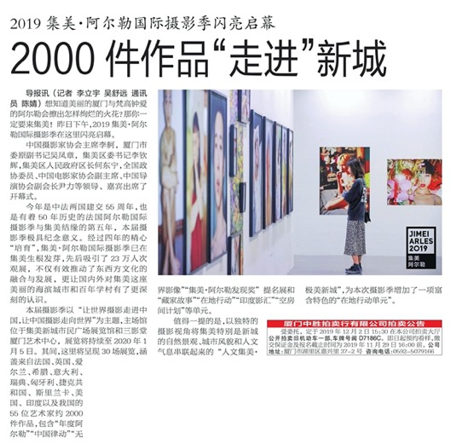

Publication : | Dongnan Zaobao/东南早报
Circulation : | 200,000
Date : | 2019-11-23
Page : | 省内新闻
Headline : | Jimei x Arles International Photo Festival, a top-level visual feast, will showcase first batch of works of the 1st festival
 | 50年前珍贵作品在集美经典重现
Ad Value : | 35,300
PV : | 200,000
Summary : | The 5th Jimei x Arles International Photo Festival will be held in Xiamen from November 22, 2019 to January 5, 2020. It will include 30 exhibitions, which will display artworks by 55 world artists. Particularly, some works of the 1st festival will be displayed this year.
Link : | http://data.fiplus.cn/show/detail.ftl?id=402881486e8e84fe016ea042d0153d06

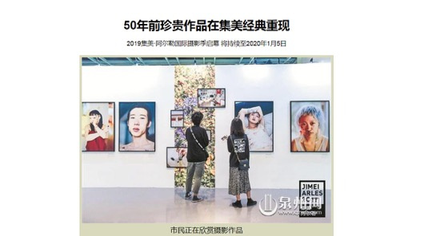
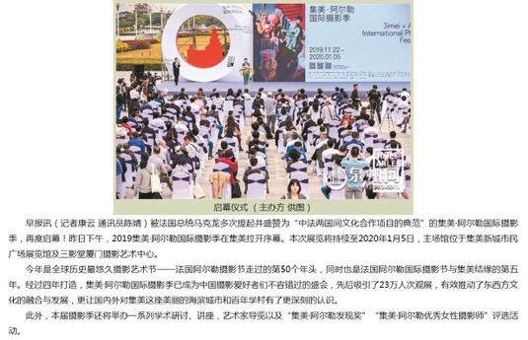

Publication : | Xiamen Daily/厦门日报
Circulation : | 220,000
Date : | 2019-11-23
Page : | 都市新闻
Headline : | Watch the photo feast at 2019 Jimei x Arles International Photo Festival
 | 看摄影盛宴
Ad Value : | 38,333
PV : | 220,000
Summary : | 2019 Jimei x Arles International Photo Festival kicked off in Xiamen on November 22 and will last till January 5, 2020. It will include 30 exhibitions, which display over 2,200 artworks by 55 artists. In addition to continuous attention to photography ecology in Asian countries or regions, this year's festival will present two exhibitions about Indian photos.
Link : | http://data.fiplus.cn/show/detail.ftl?id=402881486e8e84fe016ea03b0f2e3bc7

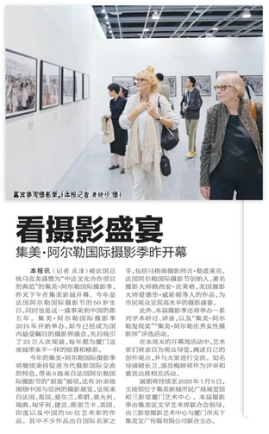

Publication : | Hercynian Morning News/海西晨报
Circulation : | 150,000
Date : | 2019-11-25
Page : | 城市读本
Headline : | The 5th Jimei x Arles International Photo Festival kicks off
 | 穿梭光影世界 领略集美之美
Ad Value : | 40,000
PV : | 150,000
Summary : | The 5th Jimei x Arles International Photo Festival kicked off in Xiamen on November 22, 2019 and will last till January 5, 2020. It will include 30 exhibitions, which will display artworks by 55 world artists. Besides, some works of the 1st festival will be displayed this year. In addition, this year's Jimei x Arles Discover Award was won by post-85 photographer Yi Lian.
Link : | http://data.fiplus.cn/show/detail.ftl?id=402881486e8e84fe016ea042045e3cfb

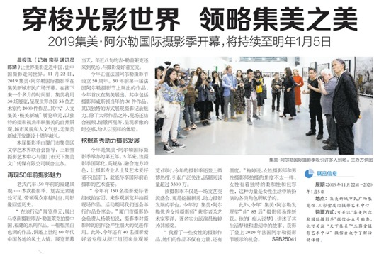

Publication : | Strait Guide/海峡导报
Circulation : | 150,000
Date : | 2019-11-25
Page : | 民生
Headline : | The 5th Jimei x Arles International Photo Festival welcomes its peak time
 | 家门口的顶级视觉“饕餮盛宴”
Ad Value : | 52,538
PV : | 150,000
Summary : | 2019 Jimei x Arles International Photo Festival kicked off on November 22, attracting hundreds of global photographers, curators and inside experts as well as photography and art lovers. This festival will last till January 5, 2020. It will display over 2,200 artworks by 55 artists from France, UK, Ireland, Greece, Italy, Sweden, Hungary, Czech, Sri Lanka, US, India and China. In addition, a series of artists' tour guides, academic forums and lectures will be held during the festival.
Link : | http://data.fiplus.cn/show/detail.ftl?id=402881486e8e84fe016ea0429e543d05

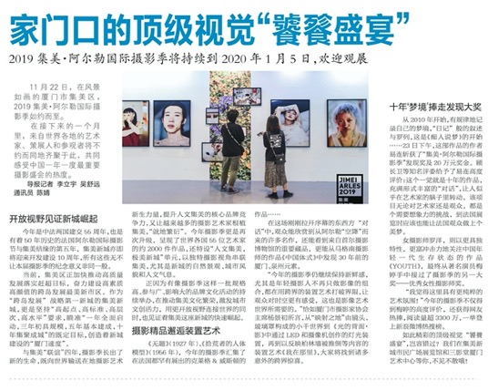

Publication : | Xiamen Daily/厦门日报
Circulation : | 220,000
Date : | 2019-11-25
Page : | 加力再加力 奋进新征程
Headline : | Chinese new photography force walks from Xiamen to the world
 | 中国摄影新锐力量从厦门走向世界
Ad Value : | 115,000
PV : | 220,000
Summary : | 2019 Jimei x Arles International Photo Festival kicked off on November 22, attracting hundreds of global photographers, curators and inside experts as well as photography and art lovers. Topics related to the festival ascended to top three of hot search list, accumulative readings of the topics exceeded 33 million times and "literary and artistic style" of the festival flooded the circle of friends. This festival will last till January 5, 2020. It will display over 2,200 artworks by 55 artists from France, UK, Ireland, Greece, Italy, Sweden, Hungary, Czech, Sri Lanka, US, India and China. In addition, a series of artists' tour guides, academic forums and lectures will be held during the festival.
Link : | http://data.fiplus.cn/show/detail.ftl?id=402881486e8e84fe016ea5525cec041e

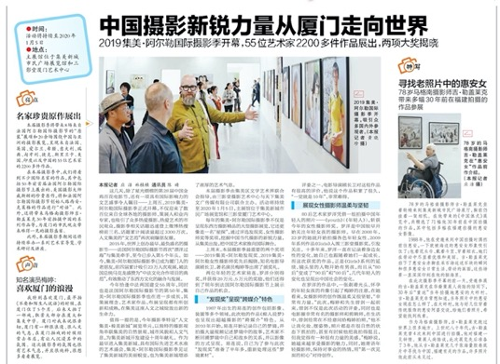

Publication : | Xiamen Daily/厦门日报
Circulation : | 220,000
Date : | 2019-12-03
Page : | 加力再加力 奋进新征程
Headline : | Face-to-face meetings between artists, curators and citizens
 | 艺术家策展人与市民面对面
Ad Value : | 57,500
PV : | 220,000
Summary : | Over the past week, 2019 Jimei x Arles International Photo Festival held a series of colorful opening week events, such as tour guides by artists and curators, photo lectures and experts meetings. This festival invited artists and curators to interact with the citizens, narrowing the distance between photography and ordinary audience.
Link : | http://data.fiplus.cn/show/detail.ftl?id=402881486ecf44bb016ecf4c6525004a

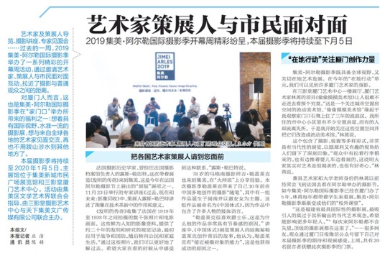

Publication : | Strait Guide/海峡导报
Circulation : | 150,000
Date : | 2019-12-04
Page : | 民生
Headline : | 2019 Jimei x Arles International Photo Festival welcomes you
 | 2019集美阿尔勒摄影季欢迎您
Ad Value : | 8,756
PV : | 150,000
Summary : | 2019 Jimei x Arles International Photo Festival was recently unveiled and will last till January 5, 2020. It includes 30 exhibitions, which display over 2,200 artworks by 55 artists. Within three days, topics on the festival recorded over 33 million readings on Weibo.
Link : | http://data.fiplus.cn/show/detail.ftl?id=402881486ecf44bb016ecf4bf153003d

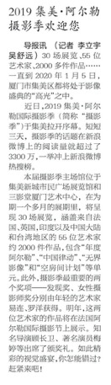

Publication : | Xiamen Evening News/厦门晚报
Circulation : | 240,000
Date : | 2019-12-30
Page : | 今日·都市
Headline : | Night fields added to 2019 Jimei x Arles International Photography Festival
 | 阿尔勒国际摄影季新增夜间专场
Ad Value : | 46,000
PV : | 240,000
Summary : | Night fields added in the last five days of 2019 Jimei x Arles International Photography Festival from January 1 to 5, extending the exhibition time to 20:30. Besides, artists guide and audio guide were also added, enhancing visitors' experience. There are also a variety of rich supporting activities, such as the 2019 Book Awards sharing, parent-kid reading.
Link : | http://data.fiplus.cn/show/detail.ftl?id=402881486f387868016f59779d9f2d5d

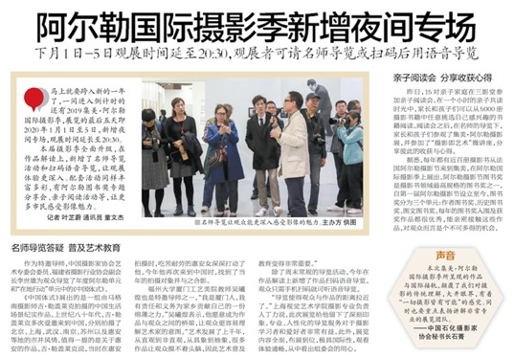

Publication : | Hercynian Morning News/海西晨报
Circulation : | 150,000
Date : | 2019-12-31
Page : | 新市民节
Headline : | 2019 Jimei x Arles International Photography Festival attracts many photography artists
 | 从无到有 看新城区强势崛起 宜居宜业 成新市民造梦之地
Ad Value : | 160,000
PV : | 150,000
Summary : | 2019 Jimei x Arles International Photography Festival attracted many Chinese and foreign photographers and photography lovers.
Link : | http://data.fiplus.cn/show/detail.ftl?id=402881486f387868016f59779d802d5c

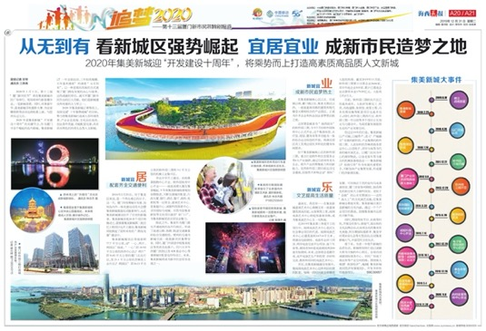

Publication : | www.chinadaily.com.cn/中国日报网
Circulation : | 7,507
Date : | 2019-11-15
Page : | 新闻
Headline : | Intl photography exhibition set for November
 | Intl photography exhibition set for November
Ad Value : | 20,000
PV : | 7,507
Summary : | The 2019 Jimei Arles International Photography Festival will begin on Nov 22 in Jimei district, Xiamen and will run until Jan 5, 2020. This year's event will feature eight exhibitions from the Les Rencontres d'Arles in France and 30 themed exhibitions by 55 artists from France, the UK, the US, Greece, Italy, India, and more.
Link : | http://xiamen.chinadaily.com.cn/2019-11/15/c_424917.htm

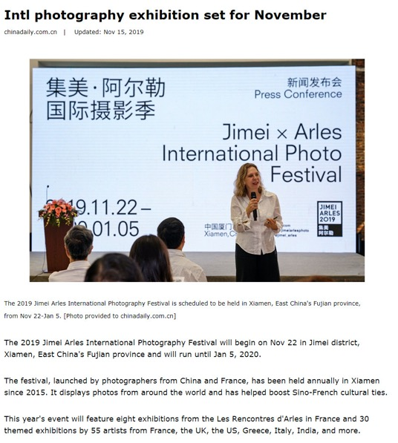
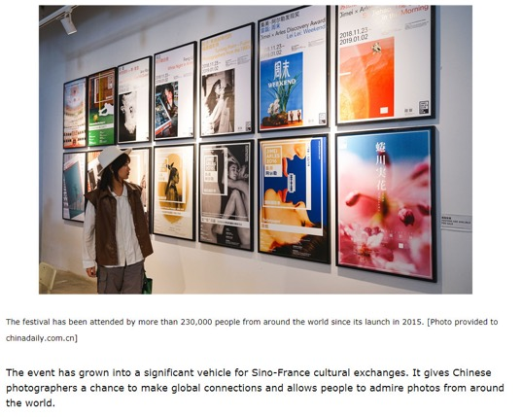

Publication : | www.fengniao.com/蜂鸟网
Circulation : | 46,872
Date : | 2019-11-21
Page : | 资讯
Headline : | Screening and after-screening exchange of film Peacock
 | 集美阿尔勒 | 顾长卫电影《孔雀》放映及交流会
Ad Value : | 20,000
PV : | 46,872
Summary : | Chinese well-known director Gu Changwei will act as the judge of Jimei x Arles Discovery Award 2019. His film Peacock will be screened in Three Shadows Xiamen Photography Art Centre Library at 16:00-19:15 of November 24. And an exchange after the screening will be held too.
Link : | http://image.fengniao.com/535/5359234.html

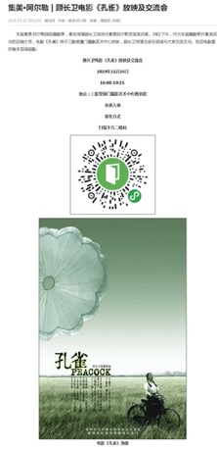
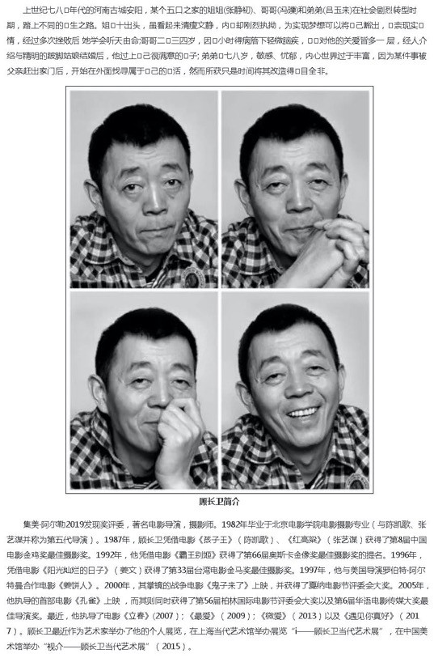

Publication : | www.fengniao.com/蜂鸟网
Circulation : | 46,872
Date : | 2019-11-22
Page : | 资讯
Headline : | "Local Action" - Fujian under the camera of Magnum photographer
 | 集美阿尔勒在地行动 | 马格南摄影师镜头下的福建
Ad Value : | 20,000
PV : | 46,872
Summary : | The section "Local Action" typically explores the links between photography and the local environment of the festival. It's an honor for 2019 Jimei x Arles International Photo Festival to invite Magnum veteran Guy Le Querrec to present his series work "The Chinese Gesture" which was shot by him during his visit to China for many times in 1980s.
Link : | http://image.fengniao.com/535/5359178.html

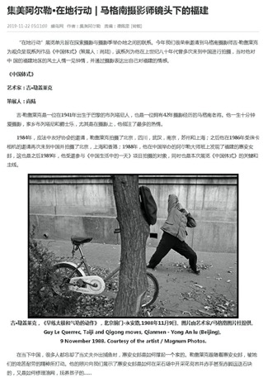

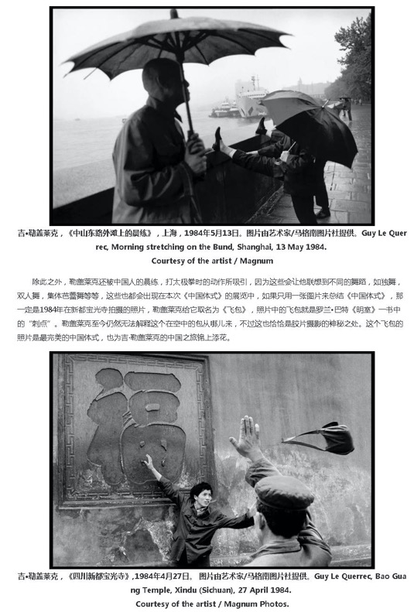
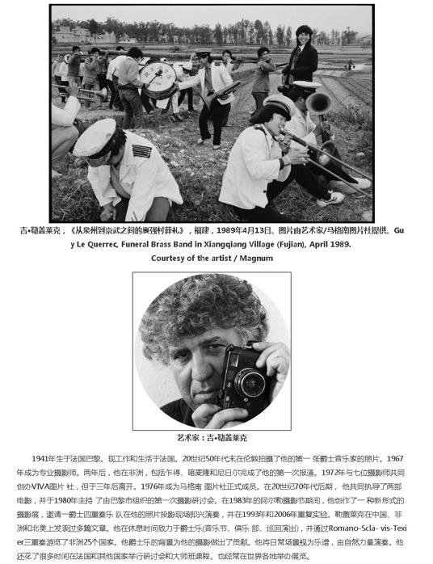

Publication : | www.ifeng.com/凤凰网
Circulation : | 7,925
Date : | 2019-11-22
Page : | N/A
Headline : | 2019 Jimei x Arles International Photo Festival will present over 30 exhibitions
 | 集美阿尔勒摄影季：30余场摄影展呈现魅力视界
Ad Value : | 30,000
PV : | 7,925
Summary : | 2019 Jimei x Arles International Photo Festival kicked off in Xiamen on November 22 and will last till January 5, 2020. It will present 8 exhibitions from Les Recontres d'Arles and over 20 photo exhibitions concentrating on China and Asia. Notably, this year's festival will present two exhibitions about Indian photos.
Link : | http://art.ifeng.com/2019/1122/3491797.shtml

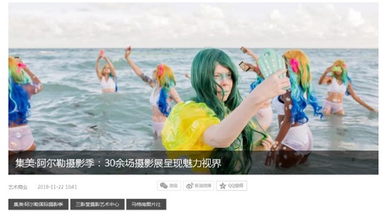
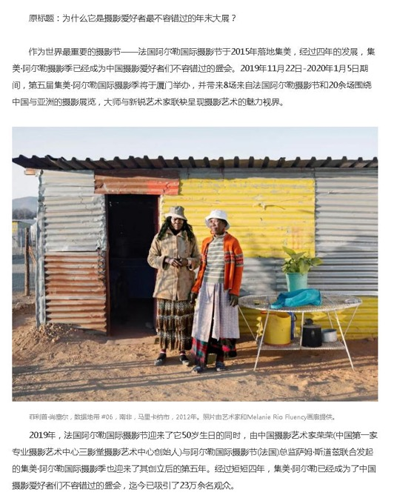
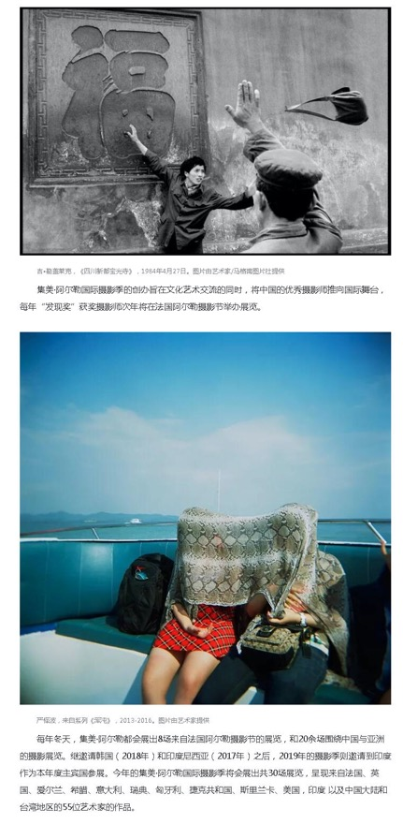
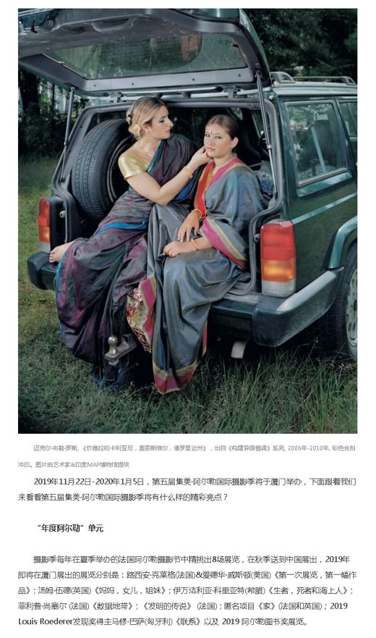
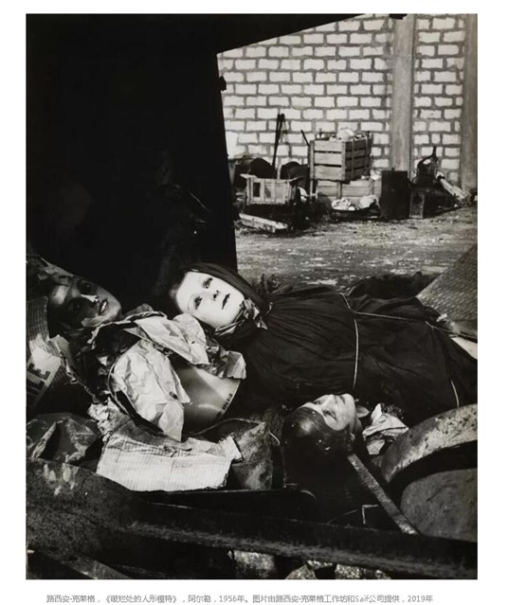
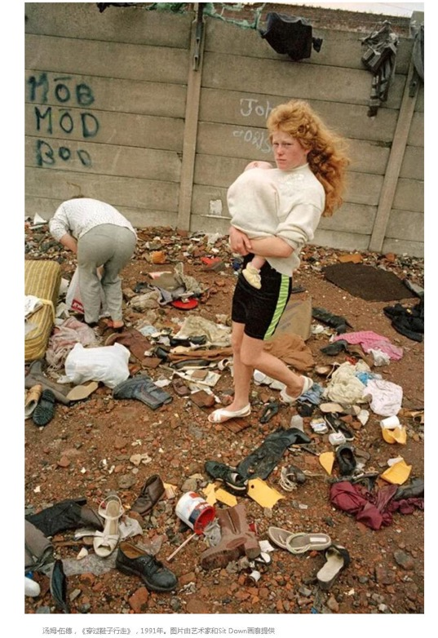
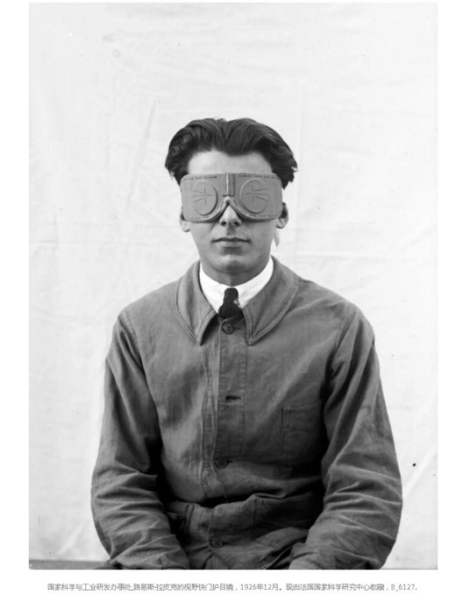
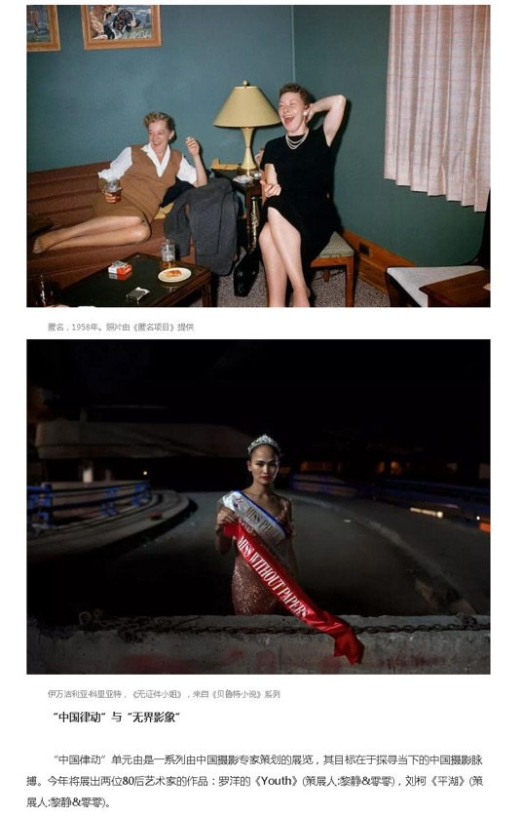
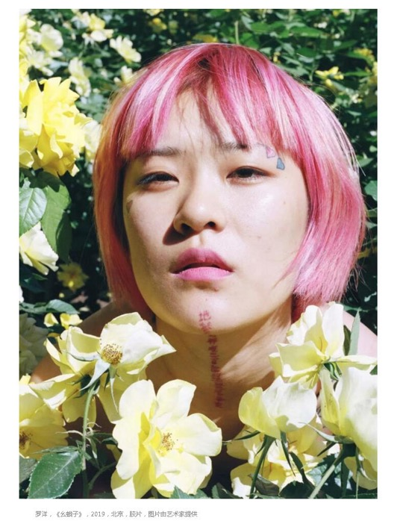
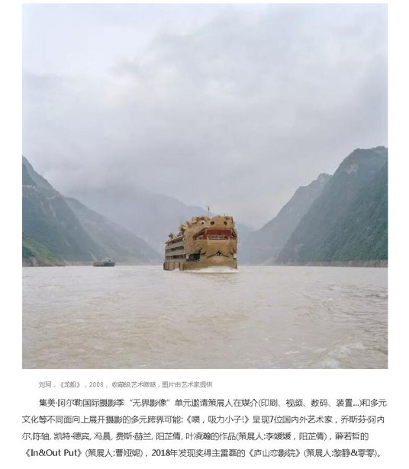
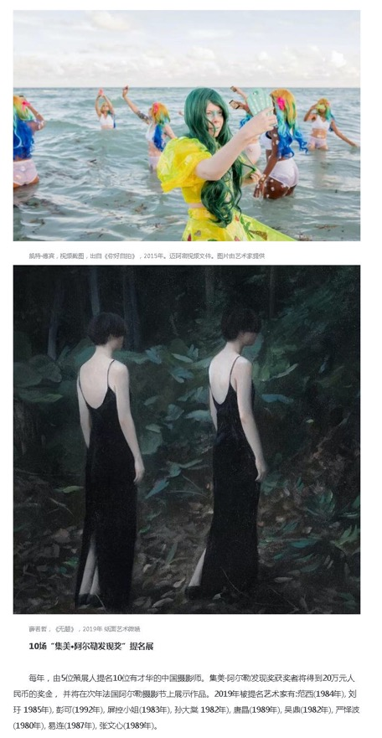
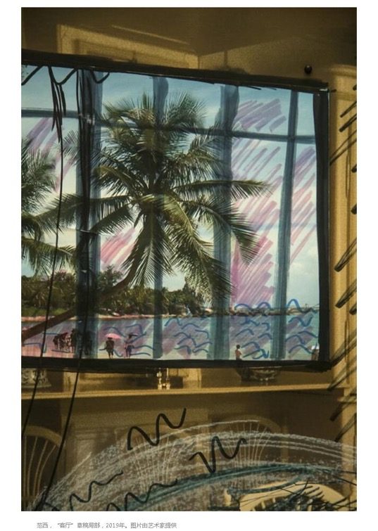

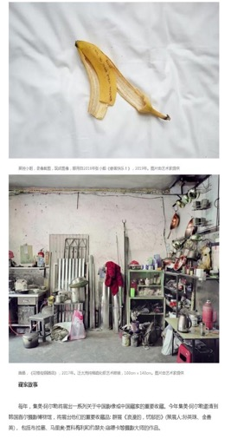
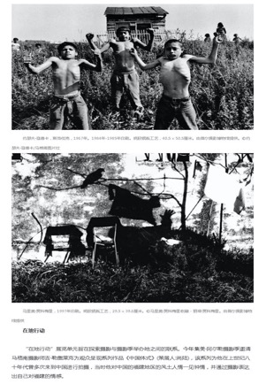
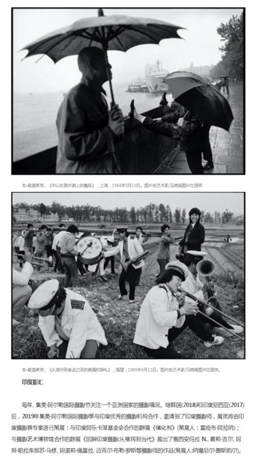

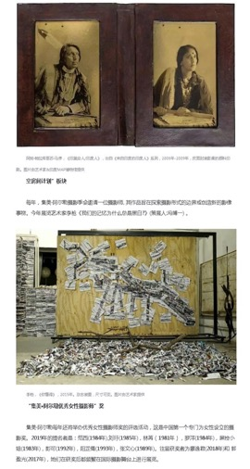

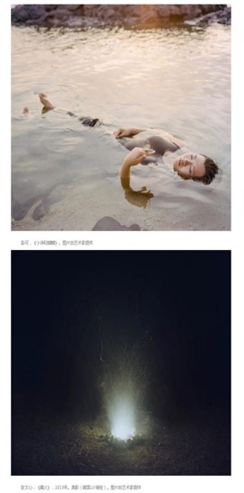
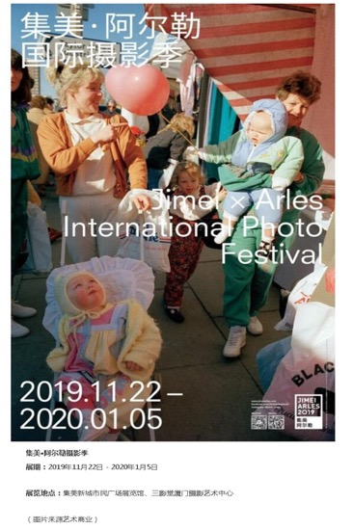

Publication : | www.people.com.cn/人民网
Circulation : | 9,363
Date : | 2019-11-22
Page : | 福建频道
Headline : | The 5th Jimei x Arles International Photo Festival kicks off in Xiamen
 | 2019集美阿尔勒国际摄影季拉开帷幕
Ad Value : | 20,000
PV : | 9,363
Summary : | The 5th Jimei x Arles International Photo Festival kicked off in Xiamen on November 22, 2019 and will last till January 5, 2020. It will include 30 exhibitions, which will display over 2,200 artworks by 55 world artists.
Link : | http://fj.people.com.cn/n2/2019/1122/c181466-33568597.html

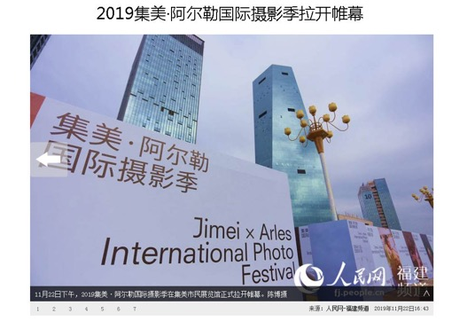
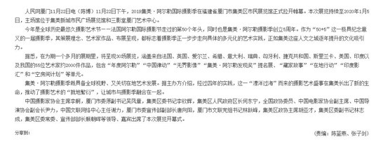

Publication : | www.fengniao.com/蜂鸟网
Circulation : | 46,872
Date : | 2019-11-22
Page : | 资讯
Headline : | 2019 Jimei x Arles International Photo Festival kicks off in Xiamen
 | 进入影像“高光时刻” 2019集美阿尔勒国际摄影季开幕
Ad Value : | 20,000
PV : | 46,872
Summary : | 2019 Jimei x Arles International Photo Festival kicked off on November 22, attracting hundreds of global photographers, curators and inside experts as well as photography and art lovers. This festival will last till January 5, 2020. It will display over 2,200 artworks by 55 artists from France, UK, Ireland, Greece, Italy, Sweden, Hungary, Czech, Sri Lanka, US, India and China. In addition, a series of artists' tour guides, academic forums and lectures will be held during the festival.
Link : | http://image.fengniao.com/535/5359249.html

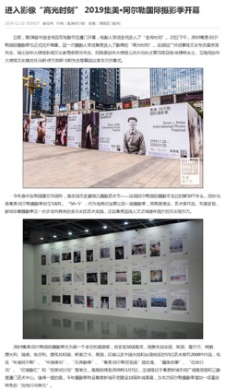
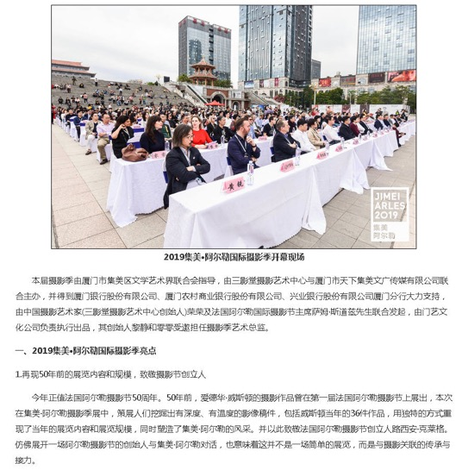
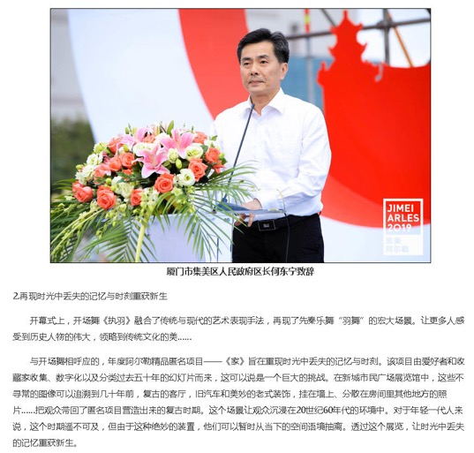

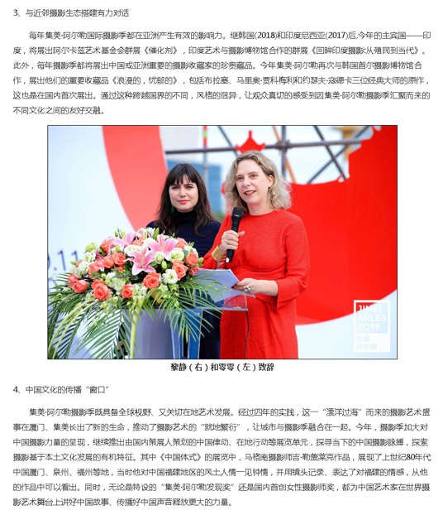
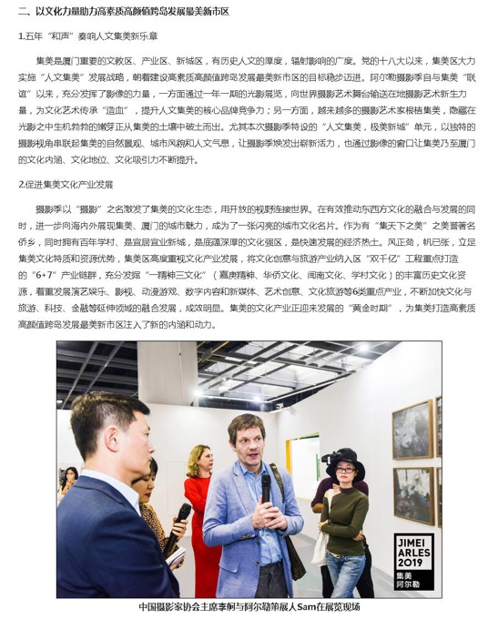
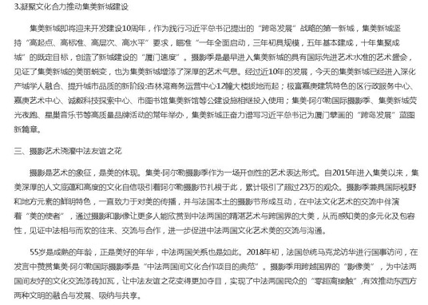

Publication : | www.bjnews.com.cn/新京报网
Circulation : | 432,856
Date : | 2019-11-22
Page : | 快讯
Headline : | The 5th Jimei x Arles International Photo Festival displays over 2,200 artworks by 55 artists
 | 55位艺术家、千余幅作品，集美阿尔勒再迎影像高光时刻
Ad Value : | 20,000
PV : | 432,856
Summary : | The 5th Jimei x Arles International Photo Festival kicked off in Xiamen on November 22, 2019 and will last till January 5, 2020. It will include 30 exhibitions, which will display over 2,200 artworks by 55 world artists. The unit of "Exhibitions from Arles 2019" was introduced.
Link : | http://www.bjnews.com.cn/feature/2019/11/22/653089.html

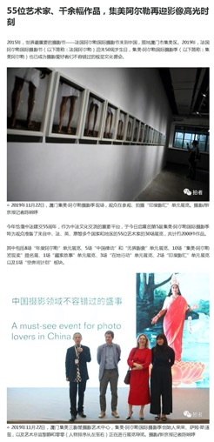
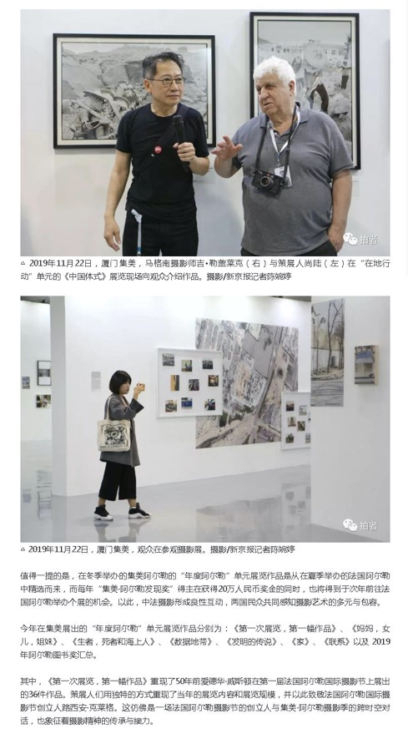
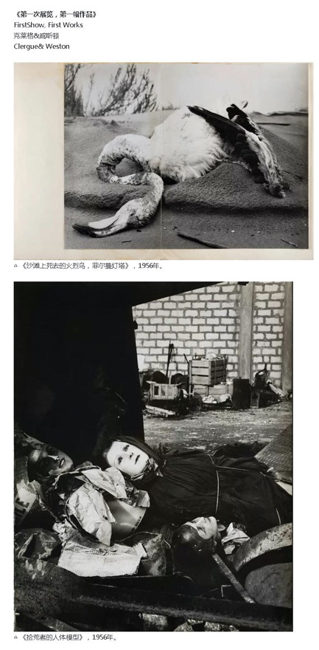
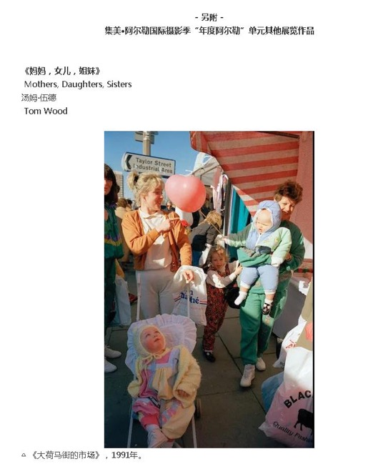
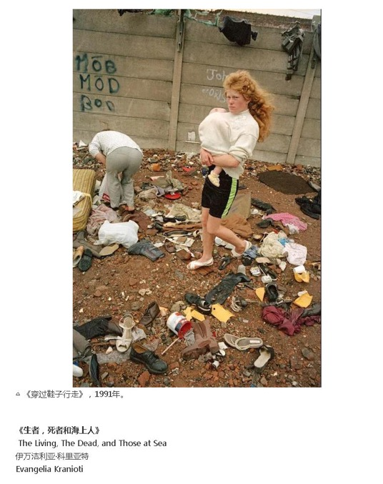

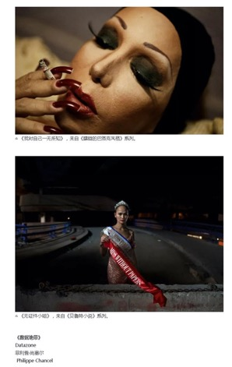
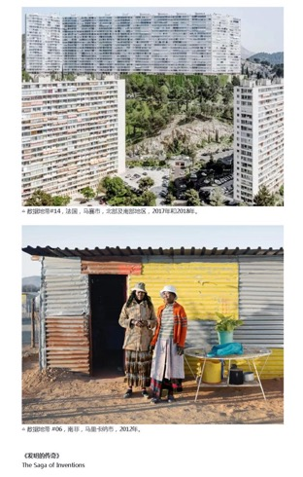
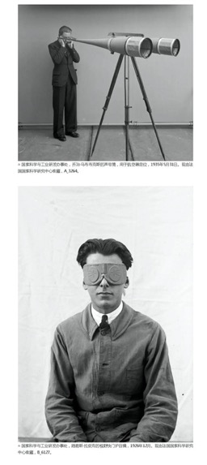

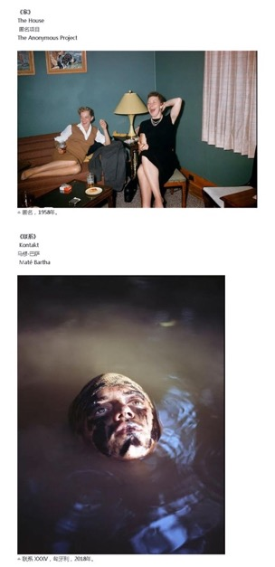

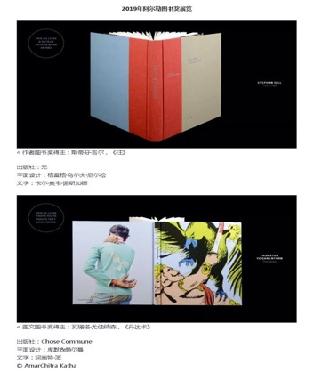
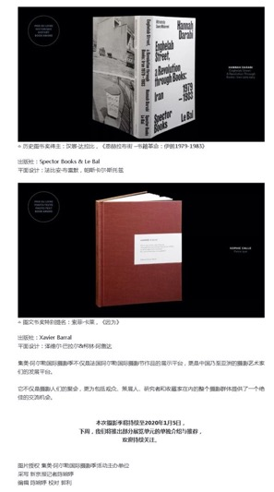

Publication : | www.artron.net/雅昌艺术网
Circulation : | 11,128
Date : | 2019-11-22
Page : | 展览现场
Headline : | The 5th Jimei x Arles International Photo Festival welcomes its peak time
 | 【图集】海图！“50+5” 5岁的集美阿尔勒摄影季迎来影像“高光时刻”
Ad Value : | 20,000
PV : | 11,128
Summary : | 2019 Jimei x Arles International Photo Festival kicked off on November 22, attracting hundreds of global photographers, curators and inside experts as well as photography and art lovers. This festival will last till January 5, 2020. It will display over 2,200 artworks by 55 artists from France, UK, Ireland, Greece, Italy, Sweden, Hungary, Czech, Sri Lanka, US, India and China. In addition, a series of artists' tour guides, academic forums and lectures will be held during the festival.
Link : | https://news.artron.net/20191122/n1065469_1.html

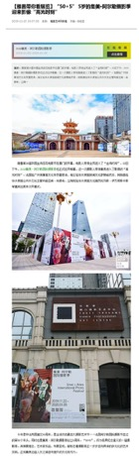
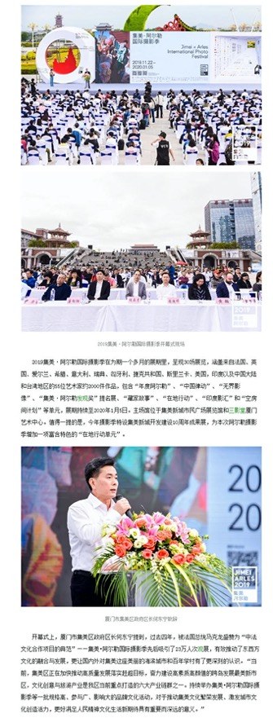
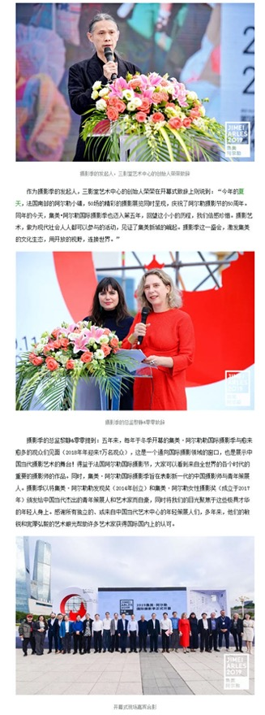
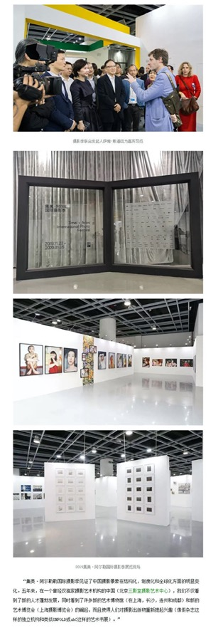
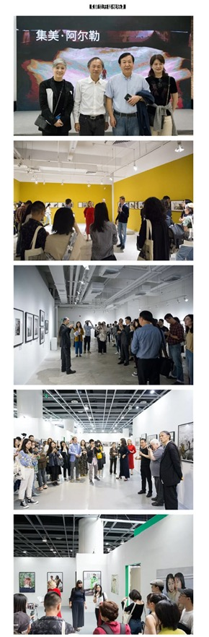
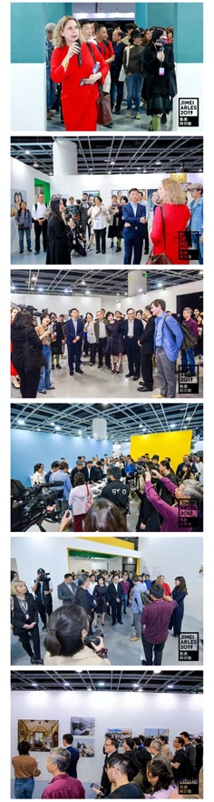
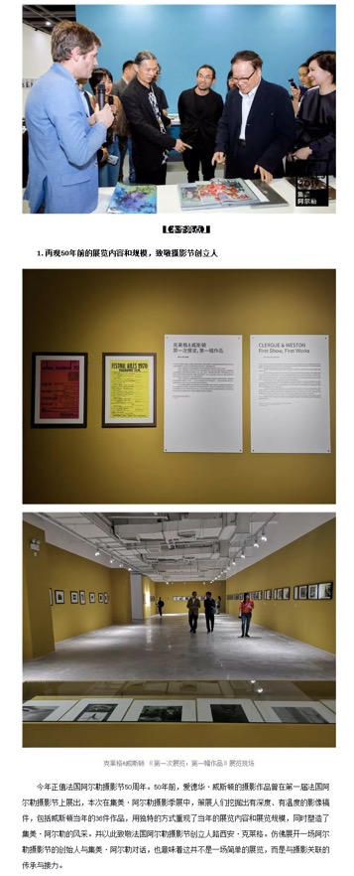
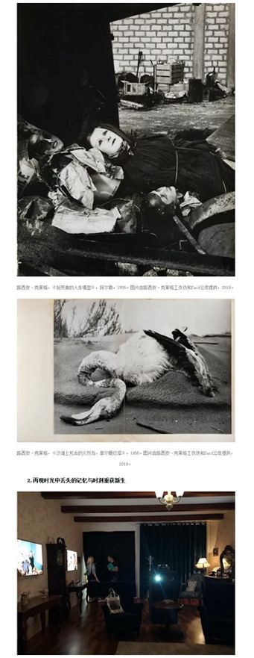
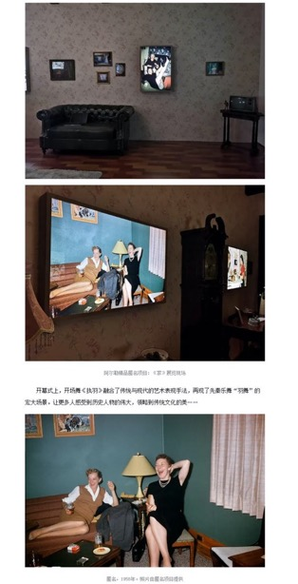
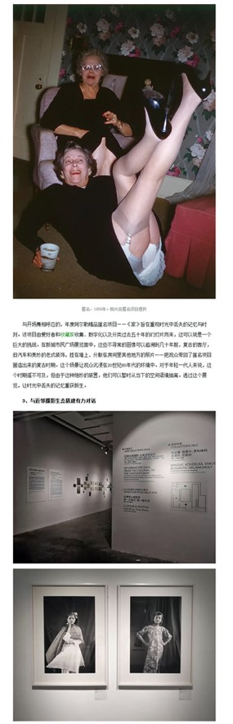
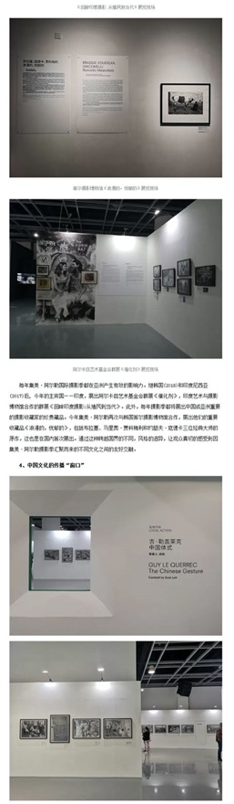
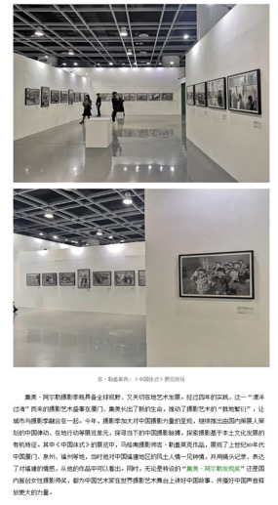
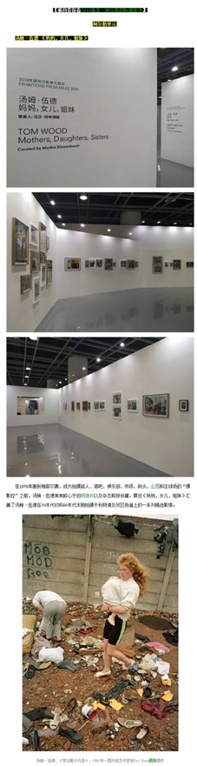
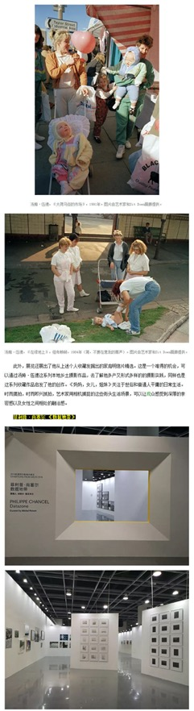
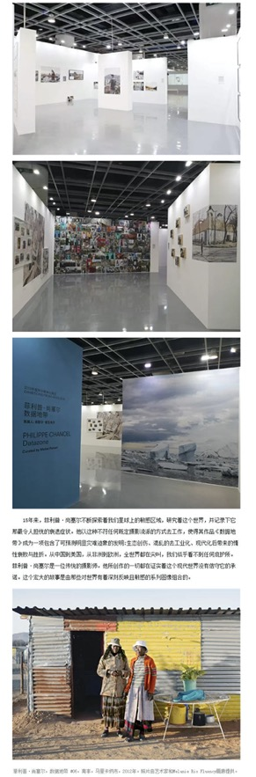
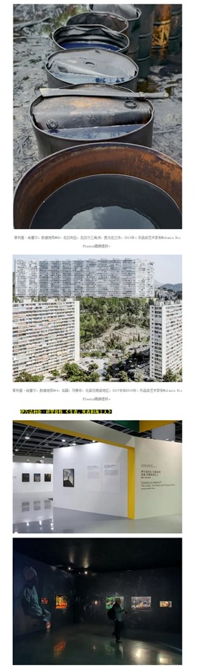
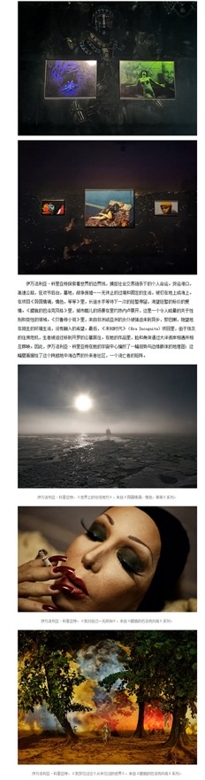
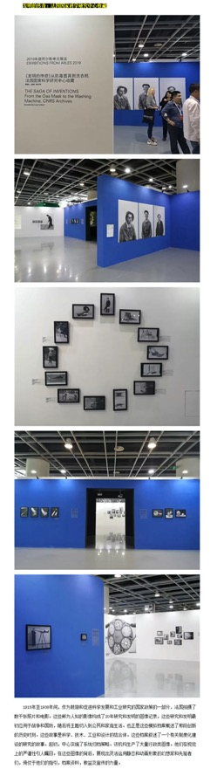
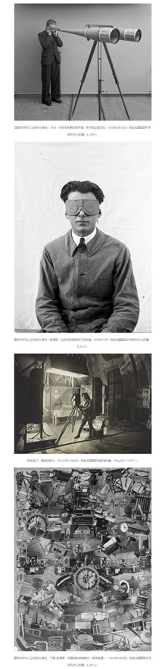
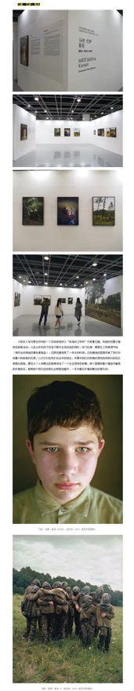
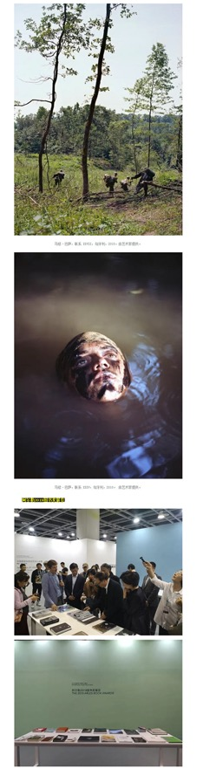
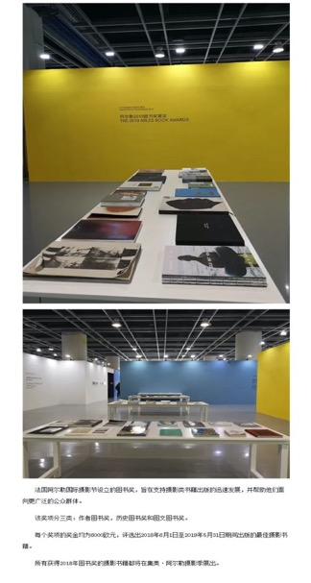
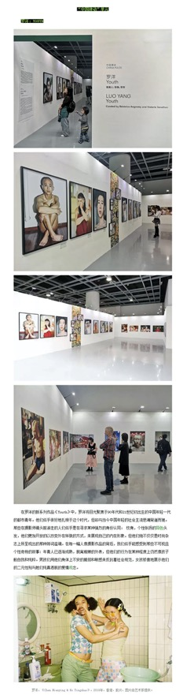
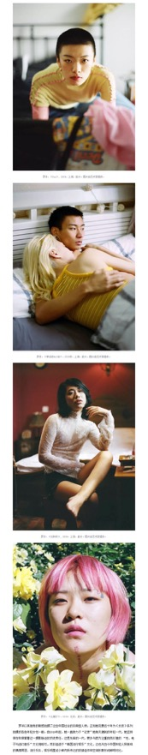
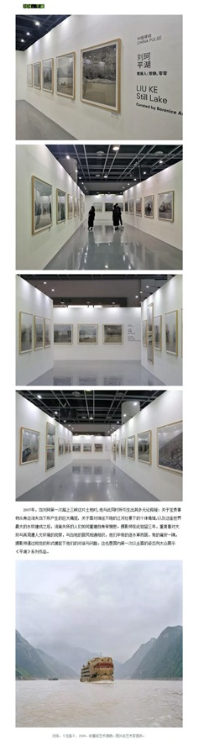
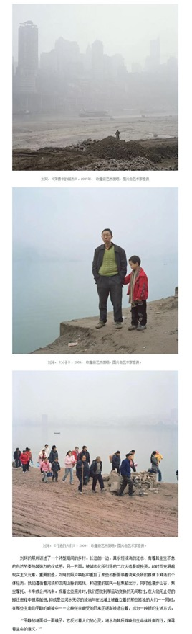
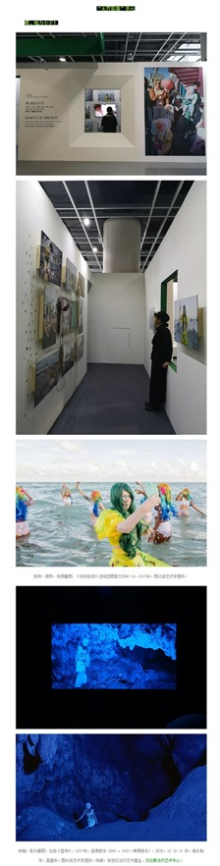
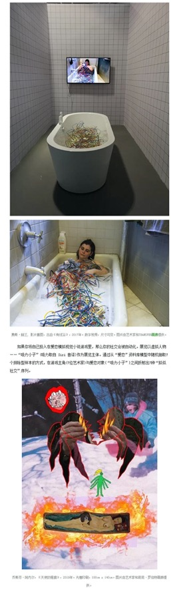
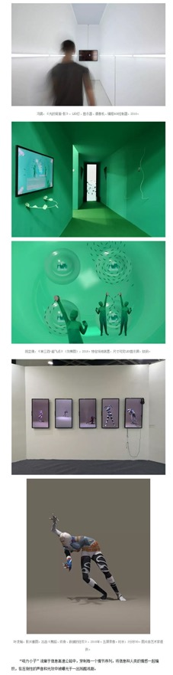
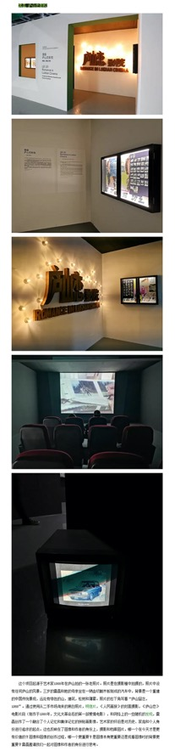
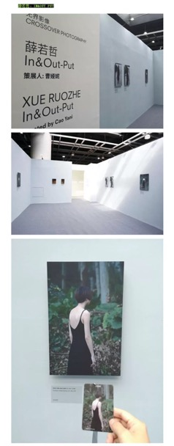
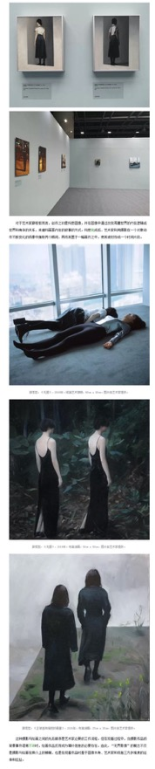
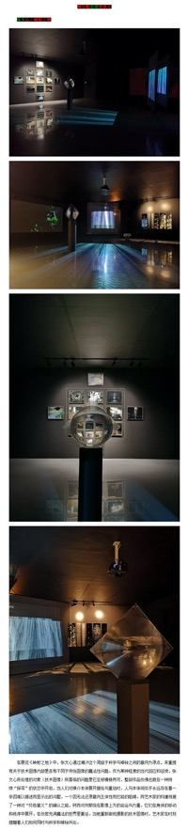

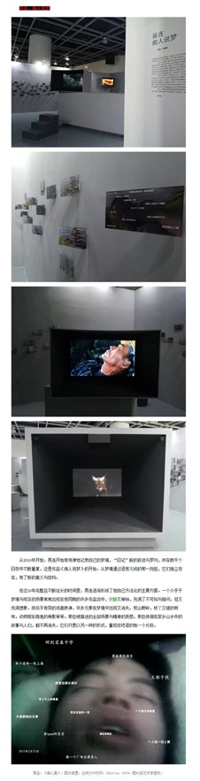
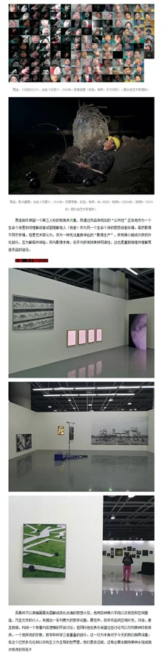
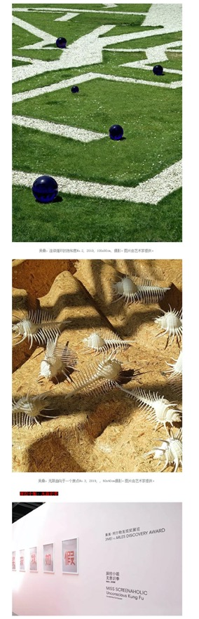
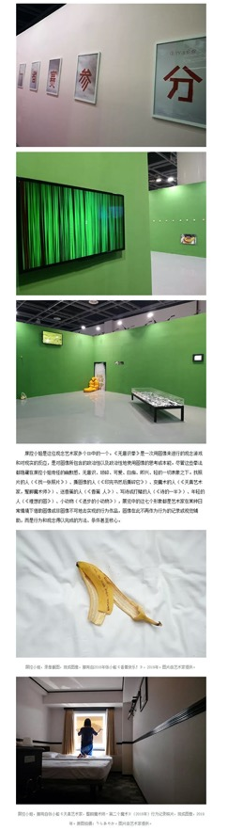
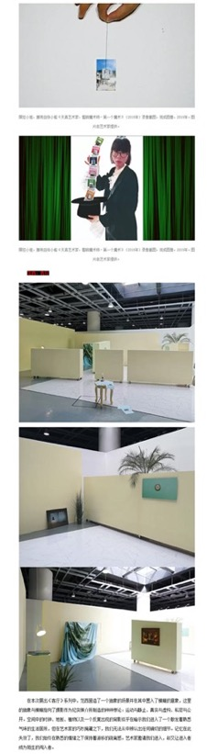

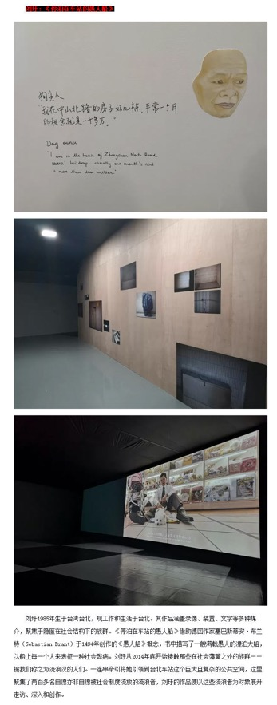
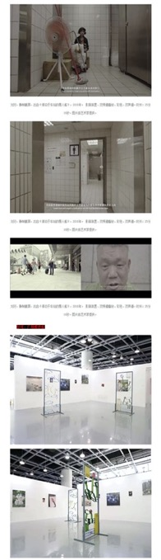
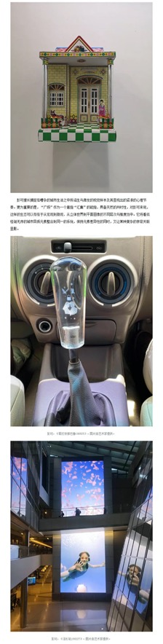
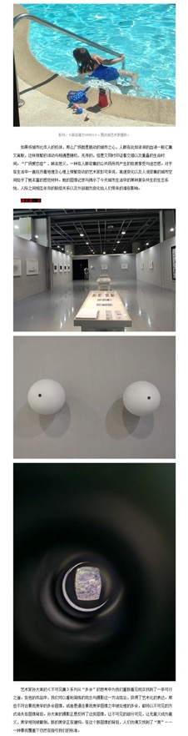
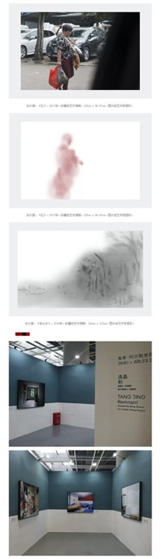
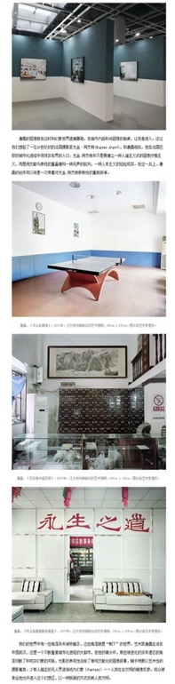
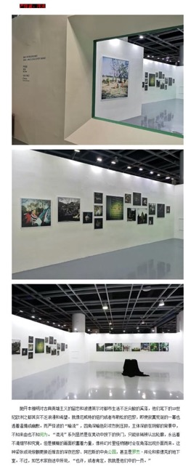

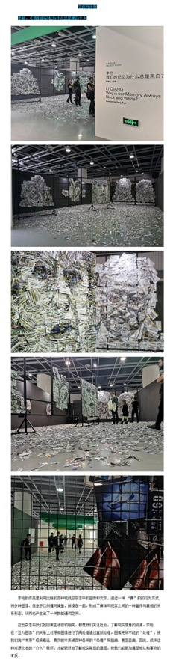
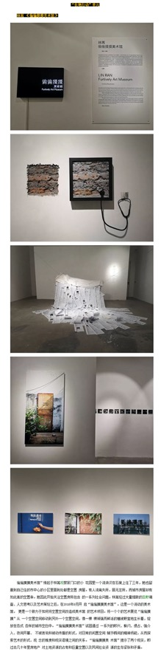
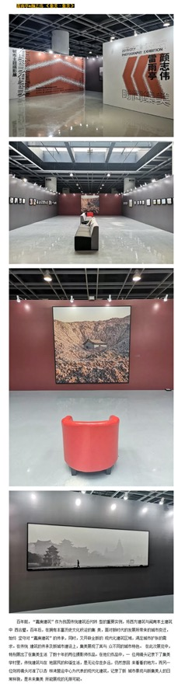
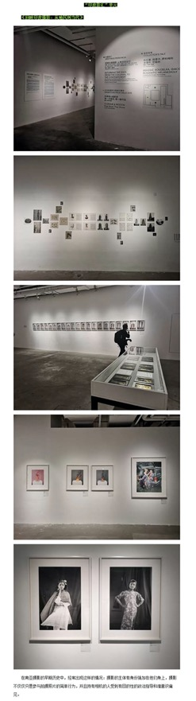
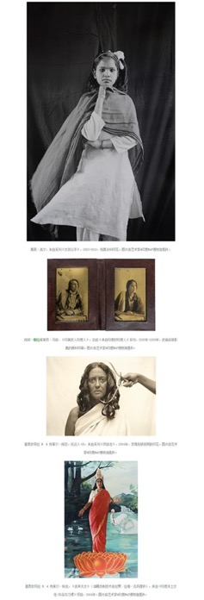
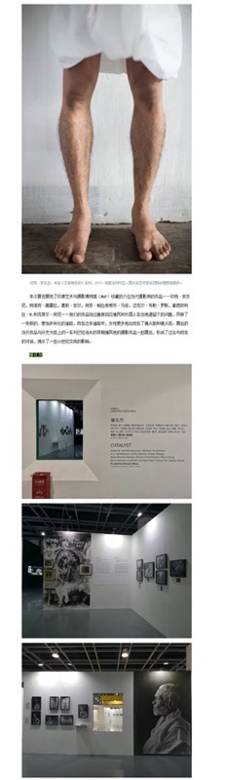

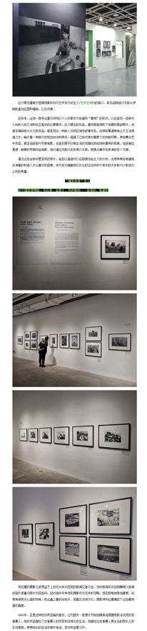
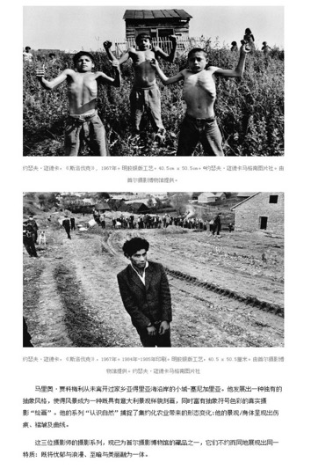

Publication : | www.fjsen.com/东南网
Circulation : | 1,000
Date : | 2019-11-22
Page : | 本网原创
Headline : | The 5th Jimei x Arles International Photo Festival kicks off in Xiamen
 | 2019集美阿尔勒国际摄影季开幕 展至明年1月
Ad Value : | 20,000
PV : | 1,000
Summary : | The 5th Jimei x Arles International Photo Festival kicked off in Xiamen on November 22, 2019 and will last till January 5, 2020. It will include 30 exhibitions, which will display over 2,200 artworks by 55 world artists.
Link : | http://xm.fjsen.com/2019-11/22/content_30068768.htm

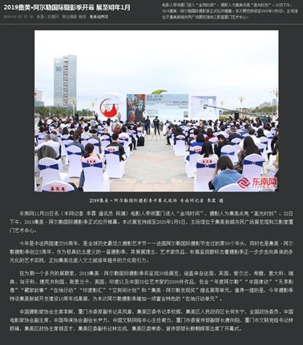
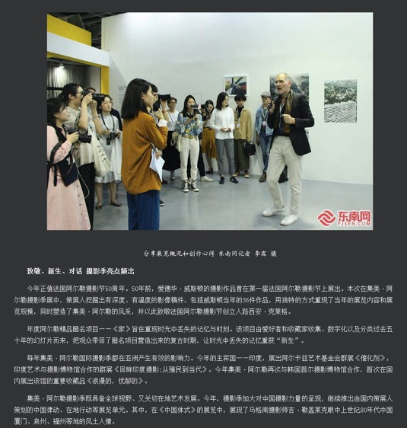
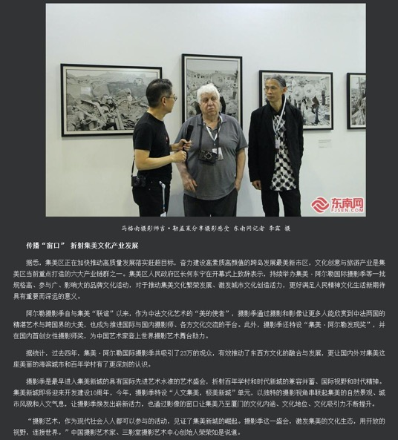
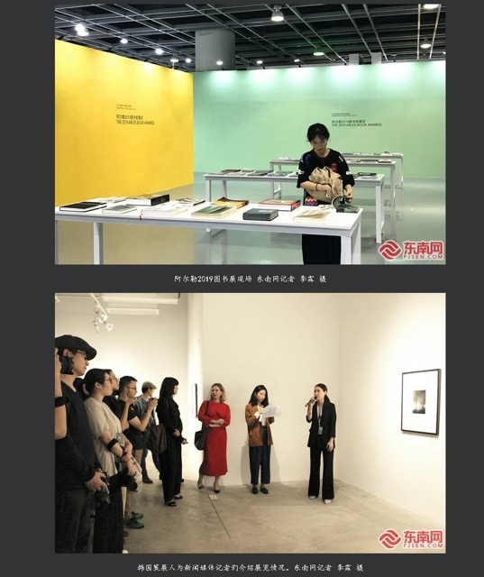
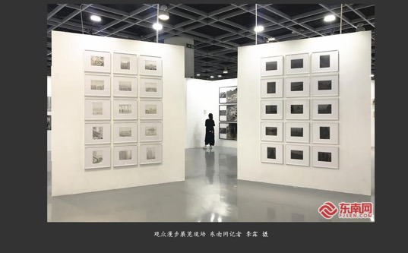

Publication : | www.fjsen.com/东南网
Circulation : | 1,000
Date : | 2019-11-22
Page : | 本网原创
Headline : | 2019 Jimei x Arles International Photo Festival kicks off
 | 2019集美阿尔勒国际摄影季开幕 展至明年1月
Ad Value : | 20,000
PV : | 1,000
Summary : | 2019 Jimei x Arles International Photo Festival kicked off in Xiamen on November 22 and will last till January 5, 2020. It will include 30 exhibitions, which display over 2,200 artworks by 55 artists.
Link : | http://xm.fjsen.com/2019-11/22/content_30068768_4.htm

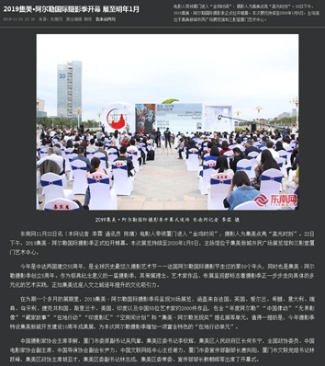
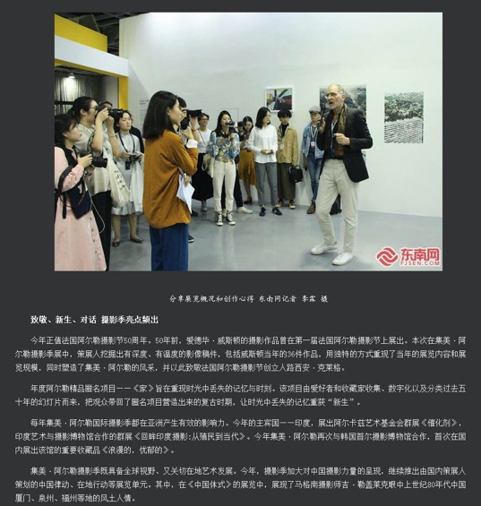
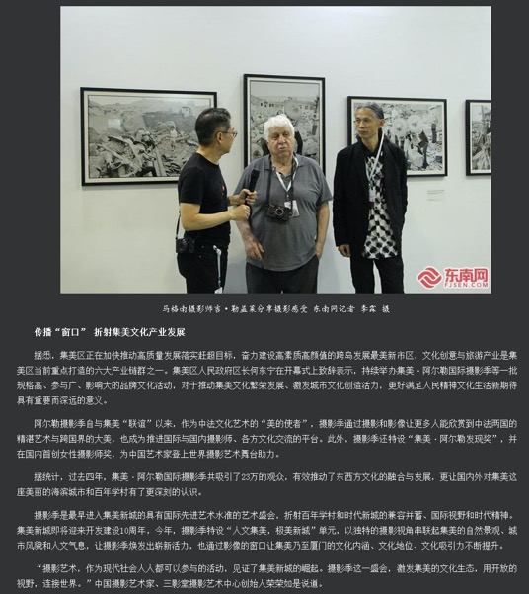
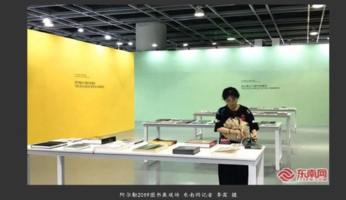
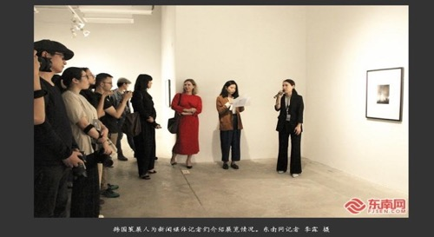
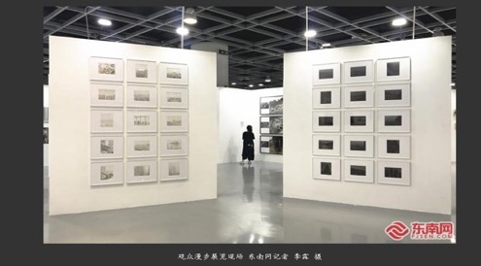

Publication : | www.taihainet.com/台海网
Circulation : | 1,000
Date : | 2019-11-23
Page : | N/A
Headline : | The 5th Jimei x Arles International Photo Festival kicks off in Xiamen
 | 2019集美阿尔勒国际摄影季闪亮启幕 2000件作品走进新城
Ad Value : | 20,000
PV : | 1,000
Summary : | The 5th Jimei x Arles International Photo Festival kicked off in Xiamen on November 22, 2019 and will last till January 5, 2020. It will include 30 exhibitions, which will display over 2,200 artworks by 55 world artists.
Link : | http://m.taihainet.com/news/xmnews/gqbd/2019-11-23/t_2330064.html

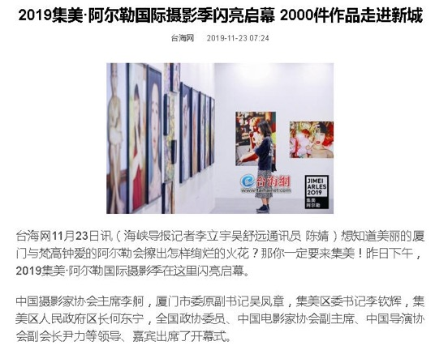
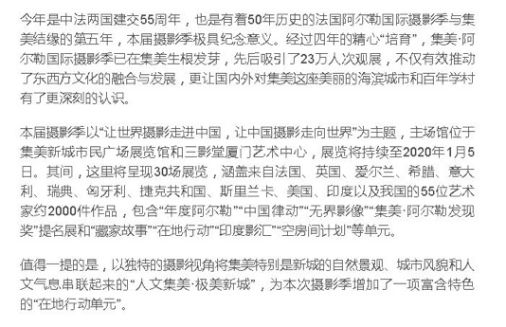

Publication : | m.163.com/网易新闻APP
Circulation : | 0
Date : | 2019-11-23
Page : | N/A
Headline : | 2019 Jimei x Arles International Photo Festival kicks off in Xiamen
 | 与金鸡共舞 厦门集美阿尔勒开启“高光时刻”
Ad Value : | 20,000
PV : | 83,028
Summary : | 2019 Jimei x Arles International Photo Festival kicked off on November 22, attracting hundreds of global photographers, curators and inside experts as well as photography and art lovers. This festival will last till January 5, 2020. It will display over 2,200 artworks by 55 artists from France, UK, Ireland, Greece, Italy, Sweden, Hungary, Czech, Sri Lanka, US, India and China. In addition, a series of artists' tour guides, academic forums and lectures will be held during the festival.
Link : | https://c.m.163.com/news/a/EULC6ETD009997SQ.html

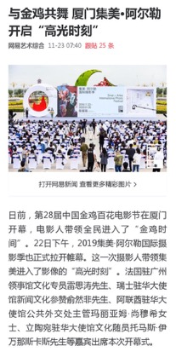
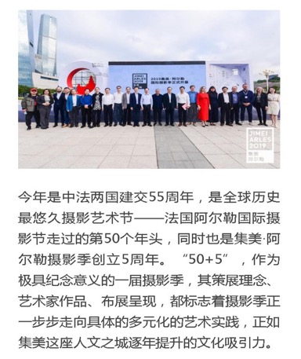

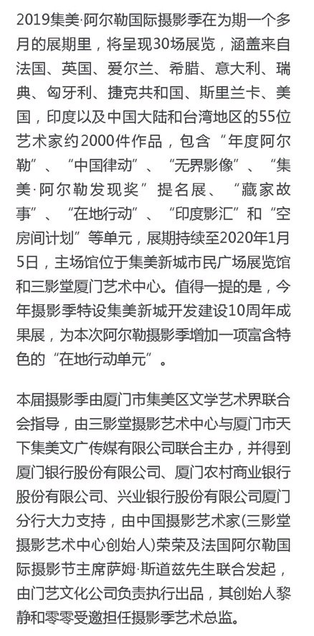
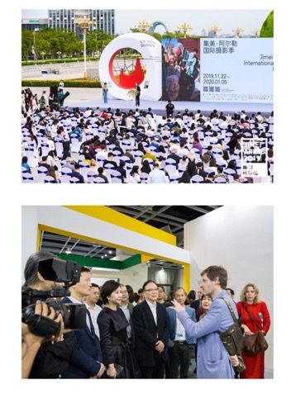
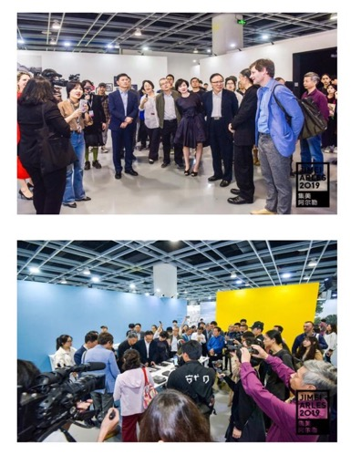

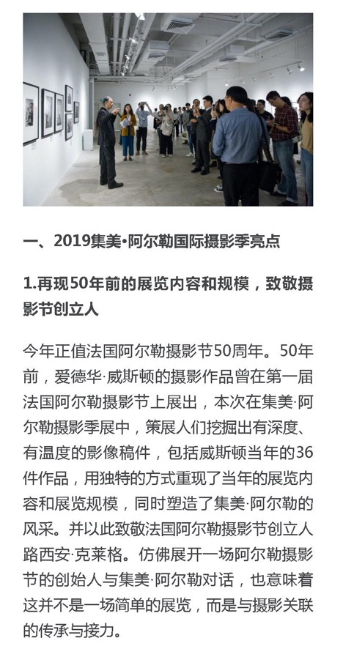
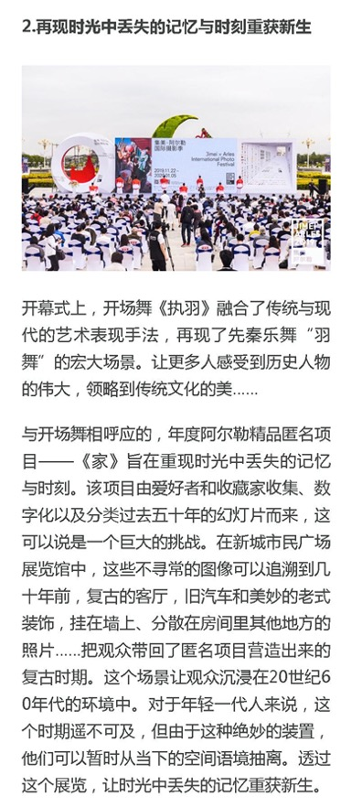
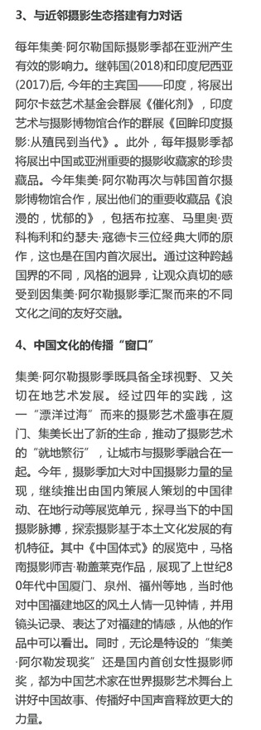

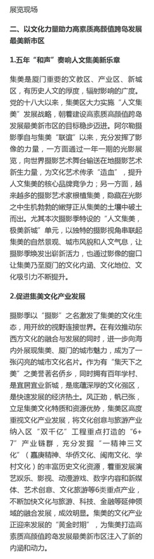
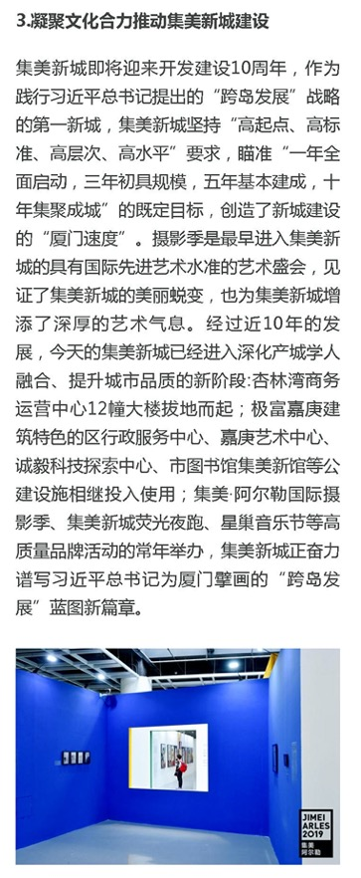
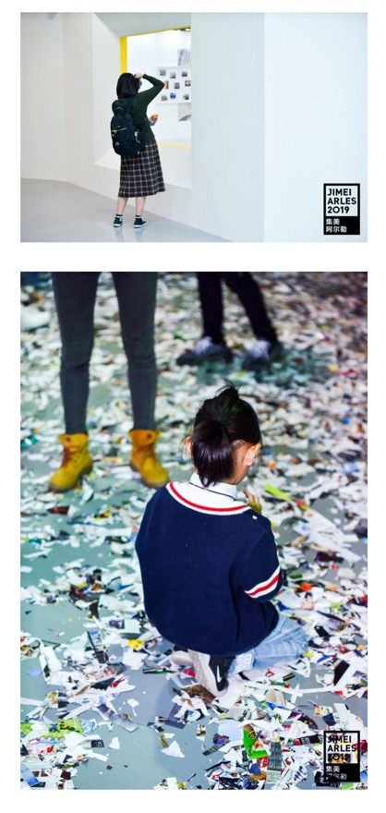
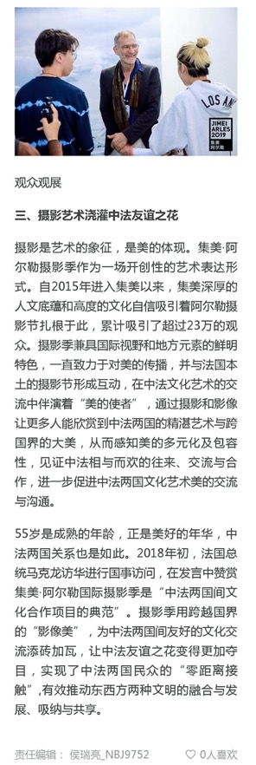

Publication : | www.xmnn.cn/厦门网
Circulation : | 276,576
Date : | 2019-11-23
Page : | 厦门
Headline : | 2019 Jimei x Arles International Photo Festival kicks off in Xiamen
 | 集美阿尔勒国际摄影季昨开幕 先后吸引23万人次观展
Ad Value : | 20,000
PV : | 276,576
Summary : | 2019 Jimei x Arles International Photo Festival kicked off in Xiamen on November 22 and will last till January 5, 2020. It will include 30 exhibitions, which display over 2,200 artworks by 55 artists. In addition, a series of artists' tour guides, academic forums and lectures as well as Jimei x Arles Discovery Award 2019 and Jimei x Arles Women Photo Award 2019 will be held during the festival.
Link : | http://news.xmnn.cn/xmnn/2019/11/23/100630726.shtml

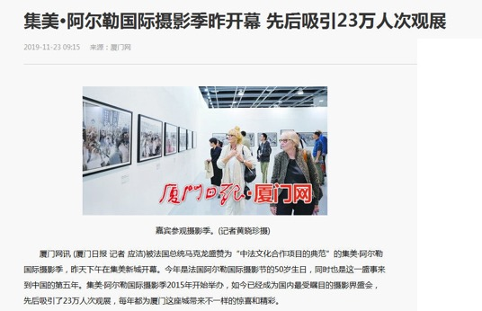
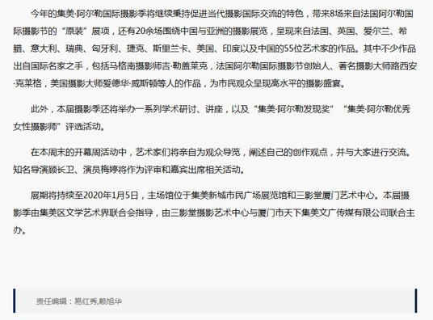

Publication : | ww.xitek.com/色影无忌
Circulation : | 96,768
Date : | 2019-11-23
Page : | 下午茶
Headline : | 2019 Jimei x Arles International Photo Festival kicks off
 | 厦门进入“高光时刻”，2019年集美·阿尔勒国际摄影季开幕
Ad Value : | 20,000
PV : | 96,768
Summary : | The 5th Jimei x Arles International Photo Festival kicked off in Xiamen on November 22, 2019 and will last till January 5, 2020. It will include 30 exhibitions, which will display over 2,200 artworks by 55 world artists. The unit of "Exhibitions from Arles 2019" was introduced.
Link : | http://she.xitek.com/sharon/201911/23-341295.html

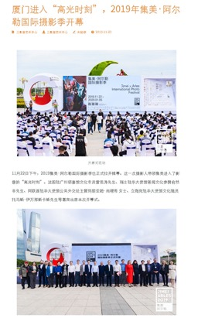

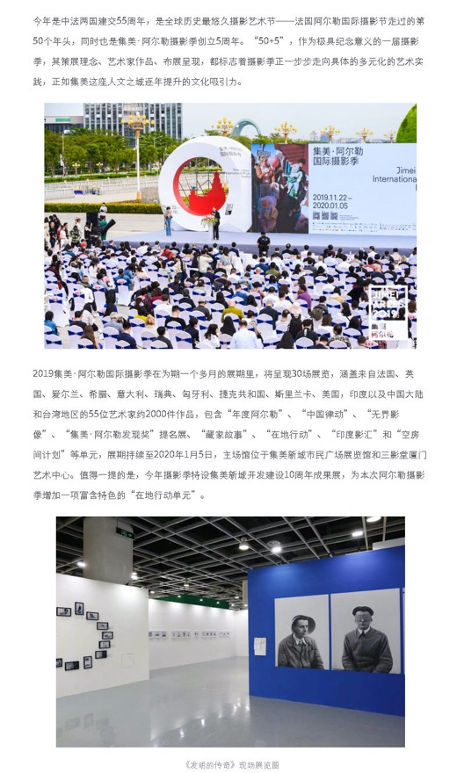
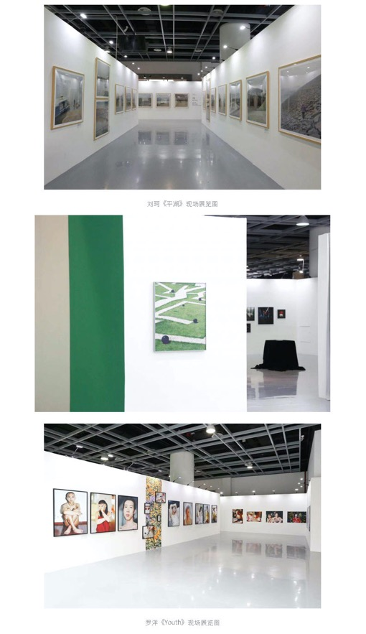
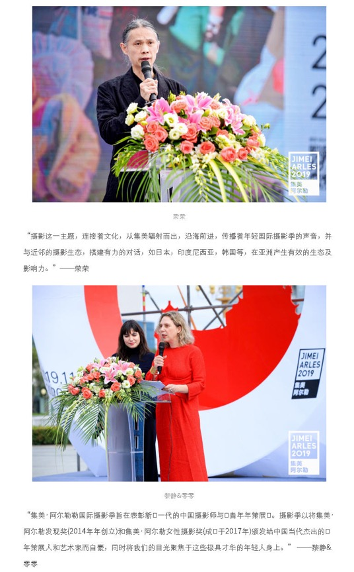
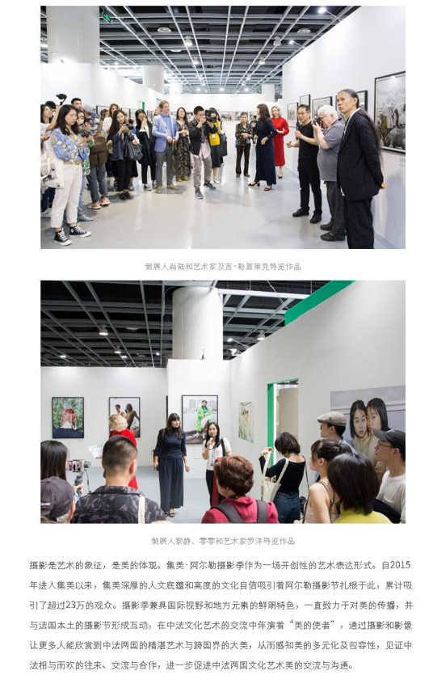

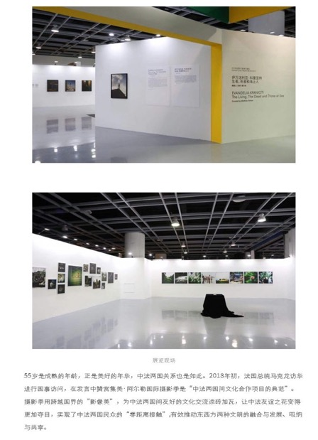

Publication : | www.cyol.com/中青在线
Circulation : | 2,978,508
Date : | 2019-11-23
Page : | 视觉
Headline : | Jimei x Arles International Photo Festival displays crossover "photo beauty"
 | 集美阿尔勒摄影季 展示跨越国界的“影像美”
Ad Value : | 20,000
PV : | 2,978,508
Summary : | 2019 Jimei x Arles International Photo Festival kicked off in Xiamen on November 22 and will last till January 5, 2020. It will include 30 exhibitions, which display over 2,200 artworks by 55 artists. In addition to continuous attention to photography ecology in Asian countries or regions, this year's festival will present two exhibitions about Indian photos.
Link : | http://news.cyol.com/app/2019-11/23/content_18250394.htm

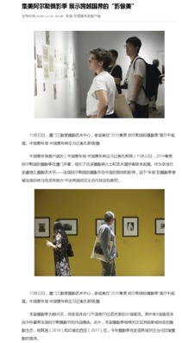
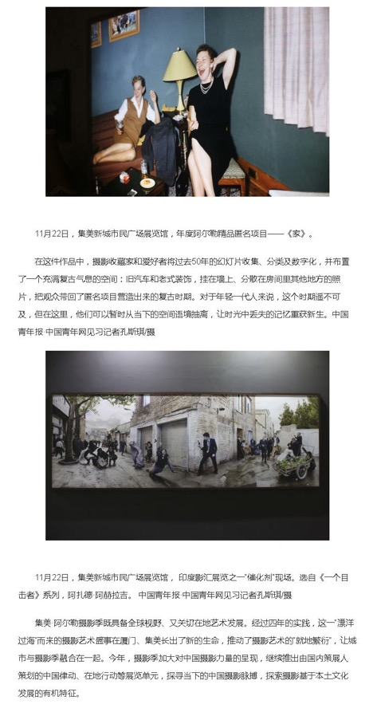
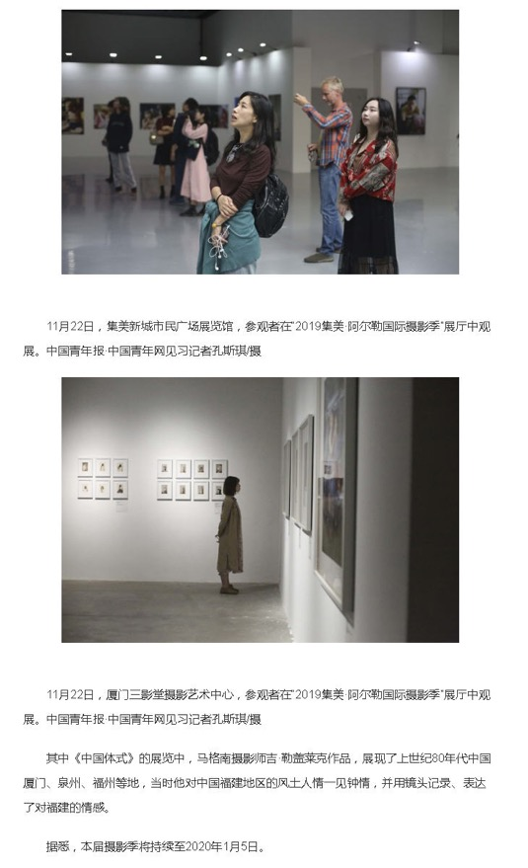

Publication : | www.youth.cn/中国青年网
Circulation : | 94,650
Date : | 2019-11-23
Page : | N/A
Headline : | Jimei x Arles International Photo Festival displays crossover "photo beauty"
 | 集美阿尔勒摄影季 展示跨越国界的“影像美”
Ad Value : | 20,000
PV : | 94,650
Summary : | 2019 Jimei x Arles International Photo Festival kicked off in Xiamen on November 22 and will last till January 5, 2020. It will include 30 exhibitions, which display over 2,200 artworks by 55 artists. In addition to continuous attention to photography ecology in Asian countries or regions, this year's festival will present two exhibitions about Indian photos.
Link : | http://t.m.youth.cn/transfer/toutiao/url/picture.youth.cn/zxtj/201911/t20191123_12126424.htm

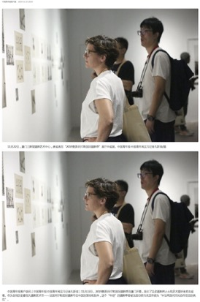

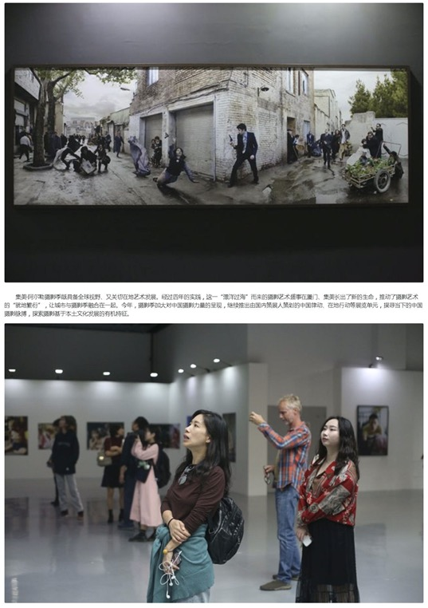
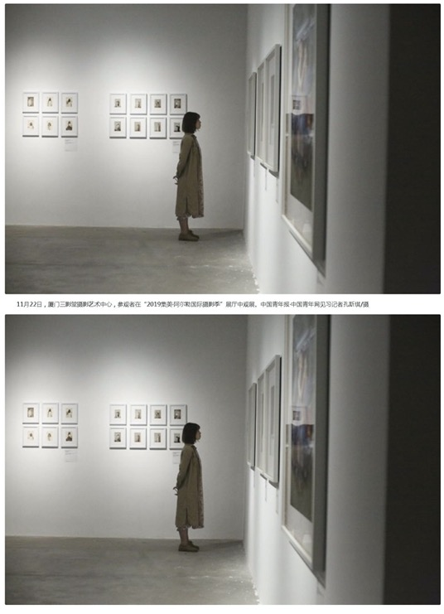

Publication : | www.jiemian.com/界面网
Circulation : | 1,176,739
Date : | 2019-11-24
Page : | 界面影像
Headline : | The 5th Jimei x Arles International Photo Festival connects the world through photos
 | 2019集美阿尔勒国际摄影季：摄影，连通自身与世界
Ad Value : | 20,000
PV : | 1,176,739
Summary : | The 5th Jimei x Arles International Photo Festival kicked off in Xiamen on November 22, 2019 and will last till January 5, 2020. It will include 30 exhibitions, which will display over 2,200 artworks by 55 world artists. The unit of "Exhibitions from Arles 2019" was introduced.
Link : | https://www.jiemian.com/article/3712264.html

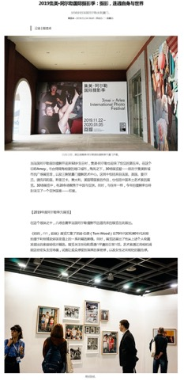
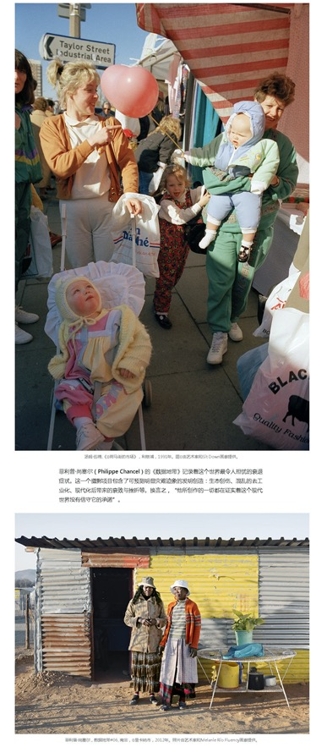
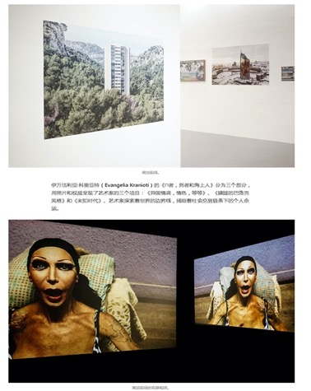

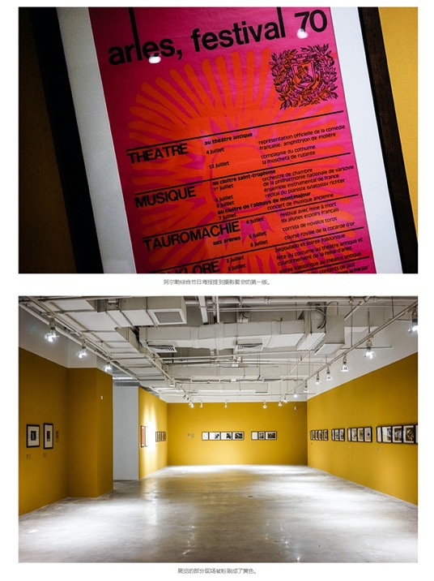
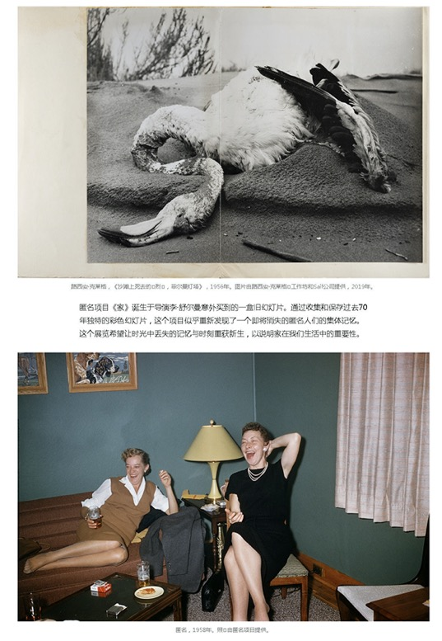
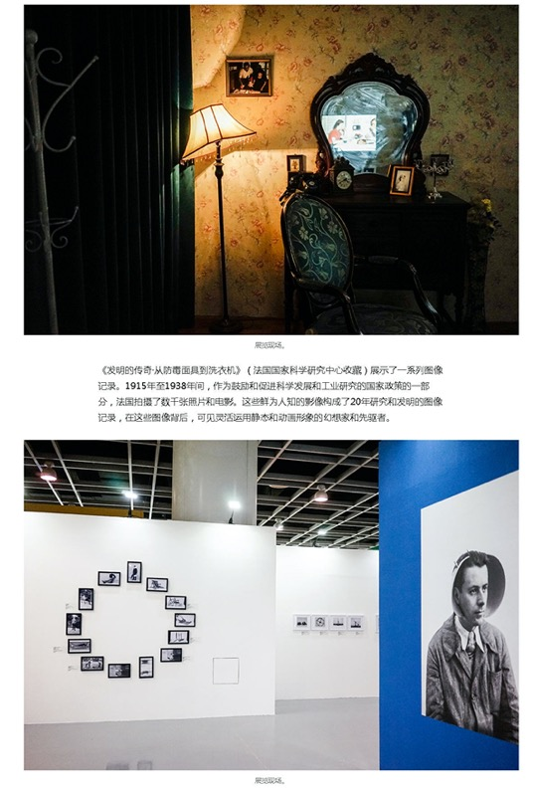
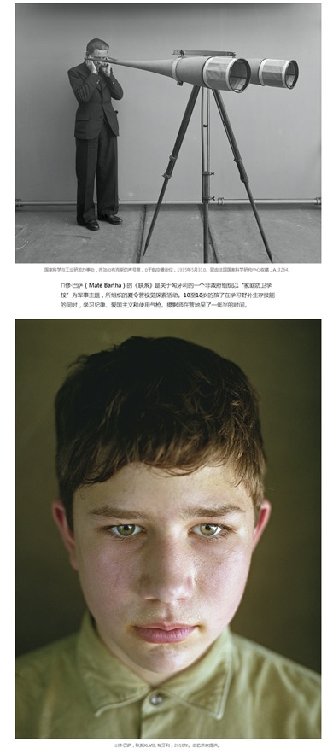
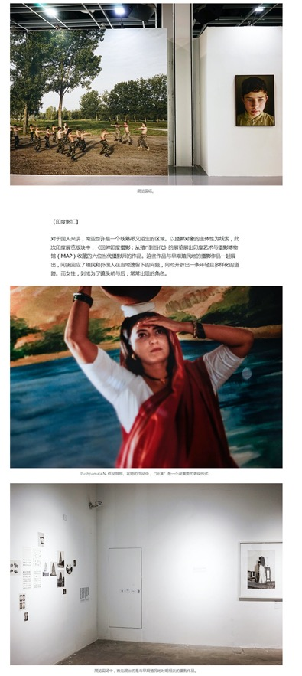
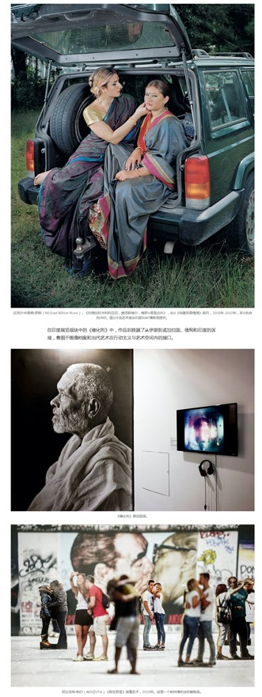

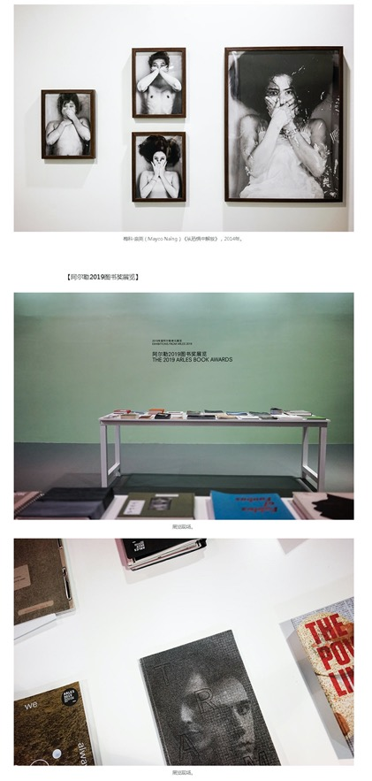
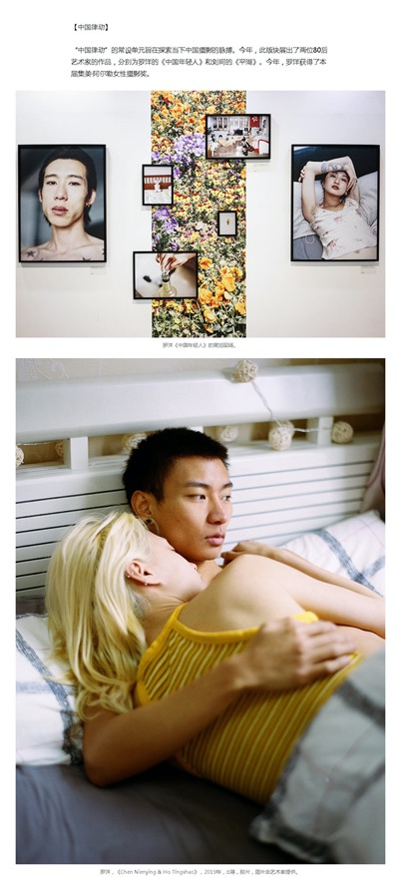
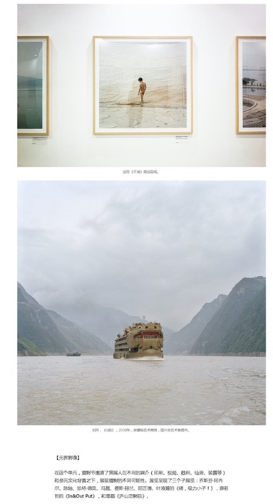

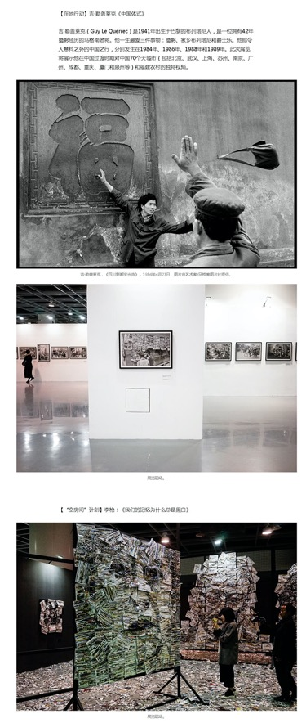
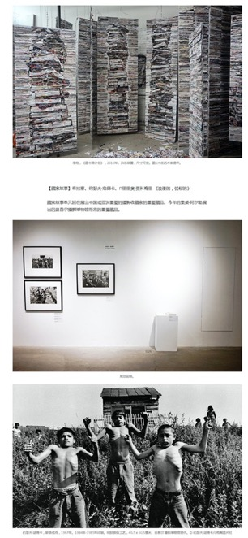
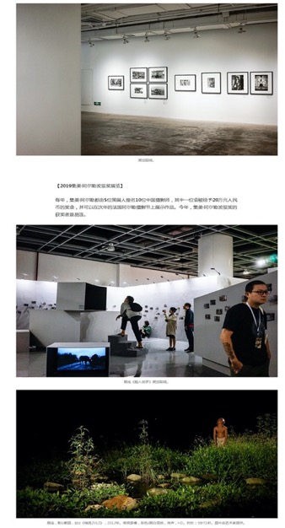

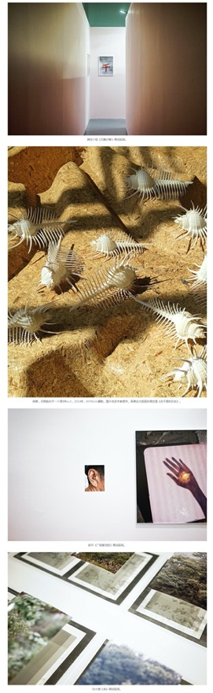
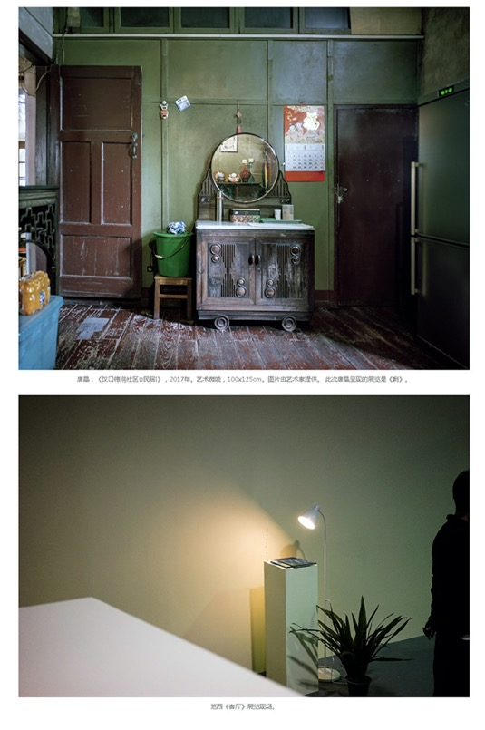

Publication : | www.artron.net/雅昌艺术网
Circulation : | 11,128
Date : | 2019-11-24
Page : | 媒体关注
Headline : | Jimei x Arles Discovery Award 2019 unveiled
 | 【雅昌快讯】易连荣获2019集美阿尔勒发现奖
Ad Value : | 20,000
PV : | 11,128
Summary : | 2019 Jimei x Arles International Photo Festival unveiled the Discovery Award. Photographer Yi Lian won the award for his work "Ask for the Moon" and was granted with 200,000 yuan's scholarship. He will display his work at Rencontres d'Arles 2020.
Link : | https://news.artron.net/20191124/n1065520_.html

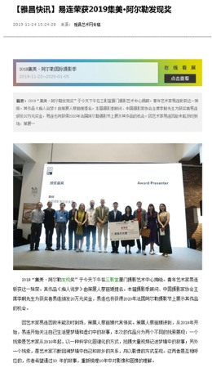
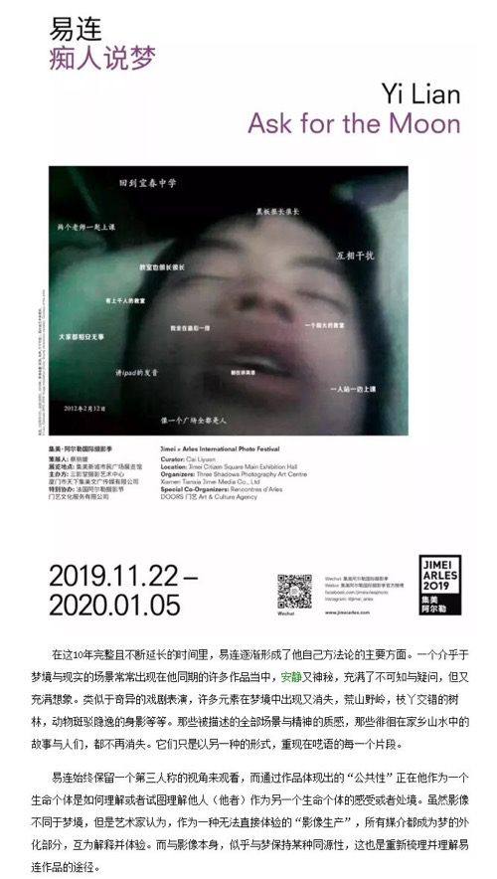
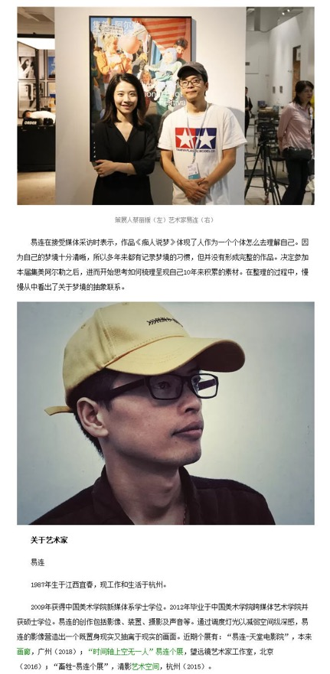
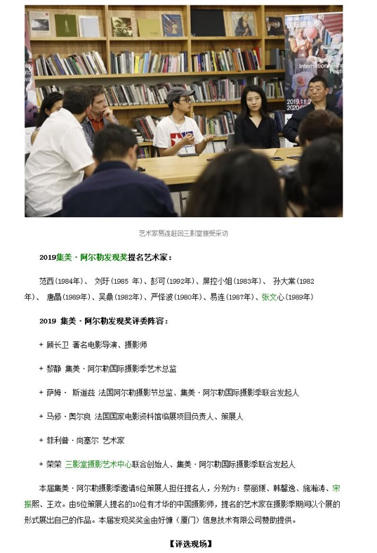
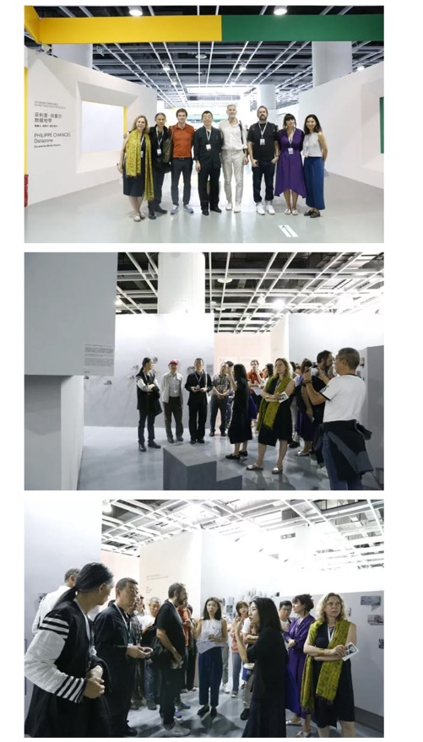
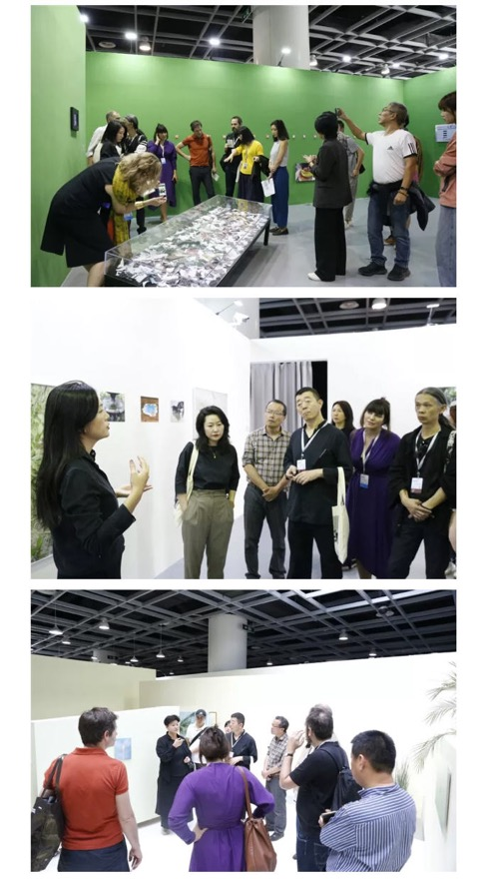
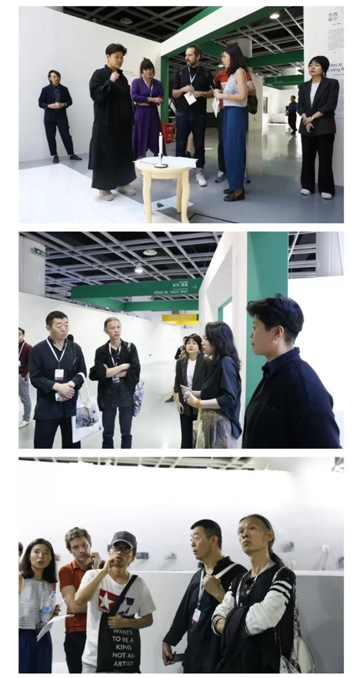

Publication : | www.heiguang.com/黑光网
Circulation : | 1,000
Date : | 2019-11-25
Page : | 热点资讯
Headline : | 2019 Jimei x Arles International Photo Festival kicks off
 | 厦门进入“高光时刻”，2019年集美阿尔勒国际摄影季开幕
Ad Value : | 20,000
PV : | 1,000
Summary : | The 5th Jimei x Arles International Photo Festival kicked off in Xiamen on November 22, 2019 and will last till January 5, 2020. It will include 30 exhibitions, which will display over 2,200 artworks by 55 world artists. The unit of "Exhibitions from Arles 2019" was introduced.
Link : | http://www.heiguang.com/news/hydt/20191125/81603.html

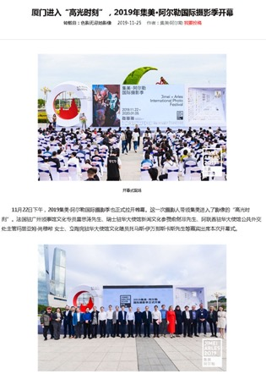

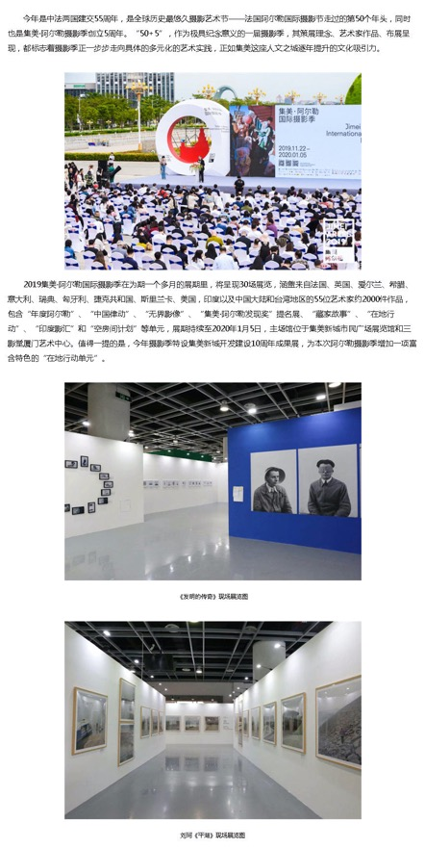
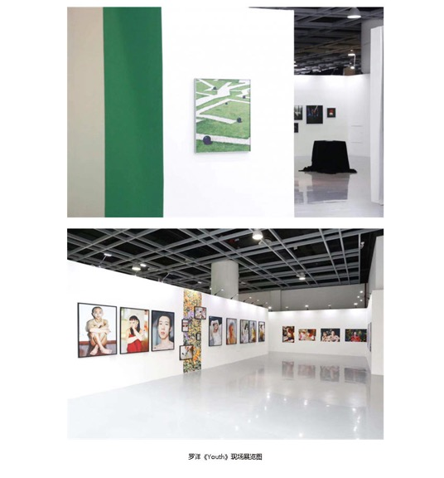
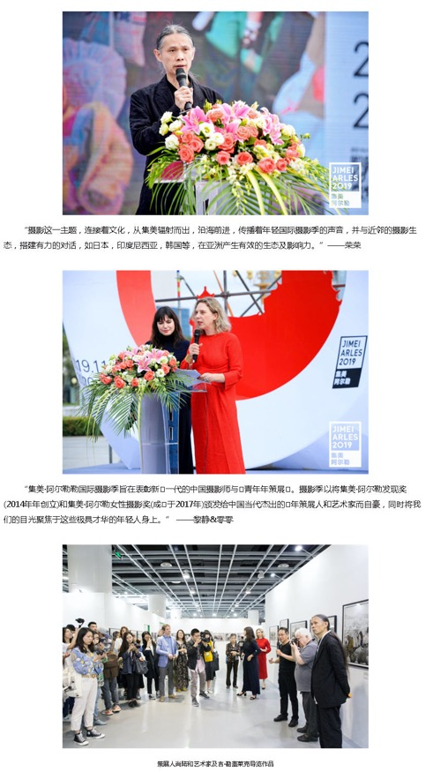
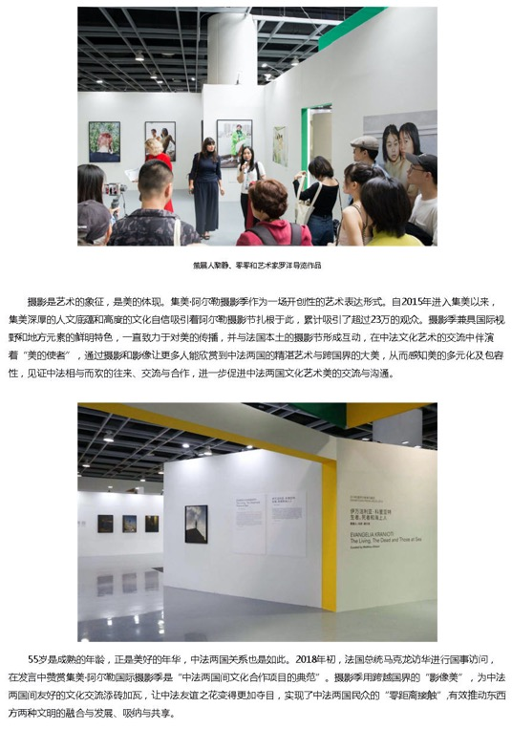

Publication : | www.xmnn.cn/厦门网
Circulation : | 359,830
Date : | 2019-11-25
Page : | 厦门
Headline : | The 5th Jimei x Arles International Photo Festival kicks off
 | 2019集美阿尔勒国际摄影季开幕 将持续至明年1月5日
Ad Value : | 20,000
PV : | 359,830
Summary : | The 5th Jimei x Arles International Photo Festival kicked off in Xiamen on November 22, 2019 and will last till January 5, 2020. It will include 30 exhibitions, which will display artworks by 55 world artists. Besides, some works of the 1st festival will be displayed this year. In addition, this year's Jimei x Arles Discover Award was won by post-85 photographer Yi Lian.
Link : | https://news.xmnn.cn/xmnn/2019/11/25/100631086.shtml

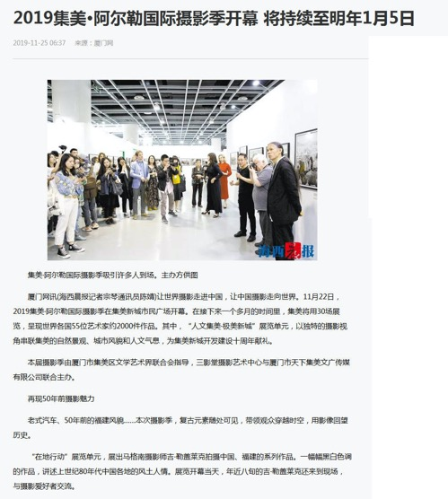
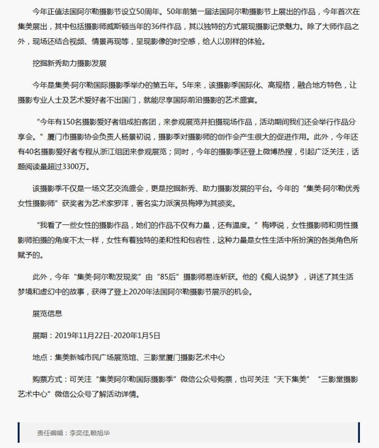

Publication : | www.taihainet.com/台海网
Circulation : | 1,000
Date : | 2019-11-25
Page : | 各区报道
Headline : | 2019 Jimei x Arles International Photo Festival will last till January 5, 2020
 | 集美阿尔勒国际摄影季将持续到2020年1月5日 家门口的顶级视觉“饕餮盛宴”
Ad Value : | 20,000
PV : | 1,000
Summary : | 2019 Jimei x Arles International Photo Festival kicked off in Xiamen on November 22. Artists, curators and visitors from across the globe will gather at Xiamen over next month to enjoy this important photo feast.
Link : | http://www.taihainet.com/news/xmnews/gqbd/2019-11-25/2330626.html

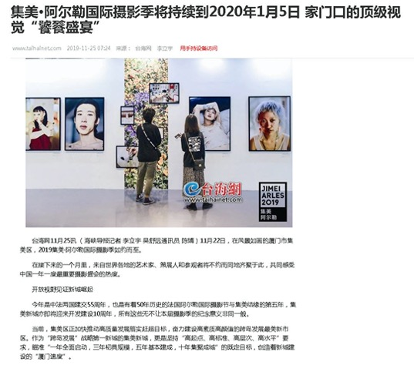
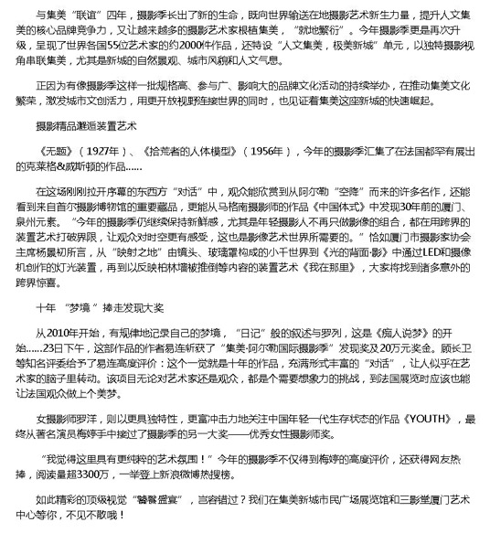

Publication : | www.xmnn.cn/厦门网
Circulation : | 359,830
Date : | 2019-11-25
Page : | 厦门
Headline : | 2019 Jimei x Arles International Photo Festival kicks off, with over 2,200 artworks to be displayed by 55 artists
 | 2019集美阿尔勒国际摄影季开幕 55位艺术家2200多件作品展出
Ad Value : | 20,000
PV : | 359,830
Summary : | 2019 Jimei x Arles International Photo Festival kicked off on November 22, attracting hundreds of global photographers, curators and inside experts as well as photography and art lovers. Topics related to the festival ascended to top three of hot search list, accumulative readings of the topics exceeded 33 million times and "literary and artistic style" of the festival flooded the circle of friends. This festival will last till January 5, 2020. It will display over 2,200 artworks by 55 artists from France, UK, Ireland, Greece, Italy, Sweden, Hungary, Czech, Sri Lanka, US, India and China. In addition, a series of artists' tour guides, academic forums and lectures will be held during the festival.
Link : | https://news.xmnn.cn/xmnn/2019/11/25/100631139.shtml

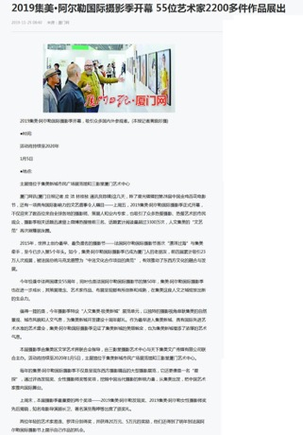
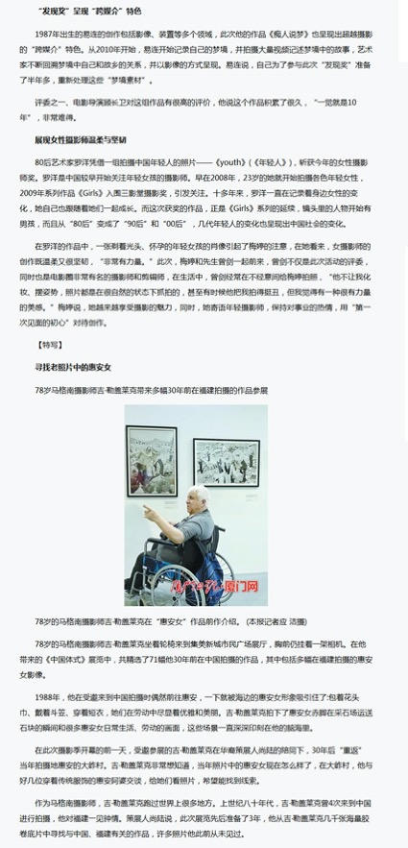
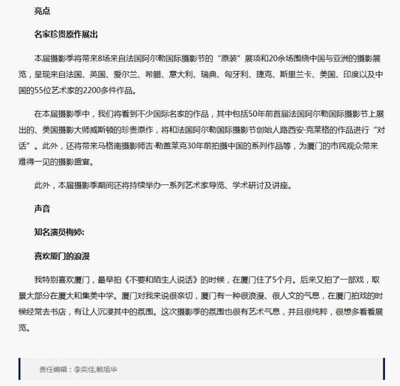

Publication : | www.fengniao.com/蜂鸟网
Circulation : | 46,872
Date : | 2019-11-25
Page : | 资讯
Headline : | Jimei x Arles Discovery Award and Women Photo Award 2019 unveiled
 | 2019集美阿尔勒发现奖与女性摄影师奖揭晓
Ad Value : | 20,000
PV : | 46,872
Summary : | Jimei x Arles Discovery Award 2019 was unveiled in Three Shadows Xiamen Photography Art Centre in the afternoon of November 23. Artist Yilian received the award for his work "Ask for the Moon", marking the fifth year of winning this award. He was granted with 200,000 yuan's scholarship and will display his work at Rencontres d'Arles 2020. Besides, Jimei x Arles Women Photo Award 2019 was unveiled in Three Shadows Xiamen Photography Art Centre in the afternoon of November 24. Artist Luo Yang received the award for his work "Youth". Actress Mei Ting jointly granted 50,000 yuan's scholarship bonus to Luo Yang. Besides, Luo Yang also got the chance to display his work at Rencontres d'Arles 2020.
Link : | http://image.fengniao.com/535/5359274.html

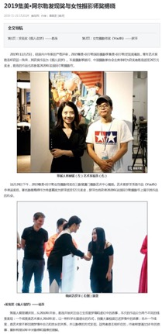
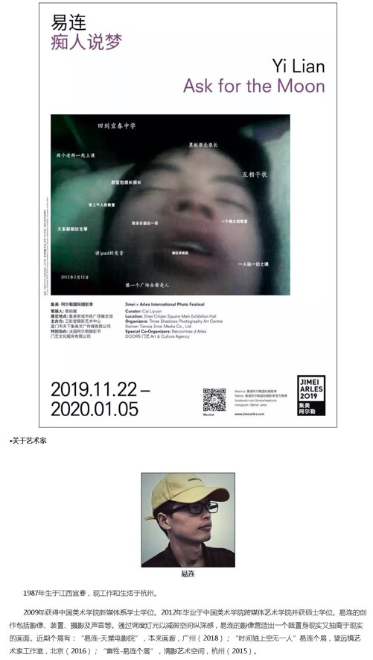
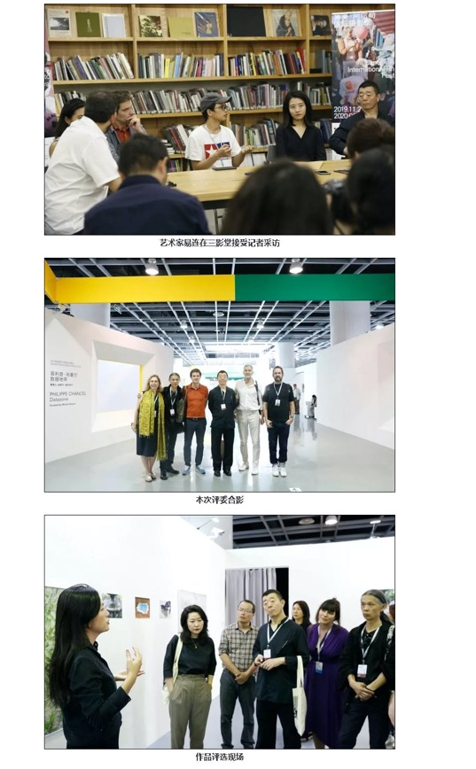
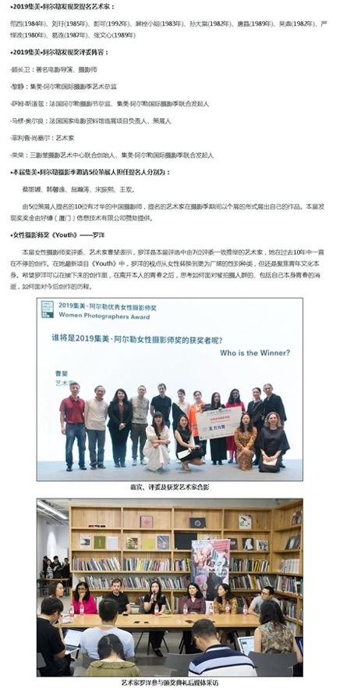
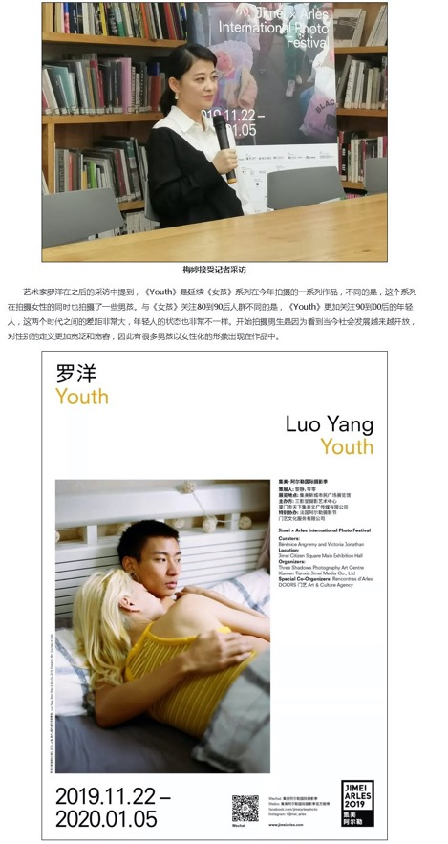
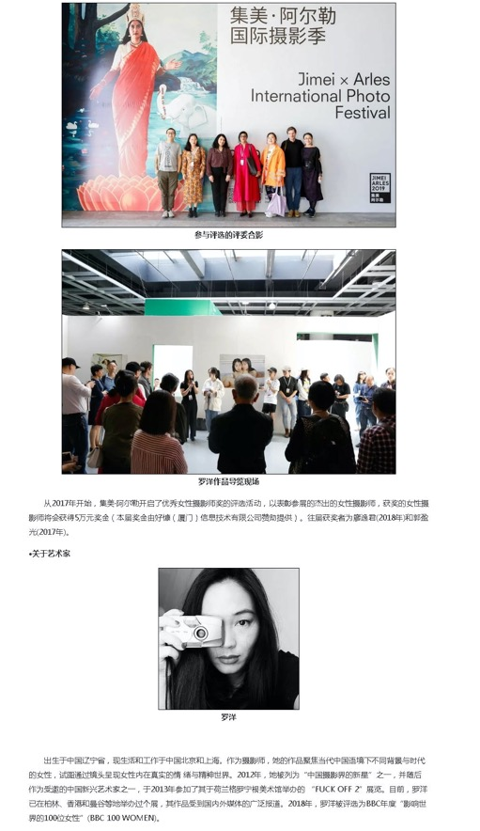

Publication : | www.taihainet.com/台海网
Circulation : | 1,000
Date : | 2019-11-25
Page : | 各区报道
Headline : | 2019 Jimei x Arles International Photo Festival kicks off
 | 2019集美阿尔勒国际摄影季开幕 演员梅婷为女性摄影师颁奖
Ad Value : | 20,000
PV : | 1,000
Summary : | 2019 Jimei x Arles International Photo Festival kicked off in Xiamen on November 22 and will last till January 5, 2020. It will include 30 exhibitions, which display over 2,200 artworks by 55 artists. In addition, Jimei x Arles Discovery Award and Women Photo Award 2019 were unveiled, with artists Yi Lian and Luo Yang winning the award respectively for translation of "Ask for the Moon" and "Youth". Actress Mei Ting granted the award for Luo Yang.
Link : | http://www.taihainet.com/news/xmnews/gqbd/2019-11-25/2330814.html

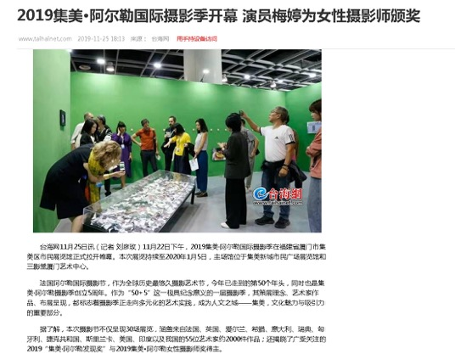
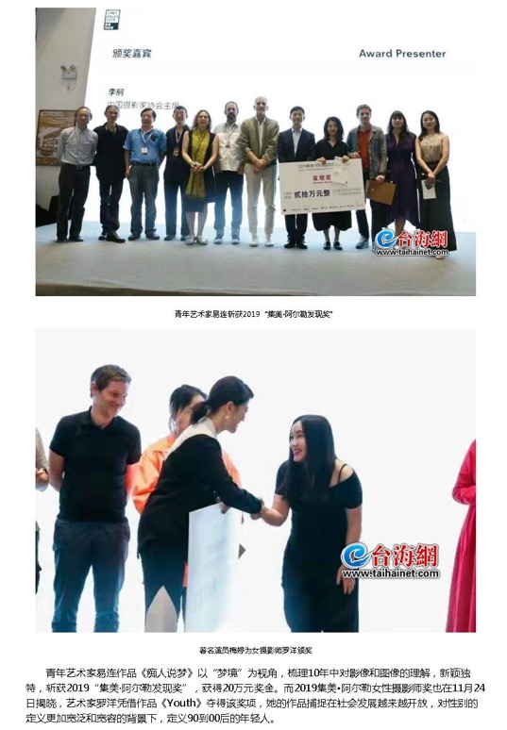
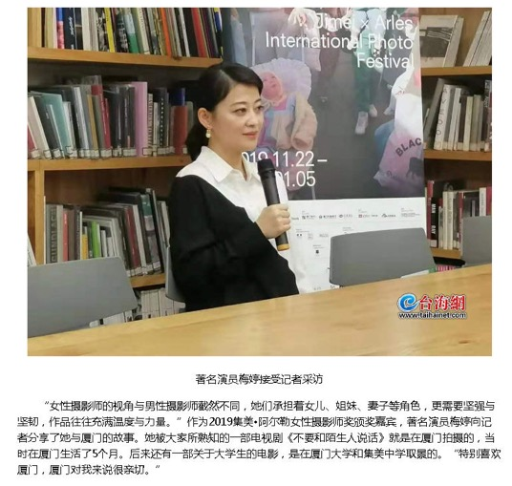

Publication : | fashion.sina.com.cn/新浪时尚
Circulation : | 7,456,489
Date : | 2019-11-25
Page : | 艺术
Headline : | 2019 Jimei x Arles International Photo Festival kicks off
 | 2019集美阿尔勒国际摄影季：55位艺术家2200件作品
Ad Value : | 20,000
PV : | 7,456,489
Summary : | 2019 Jimei x Arles International Photo Festival kicked off in Xiamen on November 22 and will last till January 5, 2020. It will include 30 exhibitions, which display over 2,200 artworks by 55 artists.
Link : | http://fashion.sina.com.cn/art/2019-11-25/2022/doc-iihnzahi3291885.shtml

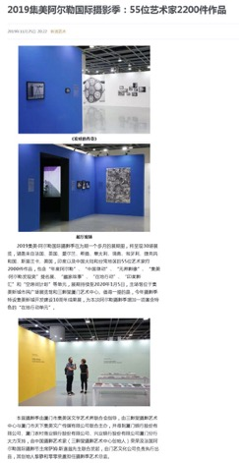
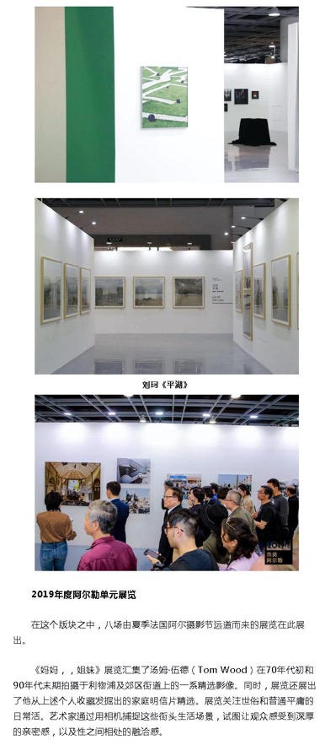
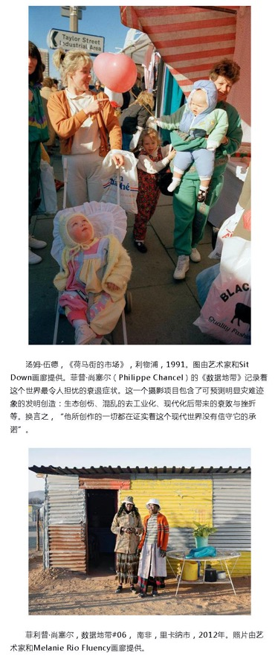
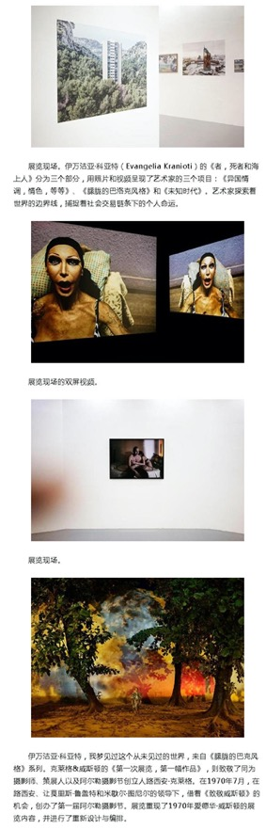
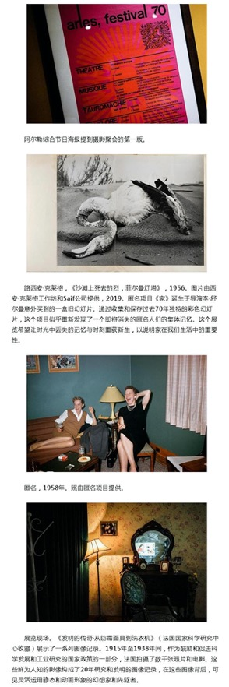
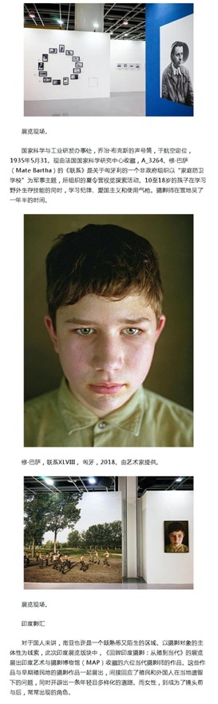

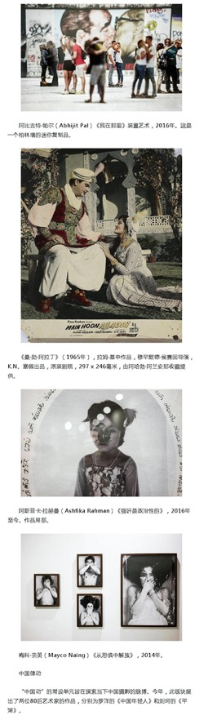
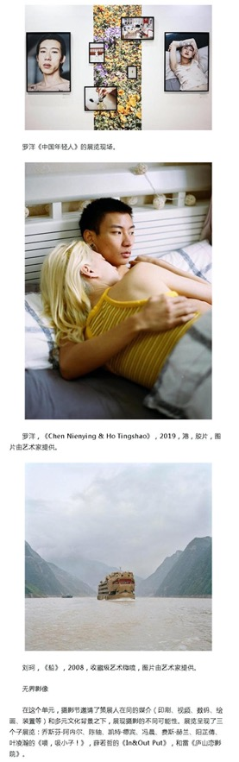

Publication : | www.sina.com.cn/新浪网
Circulation : | 448,156
Date : | 2019-11-26
Page : | 图片资讯
Headline : | 2019 Jimei x Arles International Photo Festival kicks off, with over 2,200 artworks to be displayed by 55 artists
 | 2019集美阿尔勒国际摄影季正式拉开帷幕 集美进入影像“高光时刻”
Ad Value : | 30,000
PV : | 448,156
Summary : | 2019 Jimei x Arles International Photo Festival kicked off on November 22, attracting hundreds of global photographers, curators and inside experts as well as photography and art lovers. This festival will last till January 5, 2020. It will display over 2,200 artworks by 55 artists from France, UK, Ireland, Greece, Italy, Sweden, Hungary, Czech, Sri Lanka, US, India and China. In addition, a series of artists' tour guides, academic forums and lectures will be held during the festival.
Link : | http://photo.sina.com.cn/info/2019-11-26/doc-iihnzahi3413309.shtml

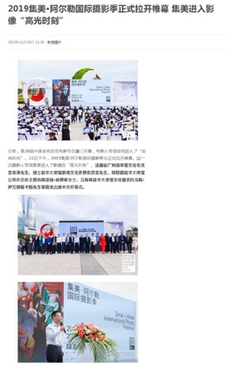
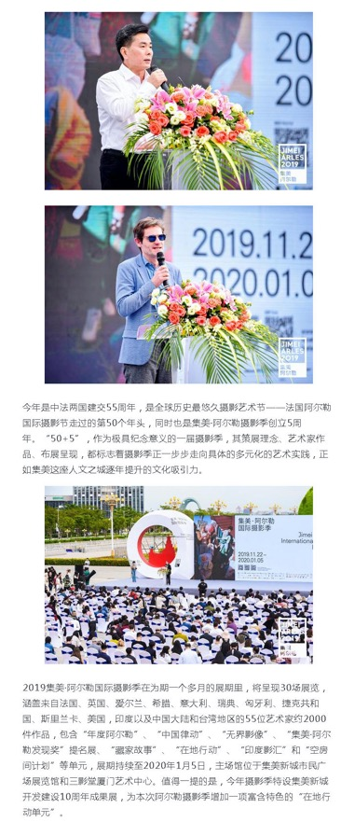
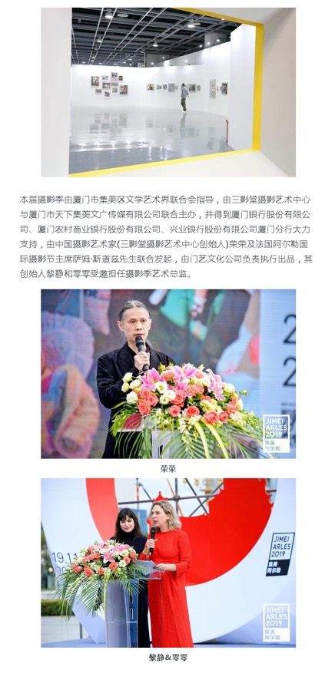
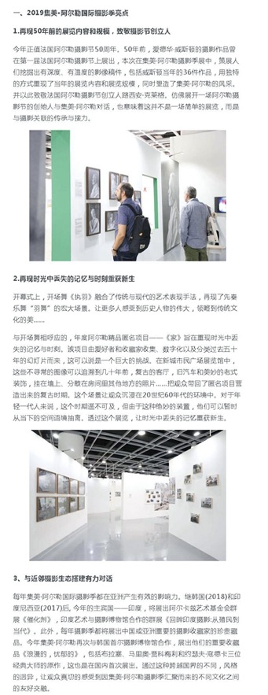
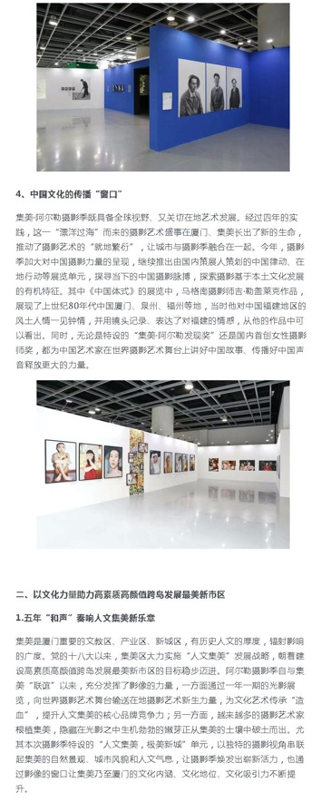
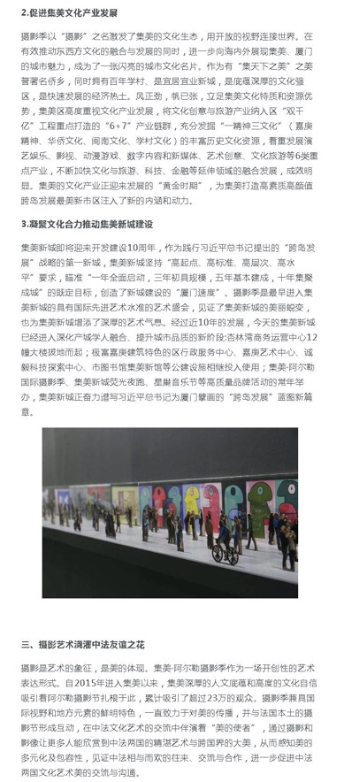
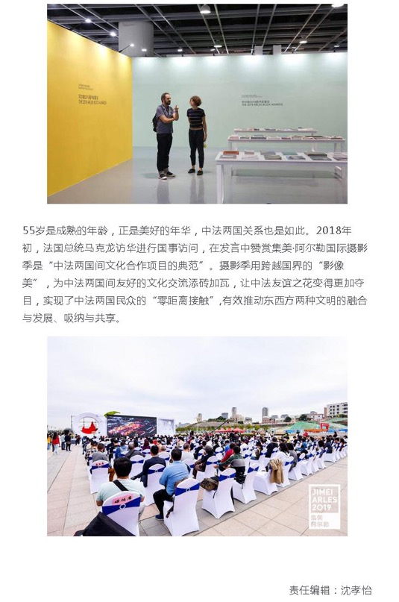

Publication : | www.fjsen.com/东南网
Circulation : | 1,000
Date : | 2019-11-26
Page : | N/A
Headline : | Guy le Guerrec presents a lecture in Jimei
 | 法国摄影师吉勒盖莱克来集美开讲座
Ad Value : | 20,000
PV : | 1,000
Summary : | The Chinese Gesture by Guy le Guerrec, an exhibition of 2019 Jimei x Arles International Photo Festival, will be presented in the section "Local Action". Over 70 black and white documentary photos represented "Chinese stories" of 30 years ago to Chinese audience. Guy le Guerrec who nears 80 years old came to the exhibition, guided for audience and held a photo lecture.
Link : | http://xm.fjsen.com/2019-11/26/content_30072123.htm

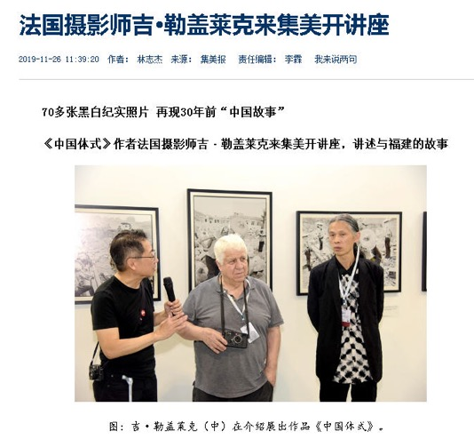
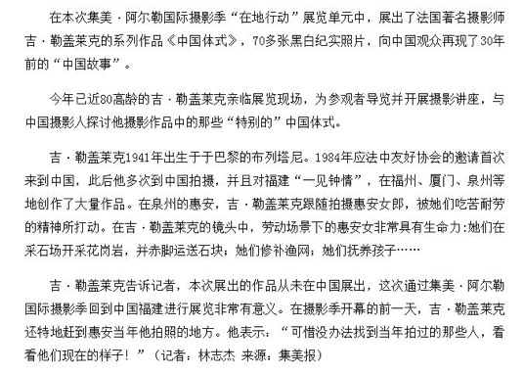

Publication : | www.fengniao.com/蜂鸟网
Circulation : | 46,872
Date : | 2019-11-26
Page : | 评论
Headline : | Postscript of 2019 Jimei x Arles International Photo Festival: back to photography and beyond vision
 | 2019集美阿尔勒摄影季后记：回归摄影 超越视觉
Ad Value : | 20,000
PV : | 46,872
Summary : | This article summarizes the highlights at 2019 Jimei x Arles International Photo Festival that kicked off in Xiamen on November 22. It returned to the original intention of photography and was beyond vision. Many great artworks were displayed.
Link : | http://image.fengniao.com/535/5359252.html

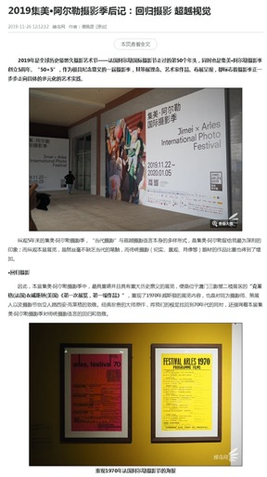
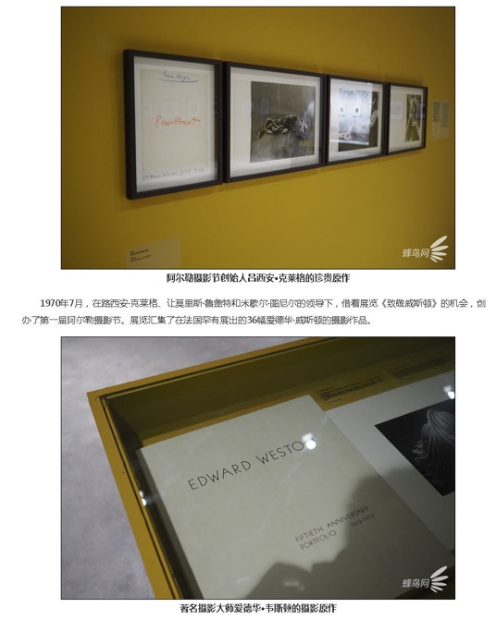
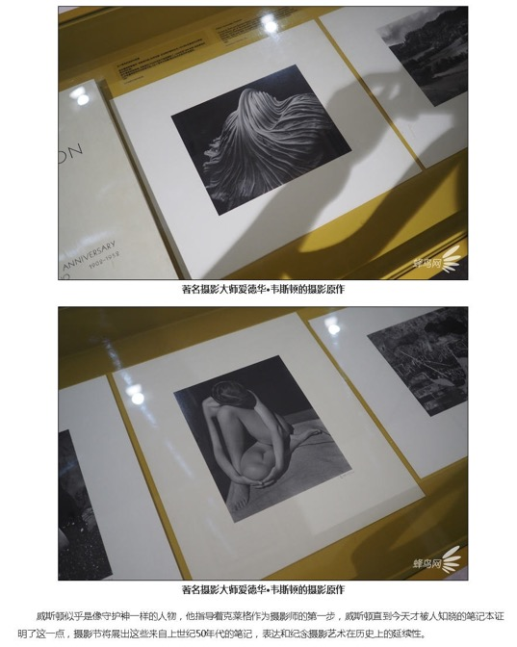
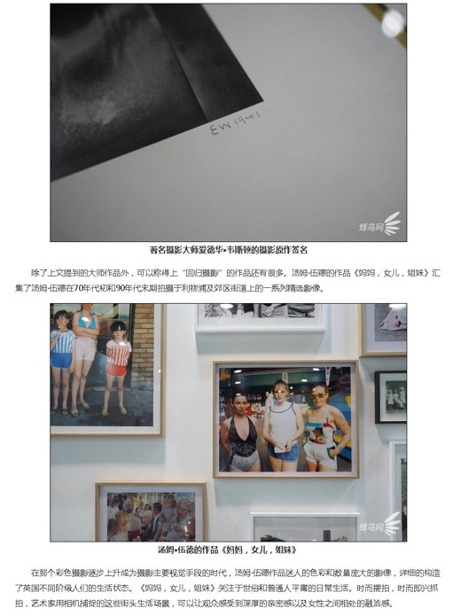
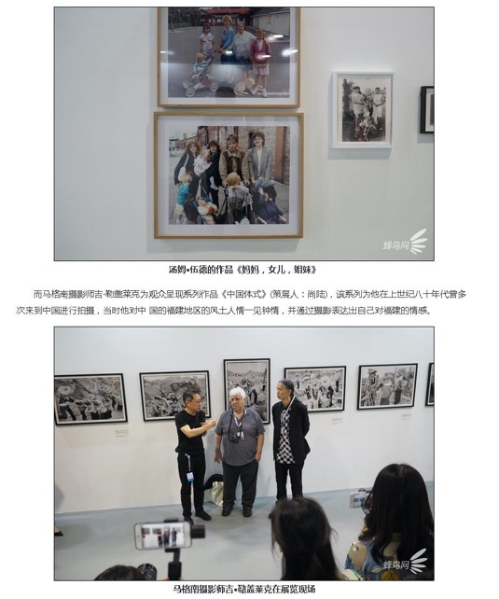
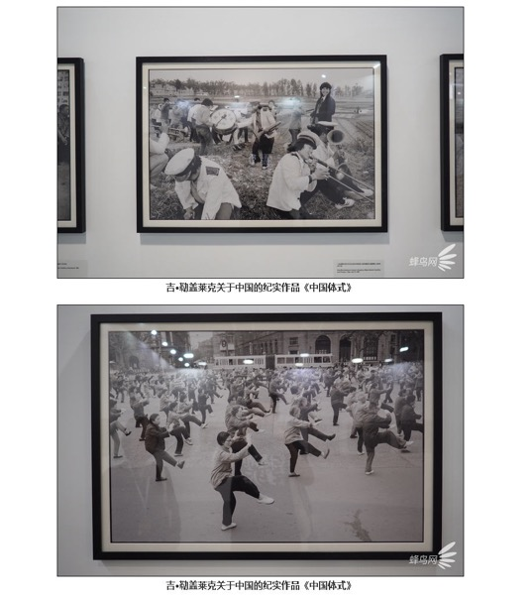
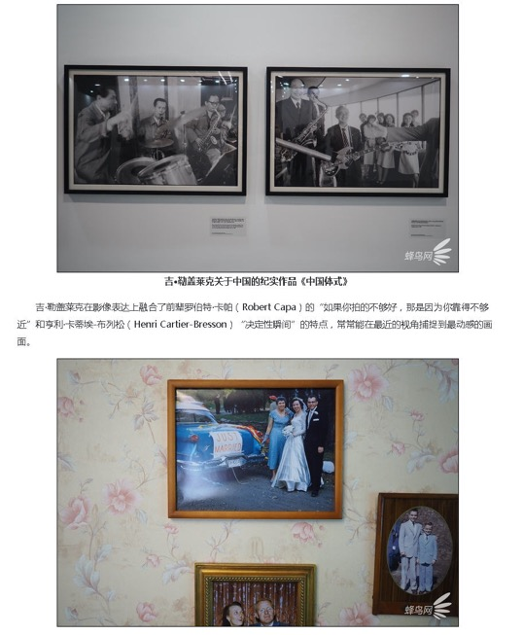
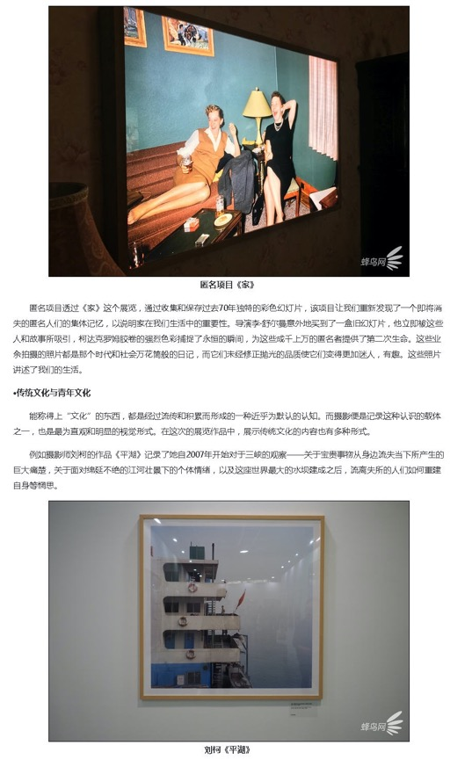
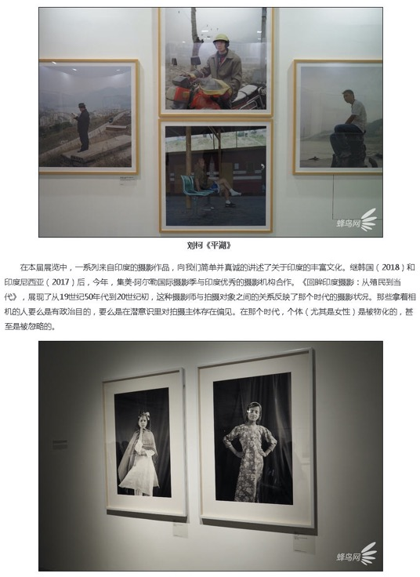
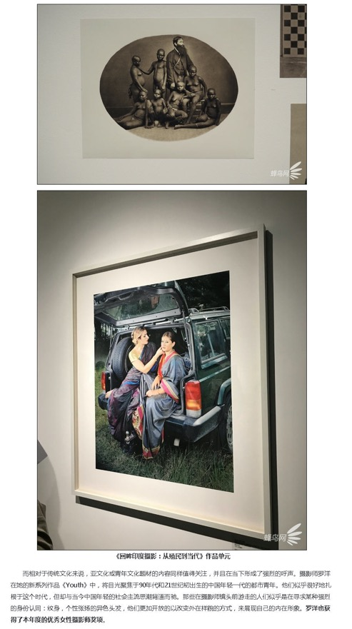
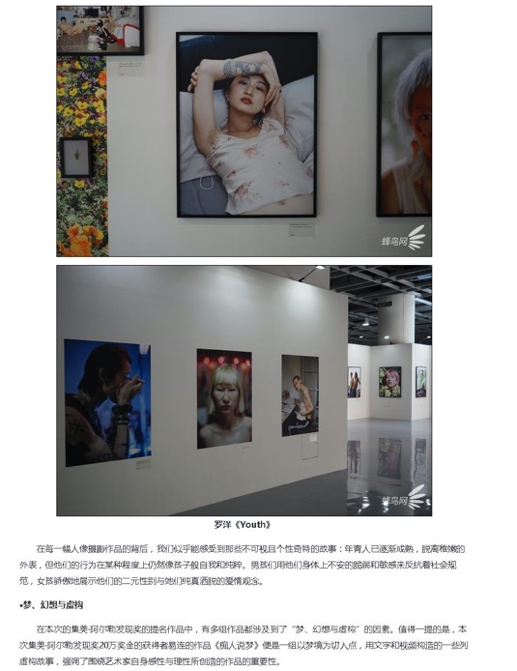
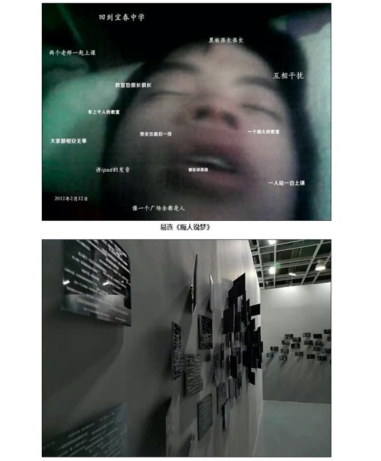
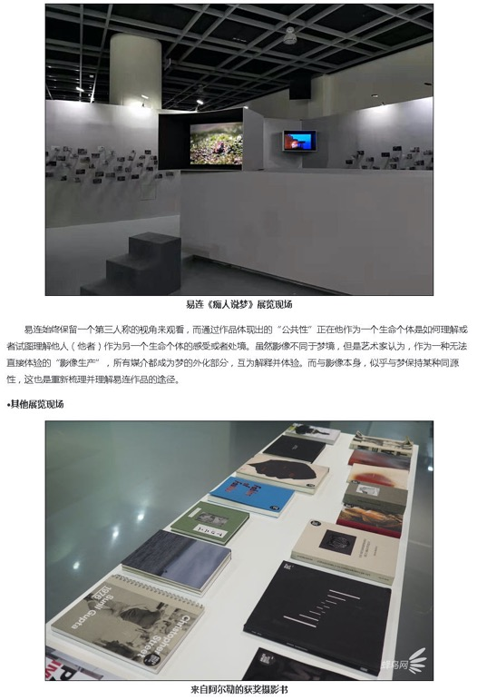
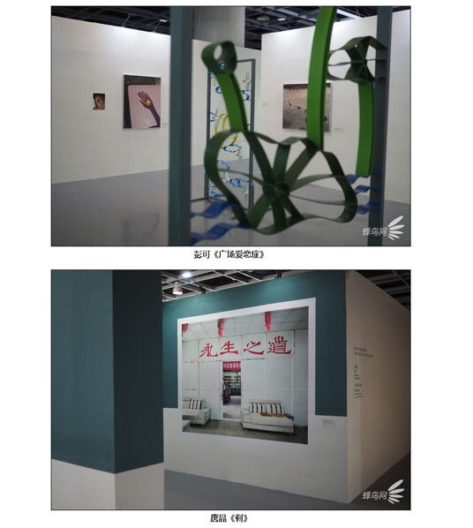

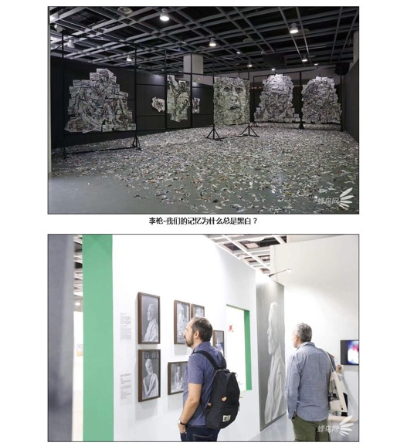

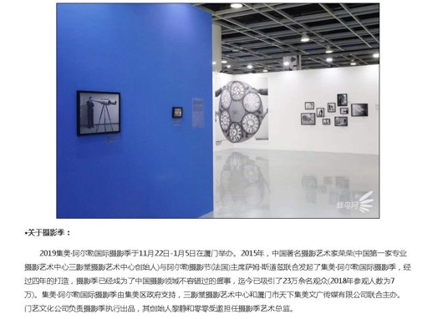

Publication : | www.163.com/网易
Circulation : | 23,901
Date : | 2019-11-29
Page : | 艺术频道
Headline : | What to talk about photography after 180 years?
 | 180岁的摄影，今天我们会如何谈论？
Ad Value : | 30,000
PV : | 23,901
Summary : | Photography has gone through 180 years since 1839. The 5th Jimei x Arles International Photo Festival kicked off in Xiamen on November 22. Like previous years, it will hold 8 exhibitions at the section "Exhibitions from Arles 2019" and 22 newly planned exhibitions. Notably, Jimei x Arles Discovery Award and Women Photo Award 2019 were unveiled, with artists Yi Lian and Luo Yang winning the award respectively for translation of "Ask for the Moon" and "Youth".
Link : | https://art.163.com/19/1129/11/EV56AJ2N00997VCT.html

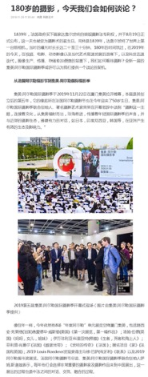
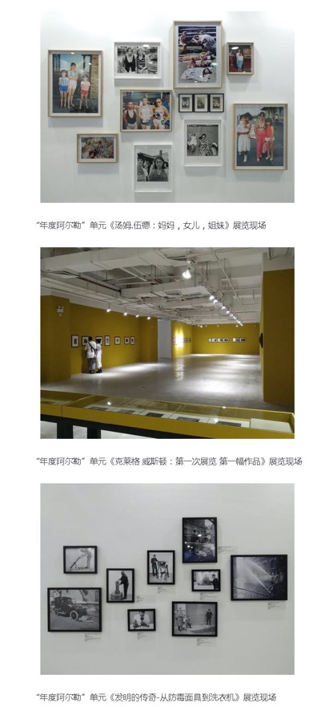
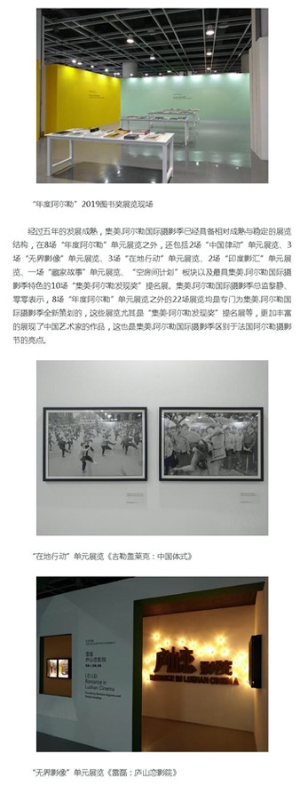
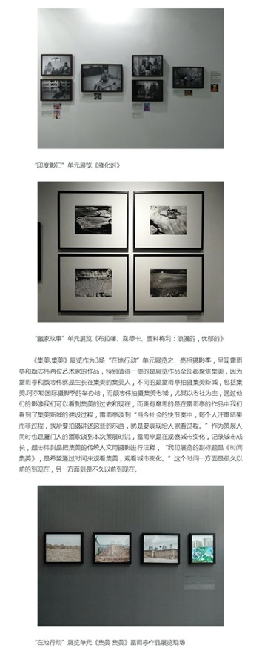
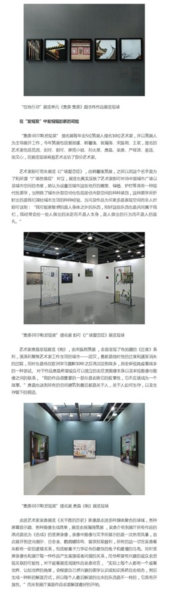
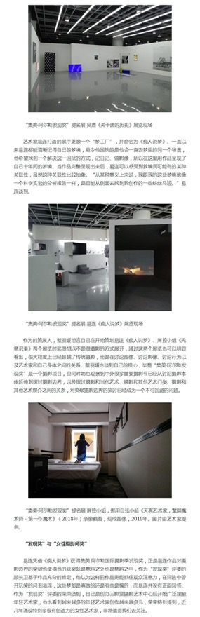
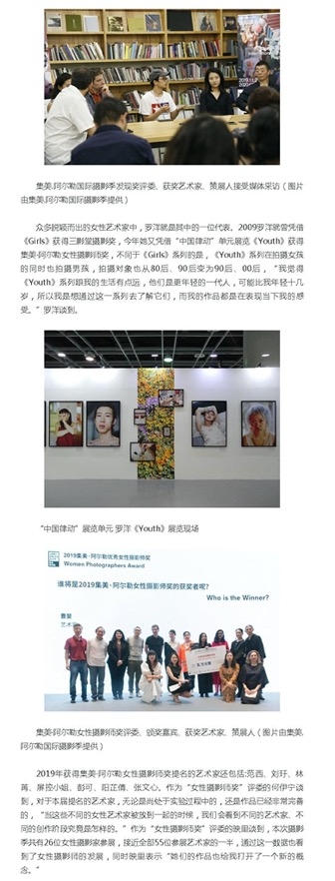
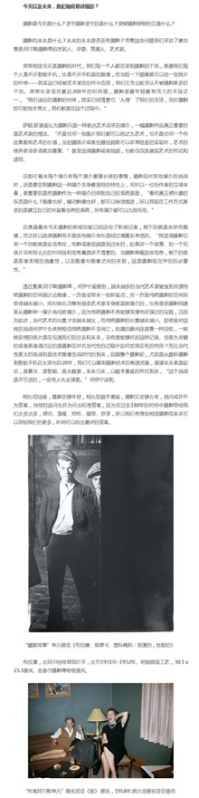
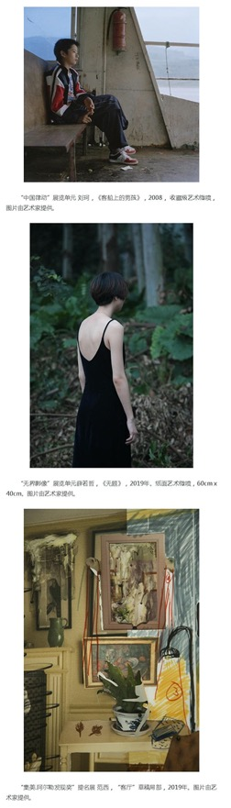
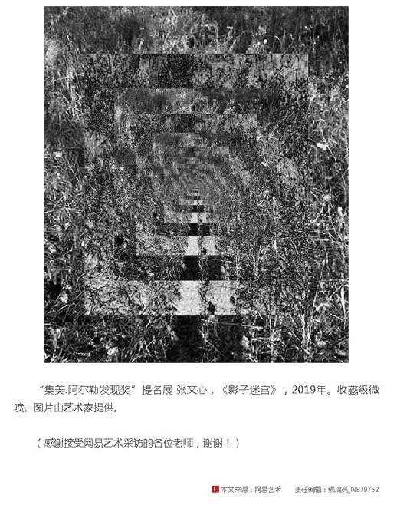

Publication : | www.sina.com.cn/新浪网
Circulation : | 448,156
Date : | 2019-11-29
Page : | 图片资讯
Headline : | Jimei x Arles Discovery Award and Women Photo Award 2019 unveiled
 | 2019集美阿尔勒发现奖与女性摄影师奖揭晓
Ad Value : | 30,000
PV : | 448,156
Summary : | Jimei x Arles Discovery Award 2019 was unveiled in Three Shadows Xiamen Photography Art Centre in the afternoon of November 23. Artist Yilian received the award for his work "Ask for the Moon", marking the fifth year of winning this award. He was granted with 200,000 yuan's scholarship and will display his work at Rencontres d'Arles 2020. Besides, Jimei x Arles Women Photo Award 2019 was unveiled in Three Shadows Xiamen Photography Art Centre in the afternoon of November 24. Artist Luo Yang received the award for his work "Youth". Actress Mei Ting jointly granted 50,000 yuan's scholarship bonus to Luo Yang. Besides, Luo Yang also got the chance to display his work at Rencontres d'Arles 2020.
Link : | http://photo.sina.com.cn/info/2019-11-29/doc-iihnzahi4137856.shtml

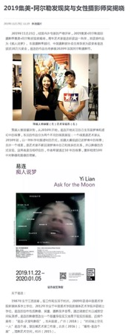
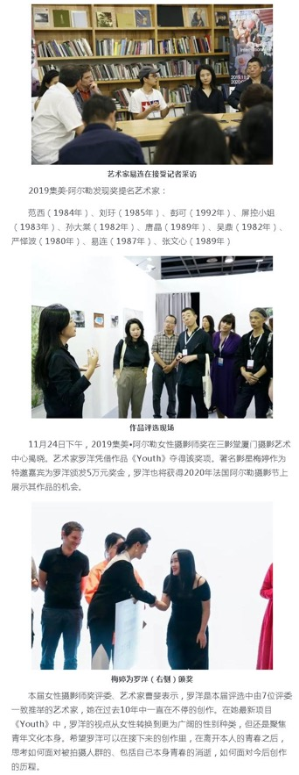
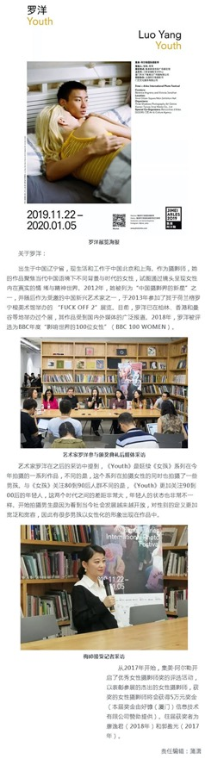

Publication : | www.xmnn.cn/厦门网
Circulation : | 359,830
Date : | 2019-12-03
Page : | 厦门
Headline : | 2019 Jimei x Arles International Photo Festival presents colorful opening week events
 | 围观！2019集美阿尔勒国际摄影季开幕周精彩纷呈
Ad Value : | 20,000
PV : | 359,830
Summary : | Over the past week, 2019 Jimei x Arles International Photo Festival held a series of colorful opening week events, such as tour guides by artists and curators, photo lectures and experts meetings. This festival invited artists and curators to interact with the citizens, narrowing the distance between photography and ordinary audience.
Link : | http://news.xmnn.cn/xmnn/2019/12/03/100634312.shtml

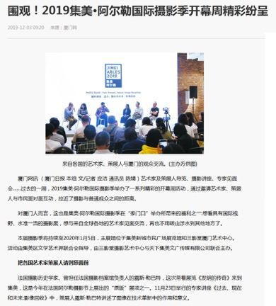
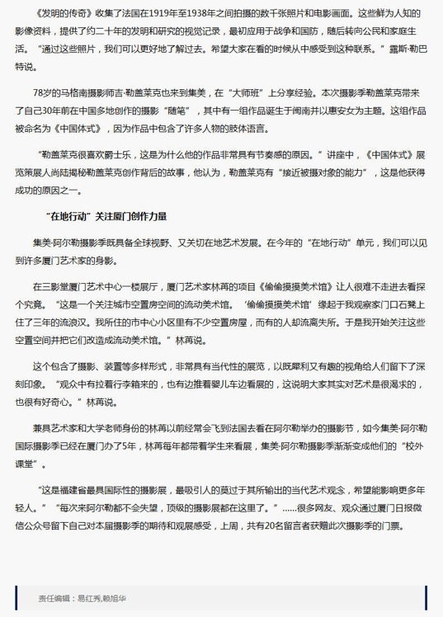

Publication : | www.taihainet.com/台海网
Circulation : | 1,000
Date : | 2019-12-03
Page : | 各区报道
Headline : | 2019 Jimei x Arles International Photo Festival presents colorful opening week events
 | 艺术家策展人与市民面对面 2019集美阿尔勒国际摄影季开幕周精彩纷呈
Ad Value : | 20,000
PV : | 1,000
Summary : | Over the past week, 2019 Jimei x Arles International Photo Festival held a series of colorful opening week events, such as tour guides by artists and curators, photo lectures and experts meetings. This festival invited artists and curators to interact with the citizens, narrowing the distance between photography and ordinary audience.
Link : | http://www.taihainet.com/news/xmnews/gqbd/2019-12-03/2333269.html

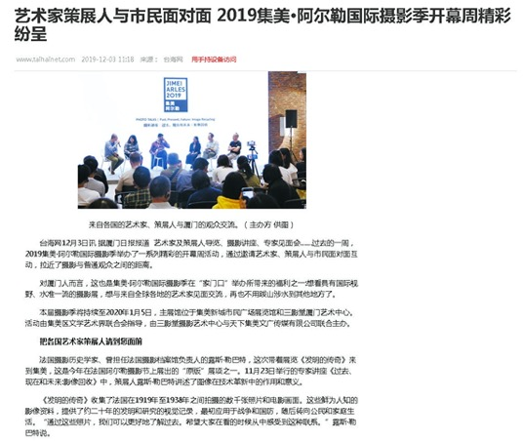
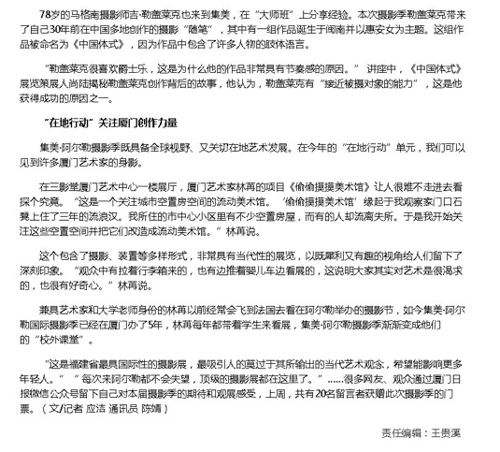

Publication : | www.taihainet.com/台海网
Circulation : | 1,000
Date : | 2019-12-04
Page : | 各区报道
Headline : | Xiamen Jimei attract much attention because of 2019 Jimei x Arles International Photo Festival
 | 30场展览2000件作品！摄影季为厦门集美带来高光时刻
Ad Value : | 20,000
PV : | 1,000
Summary : | 2019 Jimei x Arles International Photo Festival was recently unveiled and will last till January 5, 2020. It includes 30 exhibitions, which display over 2,200 artworks by 55 artists. Within three days, topics on the festival recorded over 33 million readings on Weibo.
Link : | http://www.taihainet.com/news/xmnews/gqbd/2019-12-04/2333452.html

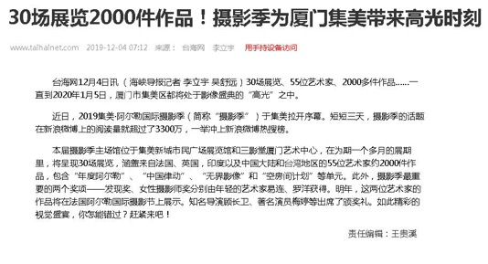

Publication : | www.taihainet.com/台海网
Circulation : | 1,000
Date : | 2019-12-04
Page : | N/A
Headline : | Xiamen Jimei attract much attention because of 2019 Jimei x Arles International Photo Festival
 | 30场展览2000件作品！摄影季为厦门集美带来高光时刻
Ad Value : | 20,000
PV : | 1,000
Summary : | 2019 Jimei x Arles International Photo Festival was recently unveiled and will last till January 5, 2020. It includes 30 exhibitions, which display over 2,200 artworks by 55 artists. Within three days, topics on the festival recorded over 33 million readings on Weibo.
Link : | http://m.taihainet.com/news/xmnews/gqbd/2019-12-04/t_2333452.html

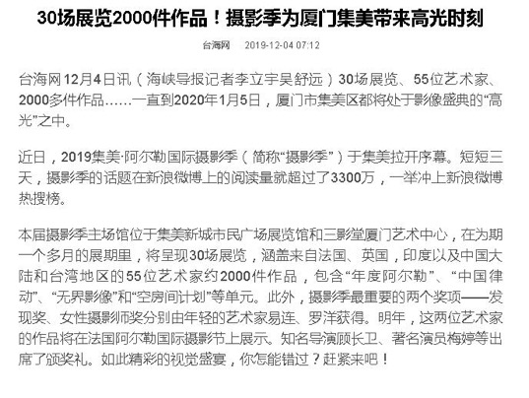

Publication : | www.taihainet.com/台海网
Circulation : | 1,000
Date : | 2019-12-05
Page : | N/A
Headline : | 2019 Jimei x Arles International Photo Festival welcomes you
 | 2019集美阿尔勒摄影季欢迎您
Ad Value : | 20,000
PV : | 1,000
Summary : | 2019 Jimei x Arles International Photo Festival was recently unveiled and will last till January 5, 2020. It includes 30 exhibitions, which display over 2,200 artworks by 55 artists. Within three days, topics on the festival recorded over 33 million readings on Weibo.
Link : | http://m.epaper.taihainet.com/20191204/hxdb687275.html

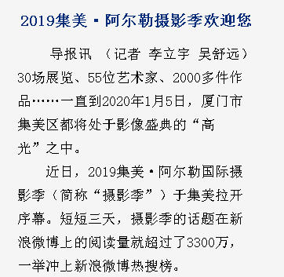
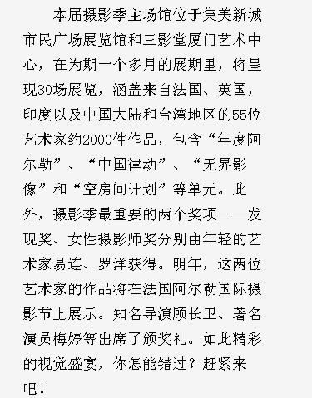

Publication : | toutiao.com/今日头条
Circulation : | 9,155,308
Date : | 2019-12-11
Page : | N/A
Headline : | Tuchong watches the 5th Jimei x Arles International Photo Festival
 | 图虫 Open See 看集美阿尔勒 | 我们生活在流淌着的历史当中
Ad Value : | 20,000
PV : | 9,155,308
Summary : | The 5th Jimei x Arles International Photo Festival kicked off in Xiamen and will last till January 5, 2020. This year's festival will present 8 exhibitions from Les Recontres d'Arles and over 20 photo exhibitions concentrating on China and Asia. As a deep cooperation photography community, Tuchong made a dialogue with Philippe Chancel who brought his work: Datazone to the festival. In addition, other exhibitions and lectures are introduced.
Link : | https://www.toutiao.com/a6769018009945113101

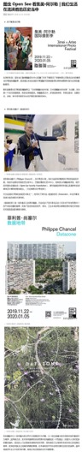
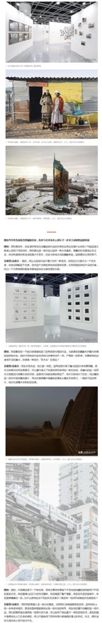
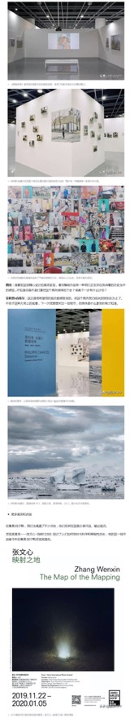
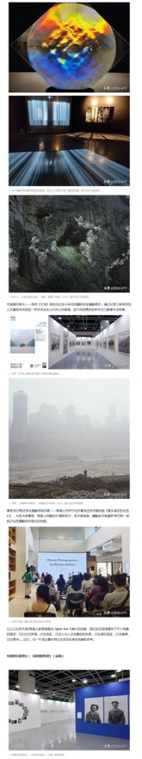
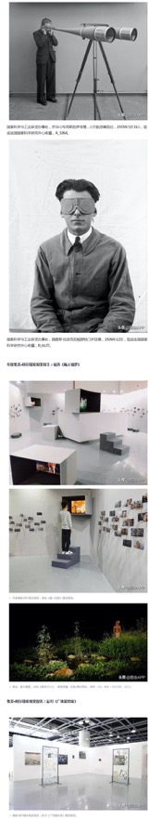
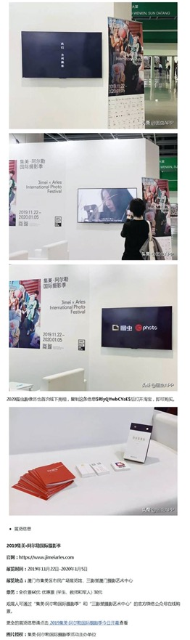

Publication : | www.fjsen.com/东南网
Circulation : | 1,000
Date : | 2019-12-12
Page : | 集美文明网
Headline : | 2019 Jimei x Arles International Photo Festival presents colorful opening week events
 | 2019集美阿尔勒国际摄影季开幕周精彩纷呈
Ad Value : | 20,000
PV : | 1,000
Summary : | Over the past week, 2019 Jimei x Arles International Photo Festival held a series of colorful opening week events, such as tour guides by artists and curators, photo lectures and experts meetings. This festival invited artists and curators to interact with the citizens, narrowing the distance between photography and ordinary audience.
Link : | http://xm.fjsen.com/2019-12/12/content_30093022.htm

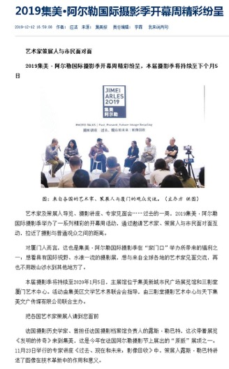
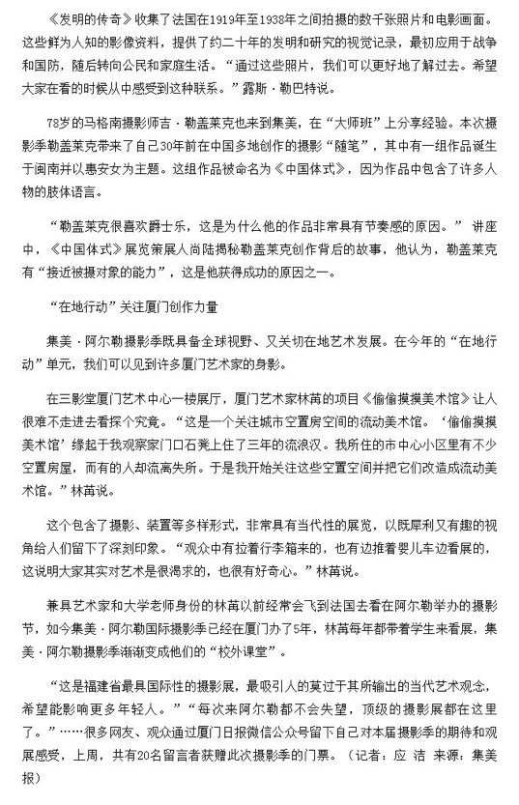

Publication : | yidianzixun.com/一点资讯
Circulation : | 391,979
Date : | 2019-12-17
Page : | 文化
Headline : | 2019 Jimei x Arles International Photography Festival will feature 30 themed exhibitions
 | 2019集美阿尔勒国际摄影季，30场展览，进去就出不来！
Ad Value : | 20,000
PV : | 391,979
Summary : | The 2019 Jimei x Arles International Photography Festival will begin on Nov 22 in Jimei district, Xiamen and will run until Jan 5, 2020. This year's event will feature eight exhibitions from the Les Rencontres d'Arles in France and 30 themed exhibitions by 55 artists from France, the UK, the US, Greece, Italy, India, and more.
Link : | https://www.yidianzixun.com/article/0O7rOuvC

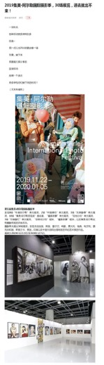
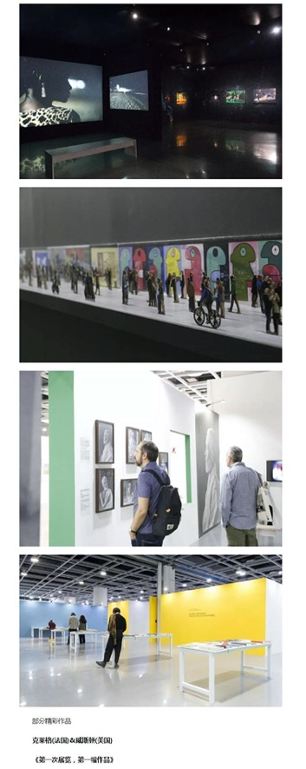
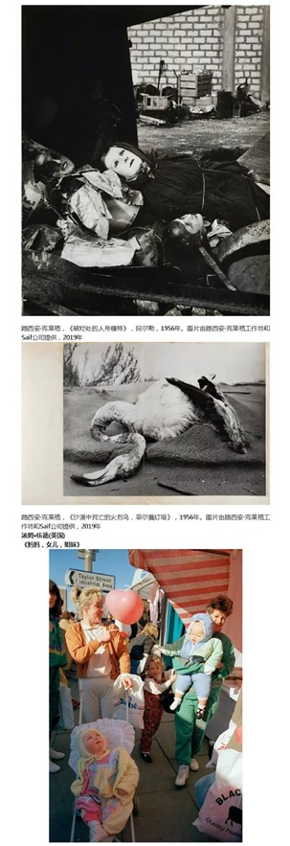
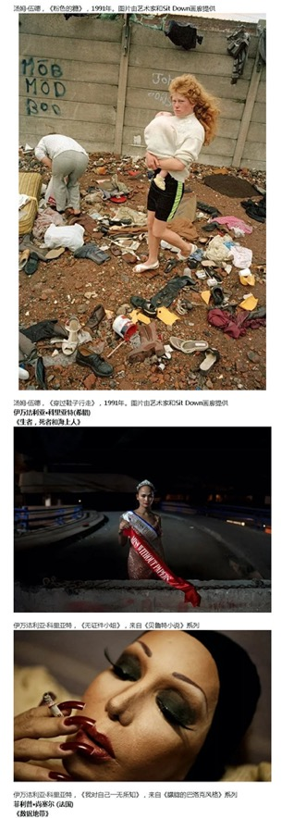
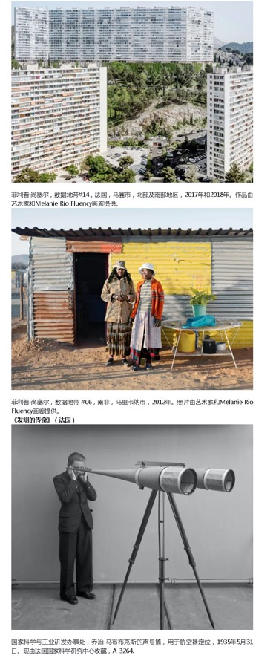
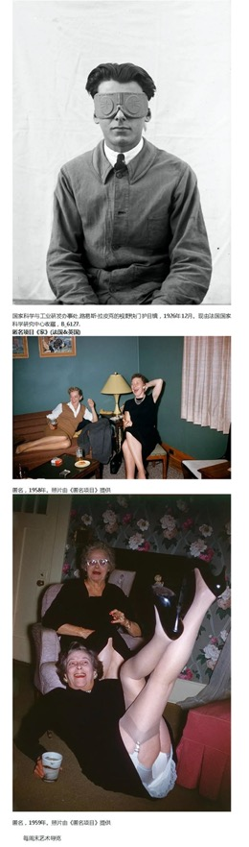
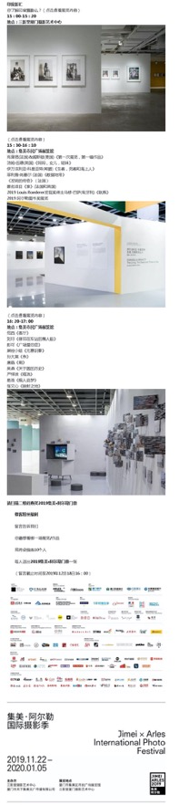

Publication : | k.sina.com.cn/新浪看点
Circulation : | 10,153,727
Date : | 2019-12-21
Page : | N/A
Headline : | 2019 Jimei x Arles International Photo Festival - Agoramaniac by Peng Ke
 | “2019集美阿尔勒发现奖展览”单元之二
Ad Value : | 20,000
PV : | 10,153,727
Summary : | Agoramaniac by Peng Ke, an exhibition of 2019 Jimei x Arles International Photo Festival, is scheduled to be presented in Xinglinwan Rd, Jimei District, Xiamen from November 22, 2019 to January 5, 2020.
Link : | https://k.sina.com.cn/article_1719140934_p6678024602700ucbh.html

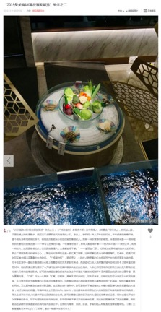

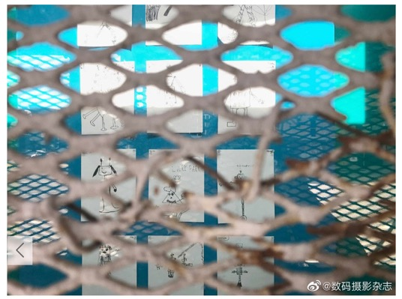

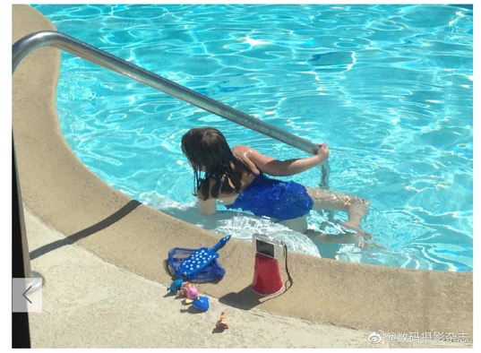
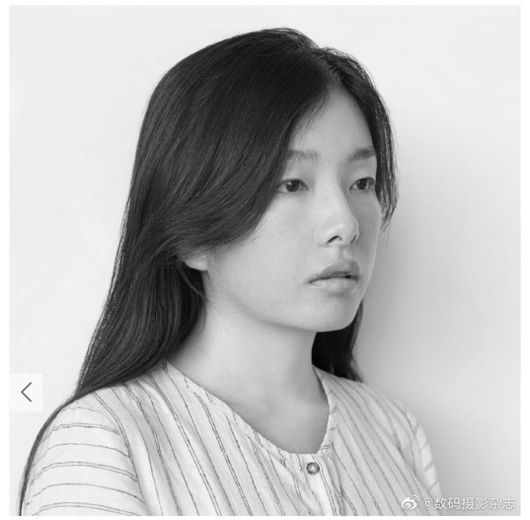

Publication : | k.sina.com.cn/新浪看点
Circulation : | 10,153,727
Date : | 2019-12-22
Page : | N/A
Headline : | 2019 Jimei x Arles International Photo Festival - Surplus by Sun Datang
 | “2019集美阿尔勒发现奖展览”单元之三
Ad Value : | 20,000
PV : | 10,153,727
Summary : | Surplus by Sun Datang, an exhibition of 2019 Jimei x Arles International Photo Festival, is scheduled to be presented in Xinglinwan Rd, Jimei District, Xiamen from November 22, 2019 to January 5, 2020.
Link : | https://k.sina.com.cn/article_1719140934_p6678024602700udk1.html

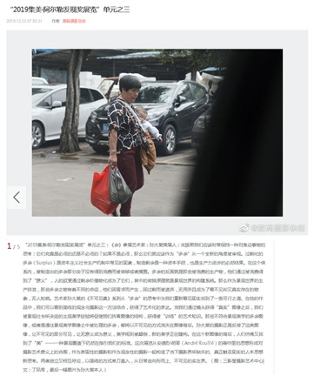
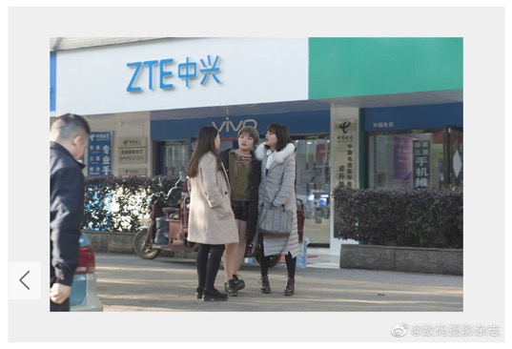
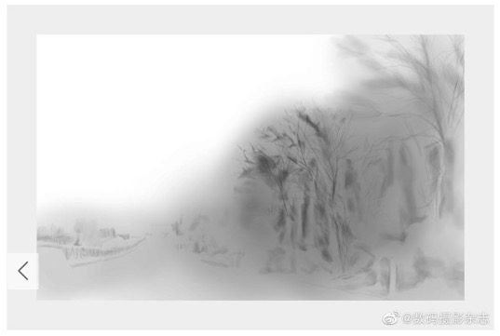
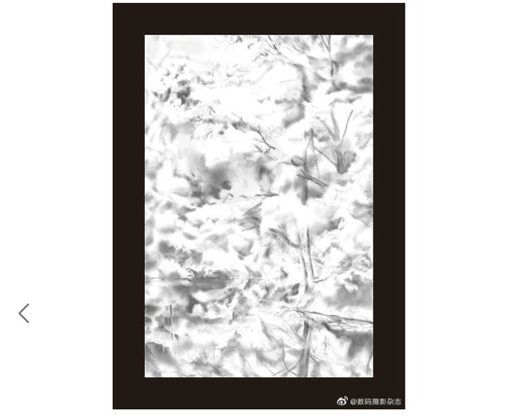

Publication : | www.sportmonline.cn/北京体育在线网
Circulation : | 1,000
Date : | 2019-12-23
Page : | 国际
Headline : | 2019 Jimei x Arles International Photo Festival - The Saga of Inventions
 | 2019集美阿尔勒国际摄影季-发明的传奇
Ad Value : | 10,000
PV : | 1,000
Summary : | The Saga of Inventions, an exhibition of 2019 Jimei x Arles International Photo Festival, is scheduled to be presented in Xinglinwan Rd, Jimei District, Xiamen from November 22, 2019 to January 5, 2020.
Link : | http://www.sportmonline.cn/gjs/2019/1223/114269.html

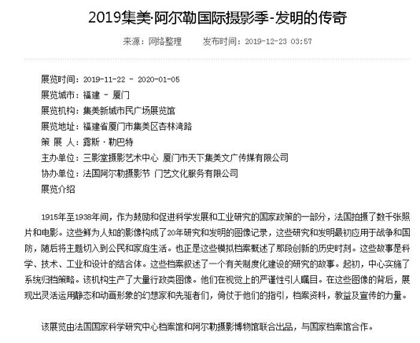
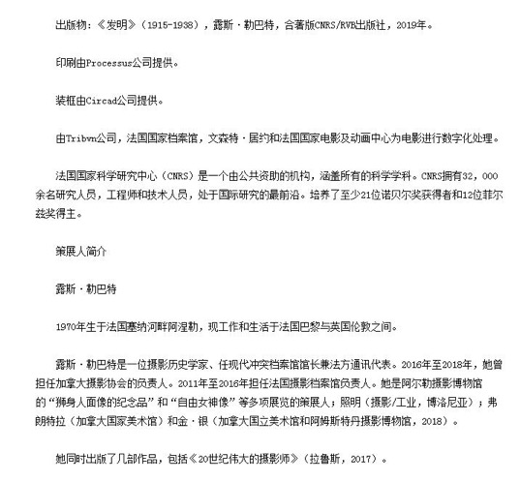

Publication : | k.sina.com.cn/新浪看点
Circulation : | 10,153,727
Date : | 2019-12-23
Page : | N/A
Headline : | 2019 Jimei x Arles International Photo Festival - Remnant by Tang Jing
 | “2019集美阿尔勒发现奖展览”单元之四
Ad Value : | 20,000
PV : | 10,153,727
Summary : | Remnant by Tang Jing, an exhibition of 2019 Jimei x Arles International Photo Festival, is scheduled to be presented in Xinglinwan Rd, Jimei District, Xiamen from November 22, 2019 to January 5, 2020.
Link : | https://k.sina.com.cn/article_1719140934_p6678024602700ueup.html

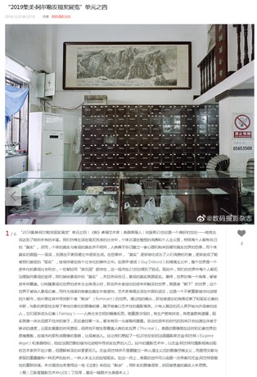
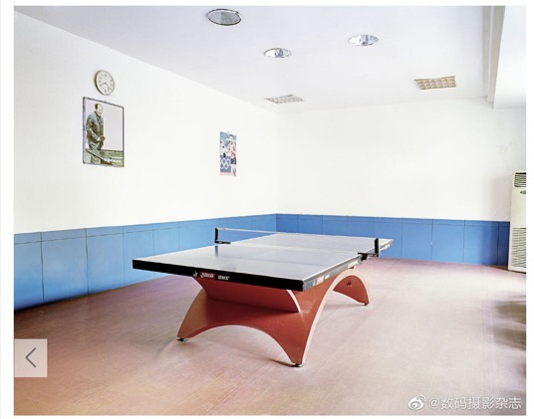
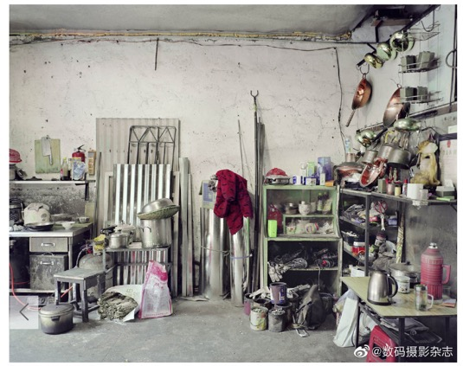
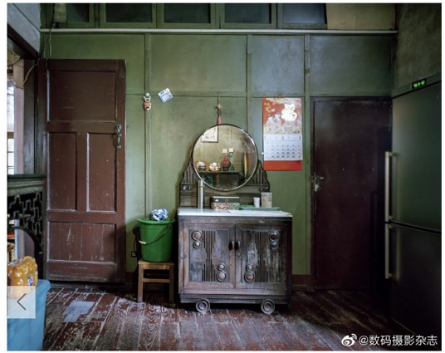
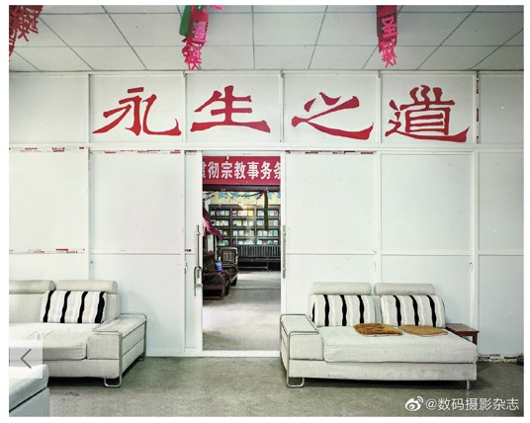
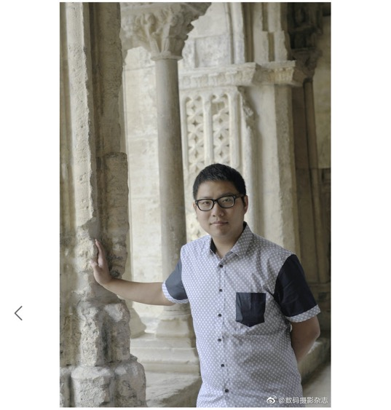

Publication : | k.sina.com.cn/新浪看点
Circulation : | 10,153,727
Date : | 2019-12-24
Page : | N/A
Headline : | 2019 Jimei x Arles International Photo Festival - Chaos by Yan Yibo
 | “2019集美阿尔勒发现奖展览”单元之五
Ad Value : | 20,000
PV : | 10,153,727
Summary : | Chaos by Yan Yibo, an exhibition of 2019 Jimei x Arles International Photo Festival, is scheduled to be presented in Xinglinwan Rd, Jimei District, Xiamen from November 22, 2019 to January 5, 2020.
Link : | https://k.sina.com.cn/article_1719140934_p6678024602700ugez.html

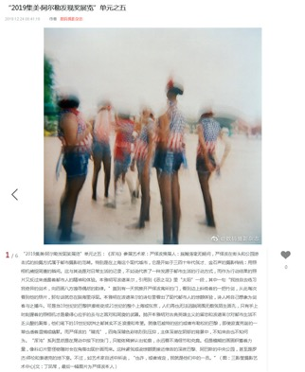
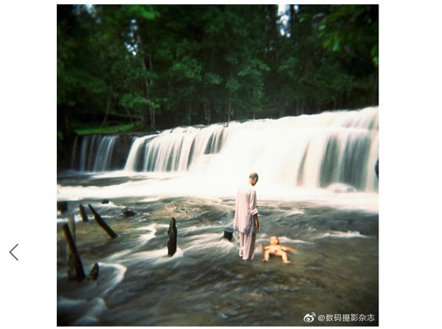
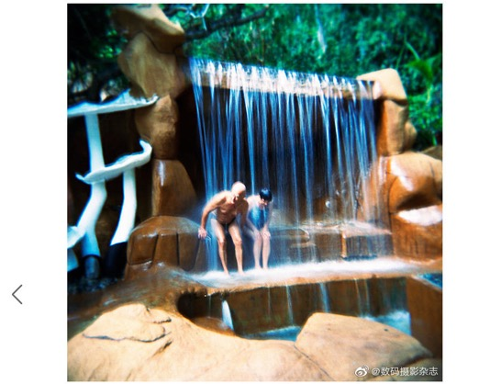
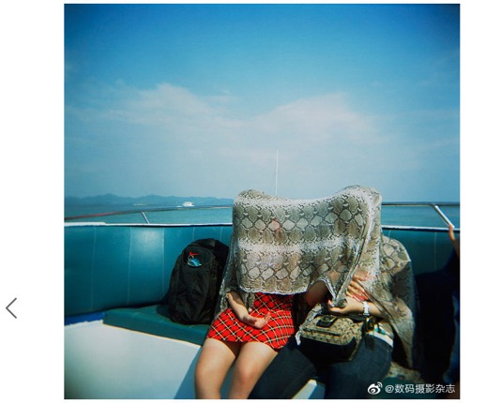
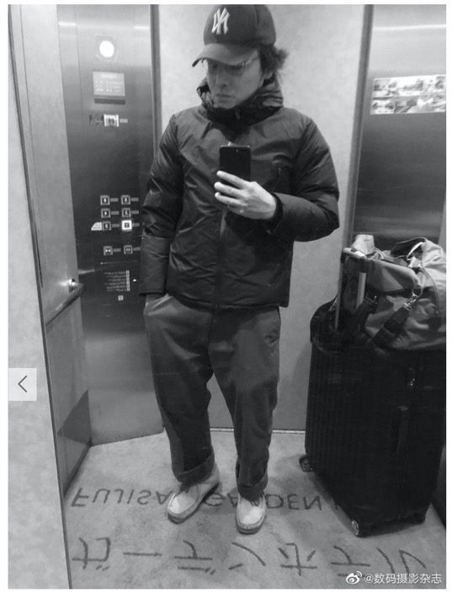

Publication : | www.thepaper.cn/澎湃新闻
Circulation : | 1,161,323
Date : | 2019-12-31
Page : | 城市漫步
Headline : | Talks from 2019 Jimei x Arles International Photography Festival
 | 艺术与社群｜从集美阿尔勒国际摄影季谈起
Ad Value : | 20,000
PV : | 1,161,323
Summary : | This article describes the writer's visit to 2019 Jimei x Arles International Photography Festival and expresses his views about some exhibitions.
Link : | http://www.thepaper.cn/newsDetail_forward_5391001

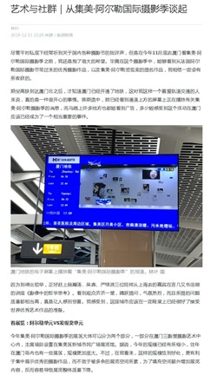
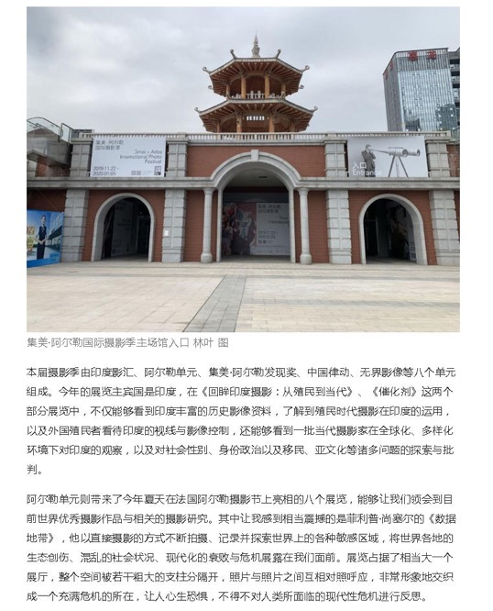
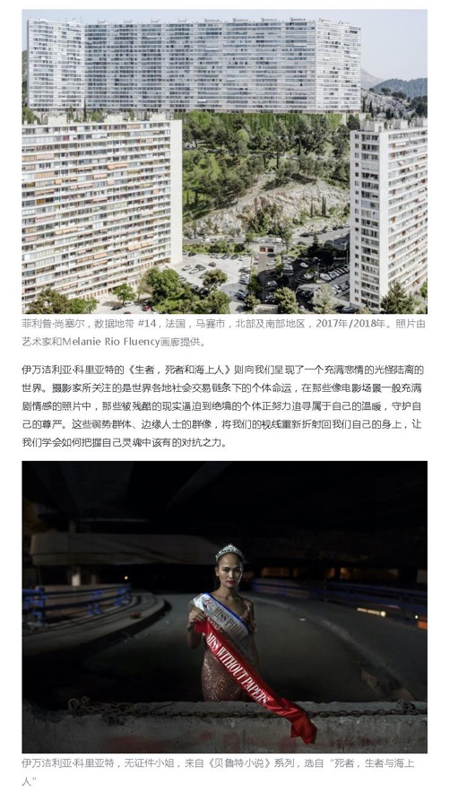
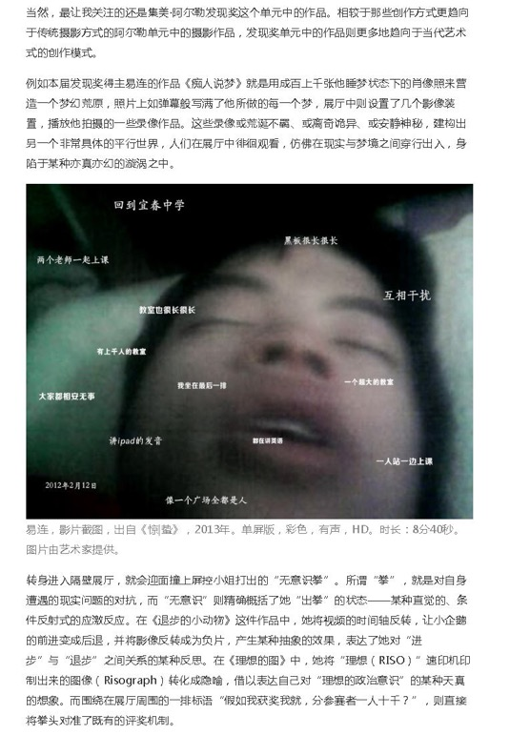
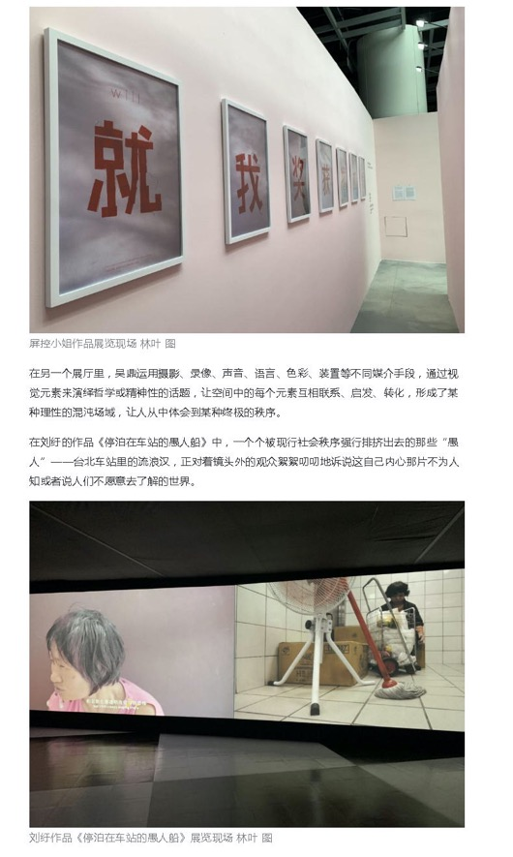
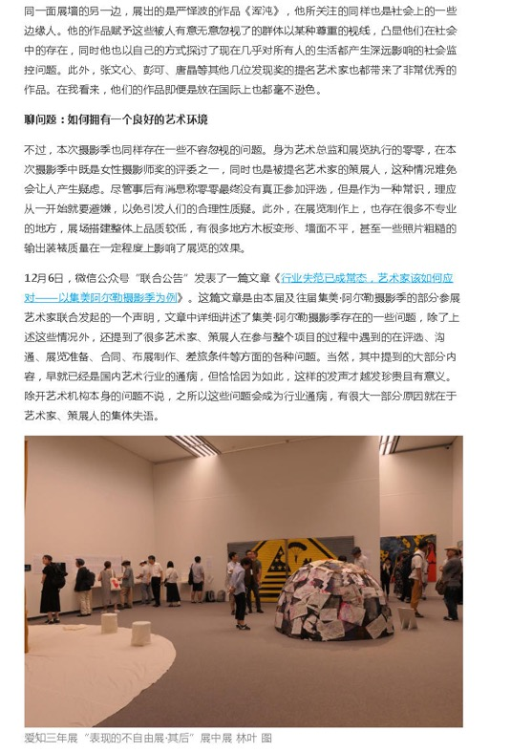
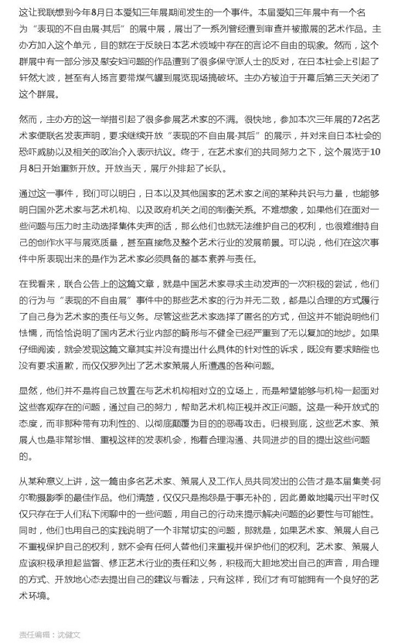

Publication : | www.ifeng.com/凤凰网
Circulation : | 8,147
Date : | 2020-01-02
Page : | N/A
Headline : | Talks from 2019 Jimei x Arles International Photography Festival
 | 从集美阿尔勒国际摄影季窥探艺术与社群
Ad Value : | 30,000
PV : | 8,147
Summary : | This article describes the writer's visit to 2019 Jimei x Arles International Photography Festival and expresses his views about some exhibitions.
Link : | http://art.ifeng.com/2020/0102/3494221.shtml

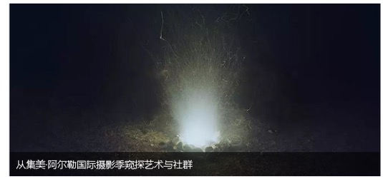
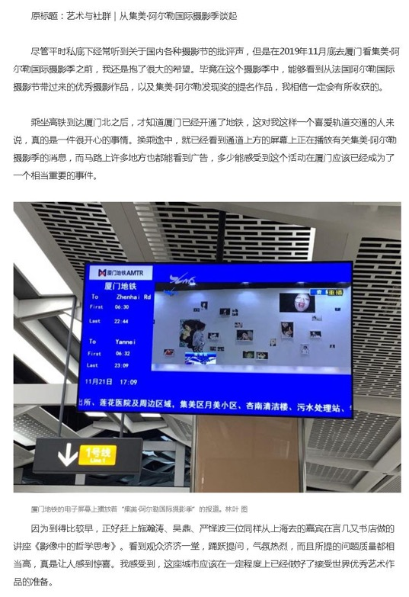
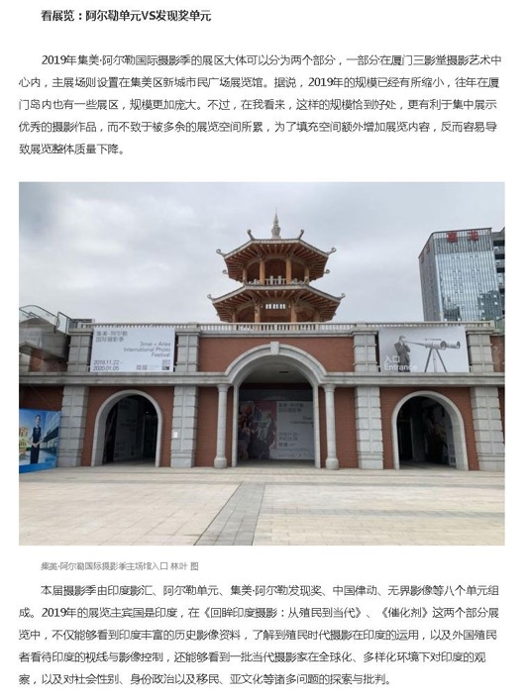
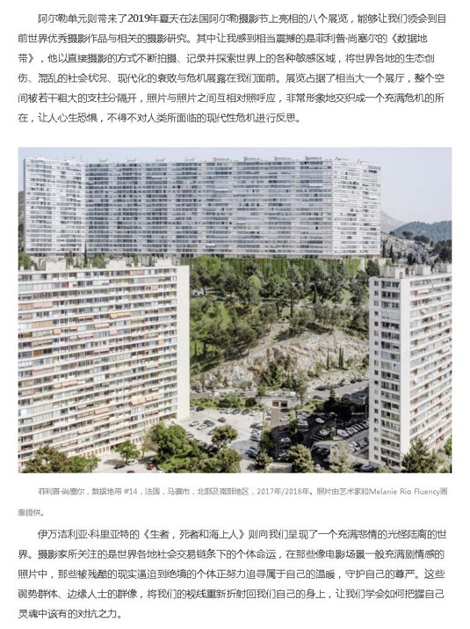
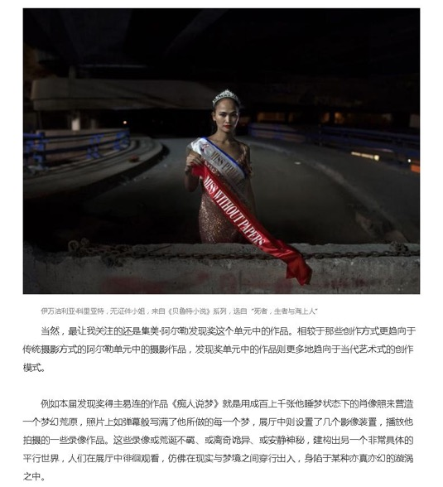
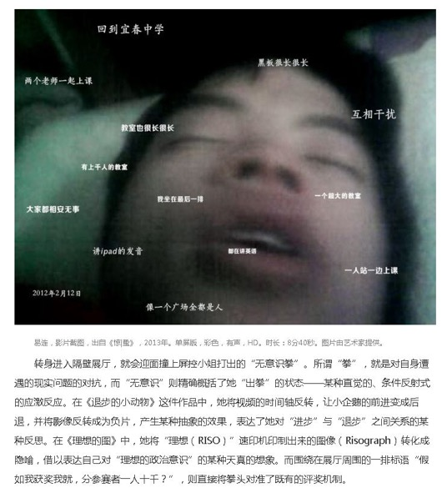
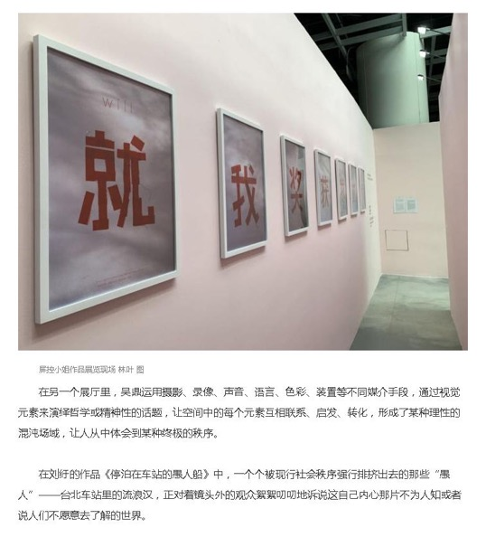
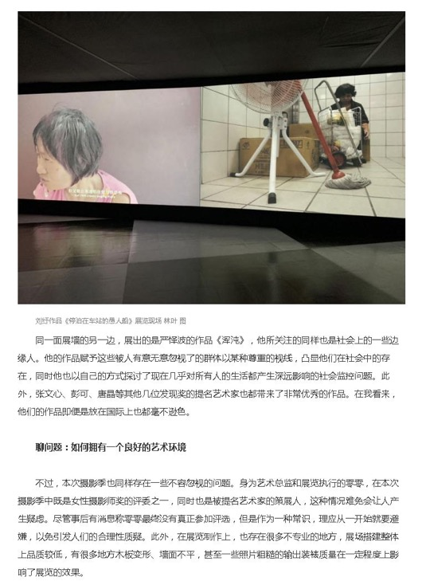
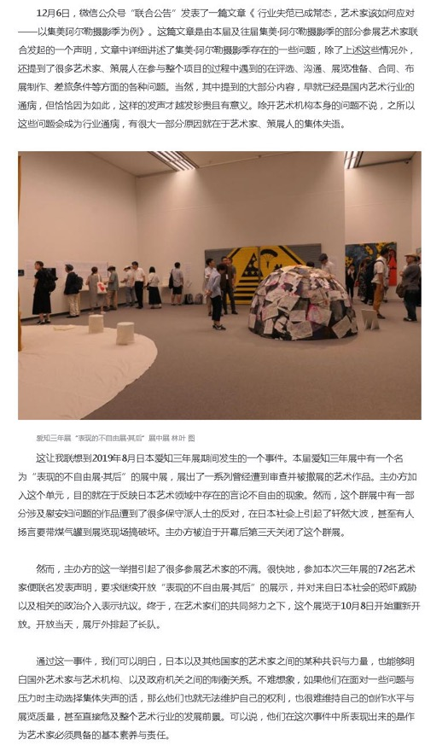
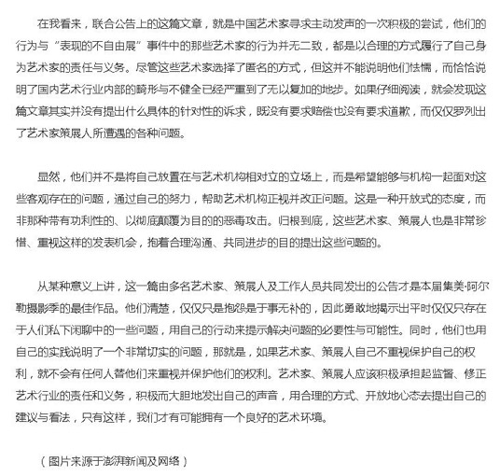

Publication : | XMTV-2/厦门电视台二套
Circulation : | 0
Date : | 2019-11-23
Page : | 厦门民生
Headline : | 2019 Jimei x Arles International Photo Festival kicks off in Xiamen
 | 2019集美阿尔勒国际摄影季开幕
Ad Value : | 30,814
PV : | 1,000
Summary : | 2019 Jimei x Arles International Photo Festival kicked off in Xiamen on November 22 and will last till January 5, 2020. It will include 30 exhibitions, which display over 2,200 artworks by 55 artists. In addition, a series of artists' tour guides, academic forums and lectures as well as Jimei x Arles Discovery Award 2019 and Jimei x Arles Women Photo Award 2019 will be held during the festival.
Link : | http://xiamen.xmtv.cn/2019/11/23/VIDEQXjyPmMPQJRlCPmmp2sW191123.shtml

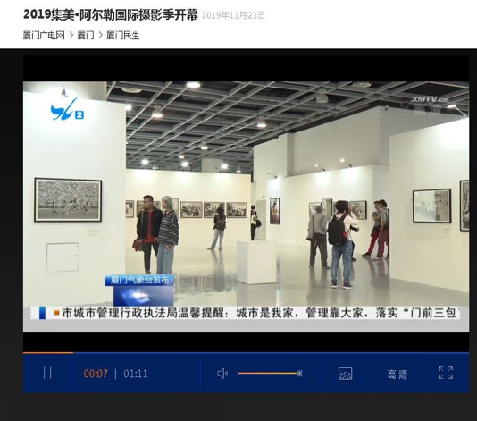

Publication : | tv.sohu.com/搜狐视频
Circulation : | 0
Date : | 2019-11-25
Page :
Headline : | 2019 Jimei x Arles International Photo Festival unveils
 | 视频 | 2019集美•阿尔勒国际摄影季奖项揭晓，李舸、顾长卫、荣荣评述
Ad Value : | 312,061
PV : | 1,002,432
Summary : | 2019 Jimei x Arles International Photo Festival unveiled in Xiamen on November 22. This year's Jimei x Arles Discovery Award and Jimei x Arles Women Photo Award were respectively awarded by artists Yi Lian and Luo Yang. Interview with Li Ke, Gu Changwei and Rong Rong were included.
Link : | http://3g.k.sohu.com/t/n408453007

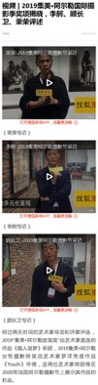
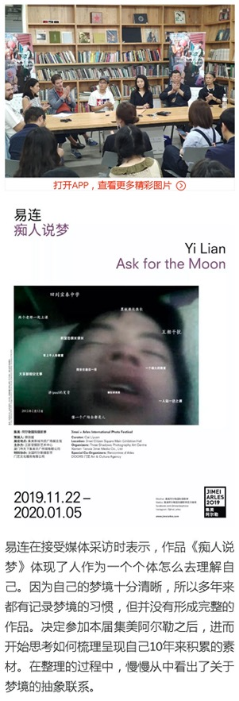
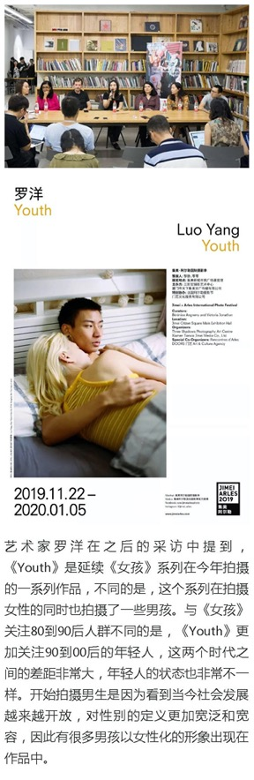
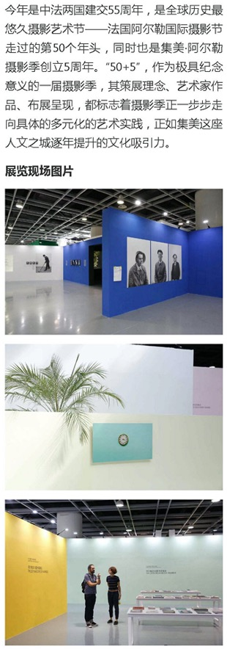

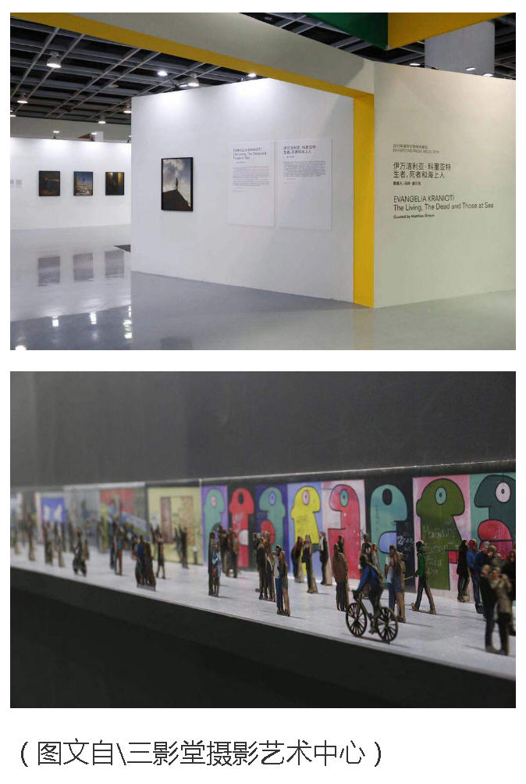

Publication : | v.163.com/网易视频
Circulation : | 0
Date : | 2019-11-29
Page :
Headline : | Thoughts or feelings about the 5th Jimei x Arles International Photo Festival
 | 2019集美阿尔勒国际摄影季观感_网易视频
Ad Value : | 57,826
PV : | 521,044
Summary : | This video refers to impressions or feelings about the 5th Jimei x Arles International Photo Festival. This festival contains many sections, has tour guides by artists and striking photos of different themes.
Link : | https://3g.163.com/v/video/VCU2DA8Q6.html

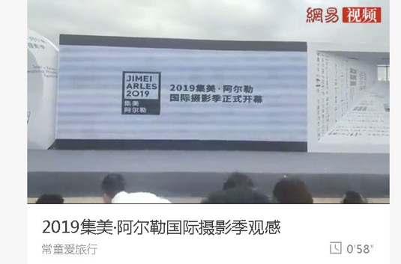

Publication : | Weibo.com/新浪微博-集美阿尔勒国际摄影季官方微博
Circulation : | 1,318
Date : | 2019-11-16
Page : | N/A
Headline : | Guide to opening week events of 2019 Jimei x Arles International Photo Festival
 | 下周，2019 集美阿尔勒 在厦门等你！ 11月22日-24日，集美·阿尔勒开幕周丰富的活动等着你来，国内外艺术家和策展人导览，四场精彩的 摄影 讲座，专家见面会，发现奖与优秀女性 摄影 师奖的揭晓，以及顾长卫导演电影《孔雀》的放映......更详细的活动周安排👉http://t.cn/AirEyyn0 ​​
Ad Value : | 20
PV : | 1,318
Summary : | The 5th Jimei x Arles International Photo Festival kicked off in Xiamen on November 22. Over next three days from November 22 to 24, a variety of cultural events will be held. The schedules of the events are given.
Link : | http://weibo.com/6052720349/Igs6oixth?type=comment

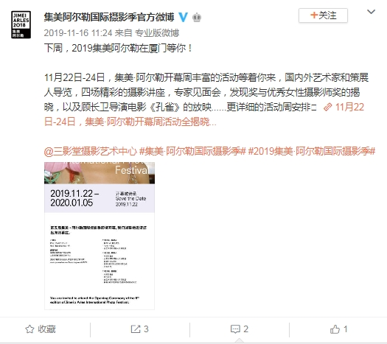

Publication : | Weibo.com/新浪微博-三影堂摄影艺术中心
Circulation : | 53,028
Date : | 2019-11-17
Page : | N/A
Headline : | Guide to opening week events of 2019 Jimei x Arles International Photo Festival
 | #2019集美·阿尔勒国际 摄影 季# 11月22日下周五，2019 集美阿尔勒 国际 摄影 季就要在厦门开幕咯！🎉22日-24日的三天里，开幕周丰富的活动等着你来！👏🏻👏🏻国内外艺术家和策展人导览，四场精彩的 摄影 讲座，专家见面会，发现奖与优秀女性 摄影 师奖的揭晓，以及顾长卫导演电影《孔雀》的放映......更详细的活动周安排👉🏻http://t.cn/AirdZGrP
Ad Value : | 795
PV : | 53,028
Summary : | The 5th Jimei x Arles International Photo Festival kicked off in Xiamen on November 22. Over next three days from November 22 to 24, a variety of cultural events will be held. The schedules of the events are given.
Link : | http://weibo.com/1879211747/IgBrxf7fz?type=comment

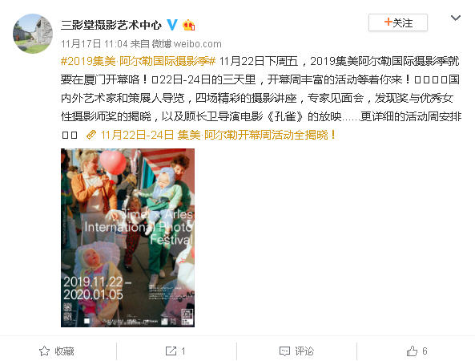

Publication : | Weibo.com/新浪微博-三影堂摄影艺术中心
Circulation : | 53,028
Date : | 2019-11-20
Page : | N/A
Headline : | Screening and after-screening exchange of film Peacock
 | #2019集美·阿尔勒国际 摄影 季# 本届集美·阿尔勒国际 摄影 季，著名导演顾长卫将担任 集美阿尔勒 发现奖评委。24日下午，作为本届 摄影 季开幕周活动的压轴大戏，电影《孔雀》将于三影堂厦门 摄影 艺术中心免费放映，顾长卫导演也会在现场与大家交流互动。欢迎各位爱好者前来观影，机会有限，不要错过哦~ 详情及报名方式👉🏻http://t.cn/AidqrV5M
Ad Value : | 795
PV : | 53,028
Summary : | Chinese well-known director Gu Changwei will act as the judge of Jimei x Arles Discovery Award 2019. His film Peacock will be screened in Three Shadows Xiamen Photography Art Centre Library at 16:00-19:15 of November 24. And an exchange after the screening will be held too.
Link : | http://weibo.com/1879211747/Ih3r2lwyp?type=comment

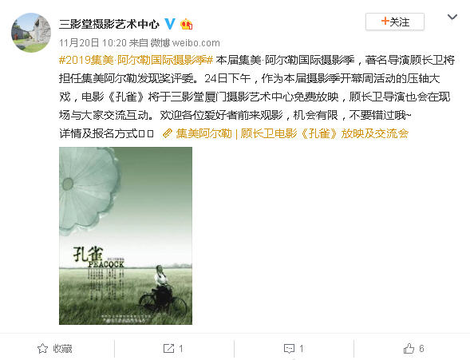

Publication : | Weibo.com/新浪微博-艺术市场杂志
Circulation : | 13,246
Date : | 2019-11-22
Page : | N/A
Headline : | The 5th Jimei x Arles International Photo Festival unveils in Xiamen
 | 2019集美·阿尔勒国际摄影季在厦门开幕！2019 集美·阿尔勒国际摄影季正式拉开帷幕。中国摄影家协会主席李舸，中共厦门市委原副书记吴凤章，中共集美区委书记李钦辉，集美区政府区长何东宁，全国政协委员、中国电影家协会副主席、中国导演协会副会长尹力，中国文联网络中心主任谢力女士，著名电影艺术 ...全文
Ad Value : | 199
PV : | 13,246
Summary : | The 5th Jimei x Arles International Photo Festival kicked off in Xiamen on November 22, 2019 and will last till January 5, 2020. It will include 30 exhibitions, which will display over 2,200 artworks by 55 world artists. The unit of "Exhibitions from Arles 2019" was introduced.
Link : | https://weibo.com/2006370267/IhqrUvFK7

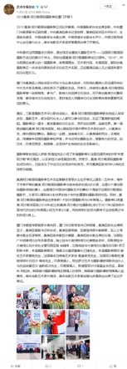

Publication : | Weibo.com/新浪微博-图虫摄影网
Circulation : | 5,811,980
Date : | 2019-11-22
Page : | N/A
Headline : | 2019 Jimei x Arles International Photo Festival kicks off in Xiamen
 | #2019集美·阿尔勒国际摄影季# 又来啦✨作为深度合作平台，图虫十周年概念短片《我们为何摄影》及《2020图虫影像历》也将会在今年展览的媒体区呈现，未来几天图虫还将报道阿尔勒艺术家独家采访。不止这些❗️图虫还要邀请15位幸运儿一起来看展✨ 转发此条微博 说出你最感兴趣的艺术家名称就有机会获得集 ...全文
Ad Value : | 87,180
PV : | 5,811,980
Summary : | 2019 Jimei x Arles International Photo Festival kicked off in Xiamen on November 22 and will last till January 5, 2020. It will present 8 exhibitions from Les Recontres d'Arles and over 20 photo exhibitions concentrating on China and Asia. Two short films by Tuchong photography web will be presented during the festival.
Link : | https://weibo.com/1674175865/IhmoMrIGQ

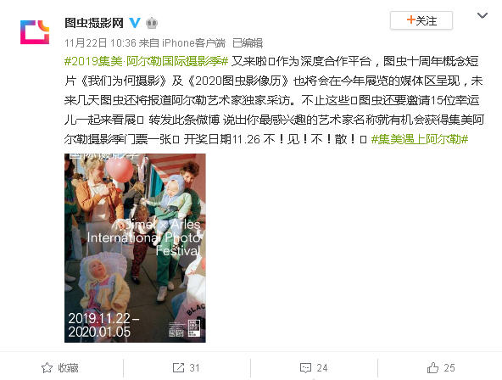

Publication : | Weibo.com/新浪微博-凤凰艺术artifeng
Circulation : | 6,031
Date : | 2019-11-22
Page : | N/A
Headline : | 2019 Jimei x Arles International Photo Festival
 | 【#艺点声音# 】每年冬天，集美·阿尔勒都会展出8场来自法国阿尔勒摄影节的展览，和20余场围绕中国与亚洲的摄影展览。继邀请韩国（2018年）和印度尼西亚（2017年）之后，2019年的摄影季则邀请到印度作为本年度主宾国参展。 展览：集美·阿尔勒摄影季 时间：2019.11.22至2020.01.05 地点：集美新城市民广场展览馆、三影堂厦门摄影艺术中心 今年的集美·阿尔勒国际摄影季将会展出共30场展览，呈现来自法国、英国、爱尔兰、希腊、意大利、瑞典、匈牙利、捷克共和国、斯里兰卡、美国，印度 以及中国大陆和台湾地区的55位艺术家的作品。 @凤凰新闻客户端
Ad Value : | 90
PV : | 6,031
Summary : | 2019 Jimei x Arles International Photo Festival kicked off in Xiamen on November 22 and will last till January 5, 2020. It will include 30 exhibitions, which display over 2,200 artworks by 55 artists. In addition to continuous attention to photography ecology in Asian countries or regions, this year's festival will present two exhibitions about Indian photos.
Link : | https://weibo.com/5607294483/Ihms70CCP

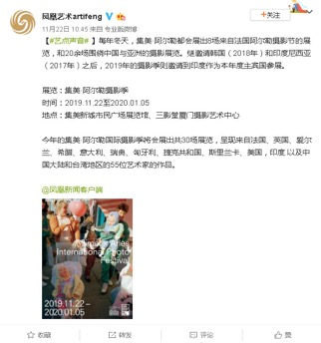

Publication : | Weibo.com/新浪微博-三影堂摄影艺术中心
Circulation : | 53,028
Date : | 2019-11-22
Page : | N/A
Headline : | 2019 Jimei x Arles International Photo Festival unveils in Xiamen
 | #2019集美·阿尔勒国际 摄影 季# 今天下午第五届 集美阿尔勒 隆重开幕🎉🎉🎉 ​​
Ad Value : | 795
PV : | 53,028
Summary : | 2019 Jimei x Arles International Photo Festival kicked off in Xiamen on November 22, with several celebrities in photography present.
Link : | http://weibo.com/1879211747/Ihozw3ond?type=comment

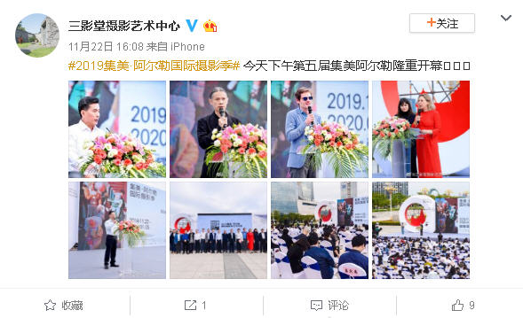

Publication : | Weibo.com/新浪微博-厦门日报
Circulation : | 792,225
Date : | 2019-11-22
Page : | N/A
Headline : | 2019 Jimei x Arles International Photo Festival kicks off in Xiamen
 | 【集美·阿尔勒国际摄影季第五次开幕】被法国总统马克龙誉为“中法文化交流”典范的集美·阿尔勒国际摄影季第五次在集美新城拉开帷幕。本届摄影季共有8场来自法国阿尔勒国际摄影节的“原装”展项，以及20余场围绕中国与亚洲的摄影展览。展期持续至2020年1月5日，主场馆位于集美新城市民广场展览馆和三影堂厦门艺术中心。详情>>http://t.cn/AidNdC0f（本报记者 应洁）
Ad Value : | 11,883
PV : | 792,225
Summary : | 2019 Jimei x Arles International Photo Festival kicked off in Xiamen on November 22 and will last till January 5, 2020. It will present 8 exhibitions from Les Recontres d'Arles and over 20 photo exhibitions concentrating on China and Asia.
Link : | https://weibo.com/1765891182/Ihp6w0UW6

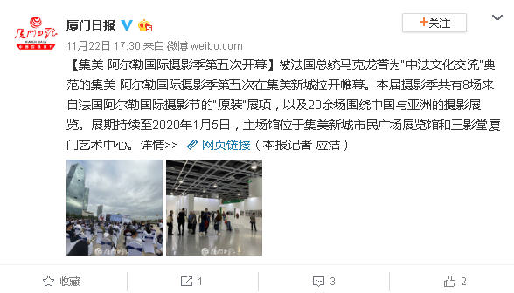

Publication : | Weibo.com/新浪微博-新浪厦门
Circulation : | 1,666,065
Date : | 2019-11-22
Page : | N/A
Headline : | Guide to 2019 Jimei x Arles International Photo Festival
 | #集美遇上阿尔勒#一年中集美最具艺术气息的时刻！8场“年度阿尔勒”单元展览、5场“中国律动”和“无界影象”单元展览、10场“集美·阿尔勒发现奖”提名展、1场“藏家故事”单元展览……满足你对摄影艺术的一切幻想！快来厦门参加阿尔勒国际摄影季吧！
Ad Value : | 24,991
PV : | 1,666,065
Summary : | 2019 Jimei x Arles International Photo Festival will present 8 exhibitions at "Exhibitions from Arles 2019", 5 exhibitions at "China Pulse" and "Crossover Photography" and 10 nominated exhibitions at "Jimei x Arles Discovery Award" and 1 exhibition at "Collector's Tale".
Link : | https://weibo.com/1740522895/Ihp6w25wq

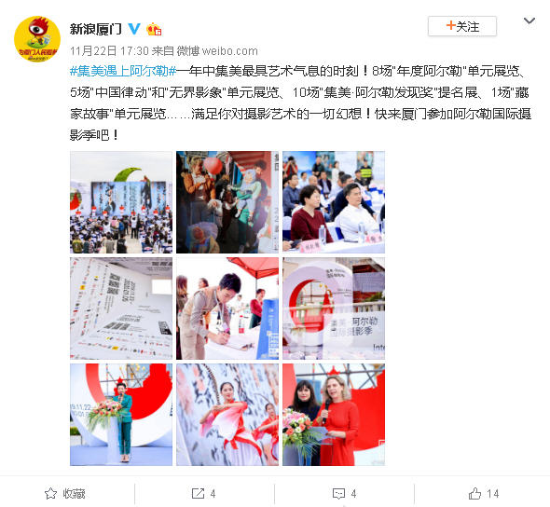

Publication : | Weibo.com/新浪微博-新京报拍者
Circulation : | 11,267
Date : | 2019-11-22
Page : | N/A
Headline : | The 5th Jimei x Arles International Photo Festival displays over 2,200 artworks by 55 artists
 | 2015年，世界最重要的摄影节——法国阿尔勒国际摄影节来到中国，落地厦门市集美区。2019年，法国阿尔勒国际摄影节（以下简称：法国阿尔勒）迎来50周岁生日，集美·阿尔勒国际摄影季（以下简称：集美阿尔勒）也已成为摄影爱好者们不容错过的视觉文化盛会。今年恰逢中法建交55周年，作为中法文化交流的重 ...全文
Ad Value : | 169
PV : | 11,267
Summary : | The 5th Jimei x Arles International Photo Festival kicked off in Xiamen on November 22, 2019 and will last till January 5, 2020. It will include 30 exhibitions, which will display over 2,200 artworks by 55 world artists. The unit of "Exhibitions from Arles 2019" was introduced.
Link : | https://weibo.com/1897123213/Ihps0ou7F

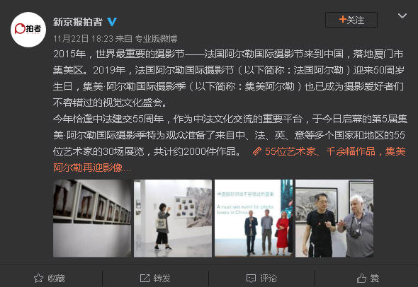

Publication : | Weibo.com/新浪微博-摄影世界
Circulation : | 3,488,726
Date : | 2019-11-22
Page : | N/A
Headline : | The 5th Jimei x Arles International Photo Festival unveils in Xiamen
 | 22 日下午，2019 @集美阿尔勒国际摄影季官方微博 集美阿尔勒国际摄影季正式拉开帷幕。今年是法国阿尔勒国际摄影节举办的第 50 个年头，同时也是集美·阿尔勒摄影季创立 5 周年。2019 集美·阿尔勒国际摄影季在为期一个多月的展期里，将呈现 30 场展览，包含“年度阿尔勒”、“中国律动”、“无界影像” ...全文
Ad Value : | 52,331
PV : | 3,488,726
Summary : | The 5th Jimei x Arles International Photo Festival kicked off in Xiamen on November 22, 2019 and will last till January 5, 2020. It will include 30 exhibitions, which will display over 2,200 artworks by 55 world artists. The unit of "Exhibitions from Arles 2019" was introduced.
Link : | https://weibo.com/1678882014/IhqzSg4i7

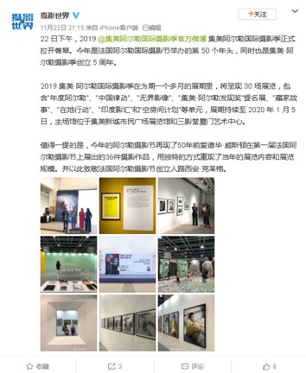

Publication : | Weibo.com/新浪微博-艺厘米APP官微
Circulation : | 10,367
Date : | 2019-11-22
Page : | N/A
Headline : | 2019 Jimei x Arles International Photo Festival unveils today
 | # 集美阿尔勒 ## 2019 集美阿尔勒 勒 摄影 季 ##中国 摄影 ##遇⻅见阿尔勒# 2019集美·阿尔勒国际 摄影 季今天正式拉开帷幕，艺厘米与你一起现场共同感受 摄影 的脉搏律动！
Ad Value : | 156
PV : | 10,367
Summary : | 2019 Jimei x Arles International Photo Festival unveiled on November 22, with many artworks to be displayed.
Link : | http://weibo.com/5728824144/Ihreuu26c?type=comment

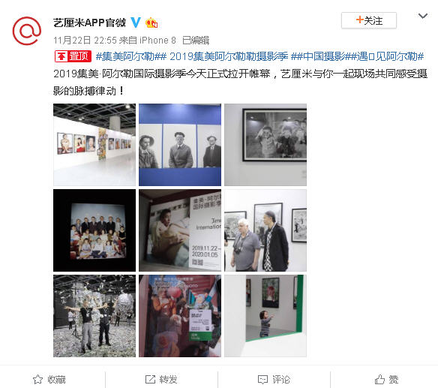

Publication : | Weibo.com/新浪微博-三影堂摄影艺术中心
Circulation : | 53,028
Date : | 2019-11-23
Page : | N/A
Headline : | 2019 Jimei x Arles International Photo Festival unveils
 | 集美·阿尔勒国际 摄影 季的成功举办，已经成为了中法文化交流合作的典范，并对集美区政府5年以来的支持表示感谢。 集美阿尔勒 国际 摄影 季艺术总监黎静及零零女士在开幕式上提到：五年来，每年于冬季开幕的集美·阿尔勒国际 摄影 季与愈来愈多的观众们⻅面，这是⼀个通向国际 摄影 领域的窗⼝，也是展示中国当代 摄影 艺术的舞台！得益于法国阿尔勒国际 摄影 节，大家可以看到来⾃全世界的各个时代的重要的 摄影 师的作品。
Ad Value : | 795
PV : | 53,028
Summary : | 2019 Jimei x Arles International Photo Festival kicked off in Xiamen on November 22 and will last till January 5, 2020. Celebrities in photography attended the opening ceremony and summarized the development of Chinese photography and expressed expectation for the festival. It will present 8 exhibitions from Les Recontres d'Arles and over 20 photo exhibitions concentrating on China and Asia.
Link : | http://weibo.com/1879211747/IhvU62YwR?type=comment

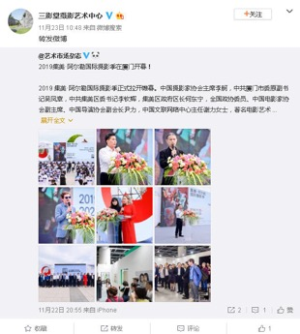

Publication : | Weibo.com/新浪微博-图虫摄影网
Circulation : | 5,822,085
Date : | 2019-11-23
Page : | N/A
Headline : | 2019 Jimei x Arles International Photo Festival kicks off in Xiamen
 | #2019集美阿尔勒摄影季# 盛大开幕✨11月22日至1月5日，集美阿尔勒将持续展出8场来自法国阿尔勒摄影节的展览，和20余场围绕中国与亚洲的摄影展览。图虫十周年概念短片《我们为何摄影》及《2020图虫影像历》也在#集美阿尔勒# 媒体区呈现！快来找我们玩吧🔫
Ad Value : | 87,331
PV : | 5,822,085
Summary : | 2019 Jimei x Arles International Photo Festival kicked off in Xiamen on November 22 and will last till January 5, 2020. It will present 8 exhibitions from Les Recontres d'Arles and over 20 photo exhibitions concentrating on China and Asia. Two short films by Tuchong photography web will be presented during the festival.
Link : | https://weibo.com/1674175865/IhwdhpcKa

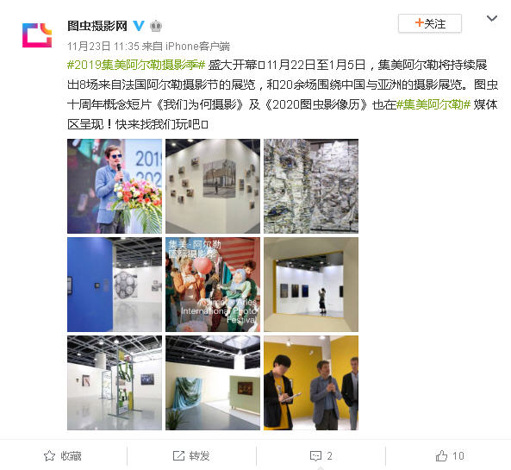

Publication : | Weibo.com/新浪微博-三影堂摄影艺术中心
Circulation : | 53,028
Date : | 2019-11-23
Page : | N/A
Headline : | Jimei x Arles Discovery Award 2019 will be unveiled this afternoon
 | #2019集美·阿尔勒国际摄影季# 2019“集美·阿尔勒发现奖”于今天下午在三影堂厦门摄影艺术中心揭晓。艺术家易连荣获第五届“集美·阿尔勒发现奖”。其作品《痴人说梦》由策展人蔡丽媛提名。本届摄影季顾问、中国摄影家协会主席李舸先生为获奖者易连颁发20万元奖金（由好慷（厦门）信息技术有限公司赞助提 ...全文
Ad Value : | 795
PV : | 53,028
Summary : | Jimei x Arles Discovery Award 2019 will be unveiled in Three Shadows Xiamen Photography Art Centre in the afternoon of November 23. Artist Yilian received the award for his work "Ask for the Moon", marking the fifth year of winning this award. He was granted with 200,000 yuan's scholarship and will display his work at Rencontres d'Arles 2020.
Link : | https://weibo.com/1879211747/IhyEUuqyg

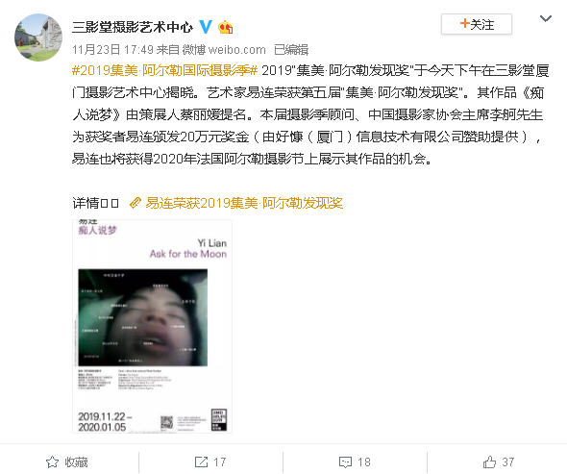

Publication : | Weibo.com/新浪微博-色影无忌她影像
Circulation : | 240,347
Date : | 2019-11-23
Page : | N/A
Headline : | Jimei x Arles Discovery Award 2019 unveiled
 | #2019集美·阿尔勒国际摄影季# 2019集美·阿尔勒发现奖揭晓！ @三影堂摄影艺术中心 摄影师易连凭借作品《痴人说梦》终获大奖，他将得到20万元人民币的奖金，并将在2020年法国阿尔勒摄影节上展示作品。 评为认为他的作品形式丰富且多样有视频、照片、文字，穿插不同人梦境的对话，让观众犹如身在艺术家脑海中转动一般，不断引发不同的联想和反应。 图一评委、颁奖嘉宾与策展人蔡丽媛在颁奖现场 图二《痴人说梦》策展人蔡丽媛现场连线摄影师易连 图三 策展人蔡丽媛讲解易连作品 图四 图五 易连《痴人说梦》展览现场照 图六 策展人蔡丽媛和摄影师易连
Ad Value : | 3,605
PV : | 240,347
Summary : | 2019 Jimei x Arles International Photo Festival unveiled the Discovery Award. Photographer Yi Lian won the award for his work "Ask for the Moon" and was granted with 200,000 yuan's scholarship. He will display his work at Rencontres d'Arles 2020.
Link : | https://weibo.com/3516203515/IhzuW3INg

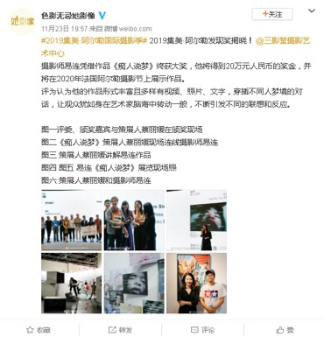

Publication : | Weibo.com/新浪微博-三影堂摄影艺术中心
Circulation : | 53,028
Date : | 2019-11-24
Page : | N/A
Headline : | Screening and after-screening exchange of film Peacock
 | #2019集美·阿尔勒国际摄影季# 顾长卫电影《孔雀》放映及交流会今天下午16:00在三影堂厦门摄影艺术中心免费放映，导演@顾长卫 也将在现场与观众交流互动。准备好了吗？还没报名的小伙伴请戳👉🏻集美阿尔勒 | 顾长卫电影《孔雀》放映及交流会
Ad Value : | 795
PV : | 53,028
Summary : | Chinese well-known director Gu Changwei will act as the judge of Jimei x Arles Discovery Award 2019. His film Peacock will be screened in Three Shadows Xiamen Photography Art Centre Library at 16:00-19:15 of November 24. And an exchange after the screening will be held too.
Link : | https://weibo.com/1879211747/IhGkSmqcw

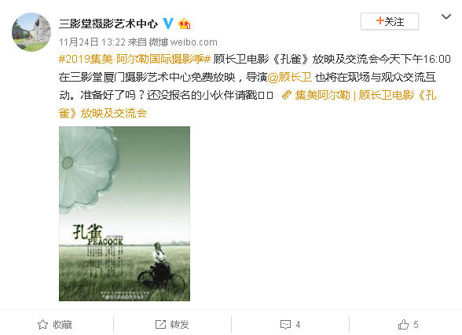

Publication : | Weibo.com/新浪微博-三影堂摄影艺术中心
Circulation : | 55,713
Date : | 2019-11-24
Page : | N/A
Headline : | Jimei x Arles Women Photo Award 2019 will be unveiled this afternoon
 | #2019集美·阿尔勒国际摄影季# 2019“集美·阿尔勒优秀女性摄影师奖”于今天下午在三影堂厦门摄影艺术中心揭晓。艺术家罗洋凭借作品《Youth》荣获该奖项。艺术家曹斐与著名演员@梅婷 共同为获奖者罗洋颁发5万元奖金（由好慷（厦门）信息技术有限公司赞助提供），罗洋也将获得2020年法国阿尔勒摄影节上展示其作品的机会。 @荣荣和映里
Ad Value : | 836
PV : | 55,713
Summary : | Jimei x Arles Women Photo Award 2019 will be unveiled in Three Shadows Xiamen Photography Art Centre in the afternoon of November 24. Artist Luo Yang received the award for his work "Youth". Artists Cao Fei and actress Mei Ting jointly granted 50,000 yuan's scholarship bonus to Luo Yang. Besides, Luo Yang also got the chance to display his work at Rencontres d'Arles 2020.
Link : | https://weibo.com/1879211747/IhH2bdQnp

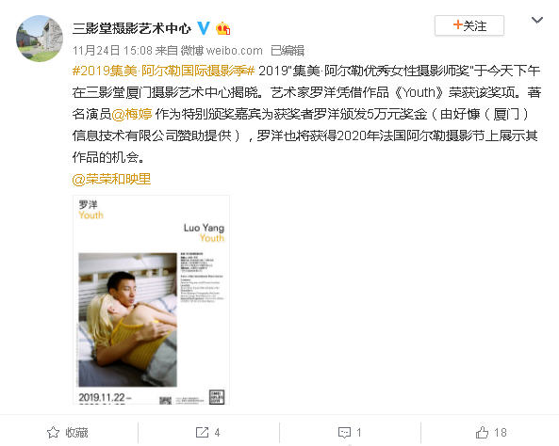

Publication : | Weibo.com/新浪微博-东南网厦门频道
Circulation : | 1,190
Date : | 2019-11-25
Page : | N/A
Headline : | 2019 Jimei x Arles International Photo Festival kicks off
 | 【2019集美·阿尔勒国际摄影季开幕 展至明年1月 】电影人带领厦门进入“金鸡时间”，摄影人为集美点亮“高光时刻”。22日下午，2019集美·阿尔勒国际摄影季正式拉开帷幕。本次展览持续至2020年1月5日，主场馆位于集美新城市民广场展览馆和三影堂厦门艺术中心。 2019集美·阿尔勒国际摄影季开幕 展至明年1月
Ad Value : | 18
PV : | 1,190
Summary : | 2019 Jimei x Arles International Photo Festival kicked off in Xiamen on November 22 and will last till January 5, 2020. It will include 30 exhibitions, which display over 2,200 artworks by 55 artists.
Link : | https://weibo.com/2153698191/IhR2v01h2

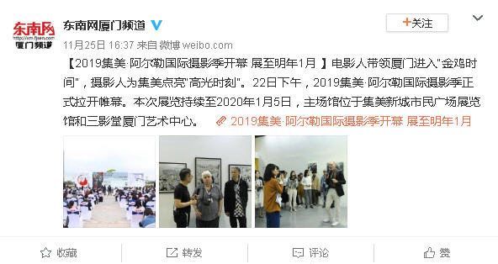

Publication : | Weibo.com/新浪微博-Art-Ba-Ba
Circulation : | 80,458
Date : | 2019-11-28
Page : | N/A
Headline : | The 5th Jimei x Arles International Photo Festival connects the world through photos
 | 【现场】2019集美·阿尔勒国际摄影季：摄影，连通自身与世界http://t.cn/AigcUcF3 当法国阿尔勒国际摄影节迎来50岁生日时，集美·阿尔勒也迎来了创立的第五年。在这个旧称Amoy，与台湾隔海相望的港口城市，海风之下，30场展览被一一陈列于集美新城市民广场展览馆，以及三影堂厦门摄影艺术中心。这其中包括来自法国、英国、爱尔兰、捷克共和国、斯里兰卡、意大利、美国等国家的作品，也包括中国本土艺术家的展览。30场展览中，有20余场聚焦于中国与亚洲。同时，与往年一样，今年的摄影季也特别关注了一个亚洲国家——印度。
Ad Value : | 1,207
PV : | 80,458
Summary : | The 5th Jimei x Arles International Photo Festival kicked off in Xiamen on November 22, 2019 and will last till January 5, 2020. It will include 30 exhibitions, which will display artworks by 55 world artists. Over 20 out of the 30 exhibitions focus on China and Asia. Unlike previous years, this year's festival paid special attention to an Asian country - India.
Link : | https://weibo.com/1571578583/IihVpBOfc

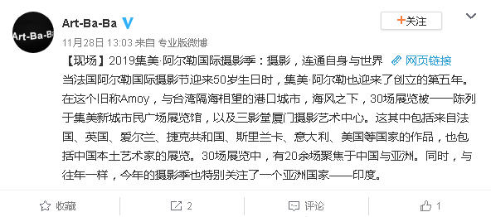

Publication : | Weibo.com/新浪微博-数码摄影杂志
Circulation : | 101,880
Date : | 2019-12-23
Page : | N/A
Headline : | 2019 Jimei x Arles International Photo Festival - Remnant by Tang Jing
 | “2019集美·阿尔勒发现奖展览”单元之四：《剩》参展艺术家：唐晶策展人：宋振熙21世纪是一个美好的世纪——物质生活达到了前所未有的丰富。我们仿佛生活在毫无忧虑的社会中，个体沉浸在愉悦的消费和个人主义里，相信每个人都有自己的“真实”。然而，个体的真实与客观的真实并不相同，人类善于自 ...全文
Ad Value : | 1,528
PV : | 101,880
Summary : | Remnant by Tang Jing, an exhibition of 2019 Jimei x Arles International Photo Festival, is scheduled to be presented in Xinglinwan Rd, Jimei District, Xiamen from November 22, 2019 to January 5, 2020.
Link : | https://weibo.com/1719140934/Im3I6qM8x

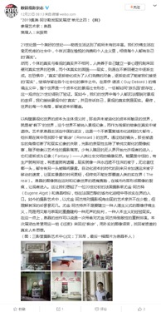

Publication : | Weibo.com/新浪微博-数码摄影杂志
Circulation : | 101,880
Date : | 2019-12-24
Page : | N/A
Headline : | 2019 Jimei x Arles International Photo Festival - Chaos by Yan Yibo
 | “2019集美·阿尔勒发现奖展览”单元之五：《浑沌》参展艺术家：严怿波策展人：施瀚涛毫无疑问，严怿波在街头和公园游击式的拍摄方式属于都市摄影的范畴。特别是在上海这个现代城市，它是开始于三四十年代张才、金石声的摄影传统：用照相机捕捉周遭的瞬间。这与其说是对日常生活的记录，不如说代表 ...全文
Ad Value : | 1,528
PV : | 101,880
Summary : | Chaos by Yan Yibo, an exhibition of 2019 Jimei x Arles International Photo Festival, is scheduled to be presented in Xinglinwan Rd, Jimei District, Xiamen from November 22, 2019 to January 5, 2020.
Link : | https://weibo.com/1719140934/Imcw9y9fd

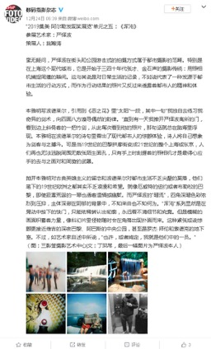

Publication : | WeChat/微信-拍者
Circulation : | 1,563
Date : | 2019-11-22
Page : | 0
Headline : | The 5th Jimei x Arles International Photo Festival displays over 2,200 artworks by 55 artists
 | 55位艺术家、近2000幅作品，集美阿尔勒再迎影像高光时刻
Ad Value : | 3,595
PV : | 1,563
Summary : | The 5th Jimei x Arles International Photo Festival kicked off in Xiamen on November 22, 2019 and will last till January 5, 2020. It will include 30 exhibitions, which will display over 2,200 artworks by 55 world artists.
Link : | https://mp.weixin.qq.com/s/WjdDh6ataAyokw_o_blWow

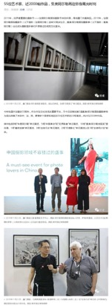
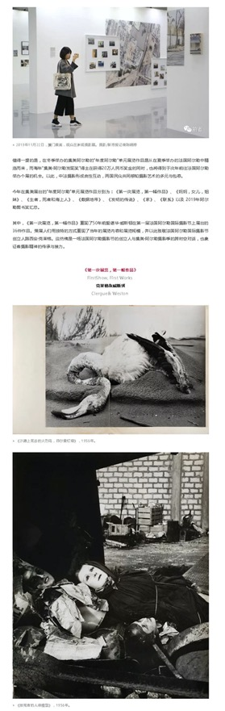
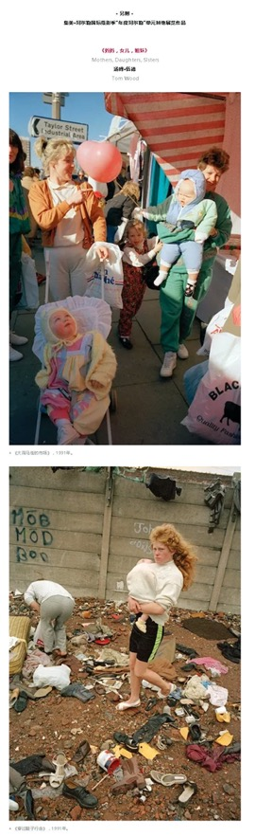
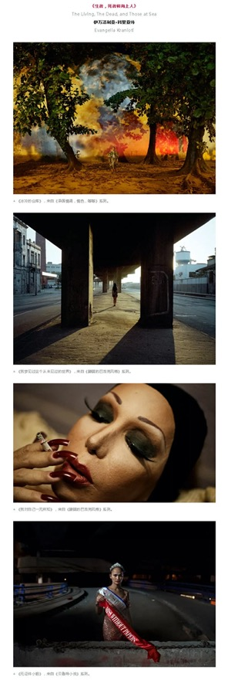
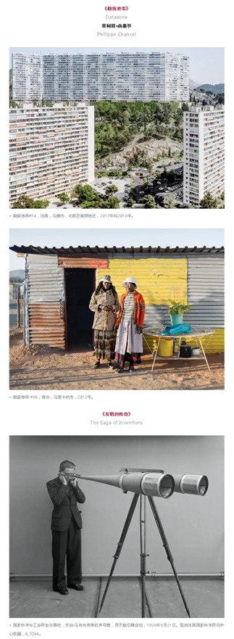

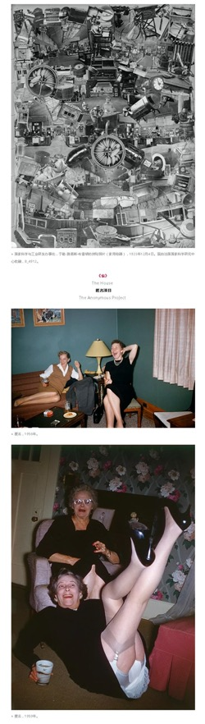

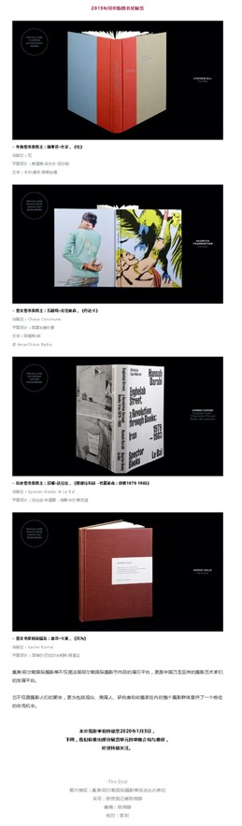

Publication : | WeChat/微信-图虫APP
Circulation : | 557
Date : | 2019-11-22
Page : | 0
Headline : | The 5th Jimei x Arles International Photo Festival kicks off
 | 2019集美阿尔勒国际摄影季今日开幕
Ad Value : | 1,281
PV : | 557
Summary : | The 5th Jimei x Arles International Photo Festival kicked off in Xiamen on November 22, 2019 and will last till January 5, 2020. It will include 30 exhibitions, which will display over 2,200 artworks by 55 world artists.
Link : | https://mp.weixin.qq.com/s/8pjsdiN1w9WIpnAMzqIung

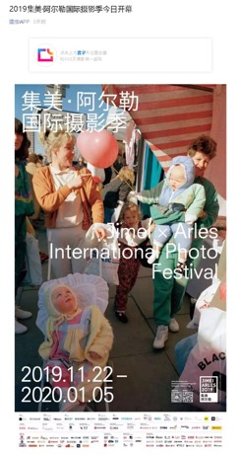
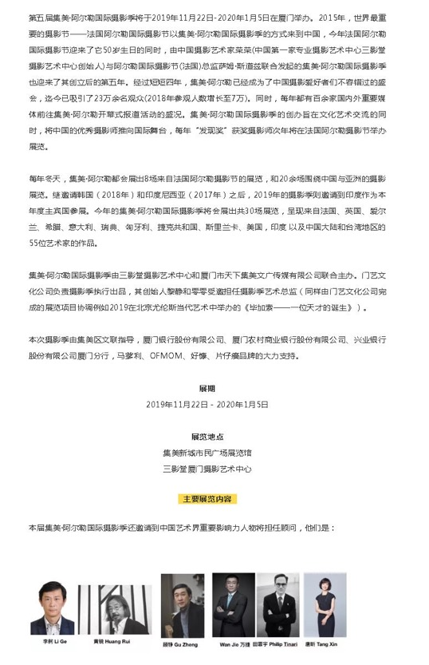
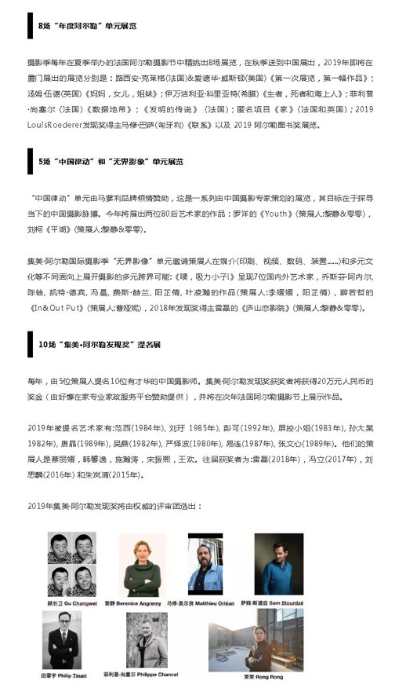
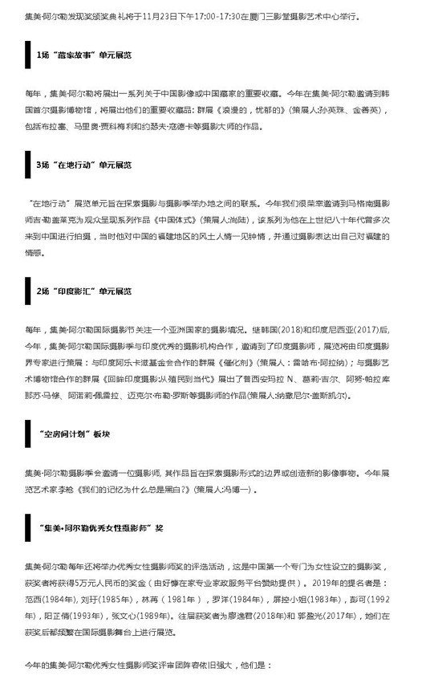
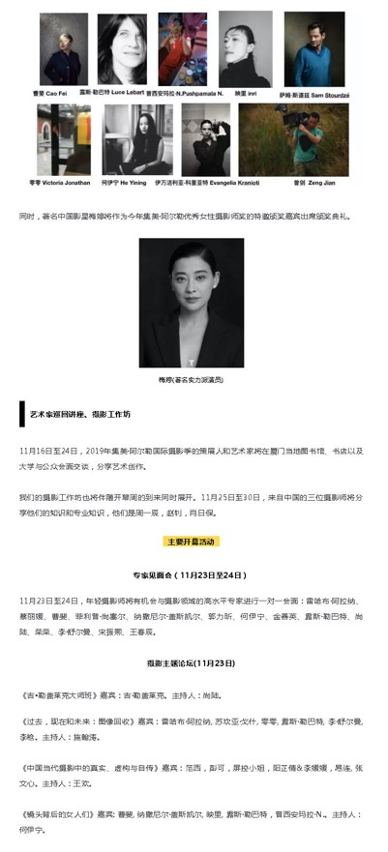
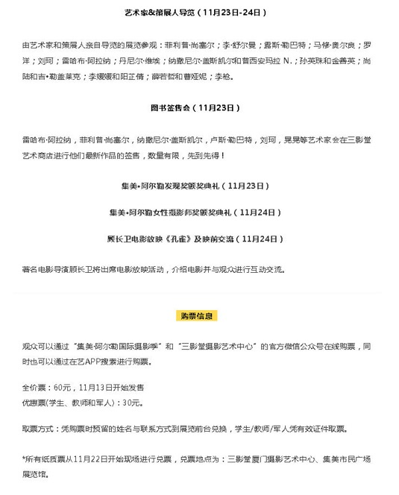

Publication : | WeChat/微信-三影堂摄影艺术中心
Circulation : | 385
Date : | 2019-11-22
Page : | 0
Headline : | Jimei x Arles International Photography Festival Photo Book Station Artists Book-signing
 | 集美阿尔勒 | 艺术家图书签售会
Ad Value : | 885
PV : | 385
Summary : | Jimei x Arles International Photography Festival Photo Book Station Artists Book-signing will be presented in Three Shadows Xiamen Photography Art Centre at 13:15 to 14:00 of November 23.
Link : | https://mp.weixin.qq.com/s/9Cz6bXA88ioUOe7r2PUfCg

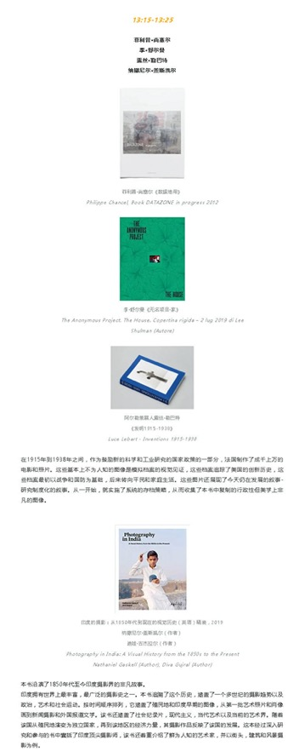
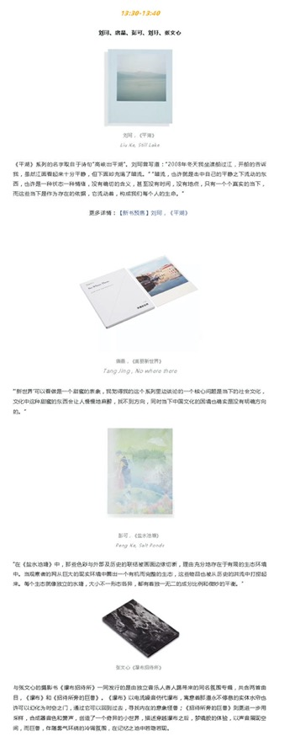
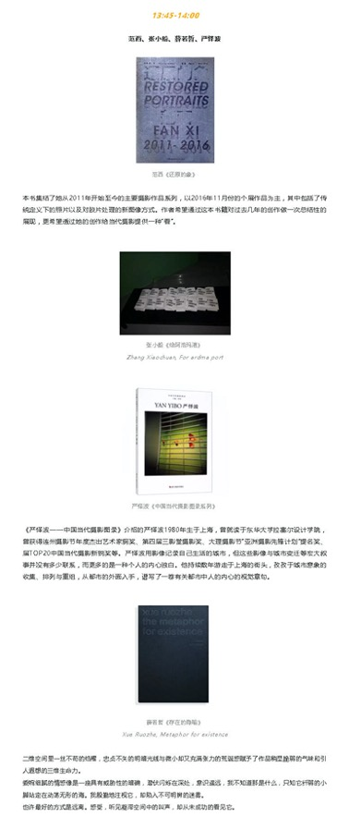

Publication : | WeChat/微信-三影堂摄影艺术中心
Circulation : | 2,038
Date : | 2019-11-22
Page : | 0
Headline : | The 5th Jimei x Arles International Photo Festival kicks off
 | 2019集美阿尔勒国际摄影季盛大开幕！
Ad Value : | 4,687
PV : | 2,038
Summary : | The 5th Jimei x Arles International Photo Festival kicked off in Xiamen on November 22, 2019 and will last till January 5, 2020. It will include 30 exhibitions, which will display over 2,200 artworks by 55 world artists.
Link : | https://mp.weixin.qq.com/s/ATlL_l5TMhtVQRwGS0sCGA

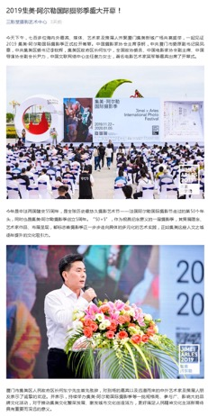
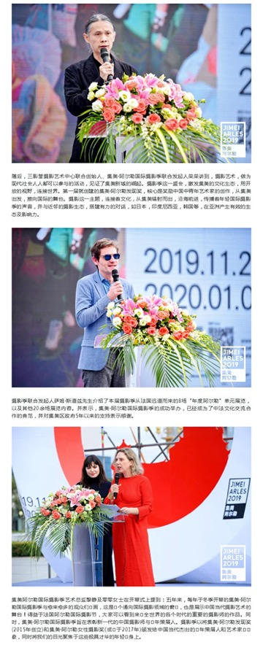
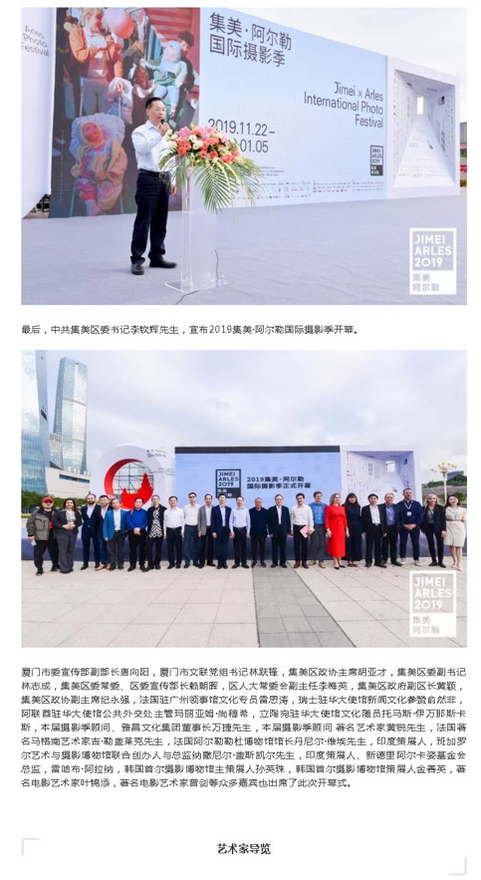
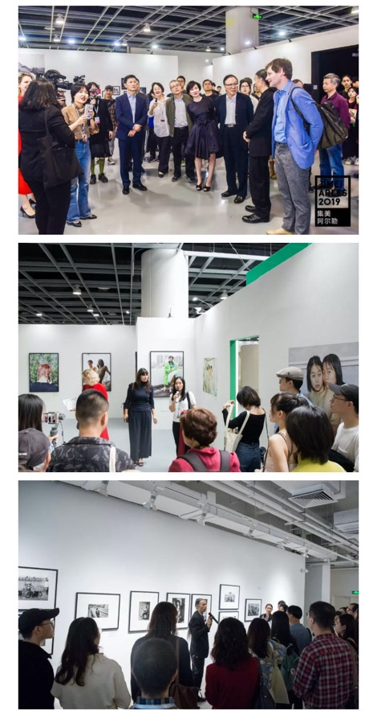
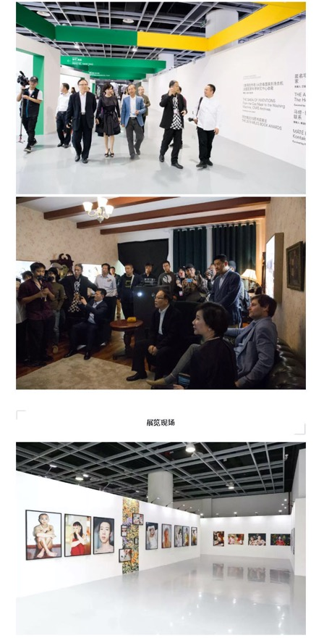
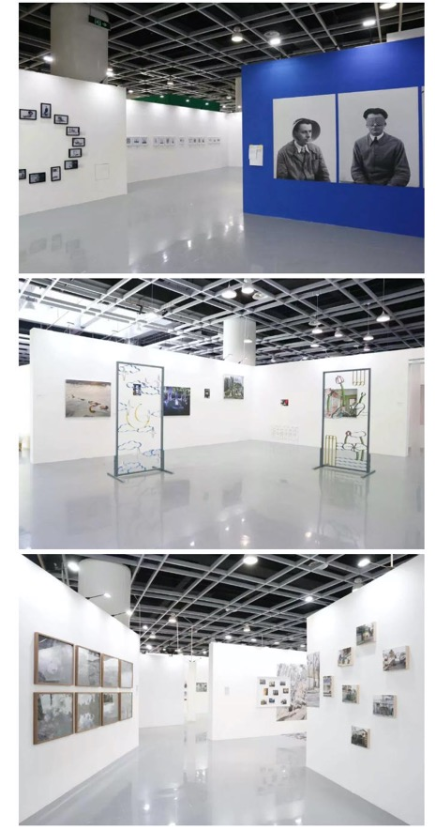

Publication : | WeChat/微信-雅昌艺术网
Circulation : | 564
Date : | 2019-11-23
Page : | 0
Headline : | The 5th Jimei x Arles International Photo Festival welcomes its peak time
 | 展览 | “50+5” 5岁的集美阿尔勒摄影季迎来影像“高光时刻”
Ad Value : | 1,297
PV : | 564
Summary : | 2019 Jimei x Arles International Photo Festival kicked off on November 22, attracting hundreds of global photographers, curators and inside experts as well as photography and art lovers. This festival will last till January 5, 2020. It will display over 2,200 artworks by 55 artists from France, UK, Ireland, Greece, Italy, Sweden, Hungary, Czech, Sri Lanka, US, India and China. In addition, a series of artists' tour guides, academic forums and lectures will be held during the festival.
Link : | https://mp.weixin.qq.com/s/uUx6By6y7ofPhKScZ3bY0Q

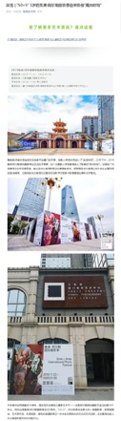
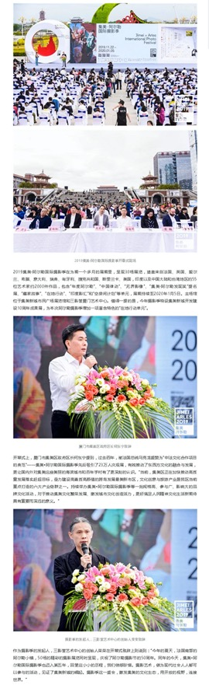
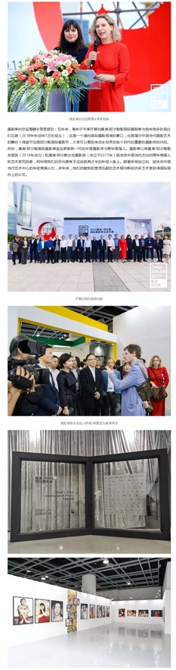
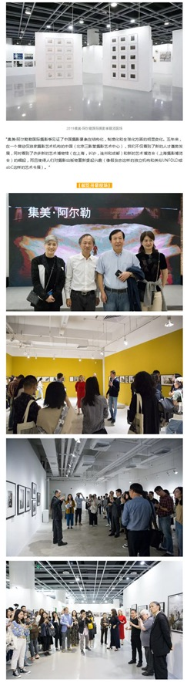

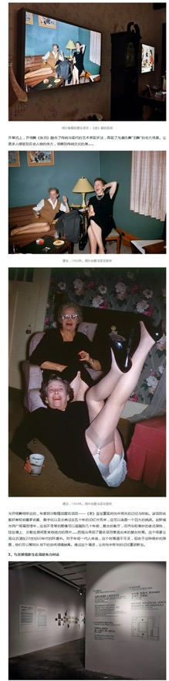
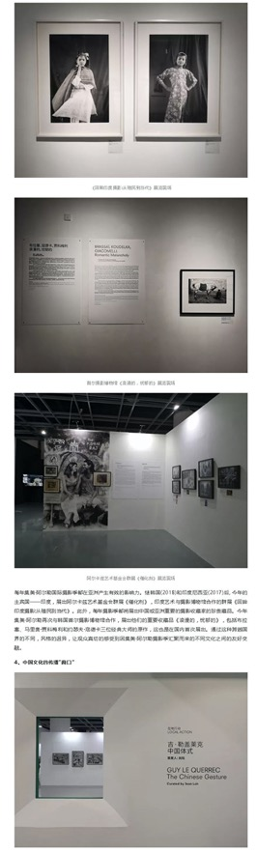
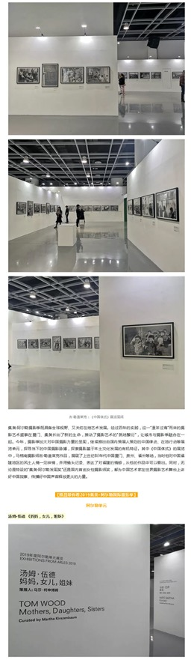
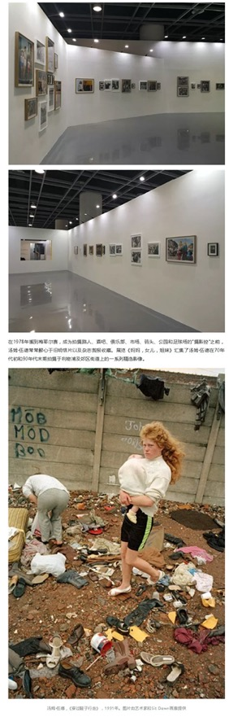
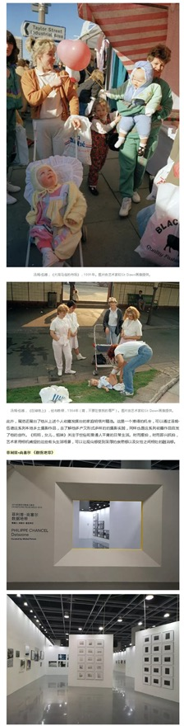
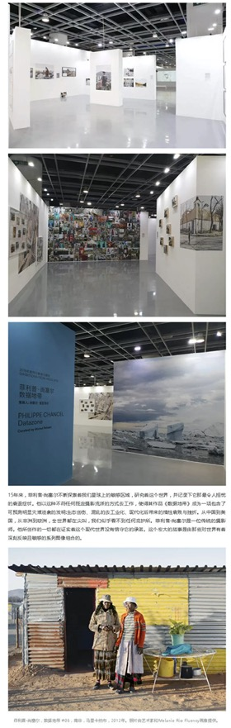
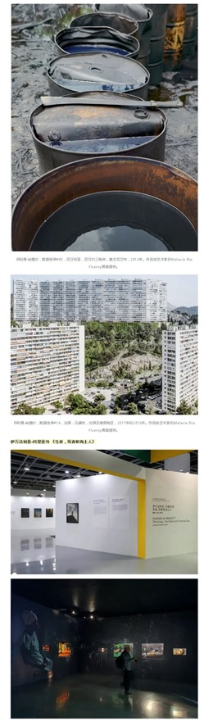
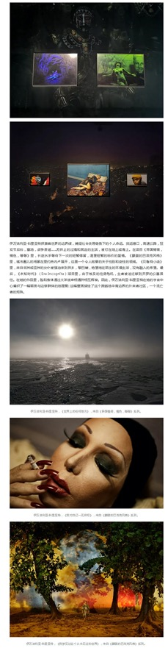
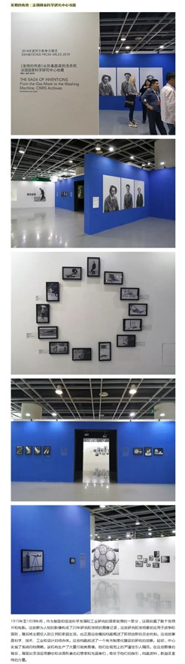
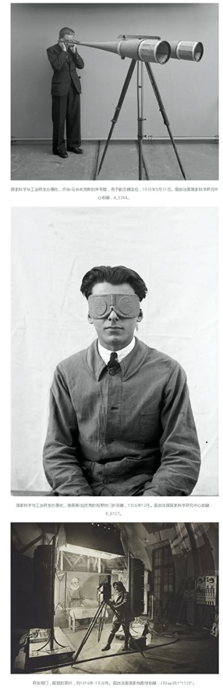
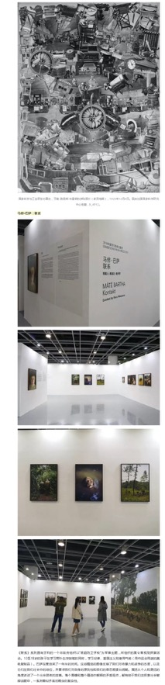
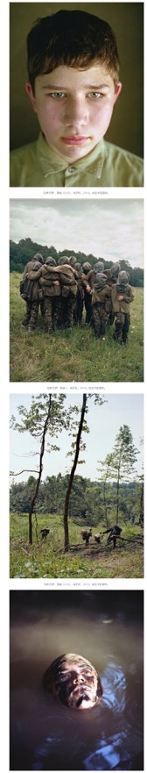
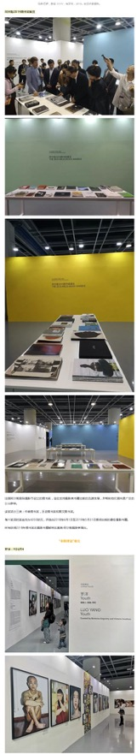
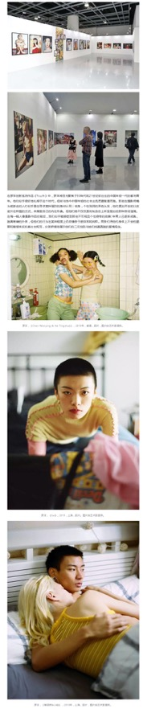
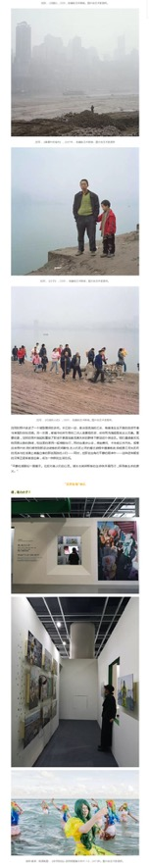
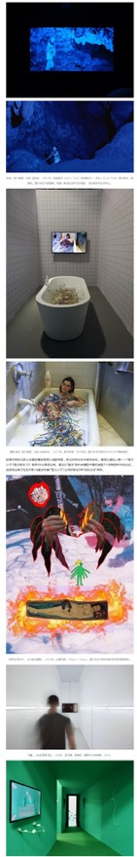
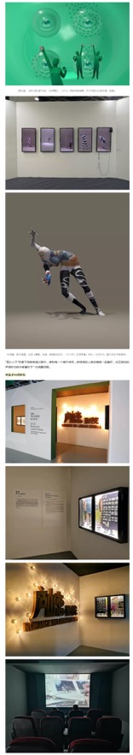
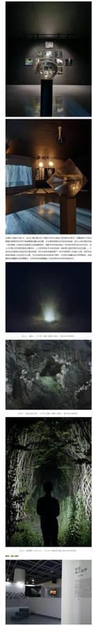
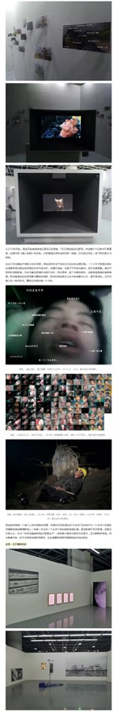
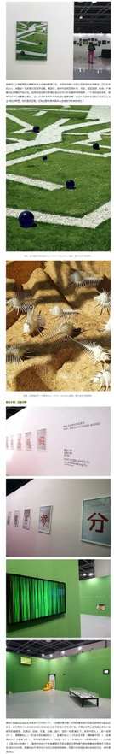
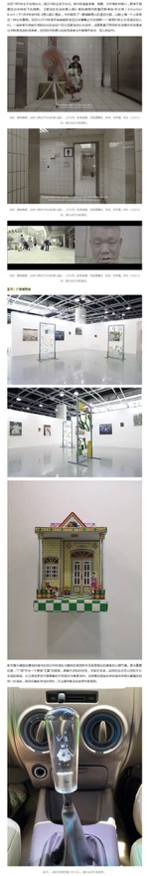
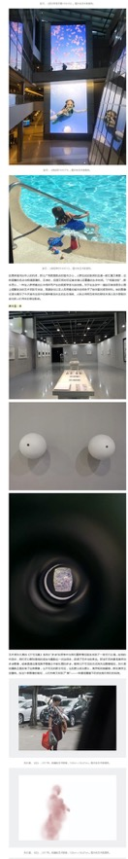
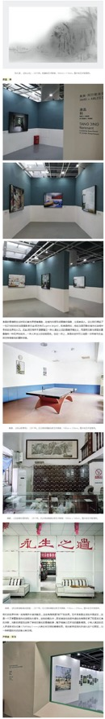
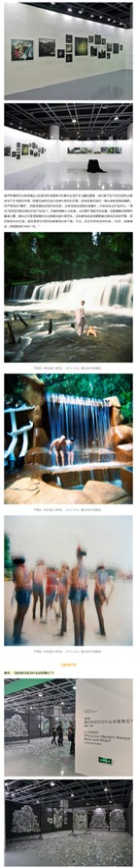
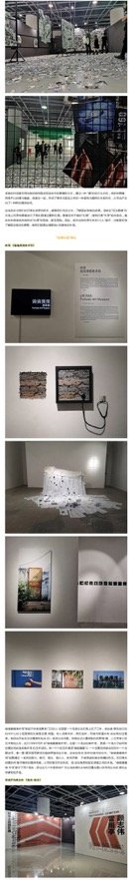
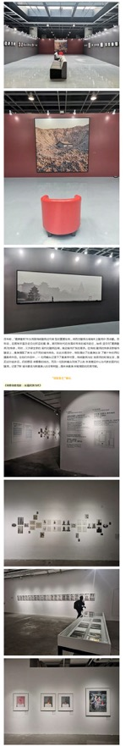
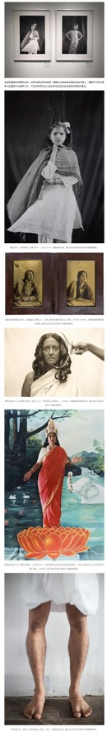
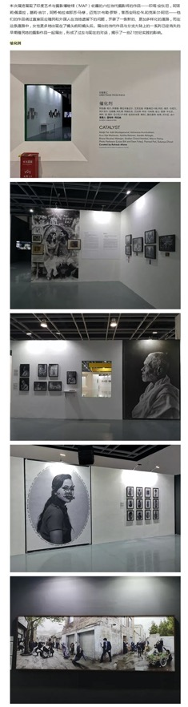
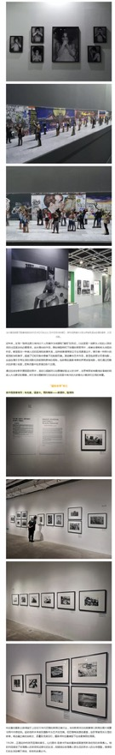
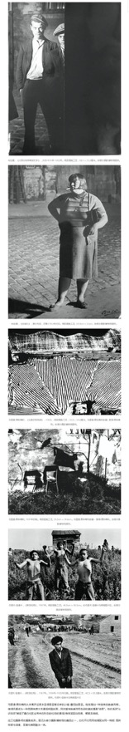

Publication : | WeChat/微信-法国之光葡萄酒
Circulation : | 121
Date : | 2019-11-23
Page : | 0
Headline : | Lumière de France assists 2019 Jimei x Arles International Photo Festival
 | 法国之光助力2019第5届集美阿尔勒国际摄影季
Ad Value : | 278
PV : | 121
Summary : | Jimei x Arles International Photo Festival welcomed its 5th year in China. This year's festival officially kicked off on November 22. Lumière de France assisted the festival and provided wines.
Link : | https://mp.weixin.qq.com/s/HUS4ttVFnN56MkIZKoflHA

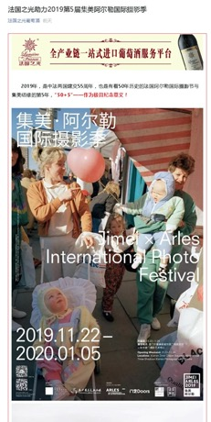
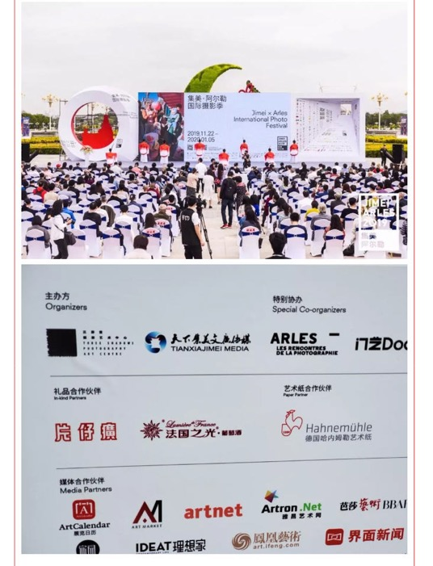
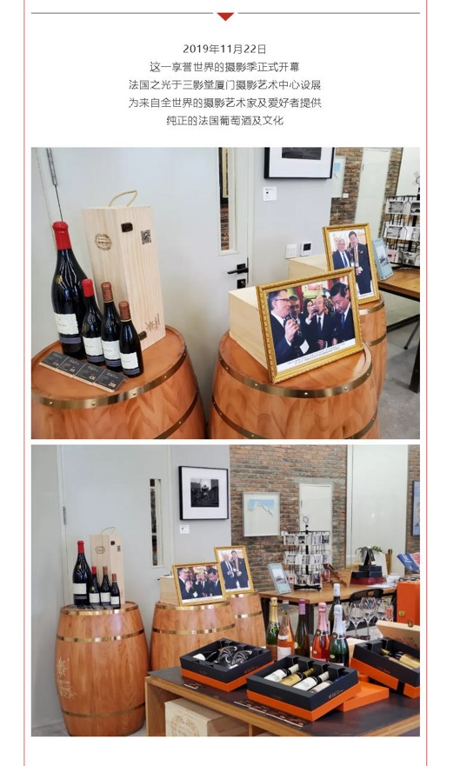
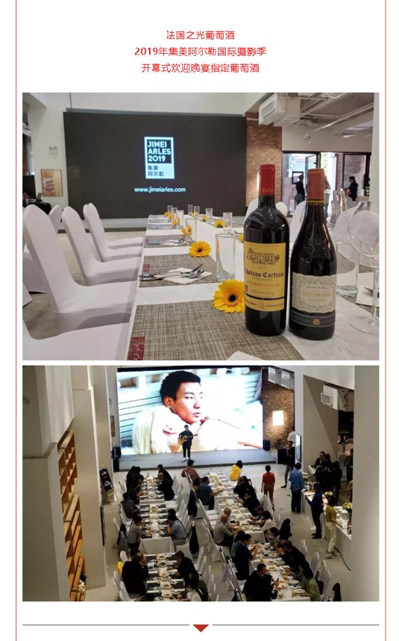
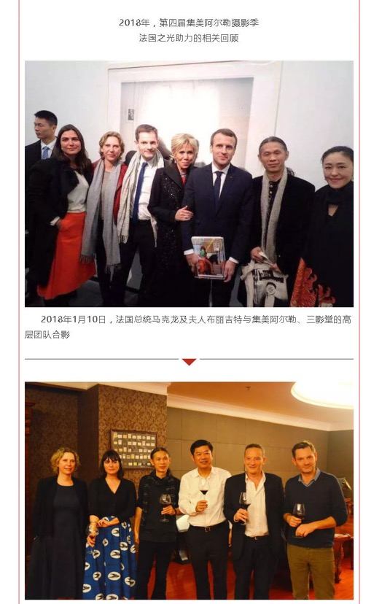
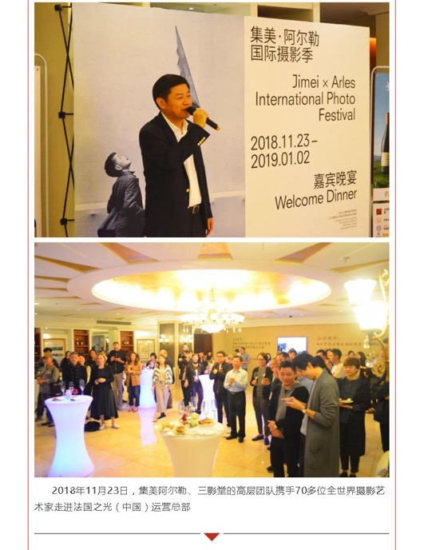
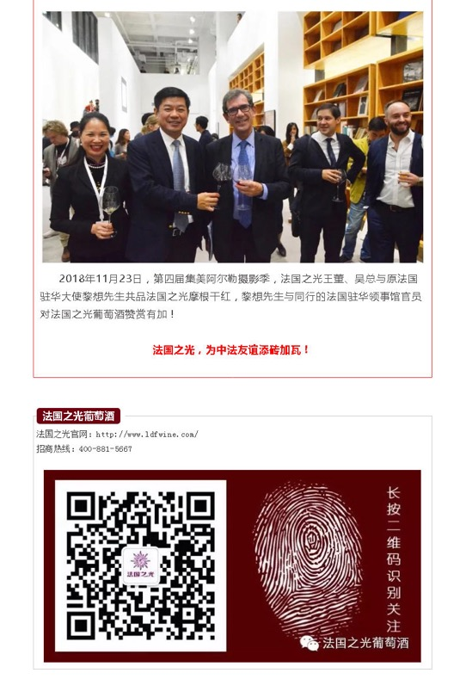

Publication : | WeChat/微信-中摄协影像中文网
Circulation : | 339
Date : | 2019-11-24
Page : | 0
Headline : | The 5th Jimei x Arles International Photo Festival kicks off
 | 2019集美阿尔勒国际摄影季盛大开幕！
Ad Value : | 780
PV : | 339
Summary : | The 5th Jimei x Arles International Photo Festival kicked off in Xiamen on November 22, 2019 and will last till January 5, 2020. It will include 30 exhibitions, which will display over 2,200 artworks by 55 world artists.
Link : | https://mp.weixin.qq.com/s/dEnufT6keJ-O22OHociMLg

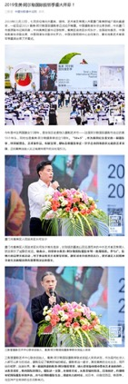
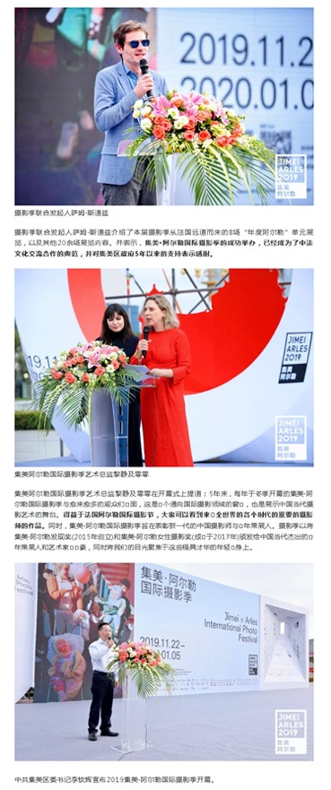
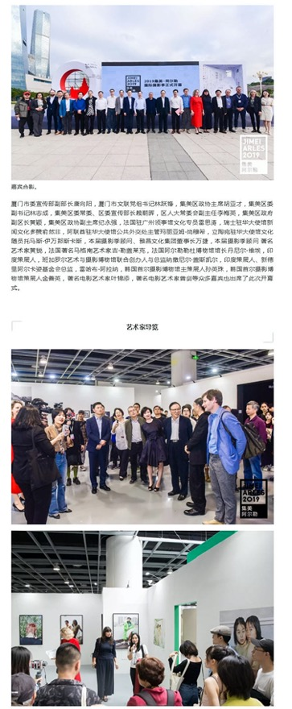
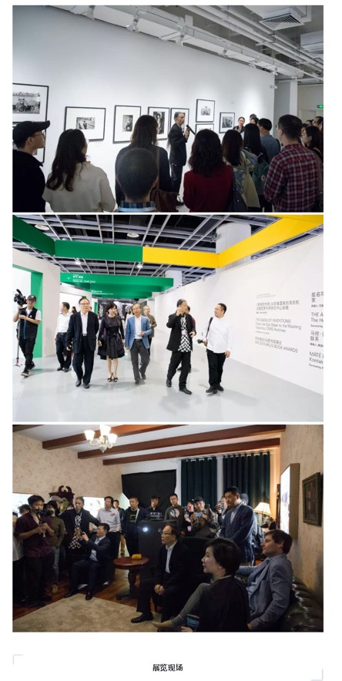
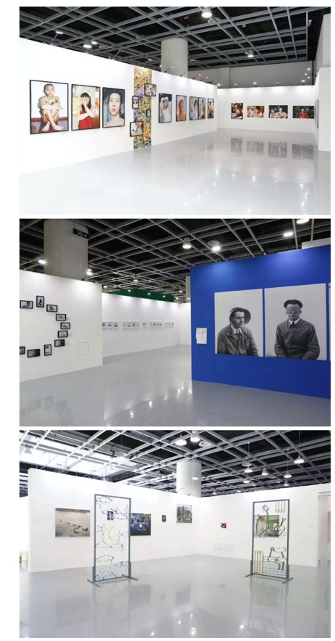
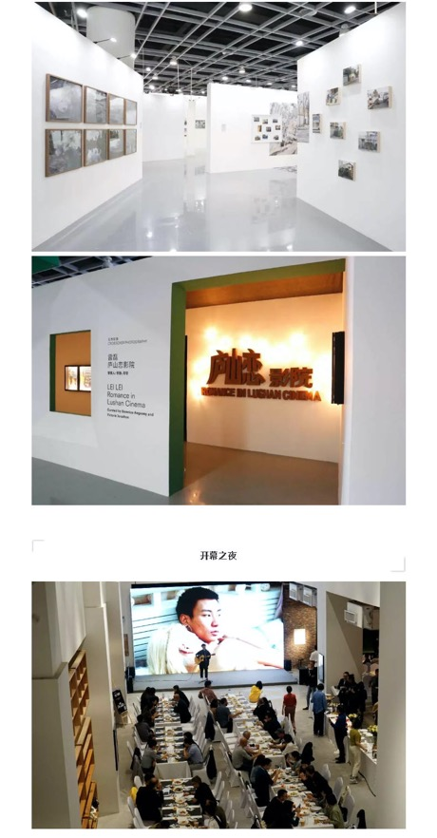
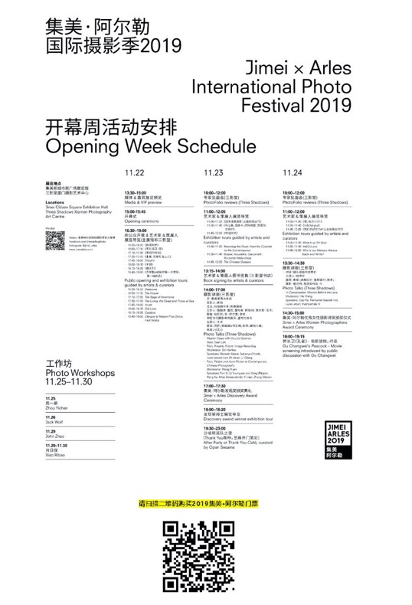

Publication : | WeChat/微信-中摄协影像中文网
Circulation : | 166
Date : | 2019-11-24
Page : | 0
Headline : | Jimei x Arles Discovery Award 2019 unveiled
 | 2019集美阿尔勒发现奖授予青年艺术家易连
Ad Value : | 382
PV : | 166
Summary : | Jimei x Arles Discovery Award 2019 was unveiled in Three Shadows Xiamen Photography Art Centre in the afternoon of November 23. Artist Yilian received the award for his work "Ask for the Moon", marking the fifth year of winning this award. He was granted with 200,000 yuan's scholarship and will display his work at Rencontres d'Arles 2020.
Link : | https://mp.weixin.qq.com/s/xDRd7oLuqAsGXyRwY00w0w

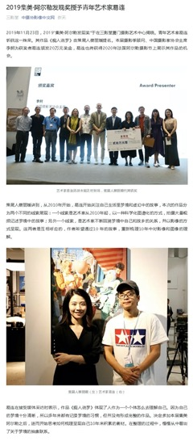
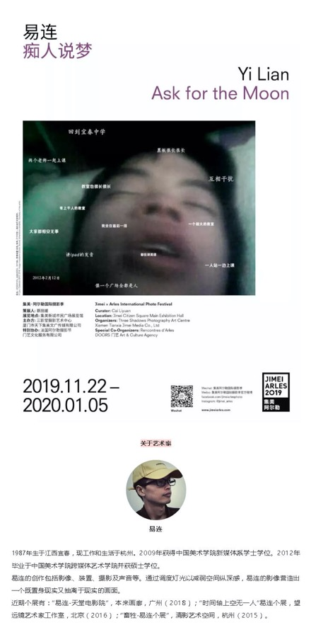
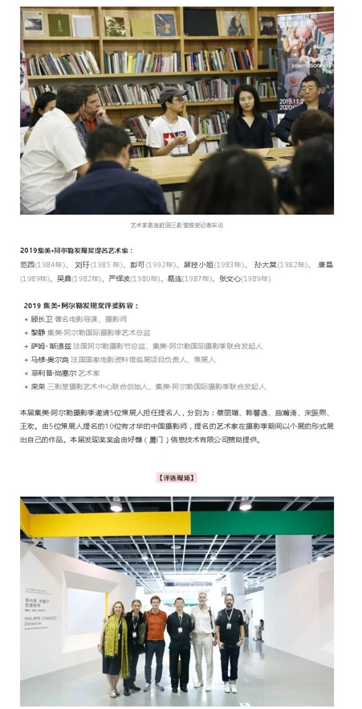
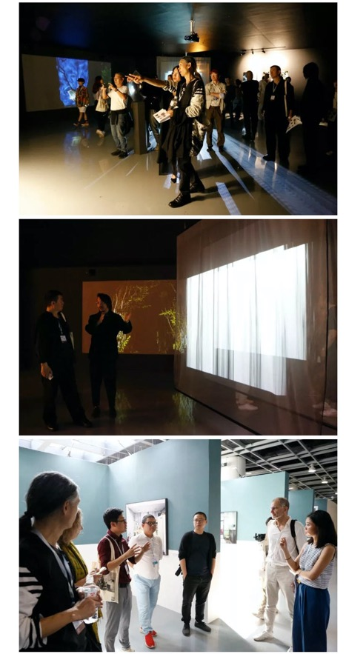

Publication : | WeChat/微信-中摄协影像中文网
Circulation : | 113
Date : | 2019-11-24
Page : | 0
Headline : | Jimei x Arles Women Photo Award 2019 unveiled
 | 2019集美•阿尔勒优秀女性摄影师奖授予艺术家罗洋
Ad Value : | 260
PV : | 113
Summary : | Jimei x Arles Women Photo Award 2019 will be unveiled in Three Shadows Xiamen Photography Art Centre in the afternoon of November 24. Artist Luo Yang received the award for his work "Youth". Artists Cao Fei and actress Mei Ting jointly granted 50,000 yuan's scholarship bonus to Luo Yang. Besides, Luo Yang also got the chance to display his work at Rencontres d'Arles 2020.
Link : | https://mp.weixin.qq.com/s/fMa1UdWWpA8IW2qUizGOwQ

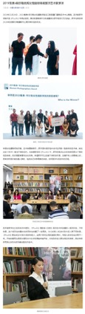
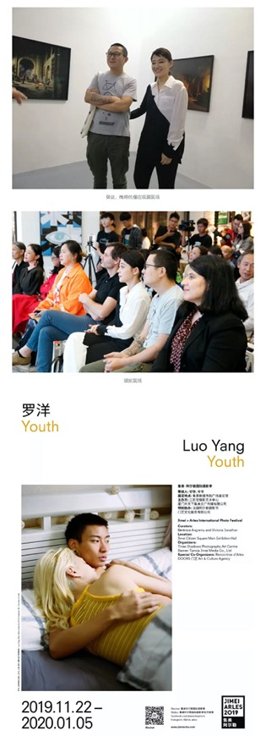
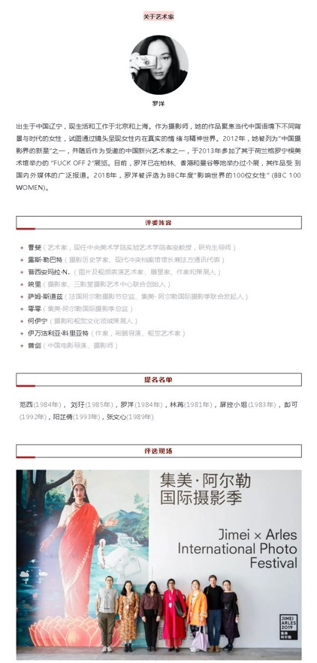
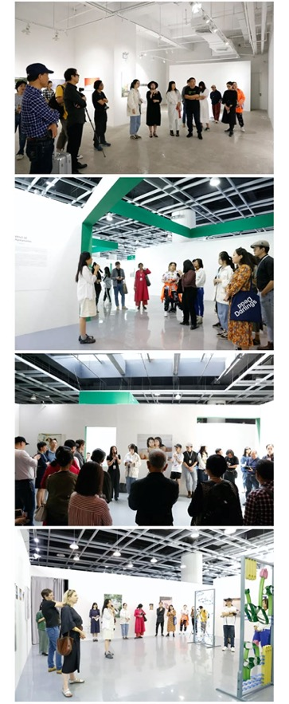
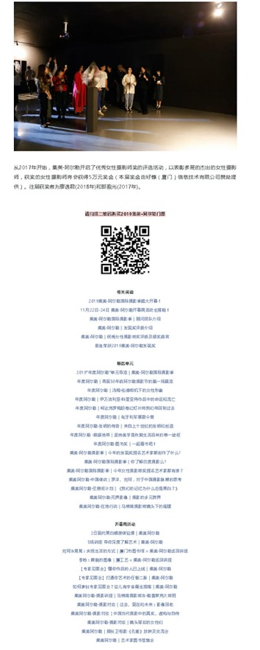

Publication : | WeChat/微信-凤凰艺术
Circulation : | 1,999
Date : | 2019-11-24
Page : | 0
Headline : | 2019 Jimei x Arles International Photo Festival hits hot search list
 | 凤凰艺术｜金鸡百花电影节厦门刚闭幕，集美阿尔勒摄影季又上热搜
Ad Value : | 4,598
PV : | 1,999
Summary : | 2019 Jimei x Arles International Photo Festival unveiled in Xiamen on November 22. This year's Jimei x Arles Discovery Award and Jimei x Arles Women Photo Award were respectively awarded by artists Yi Lian and Luo Yang.
Link : | https://mp.weixin.qq.com/s/rmenPkcl2QQLUetghZ41uQ

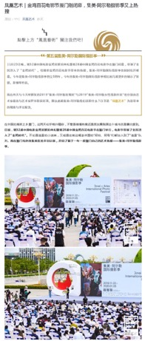
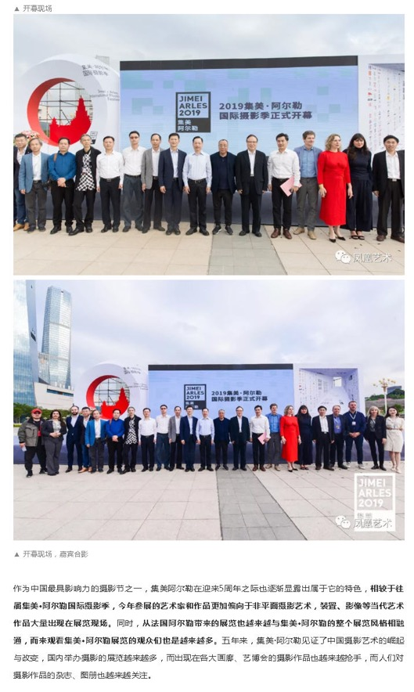
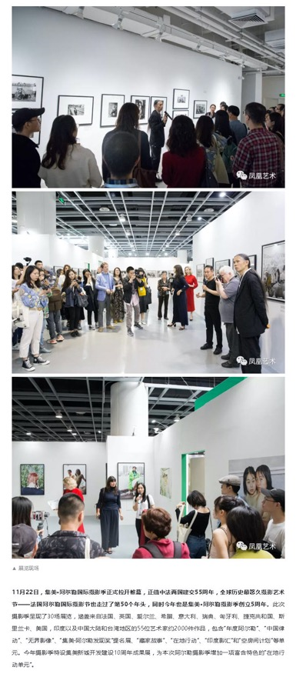
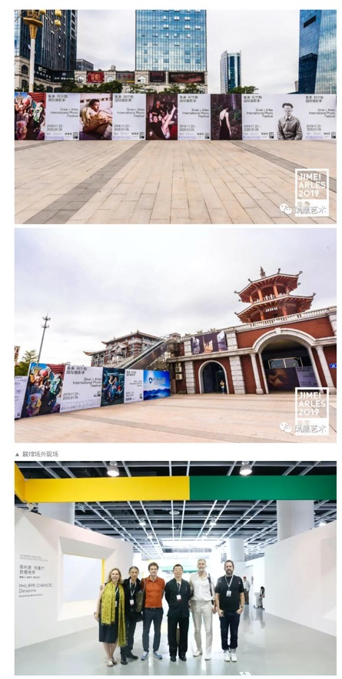
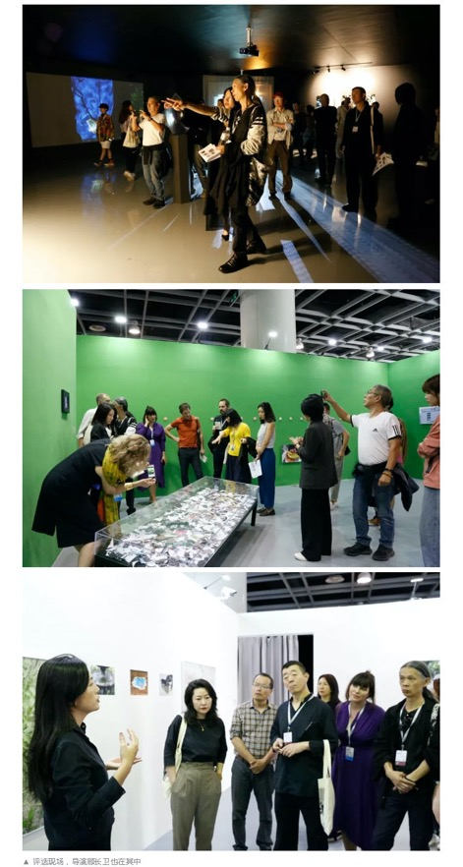
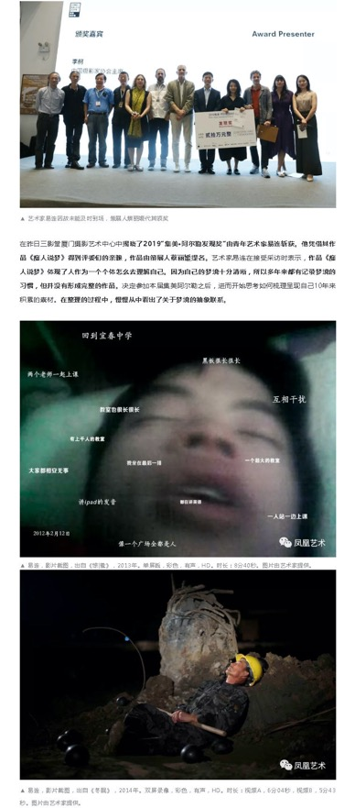
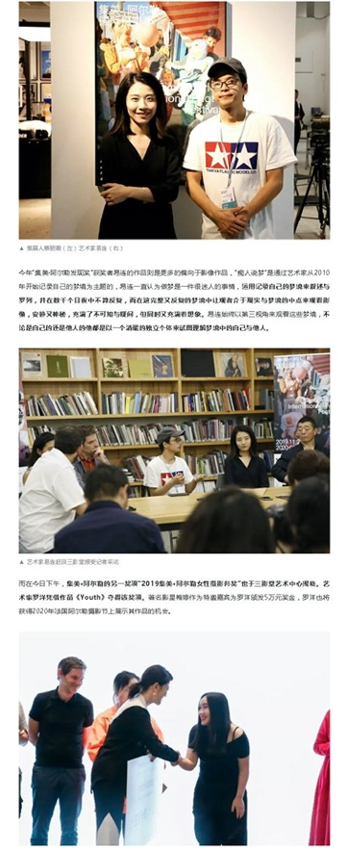
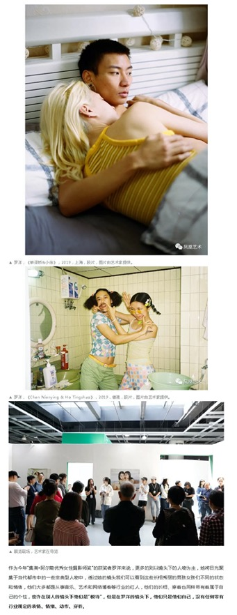
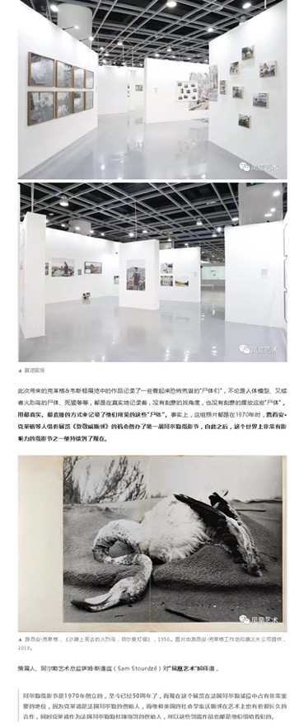
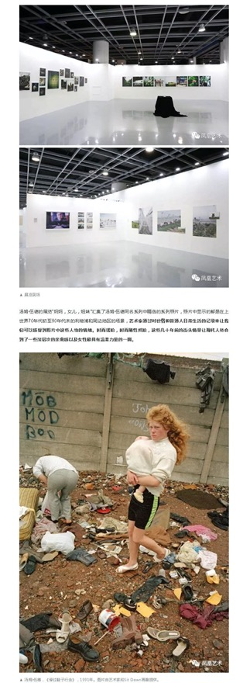
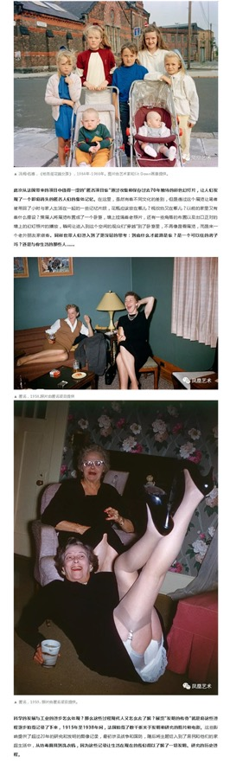
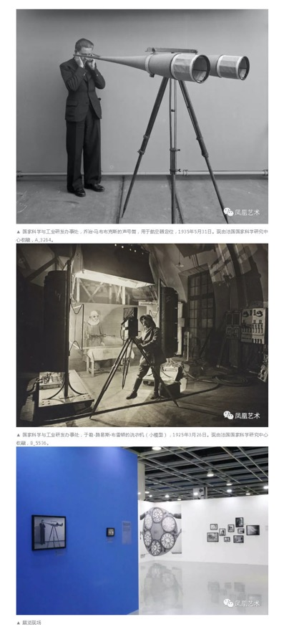
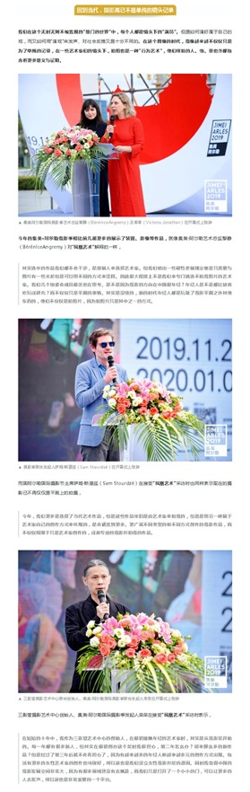
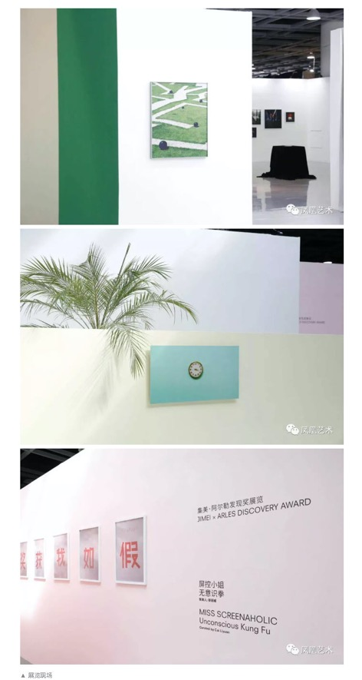

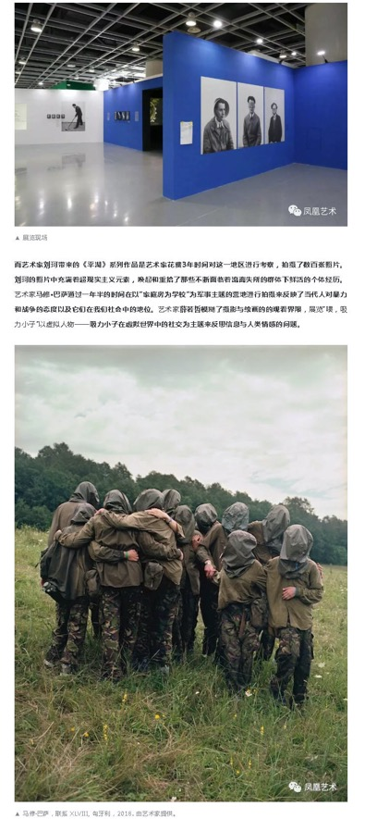

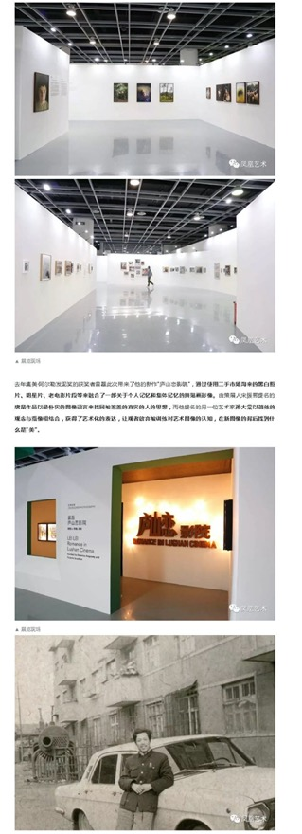
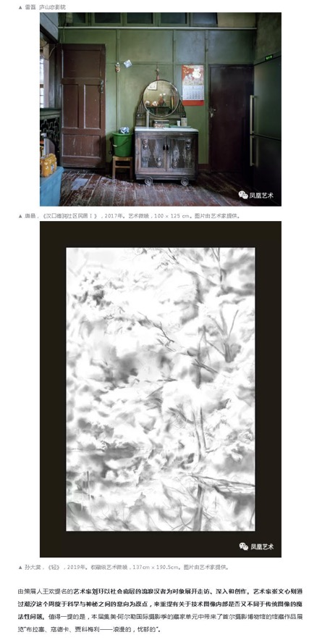

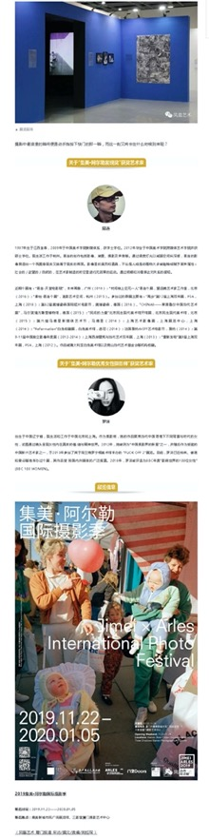

Publication : | WeChat/微信-厦门日报
Circulation : | 7,016
Date : | 2019-11-25
Page : | 0
Headline : | 2019 Jimei x Arles International Photo Festival kicks off
 | 【有福利】顾长卫、梅婷都来了！这场法国总统盛赞的光影盛会再度来厦！精彩不容错过
Ad Value : | 16,137
PV : | 7,016
Summary : | 2019 Jimei x Arles International Photo Festival kicked off in Xiamen on November 22 and will last till January 5, 2020. It will include 30 exhibitions, which display over 2,200 artworks by 55 artists. In addition, Jimei x Arles Discovery Award and Women Photo Award 2019 were unveiled, with artists Yi Lian and Luo Yang winning the award respectively for translation of "Ask for the Moon" and "Youth". Actress Mei Ting granted the award for Luo Yang.
Link : | https://mp.weixin.qq.com/s/1d2yq8_hNVLnCWgfadReVw

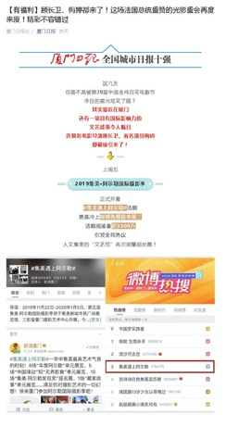
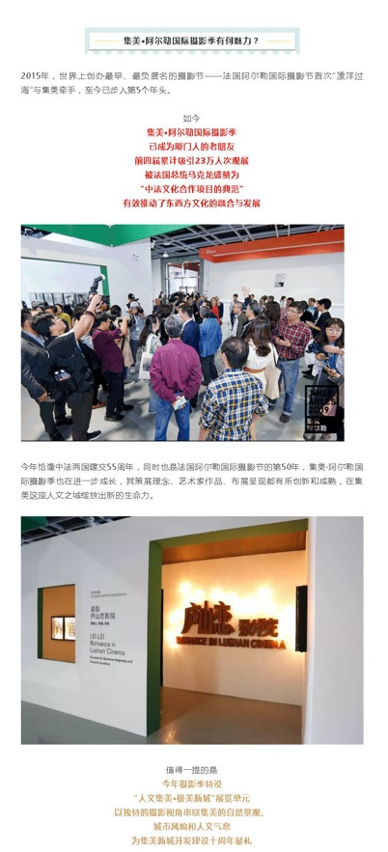
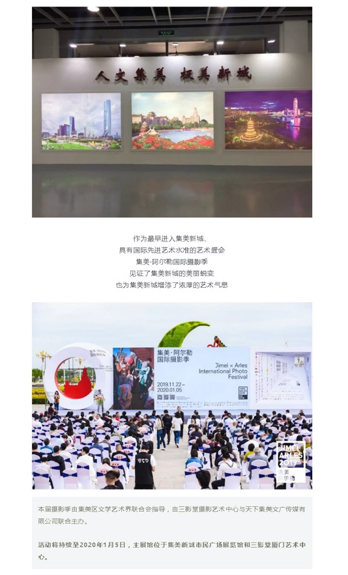
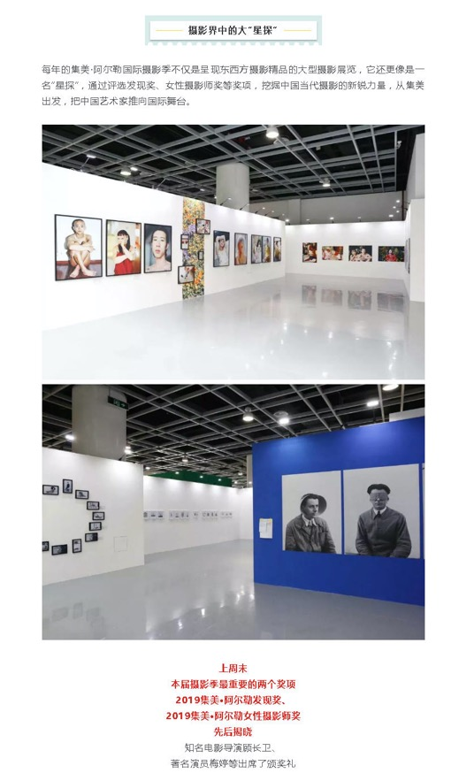
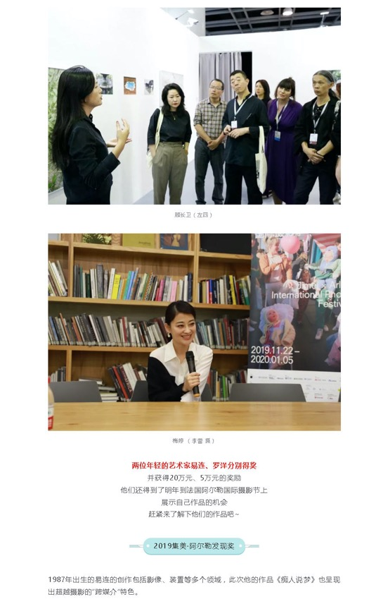
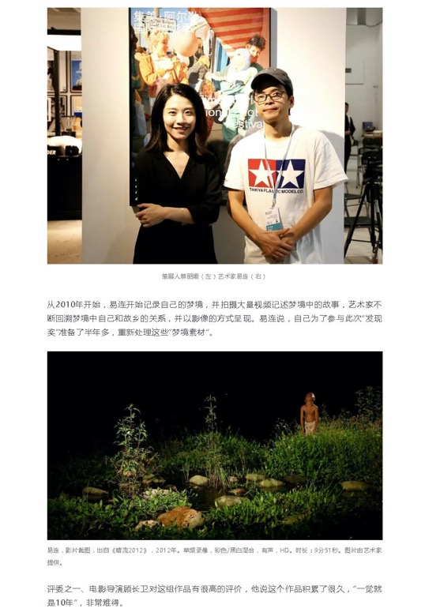
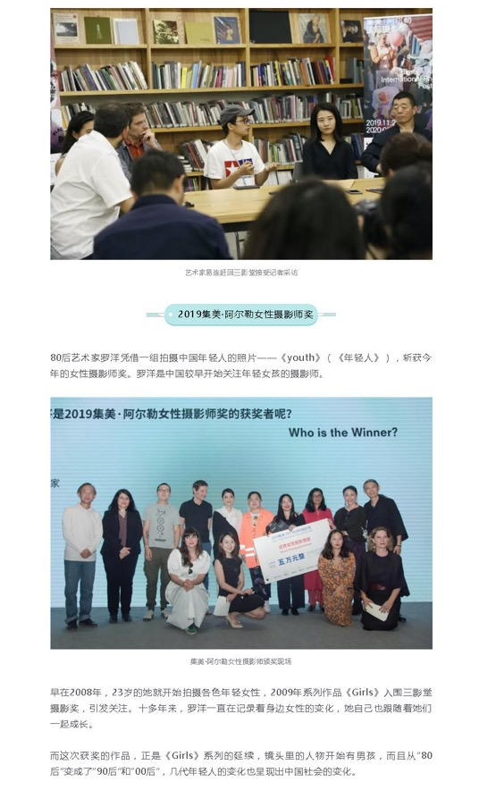
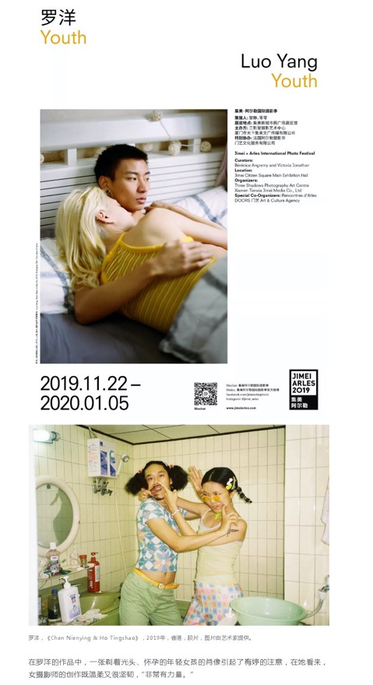
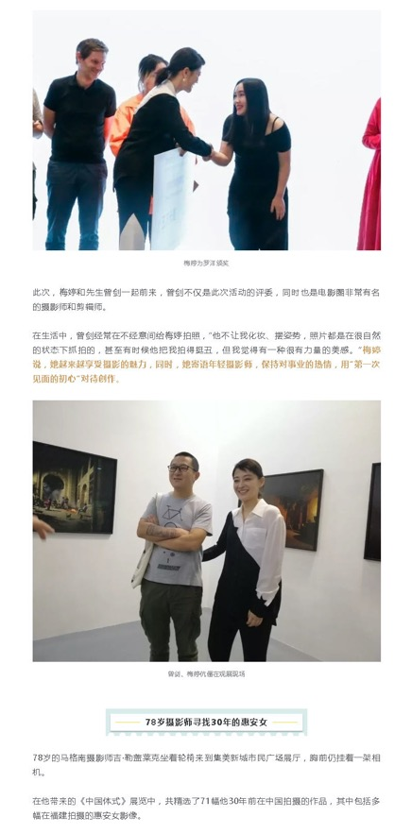
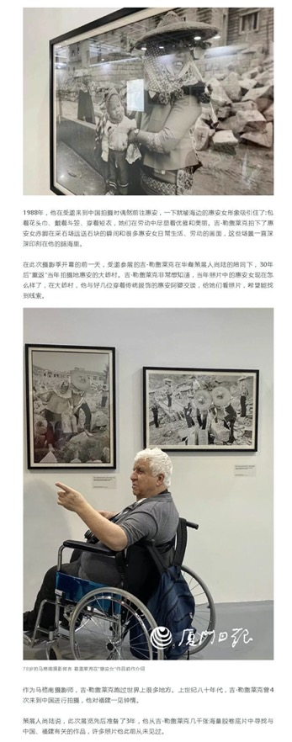
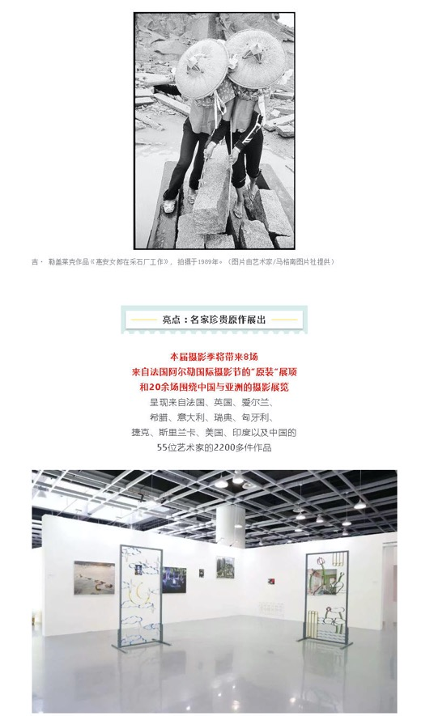
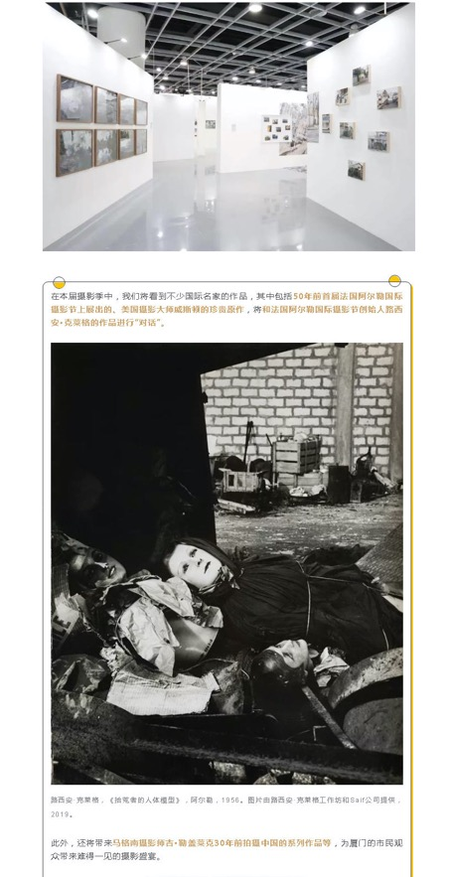

Publication : | WeChat/微信-东南早报
Circulation : | 14,696
Date : | 2019-11-25
Page : | 0
Headline : | 2019 Jimei x Arles International Photo Festival kicks off
 | 梅婷现身！距泉州仅1小时车程，这场盛会太热闹了！冲进微博热搜前三！
Ad Value : | 33,801
PV : | 14,696
Summary : | 2019 Jimei x Arles International Photo Festival kicked off in Xiamen on November 22 and will last till January 5, 2020. It will include 30 exhibitions, which display over 2,200 artworks by 55 artists. In addition, Jimei x Arles Discovery Award and Women Photo Award 2019 were unveiled, with artists Yi Lian and Luo Yang winning the award respectively for translation of "Ask for the Moon" and "Youth". Actress Mei Ting granted the award for Luo Yang.
Link : | https://mp.weixin.qq.com/s/a_YUhUcn1eSknzEiBkQj9A

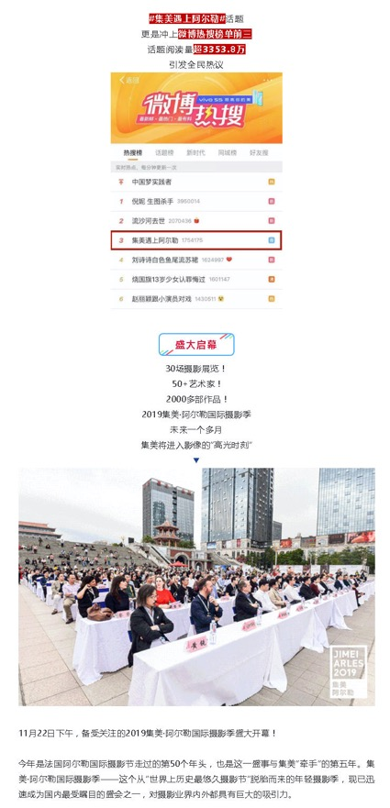
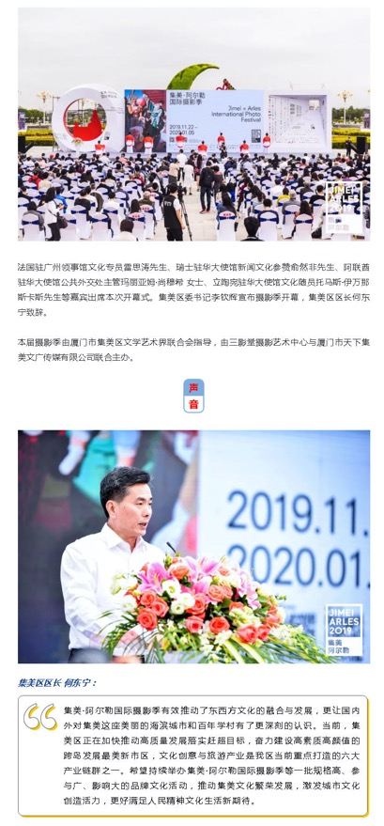
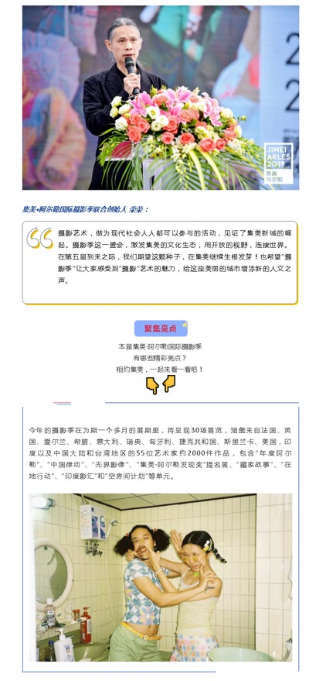
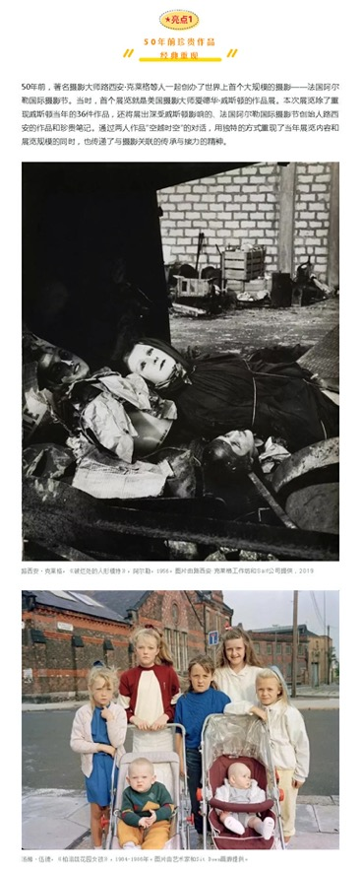
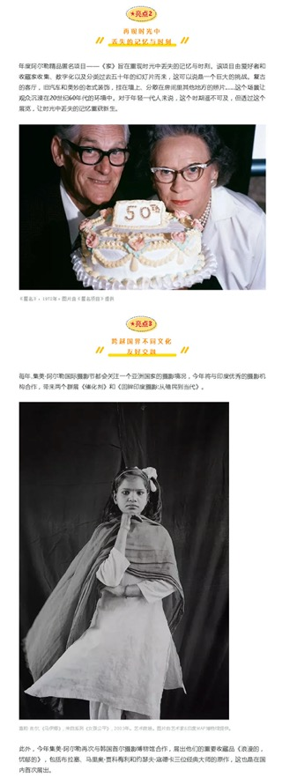
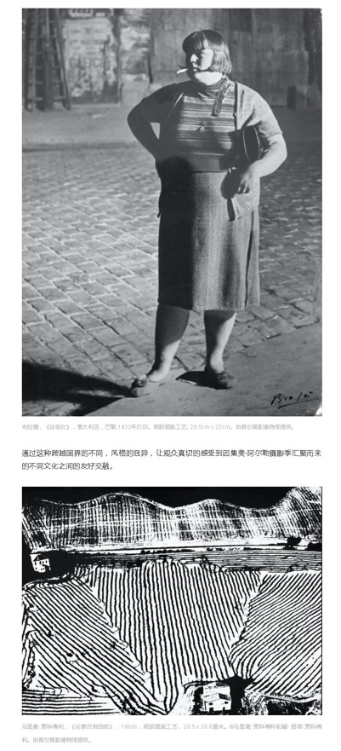
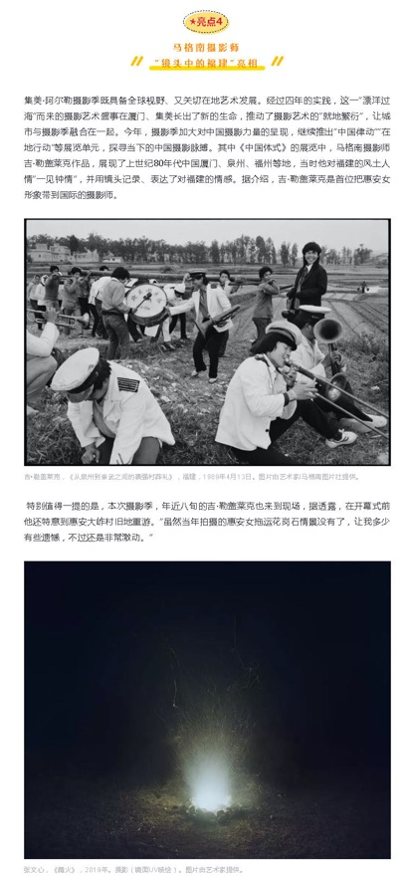
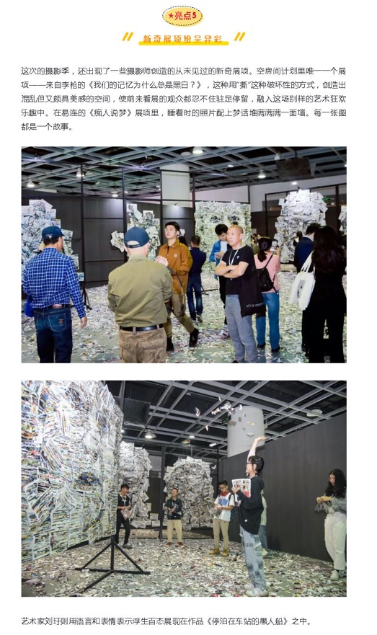
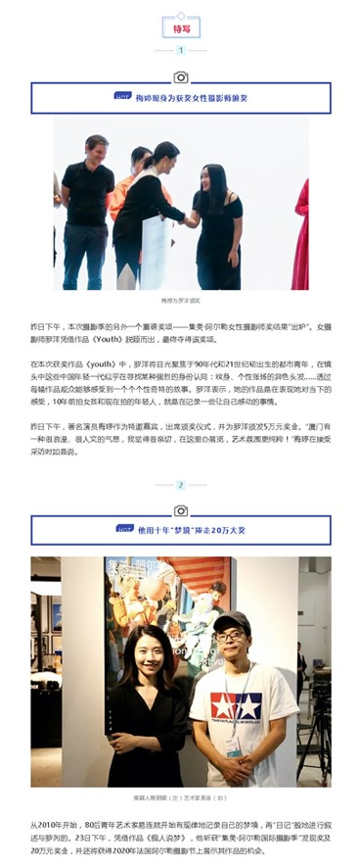
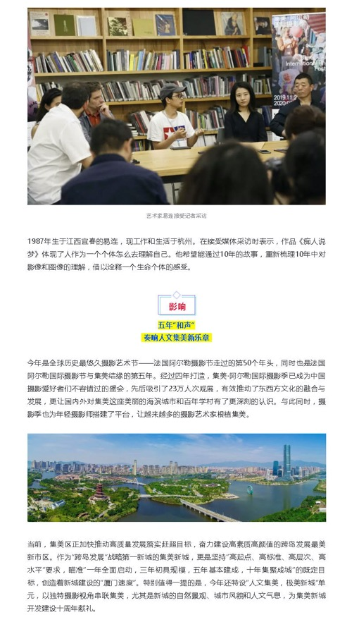
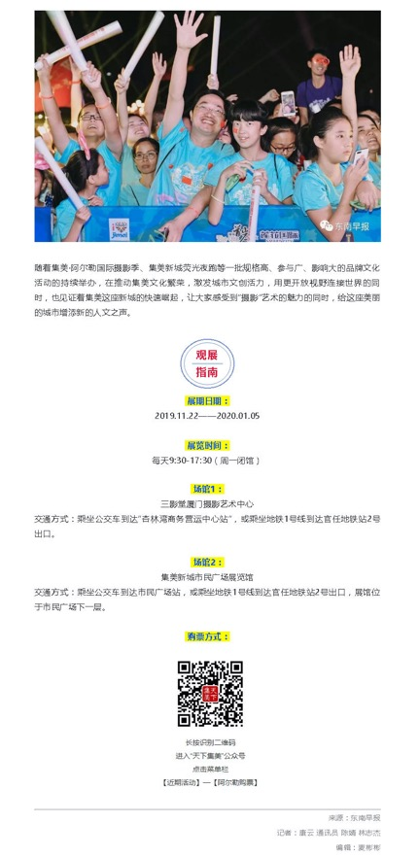

Publication : | WeChat/微信-雅昌艺术网
Circulation : | 1,832
Date : | 2019-11-25
Page : | 0
Headline : | 2019 Jimei x Arles International Photo Festival kicks off
 | 艺术播报 | “24亿作品失踪”新进展、红专厂关闭、常玉新纪录、阿尔勒摄影节、贺丹沈勤个展，写实画派十五年、楼兰原创展将启
Ad Value : | 4,214
PV : | 1,832
Summary : | 2019 Jimei x Arles International Photo Festival kicked off in Xiamen on November 22 and will last till January 5, 2020. It will include 30 exhibitions, which display over 2,200 artworks by 55 artists.
Link : | https://mp.weixin.qq.com/s/_vv9nP9ynK0Fz30vNQZqbw

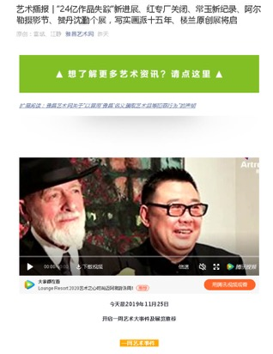
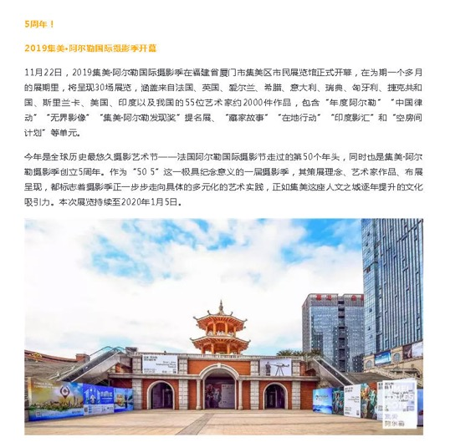

Publication : | WeChat/微信-Yes厦门
Circulation : | 11,761
Date : | 2019-11-25
Page : | 0
Headline : | 2019 Jimei x Arles International Photo Festival kicks off
 | 火爆全国！集美又一大盛事秒上热搜，演员梅婷也来啦！
Ad Value : | 27,050
PV : | 11,761
Summary : | 2019 Jimei x Arles International Photo Festival kicked off in Xiamen on November 22 and will last till January 5, 2020. In addition, Jimei x Arles Discovery Award and Women Photo Award 2019 were unveiled, with artists Yi Lian and Luo Yang winning the award respectively for translation of "Ask for the Moon" and "Youth". Actress Mei Ting granted the award for Luo Yang.
Link : | https://mp.weixin.qq.com/s/PF5yz-E4KUy_molujaDbNQ

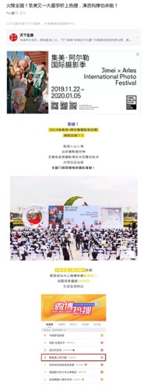
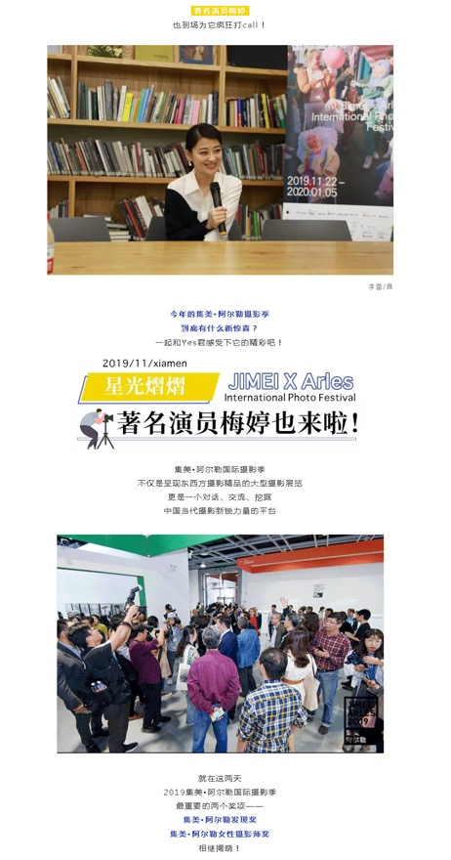
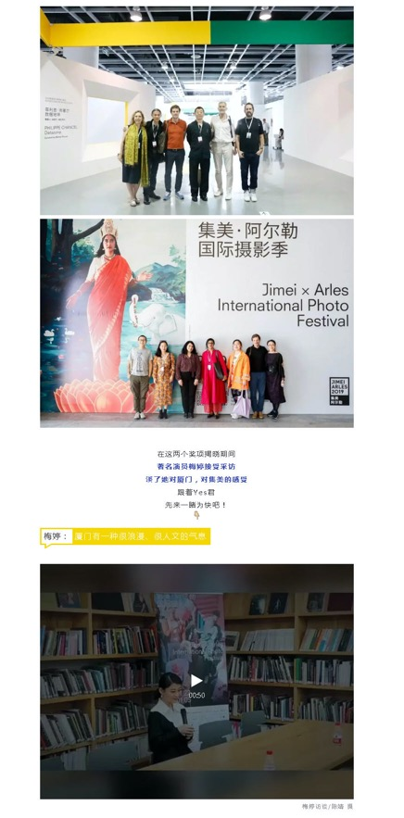
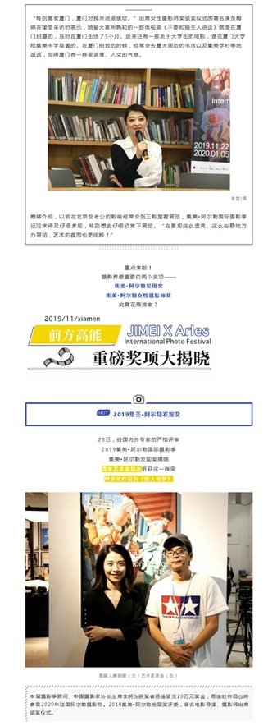
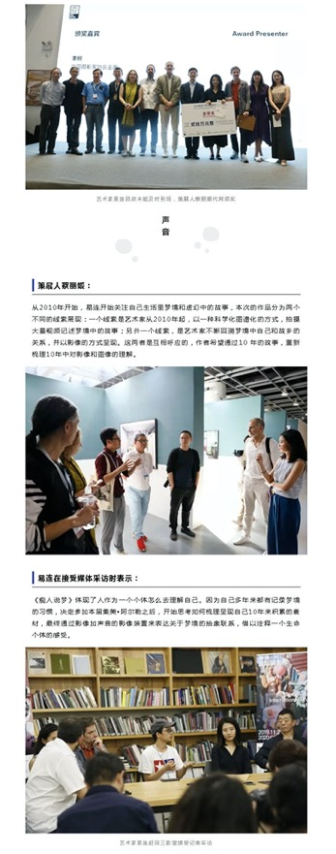
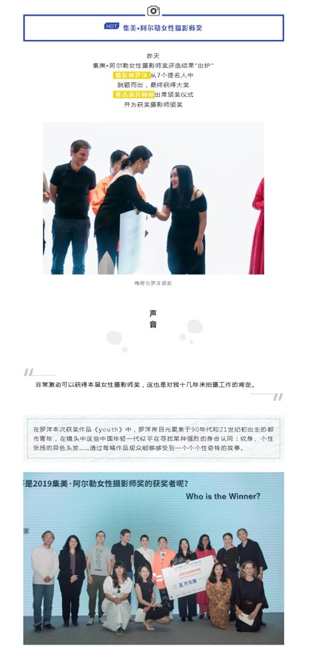
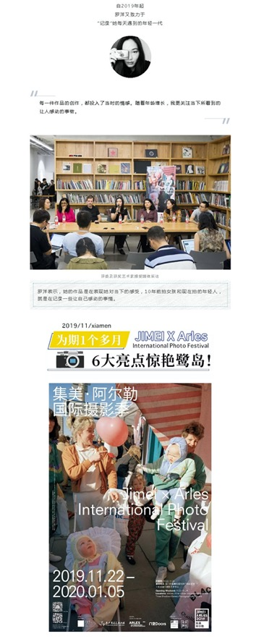
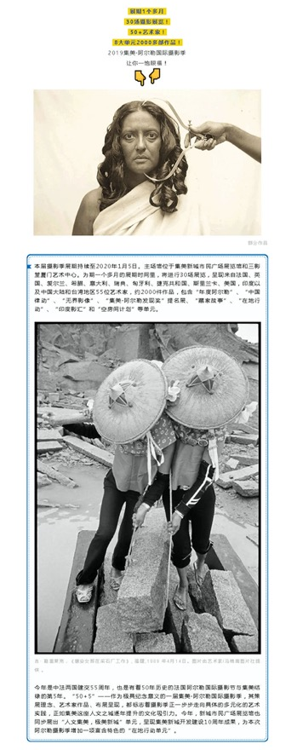
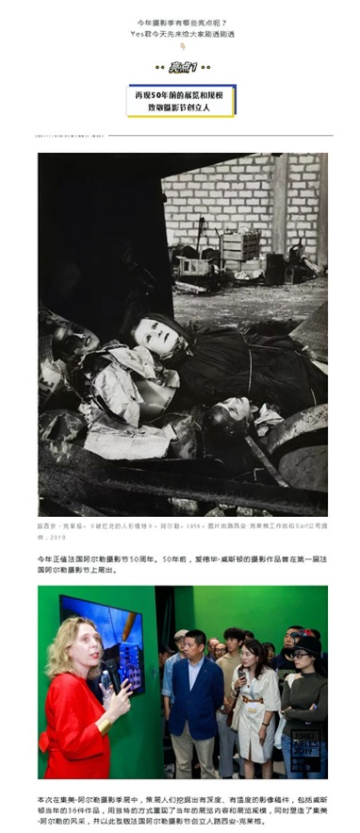
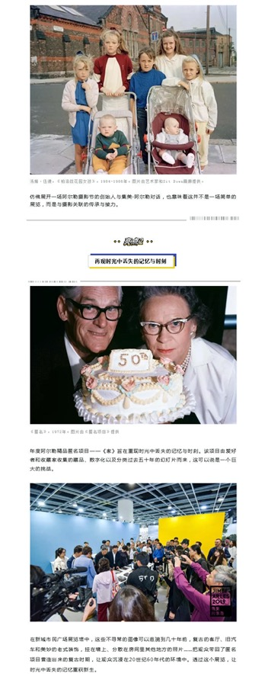
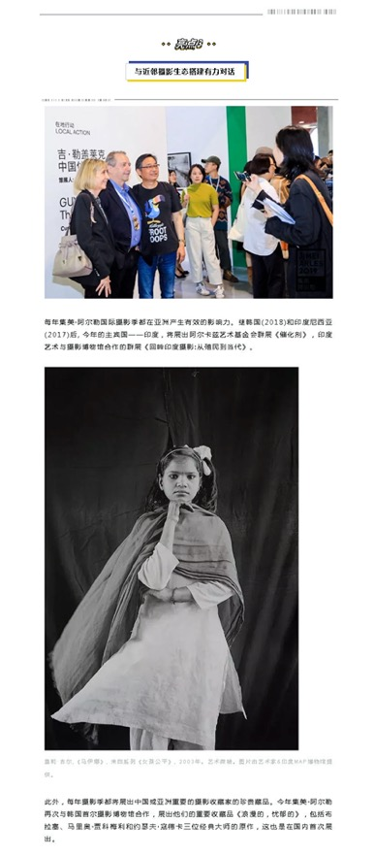
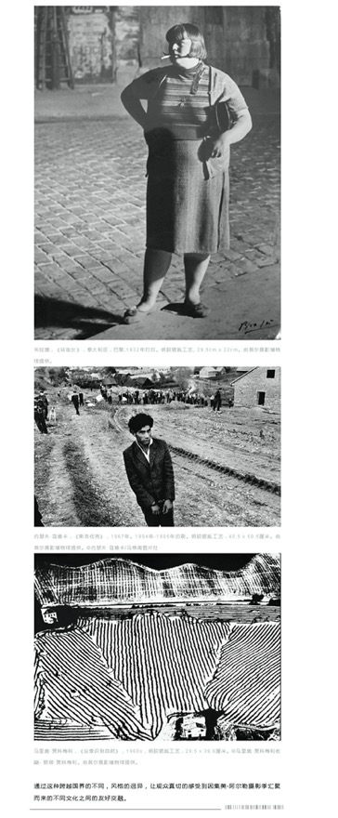
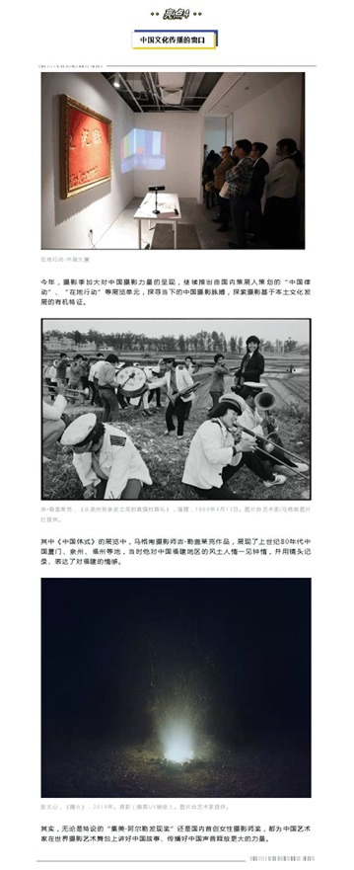
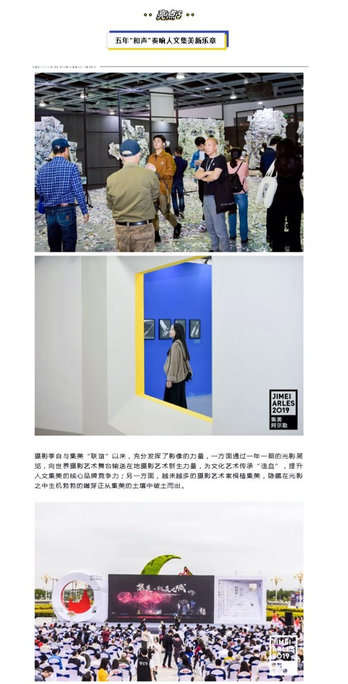
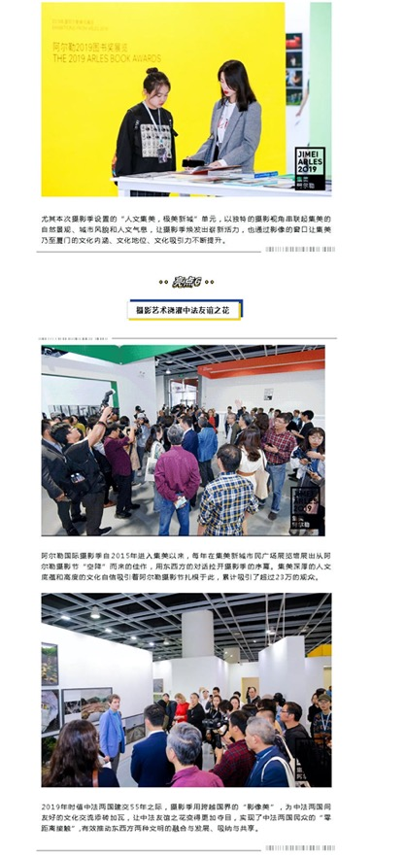
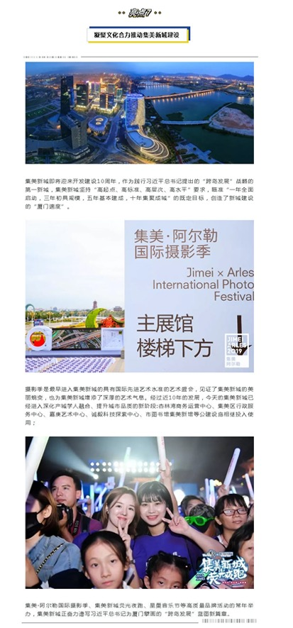

Publication : | WeChat/微信-中国摄影家协会网
Circulation : | 622
Date : | 2019-11-25
Page : | 0
Headline : | 2019 Jimei x Arles International Photo Festival kicks off
 | 2019集美阿尔勒国际摄影季开幕 易连荣、罗洋荣获奖
Ad Value : | 1,431
PV : | 622
Summary : | 2019 Jimei x Arles International Photo Festival kicked off in Xiamen on November 22 and will last till January 5, 2020. In addition, Jimei x Arles Discovery Award and Women Photo Award 2019 were unveiled, with artists Yi Lian and Luo Yang winning the award respectively for translation of "Ask for the Moon" and "Youth". Actress Mei Ting granted the award for Luo Yang.
Link : | https://mp.weixin.qq.com/s/8HRqUBX-DeaLjVpvf2pNNQ

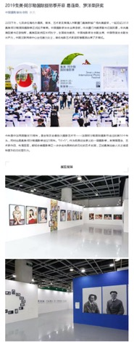
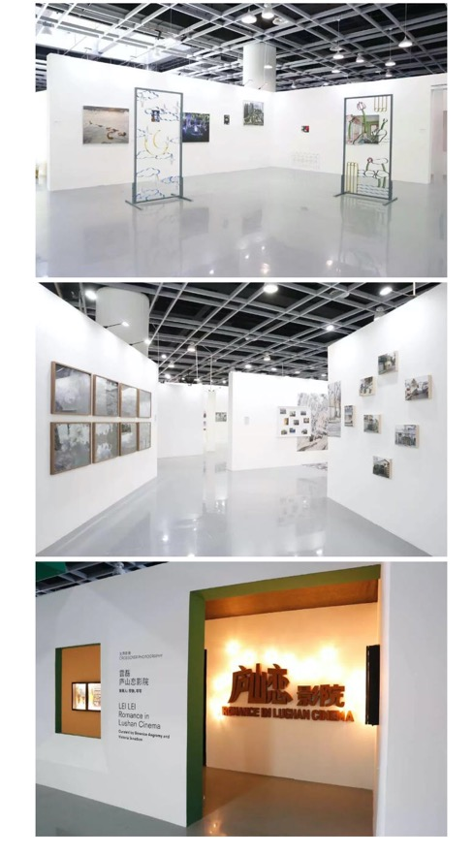
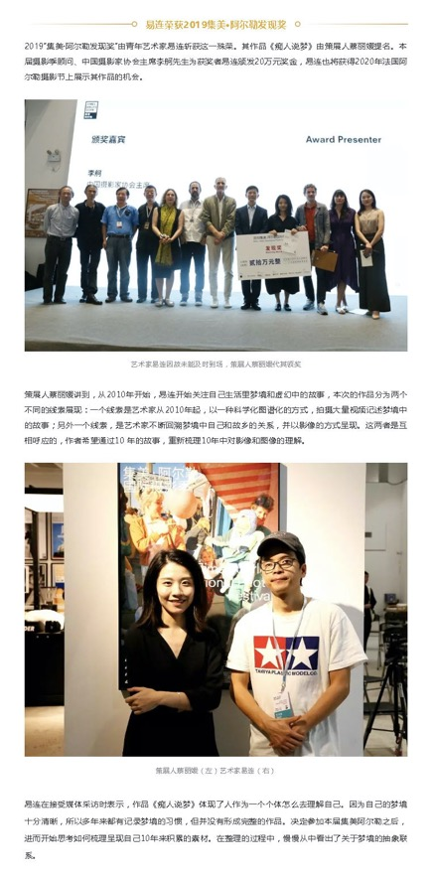
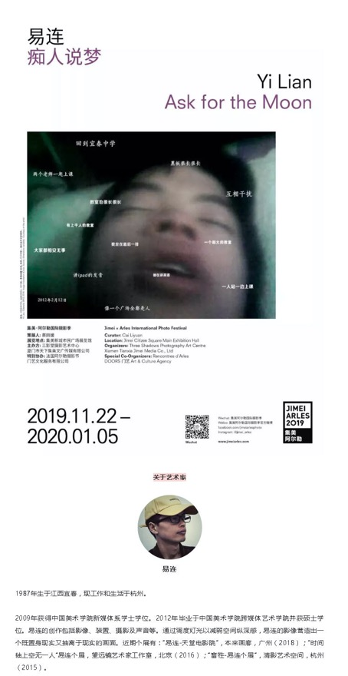
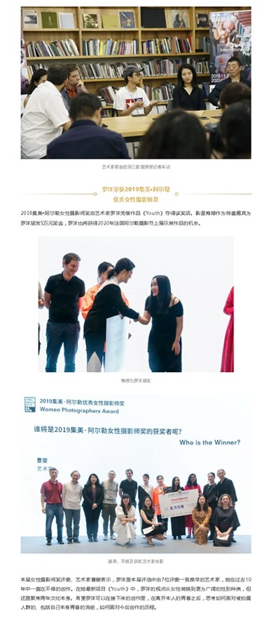
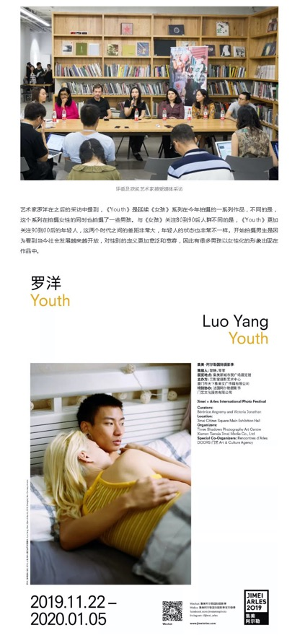
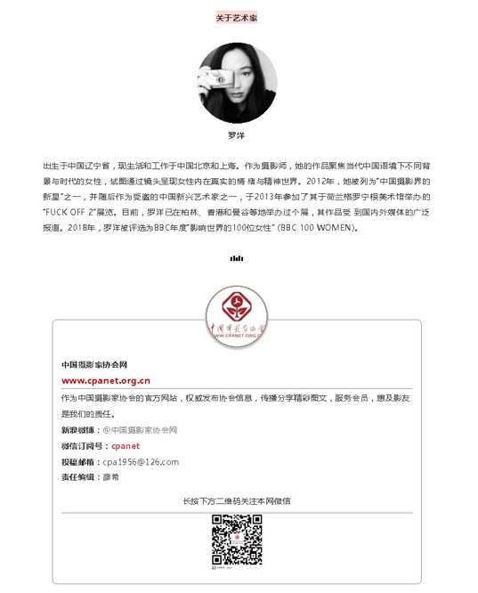

Publication : | WeChat/微信-海峡都市报
Circulation : | 3,594
Date : | 2019-11-25
Page : | 0
Headline : | 2019 Jimei x Arles International Photo Festival kicks off
 | 这场国际高规格艺术盛宴就在身边，还因此上了热搜……
Ad Value : | 8,266
PV : | 3,594
Summary : | 2019 Jimei x Arles International Photo Festival kicked off in Xiamen on November 22 and will last till January 5, 2020. It will include 30 exhibitions, which display over 2,200 artworks by 55 artists. In addition, Jimei x Arles Discovery Award and Women Photo Award 2019 were unveiled, with artists Yi Lian and Luo Yang winning the award respectively for translation of "Ask for the Moon" and "Youth". Actress Mei Ting granted the award for Luo Yang.
Link : | https://mp.weixin.qq.com/s/ceplcMweALbH6qJuSwrF4g

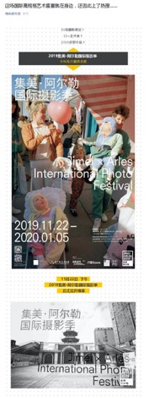
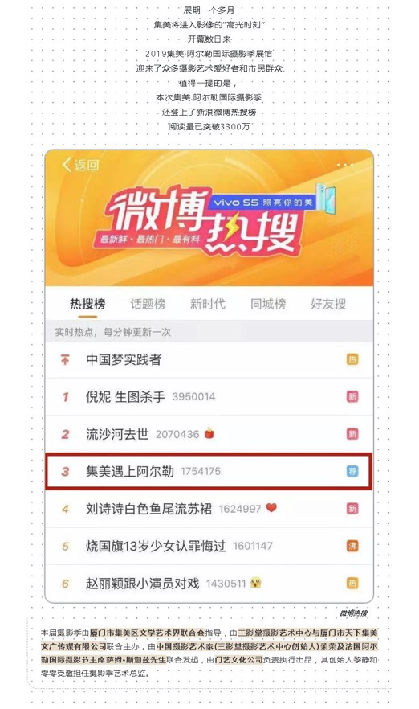
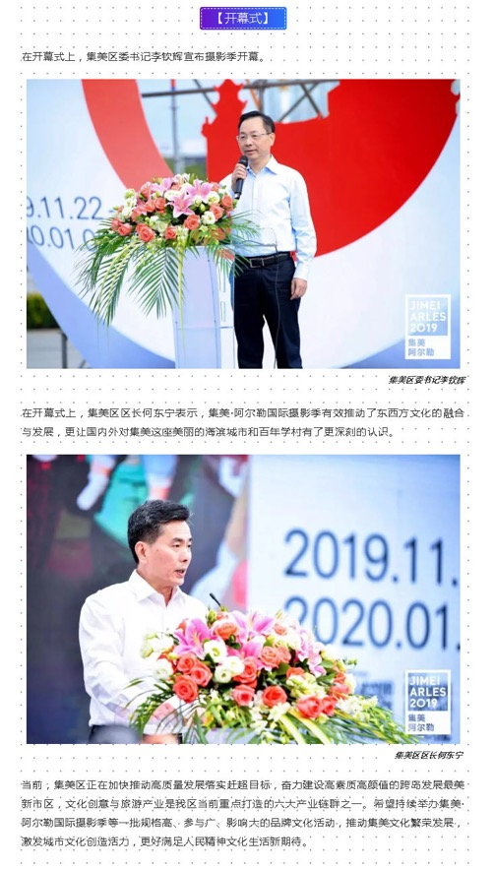
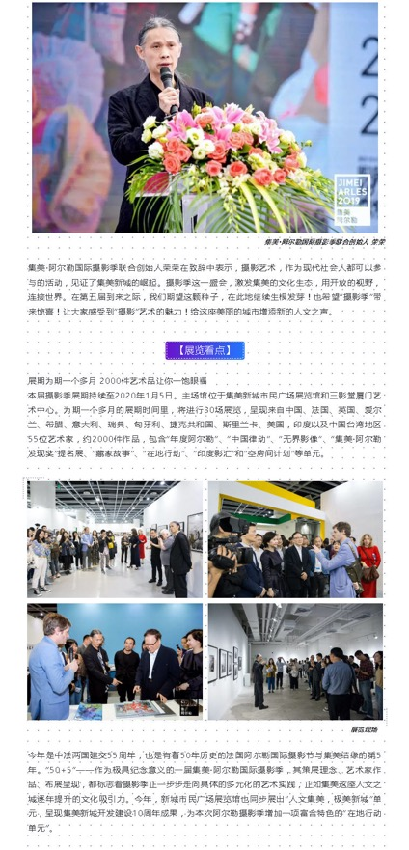
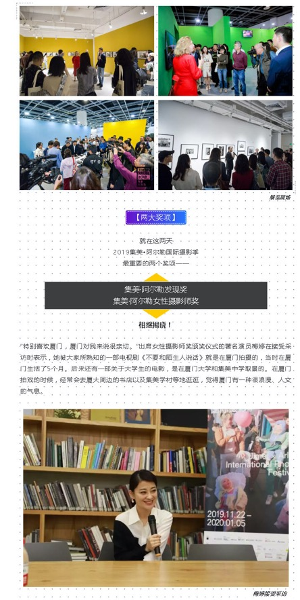
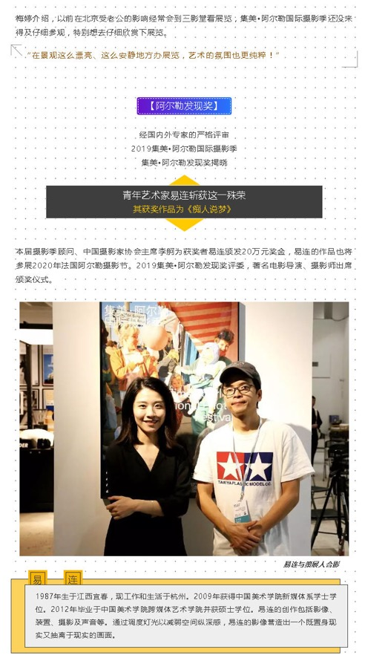
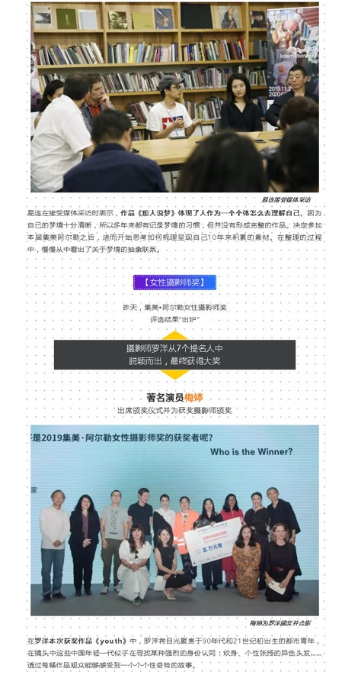
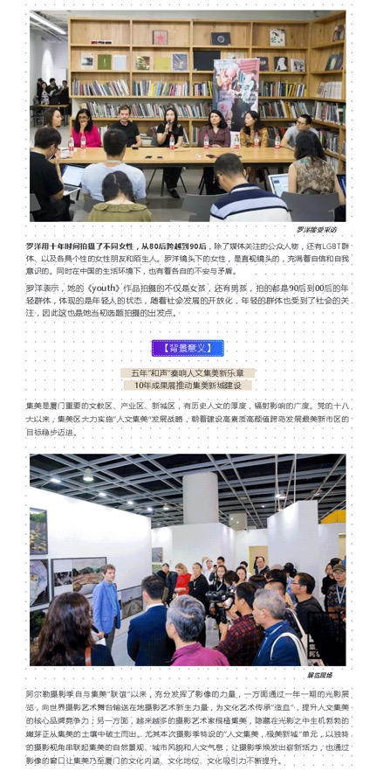
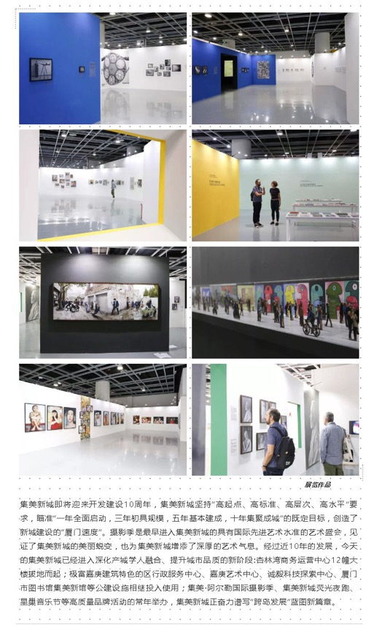

Publication : | WeChat/微信-scope艺术客
Circulation : | 155
Date : | 2019-11-25
Page : | 0
Headline : | 2019 Jimei x Arles International Photo Festival kicks off
 | Scope 艺术客 | 冬季到厦门来看展，2019集美阿尔勒的新发现
Ad Value : | 357
PV : | 155
Summary : | 2019 Jimei x Arles International Photo Festival kicked off in Xiamen on November 22 and will last till January 5, 2020. In addition, Jimei x Arles Discovery Award and Women Photo Award 2019 were unveiled, with artists Yi Lian and Luo Yang winning the award respectively for translation of "Ask for the Moon" and "Youth". Actress Mei Ting granted the award for Luo Yang.
Link : | https://mp.weixin.qq.com/s/wI3AC-8Qor86iZF_jhPSSQ

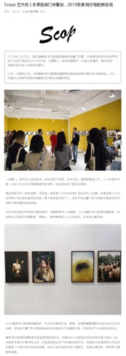
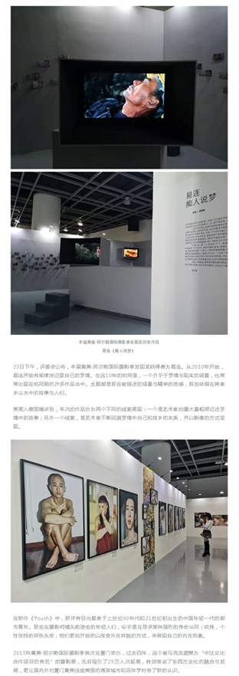
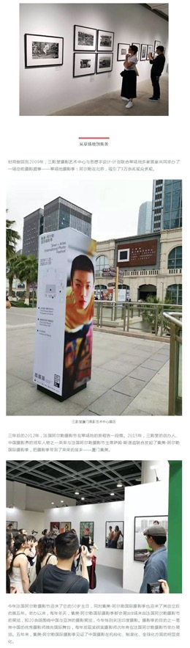
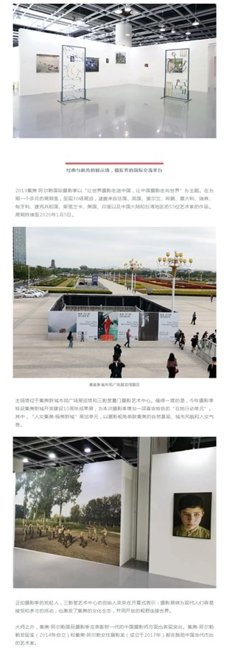
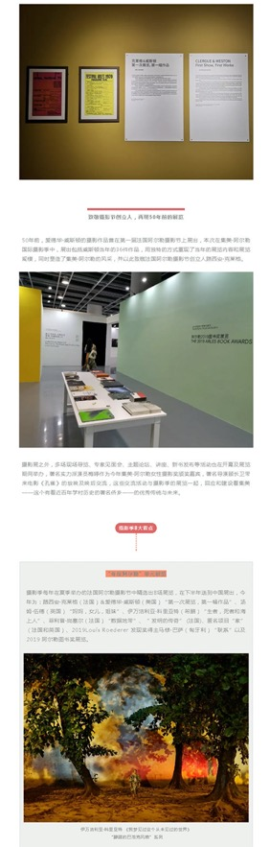
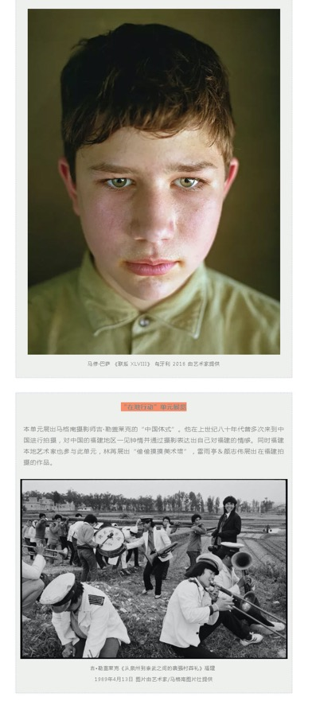
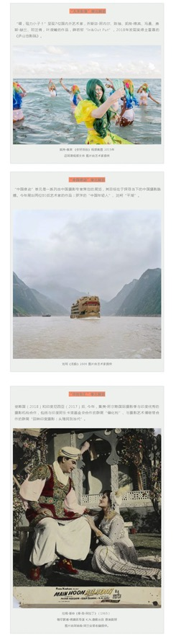
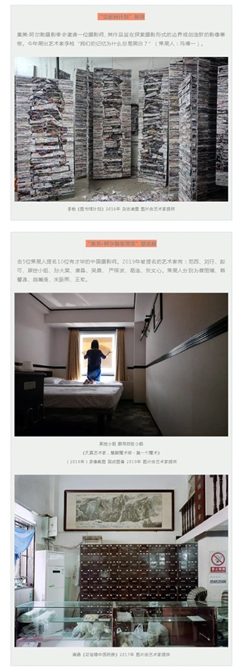
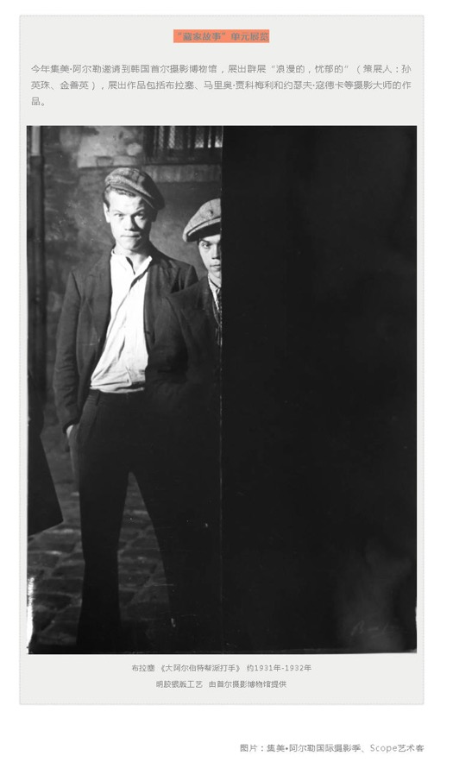

Publication : | WeChat/微信-图虫APP
Circulation : | 962
Date : | 2019-11-26
Page : | 0
Headline : | Tuchong recommends 2019 Jimei x Arles International Photo Festival: we are living in flowing history
 | 图虫 Open See 看集美阿尔勒 | 我们生活在流淌着的历史当中
Ad Value : | 2,213
PV : | 962
Summary : | 2019 Jimei x Arles International Photo Festival kicked off in Xiamen on November 22 and will last till January 5, 2020. It will present 8 exhibitions from Les Recontres d'Arles and over 20 photo exhibitions concentrating on China and Asia. This year's festival will include 30 exhibitions, which display over 2,200 artworks by 55 artists.
Link : | https://mp.weixin.qq.com/s/6B-zHZcMOuOzBNkyBmiYWw

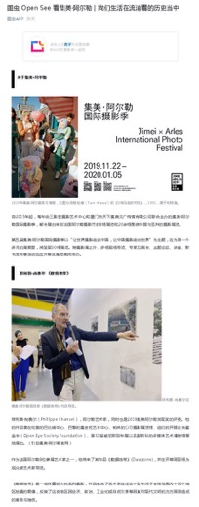
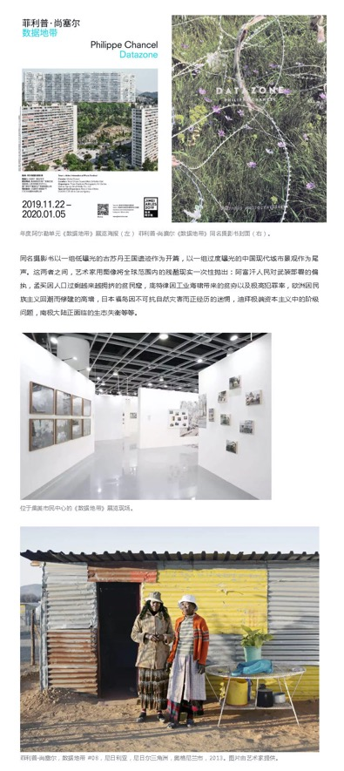
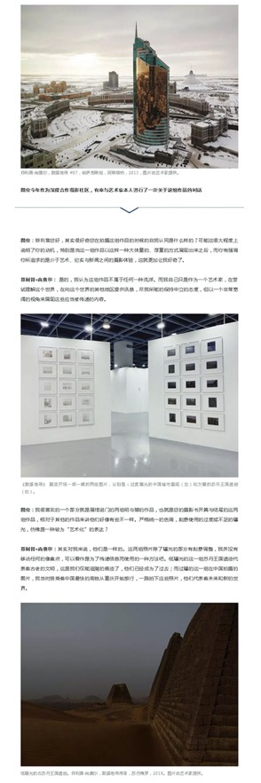
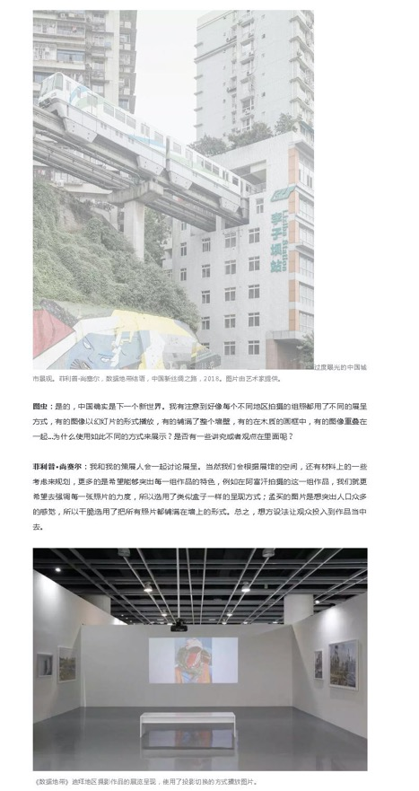
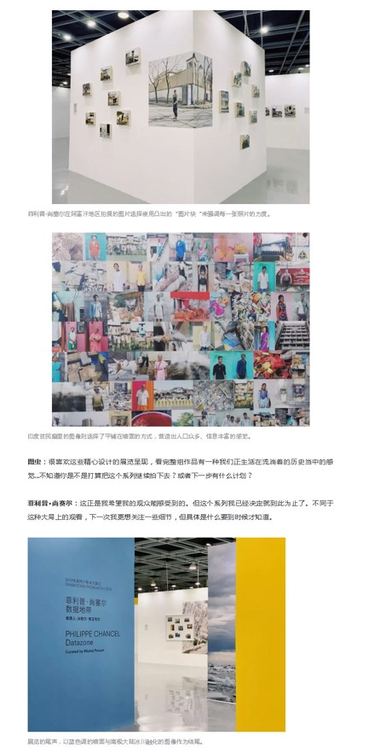
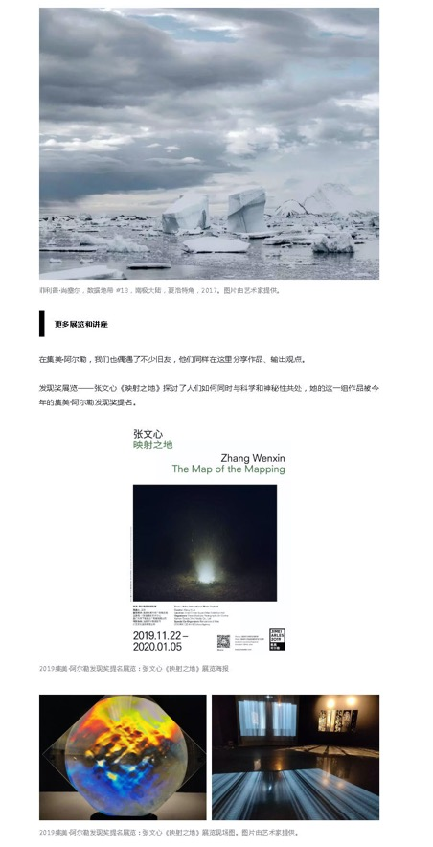
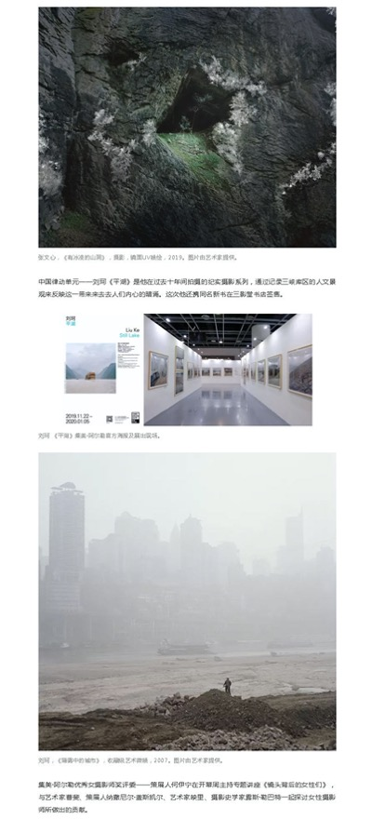
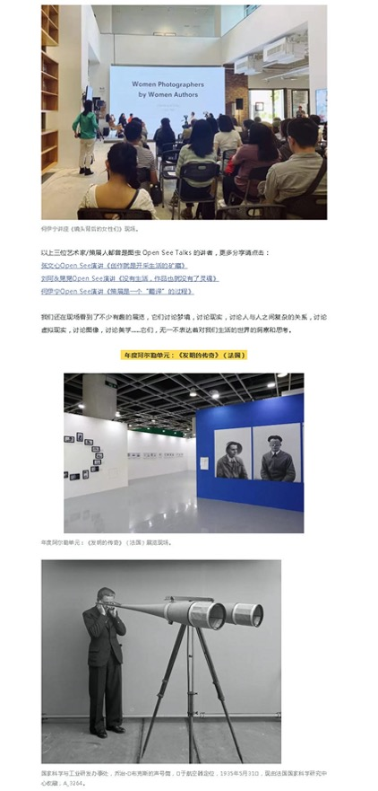
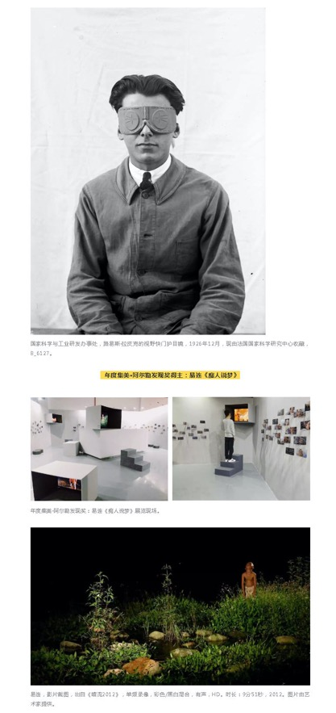
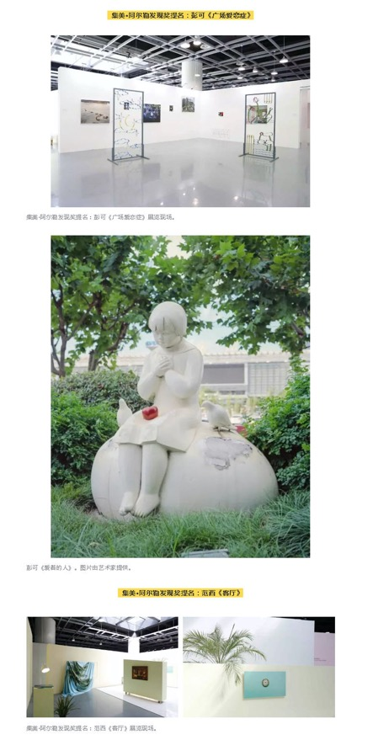
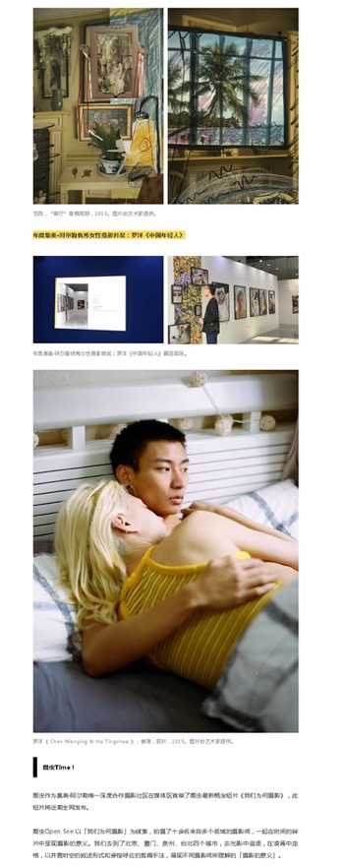
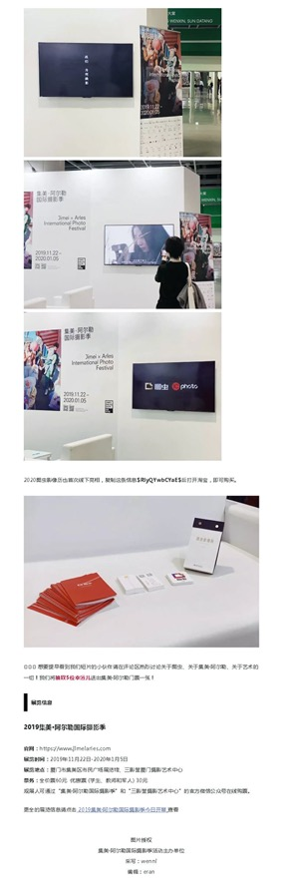

Publication : | WeChat/微信-雅趣艺术馆
Circulation : | 22
Date : | 2019-11-28
Page : | 0
Headline : | Arles International Photo Festival welcomes 50th anniversary
 | 疯狂的摄影来袭，阿尔勒摄影展50岁了
Ad Value : | 51
PV : | 22
Summary : | The 5th Jimei x Arles International Photo Festival kicked off in Xiamen on November 22, 2019 and will last till January 5, 2020. It will include 30 exhibitions, which will display over 2,200 artworks by 55 world artists.
Link : | https://mp.weixin.qq.com/s/RcCis2pcqwkQa1g9e1Urkg

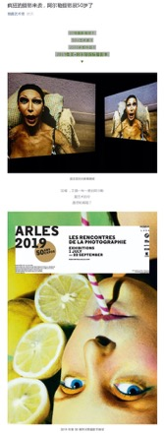
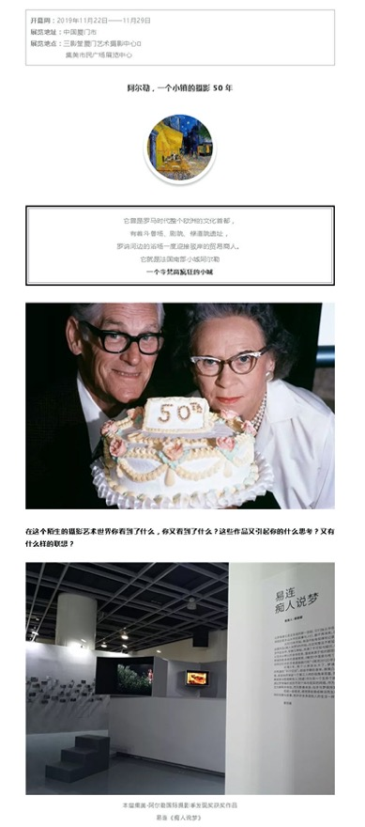
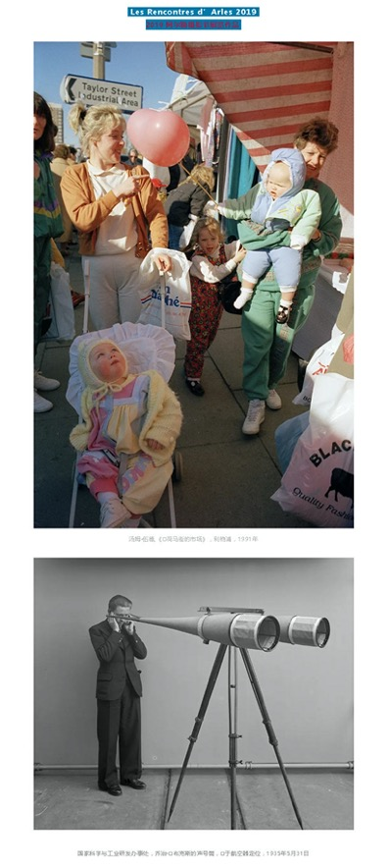
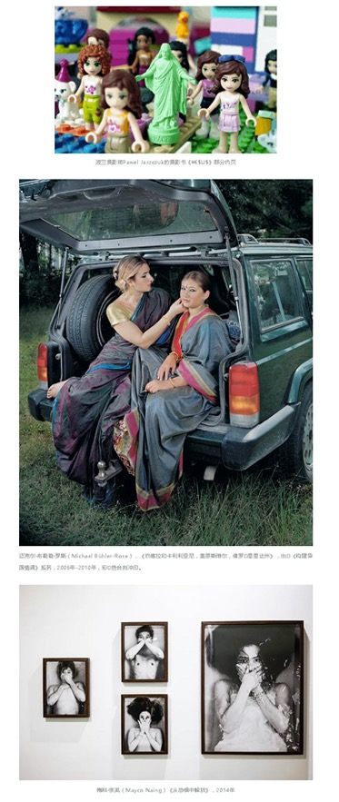

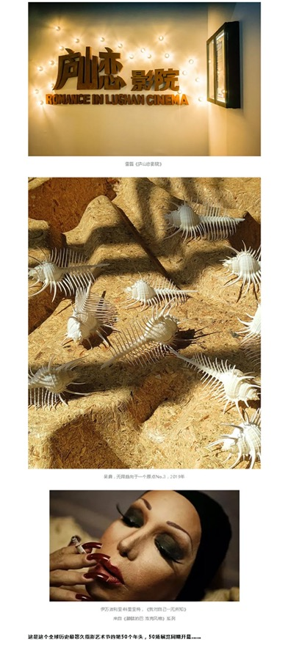
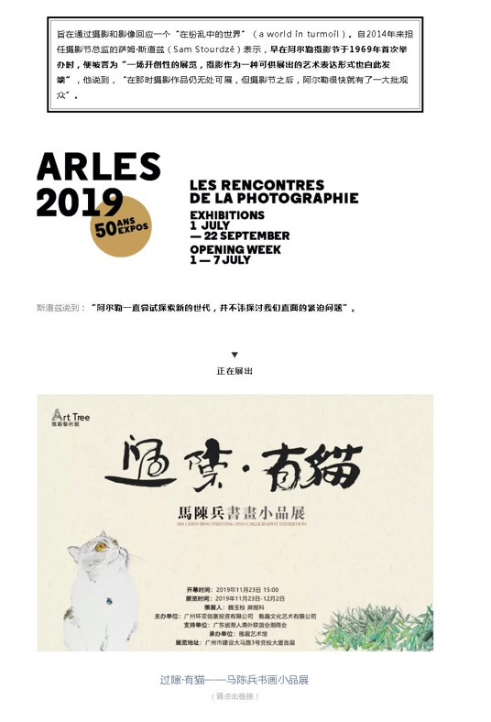

Publication : | WeChat/微信-文艺生活周刊
Circulation : | 17,598
Date : | 2019-11-29
Page : | 0
Headline : | Is it still photo exhibition?
 | 这还是摄影展吗？
Ad Value : | 40,475
PV : | 17,598
Summary : | This article describes the writer's visit to 2019 Jimei x Arles International Photo Festival that is taking place in Jimei Citizen Centre from November 22, 2019 to January 5, 2020. This festival includes 30 exhibitions, which display over 2,200 artworks by 55 artists. Some exhibitions are introduced.
Link : | https://mp.weixin.qq.com/s/1x9EiWKNzG2LosppQ2Le0Q

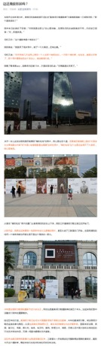
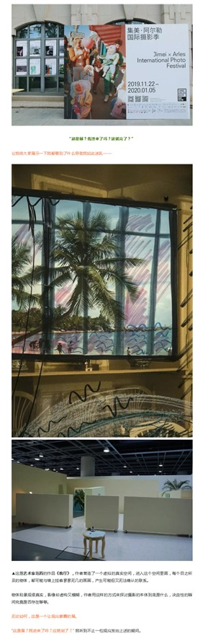
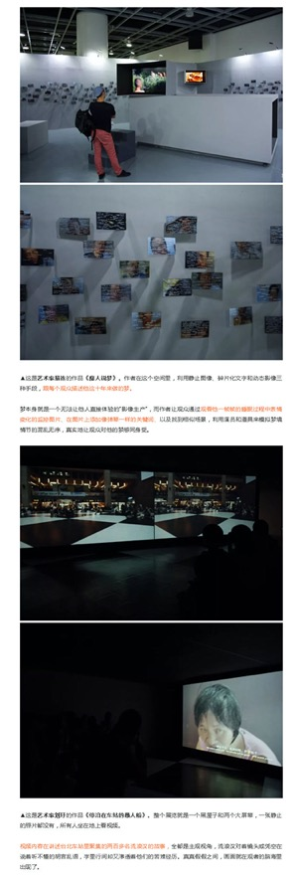
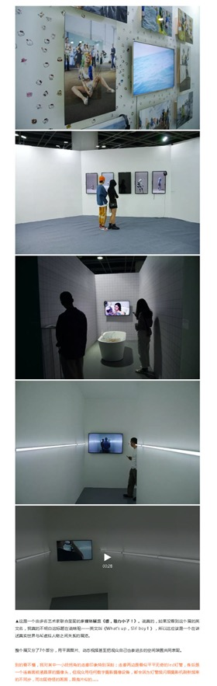
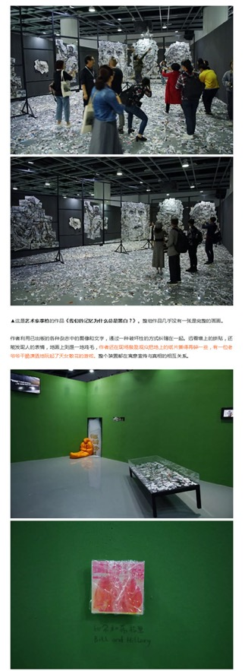
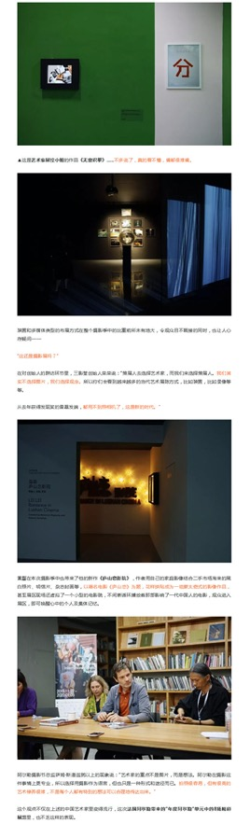
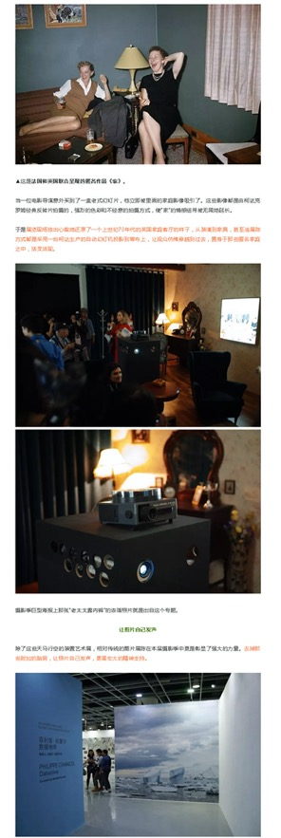
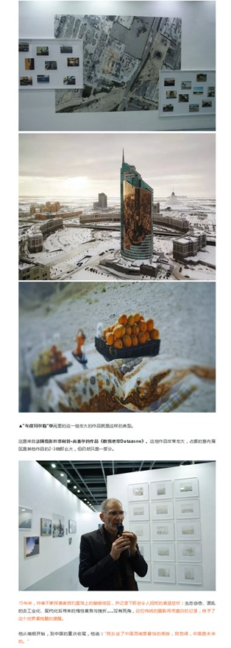
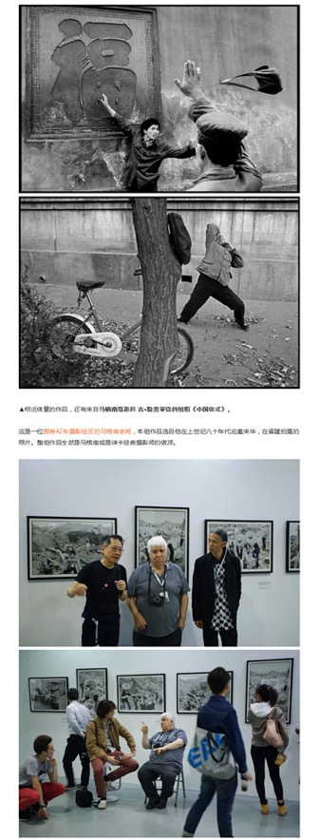
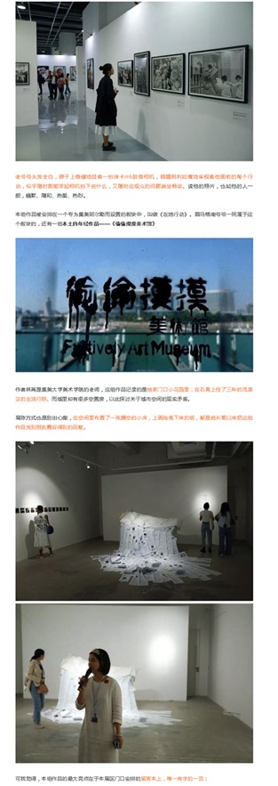
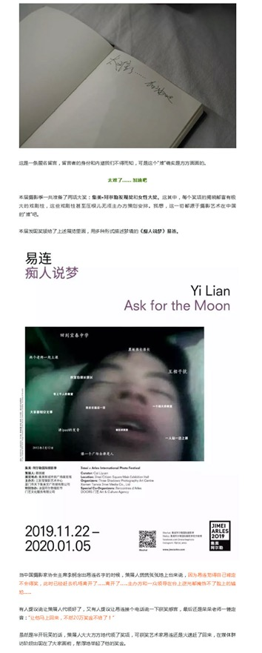
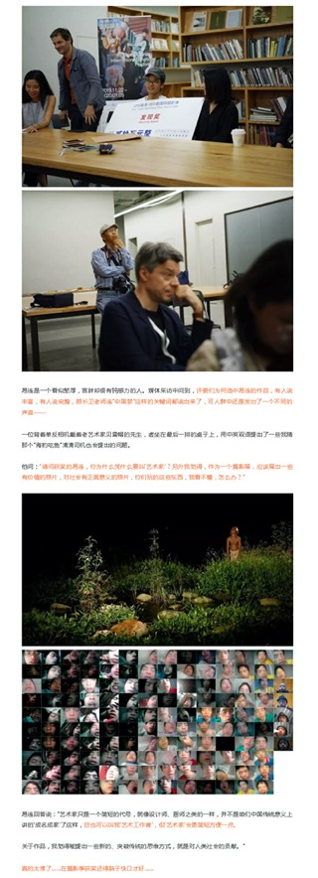
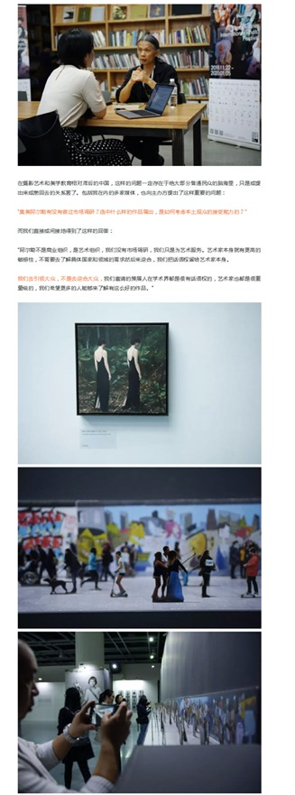
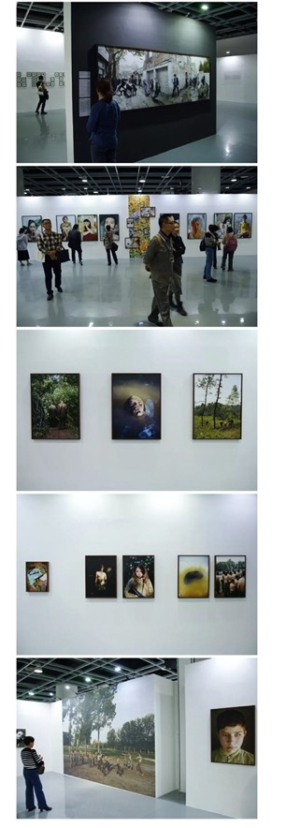
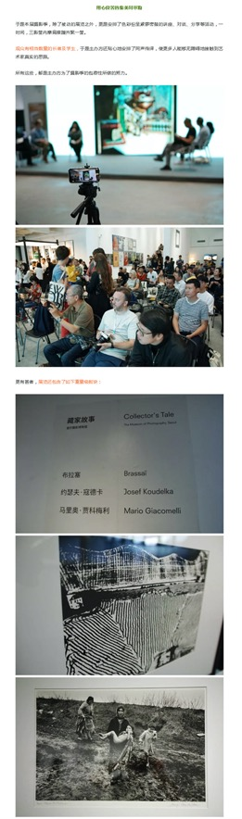
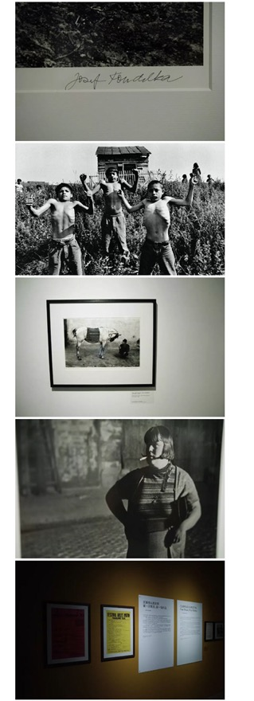
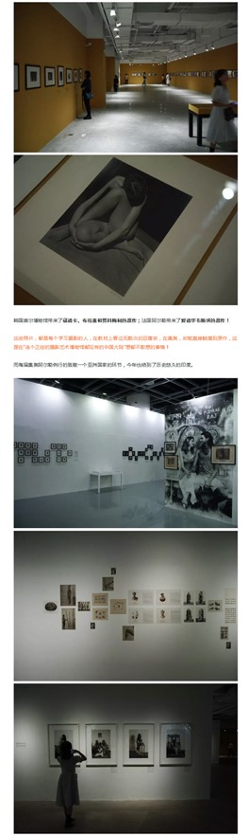
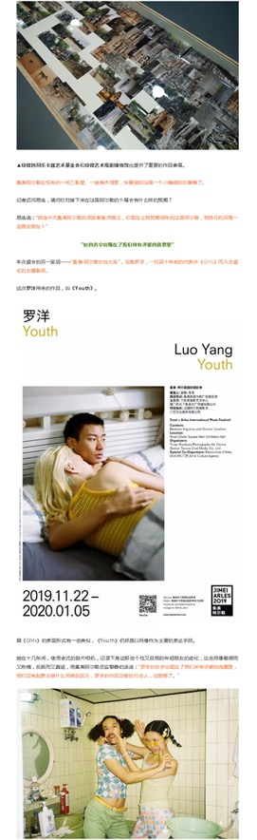
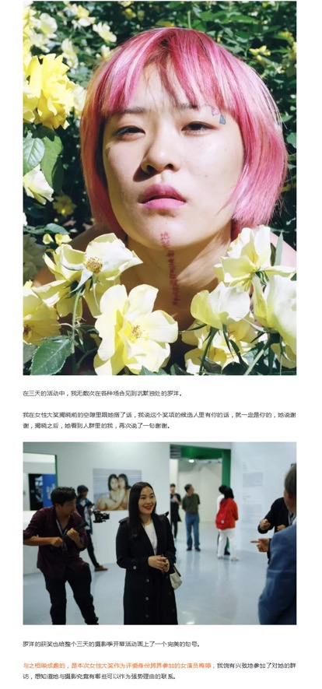
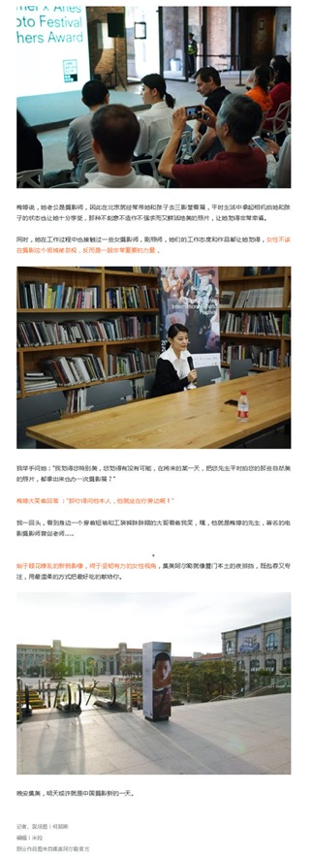

Publication : | WeChat/微信-饶舜英语访谈
Circulation : | 8
Date : | 2019-12-03
Page : | 0
Headline : | Allen Talk makes an exclusive interview with Berenice Angremy
 | 专访： 黎静（Berenice Angremy）女士，国际摄影盛宴-集美阿尔勒国际摄影节|饶舜英语访谈
Ad Value : | 18
PV : | 8
Summary : | This article refers to an exclusive interview with Berenice Angremy, well-known artistic director of Jimei x Arles International Photo Festival. She set forth on the introduction of Arles International Festival to China, Jimei x Arles International Photo Festival, requirements for participating in the festival, professional quality of photographers, Chinese photography history and works of this year's festival. According to her, 70% of works at this year's festival were from Chinese photographers.
Link : | https://mp.weixin.qq.com/s/DmclVn-JgOAPE3WOh5dh4w

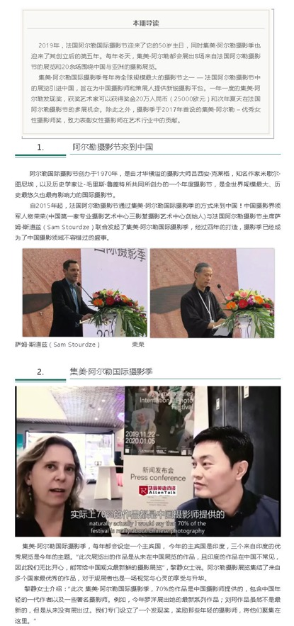
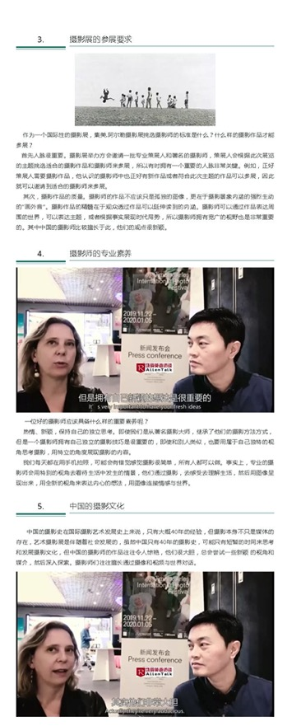
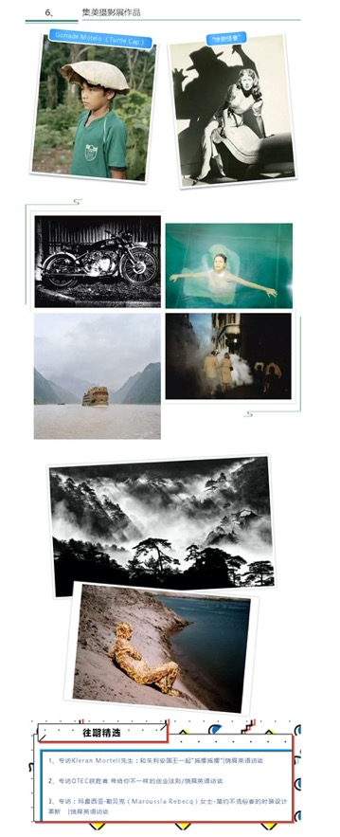

Publication : | WeChat/微信-ARTSHARD艺术碎片
Circulation : | 2,424
Date : | 2019-12-05
Page : | N/A
Headline : | Spectacular Jimei x Arles International Photo Festival overthrows worries of Charles Baudelaire
 | 在集美阿尔勒，波德莱尔对摄影的担忧并未发生丨碎片视角
Ad Value : | 5,575
PV : | 2,424
Summary : | This article reviews the 5th Jimei x Arles International Photo Festival that kicked off in Xiamen recently. Several exhibitions of the festival are introduced.
Link : | https://mp.weixin.qq.com/s?__biz=MzUxODI4NTg3OA==&mid=2247496545&idx=1&sn=bc51b7da5d59ef2341358e2fb397baa9&chksm=f9898c38cefe052e

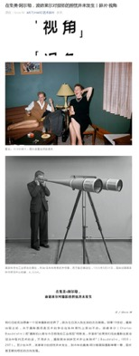
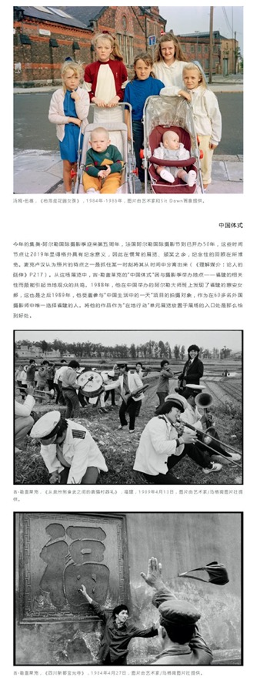
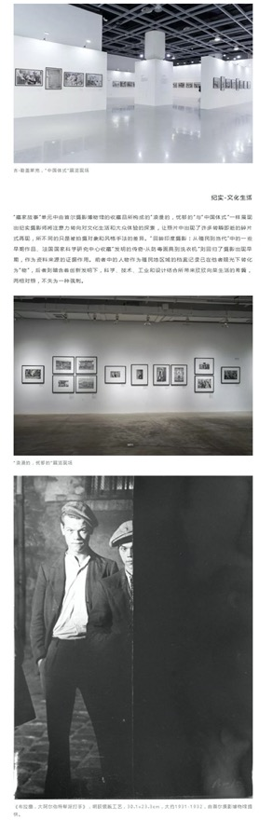
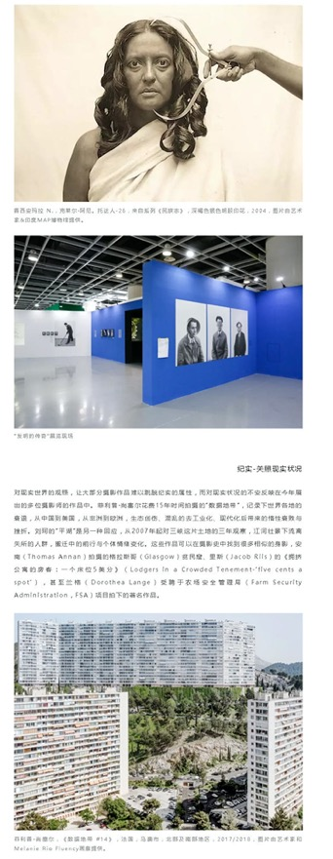
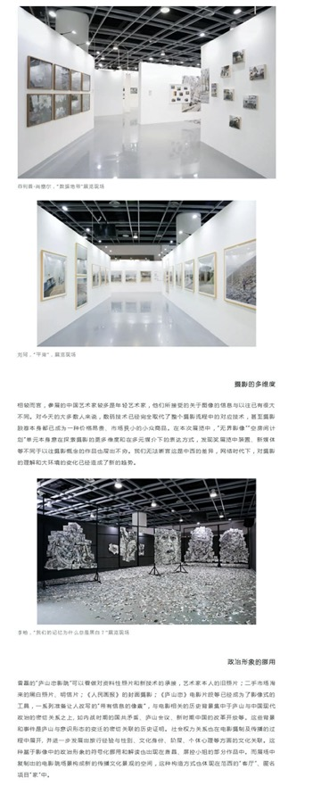
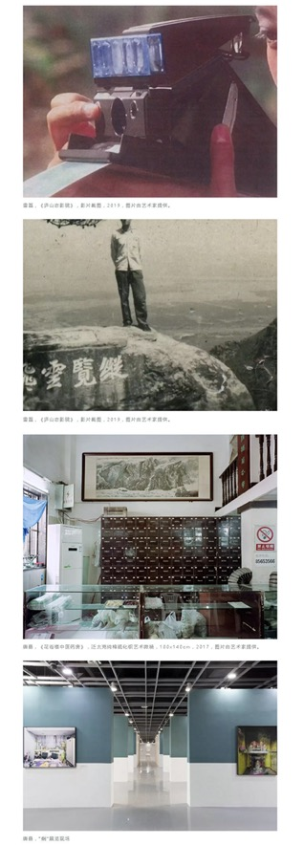
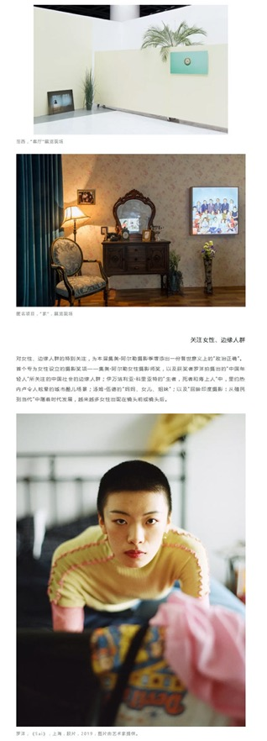
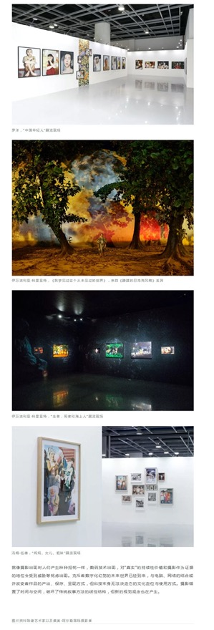

Publication : | WeChat/微信-雅昌艺术网
Circulation : | 513
Date : | 2019-12-11
Page : | N/A
Headline : | A lecture triggers thoughts about women behind the camera
 | 艺眼看世界 | 一场讲座，思考摄影师镜头背后的女性们
Ad Value : | 1,180
PV : | 513
Summary : | During 2019 Jimei x Arles International Photography Festival, "Female Images in the Camera of Tom Wood" and a photo dialogue about "Women Behind the Camera" were presented, offering unique views of women about photography and video art.
Link : | https://mp.weixin.qq.com/s?__biz=MjM5NTE2MTMyMA==&mid=2651163327&idx=2&sn=1702af3d0779f70776ff0d13d18ee45f&tt_from=sohunews

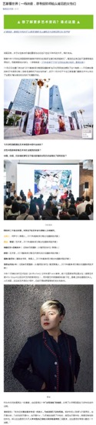
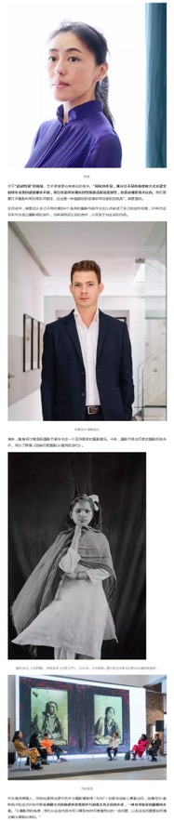
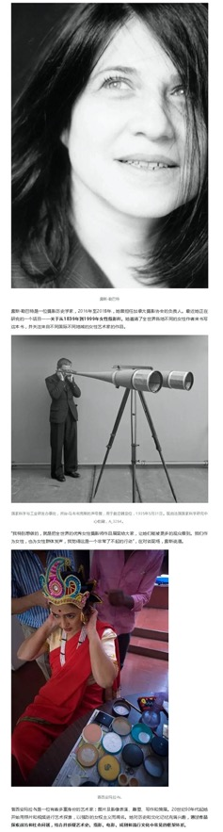
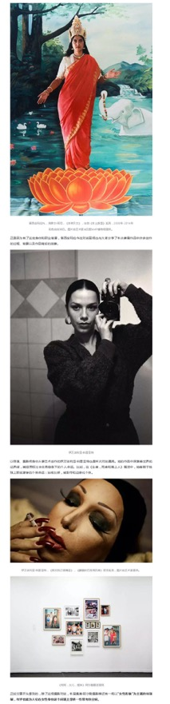
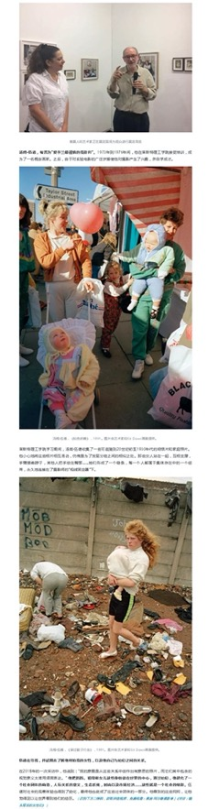

Publication : | WeChat/微信-凡是摄影
Circulation : | 896
Date : | 2019-12-12
Page : | N/A
Headline : | The 2019 Jimei x Arles International Photography Festival
 | 带你看展（15）回望与思考（上）-2019中国集美阿尔勒国际摄影季
Ad Value : | 2,061
PV : | 896
Summary : | The 2019 Jimei x Arles International Photography Festival kicked off in Xiamen on November 22. It will present 8 exhibitions from Les Recontres d'Arles and over 20 photo exhibitions concentrating on China and Asia. Several exhibitions of this festival are introduced.
Link : | https://mp.weixin.qq.com/s?__biz=MzAxMjAwOTg1MQ==&mid=2649988685&idx=1&sn=45ce2745f8b8d6bb07a8813972bcfa03&tt_from=sohunews

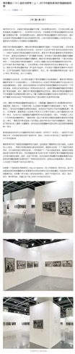
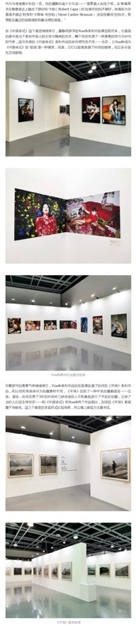
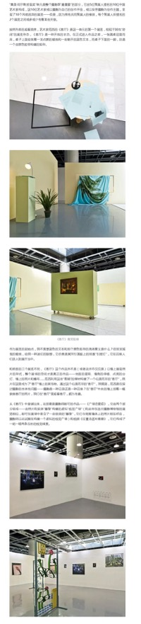
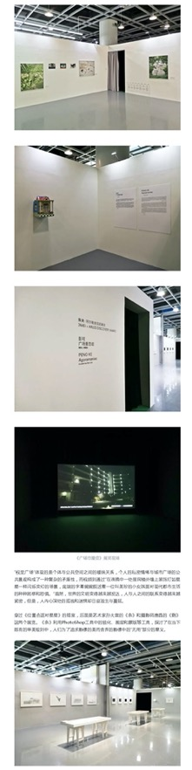
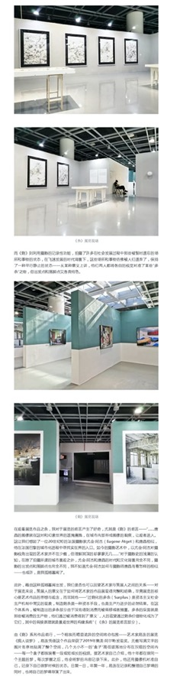
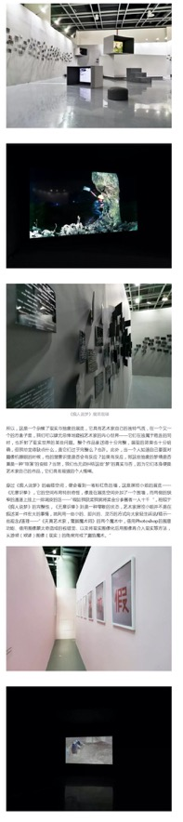
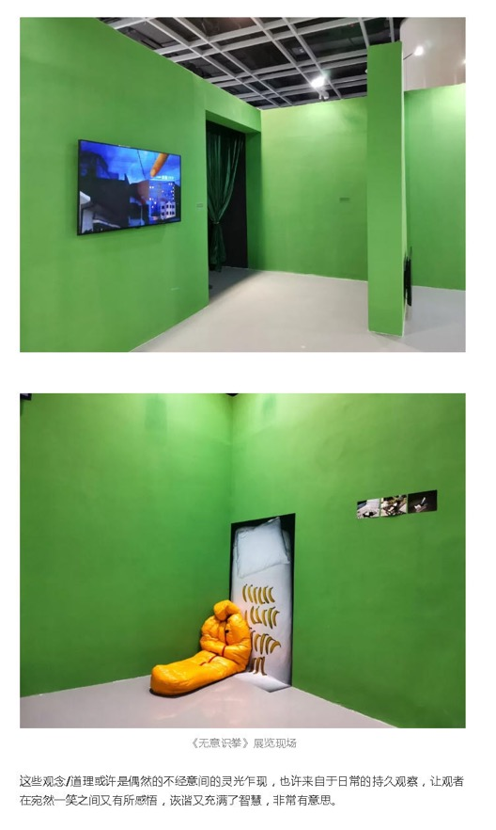

Publication : | WeChat/微信-The Hole洞见
Circulation : | 69
Date : | 2019-12-14
Page : | 0
Headline : | Review of 2019 Jimei x Arles International Photo Festival
 | Bilingual| 2019年“集美阿尔勒”国际摄影季 Jimei Arles Exhibition review
Ad Value : | 159
PV : | 69
Summary : | This article describes the writer's visit to 2019 Jimei x Arles International Photo Festival that is taking place in Xiamen from November 22, 2019 to January 5, 2020. This photo season is set in two separate halls, the major one at the Citizen Square while the other right a few stairs away at Three Shadows Photography Art Center Photography and Art center. Several exhibitions are introduced.
Link : | https://mp.weixin.qq.com/s/Fp4dIIUVocjfsIgUAv4T3g

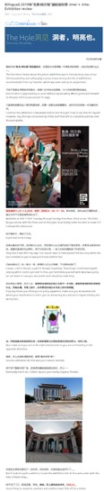
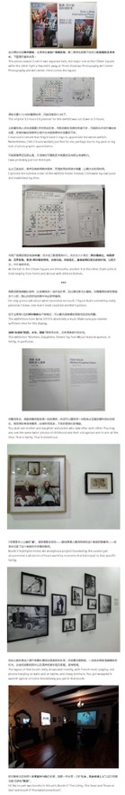
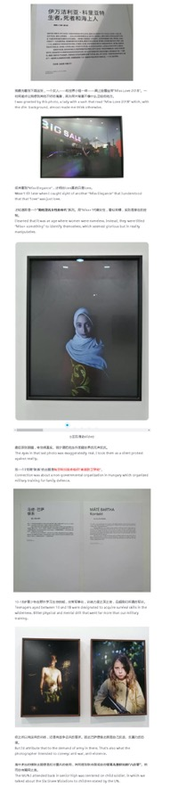
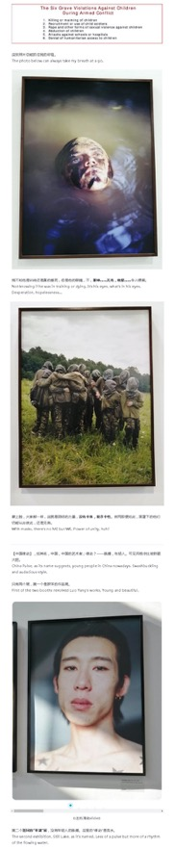
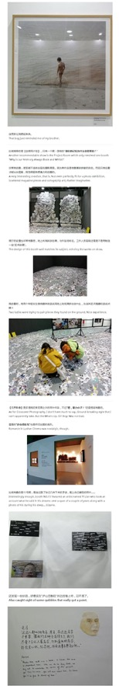
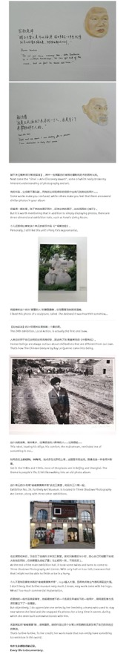
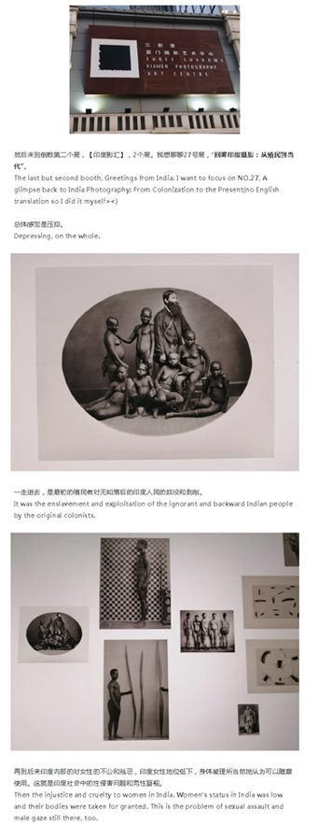
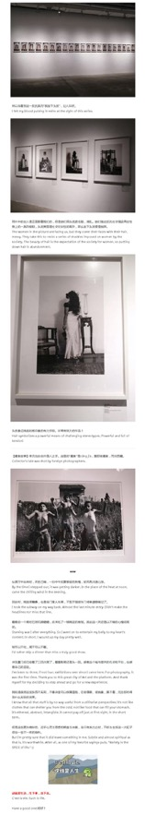

Publication : | WeChat/微信-傲客城市菜单
Circulation : | 836
Date : | 2019-12-17
Page : | N/A
Headline : | 2019 Jimei x Arles International Photography Festival will feature 30 themed exhibitions
 | 2019集美阿尔勒国际摄影季，30场展览，进去就出不来！
Ad Value : | 1,923
PV : | 836
Summary : | The 2019 Jimei x Arles International Photography Festival will begin on Nov 22 in Jimei district, Xiamen and will run until Jan 5, 2020. This year's event will feature eight exhibitions from the Les Rencontres d'Arles in France and 30 themed exhibitions by 55 artists from France, the UK, the US, Greece, Italy, India, and more.
Link : | https://mp.weixin.qq.com/s/h5wYe4W3PkbqNzwXv0O9Pw

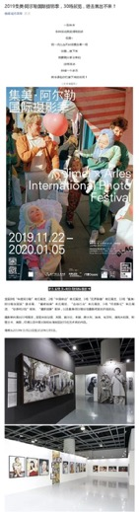
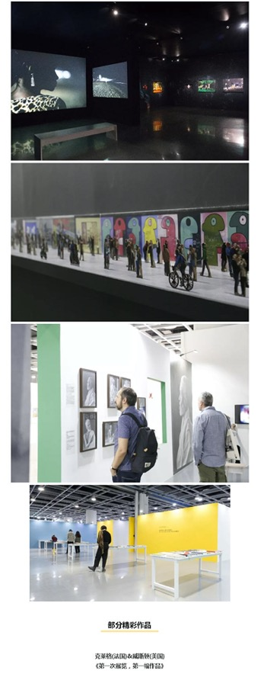
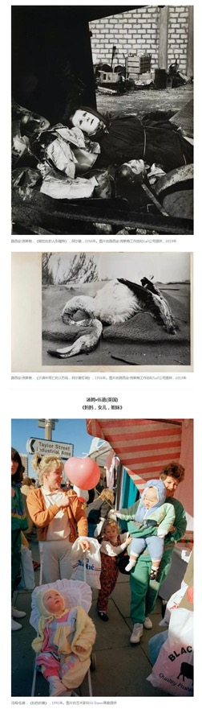
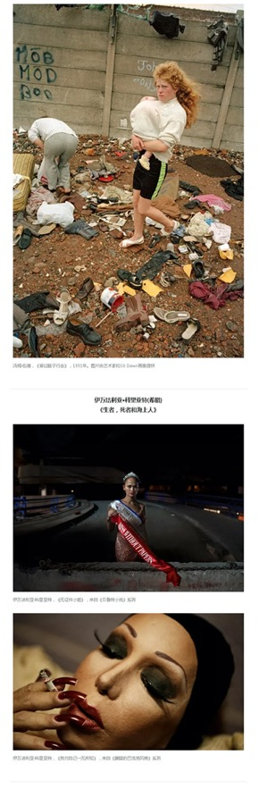
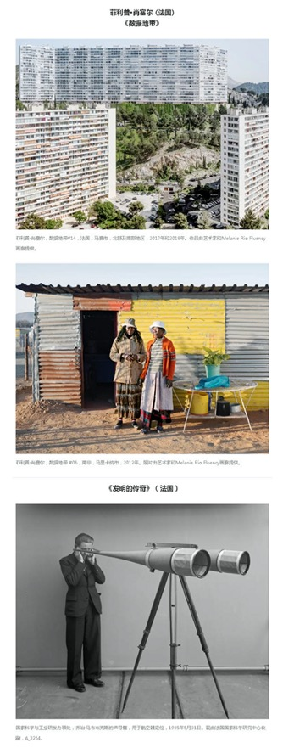
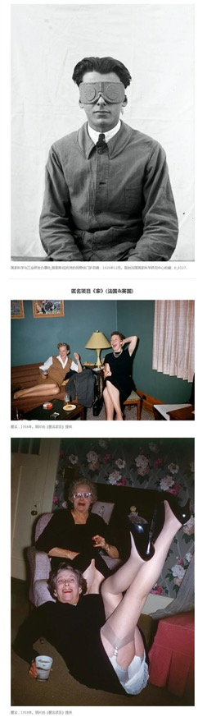
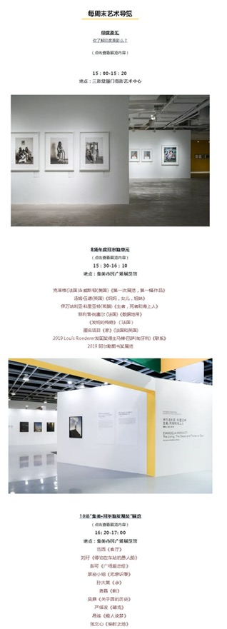
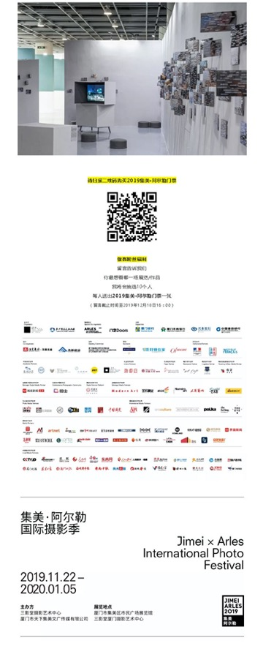

Publication : | WeChat/微信-三影堂摄影艺术中心
Circulation : | 1,069
Date : | 2019-12-29
Page : | N/A
Headline : | Comments on 2019 Jimei x Arles International Photography Festival
 | 2019集美阿尔勒摄影季最后一周｜来听听现场嘉宾精彩点评，心动不如行动！
Ad Value : | 2,459
PV : | 1,069
Summary : | This article describes views about 2019 Jimei x Arles International Photography Festival by different friends. Several impressive exhibitions of these friends and their views are shared.
Link : | https://mp.weixin.qq.com/s/0nfyKzlW5cMJOzSmAWECzg

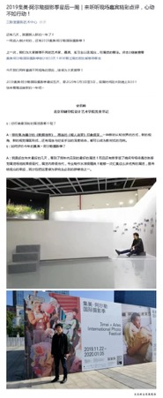
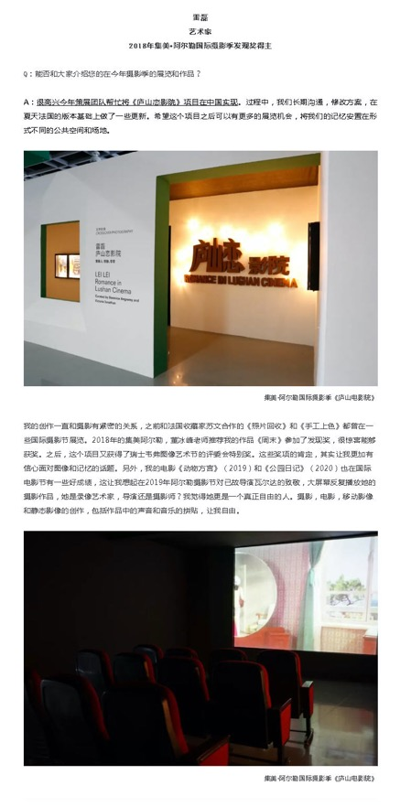
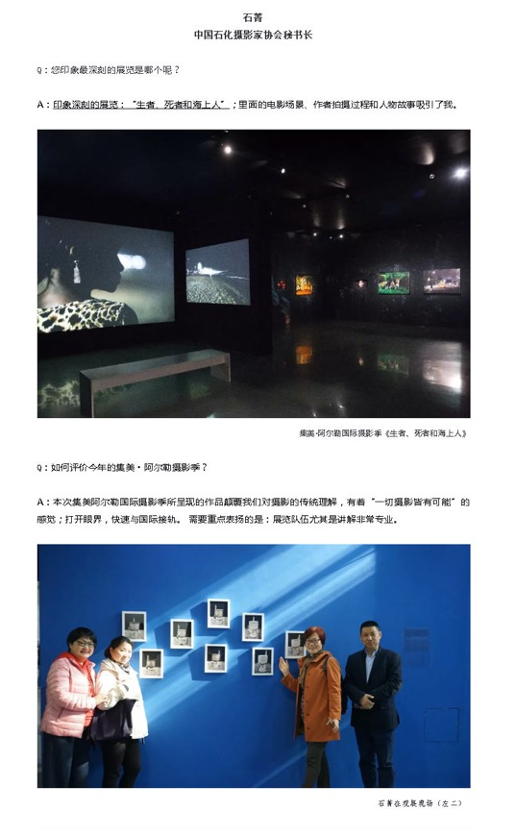
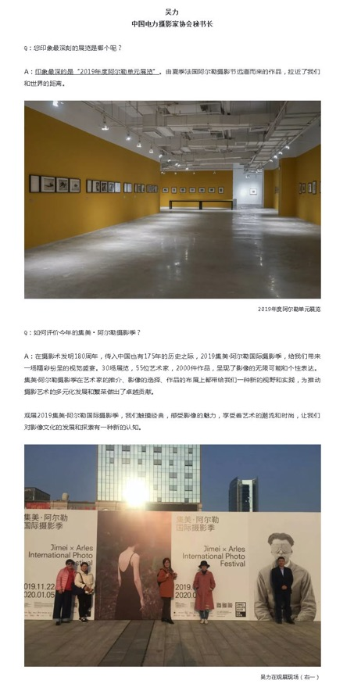
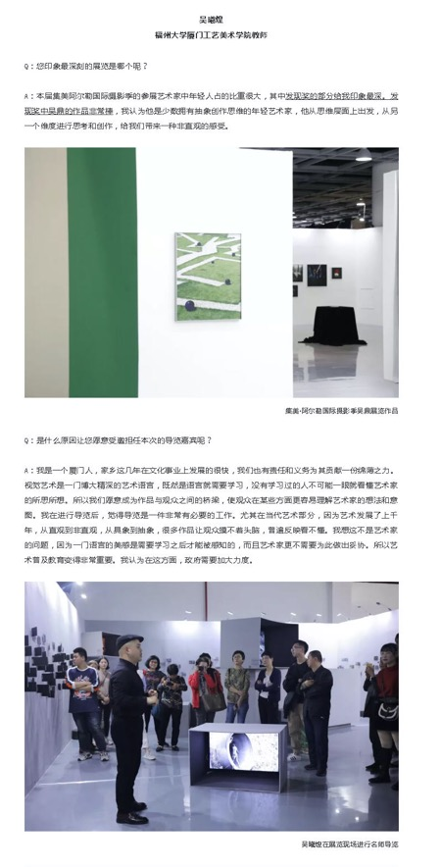
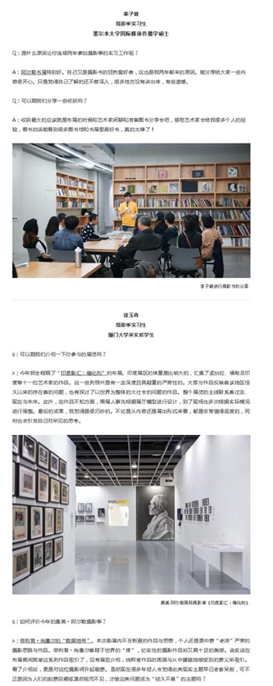
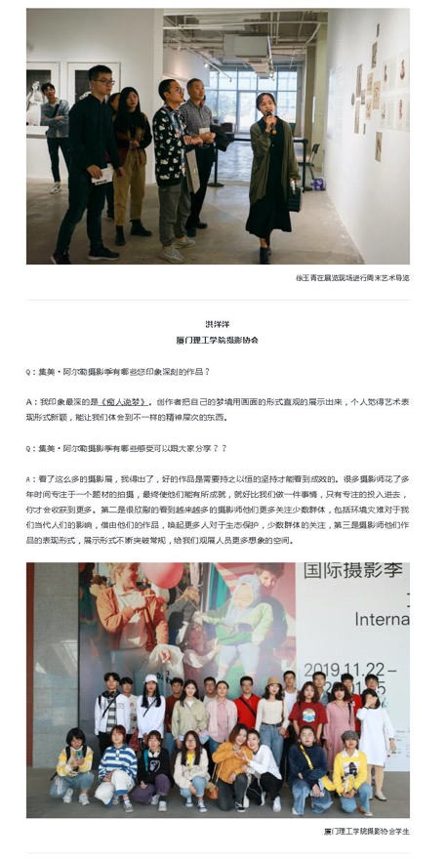
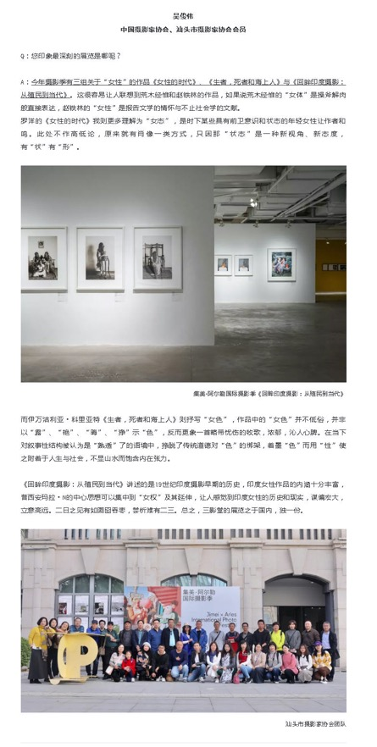
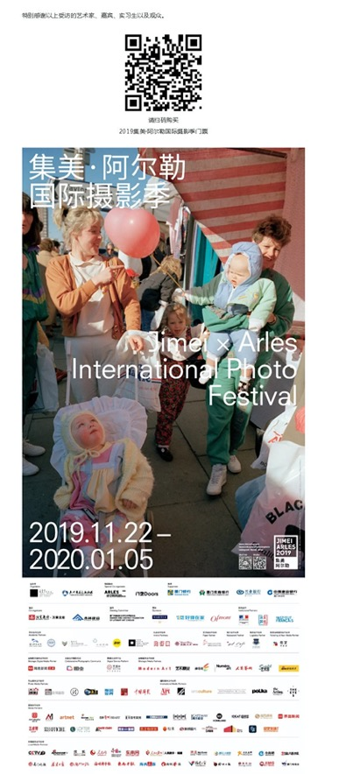

Publication : | WeChat/微信-TravelLab
Circulation : | 242
Date : | 2019-12-30
Page : | N/A
Headline : | Countdown to the end of 2019 Jimei x Arles International Photo Festival
 | 2019 倒计时，到集美阿尔勒摄影展收割最后一波“文艺写真”
Ad Value : | 557
PV : | 242
Summary : | 2019 Jimei x Arles International Photo Festival kicked off in Xiamen on November 22 and will last till January 5, 2020. It will present 8 exhibitions from Les Recontres d'Arles and over 20 photo exhibitions concentrating on China and Asia. This year's festival will include 30 exhibitions, which display over 2,200 artworks by 55 artists. Some tips about visiting exhibitions are given.
Link : | https://mp.weixin.qq.com/s?__biz=MzA4NzkxNjcwNw==&mid=2649438546&idx=1&sn=65512b0b3b62c01131ad03390578145b&tt_from=sohunews

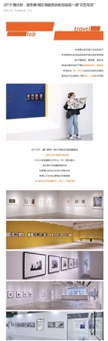
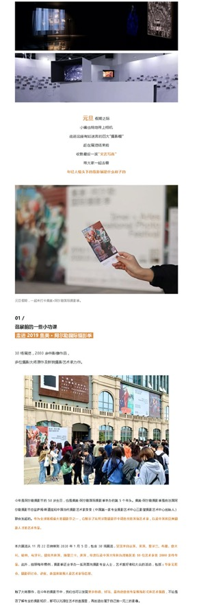
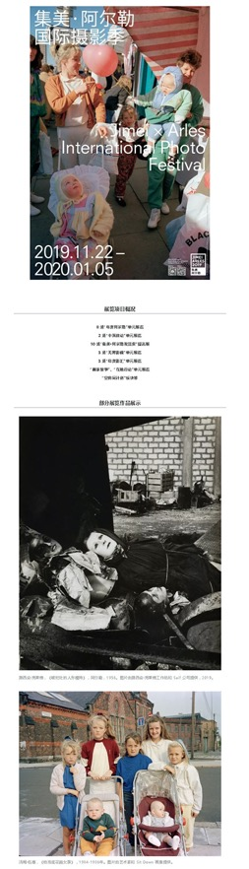
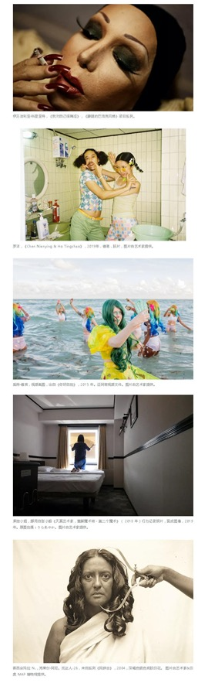
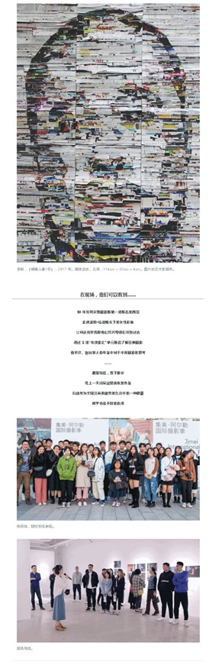
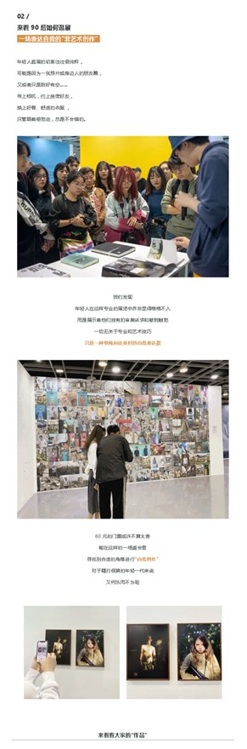
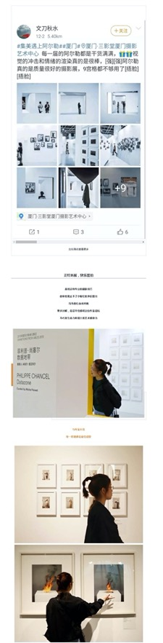
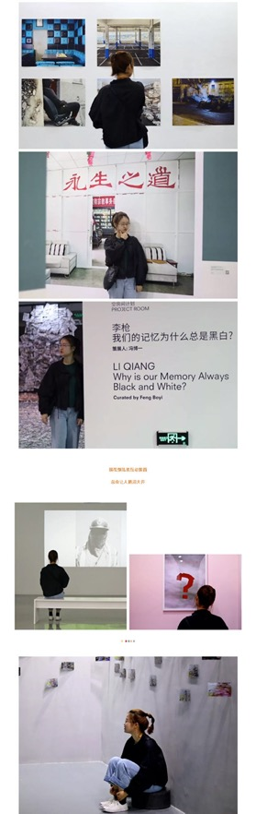
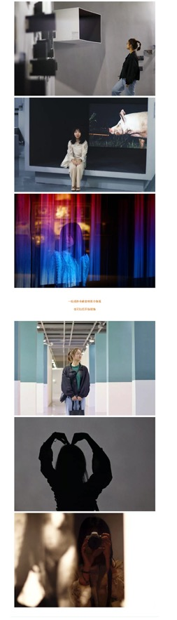
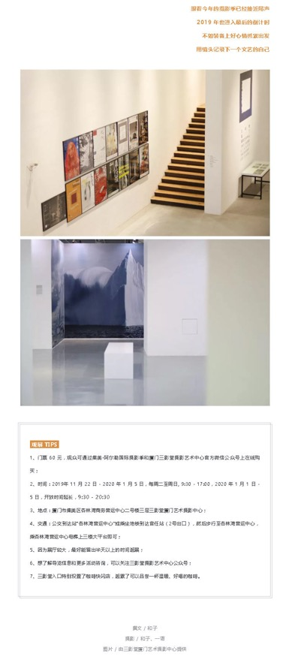

Publication : | WeChat/微信-最爱大厦门
Circulation : | 1,599
Date : | 2019-12-31
Page : | N/A
Headline : | Only 5 days to the end of 2019 Jimei x Arles International Photography Festival
 | 倒计时5天！梅婷、顾长卫倾情力荐の「阿尔勒摄影展」，错过再等一年！
Ad Value : | 3,678
PV : | 1,599
Summary : | The 2019 Jimei x Arles International Photography Festival kicked off on Nov 22 in Jimei district, Xiamen and will run until Jan 5, 2020. This year's event will feature eight exhibitions from the Les Rencontres d'Arles in France and 30 themed exhibitions by 55 artists from France, the UK, the US, Greece, Italy, India, and more. It is recommended by actress Mei Ting and director Gu Changwei.
Link : | https://mp.weixin.qq.com/s?__biz=MzI3NzUyNzM5NQ==&mid=2247520560&idx=2&sn=9eb366476f3a54beec8c76543102b3b0&tt_from=sohunews

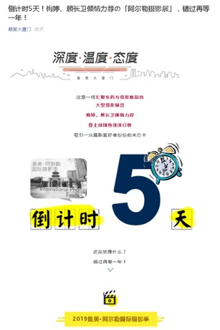
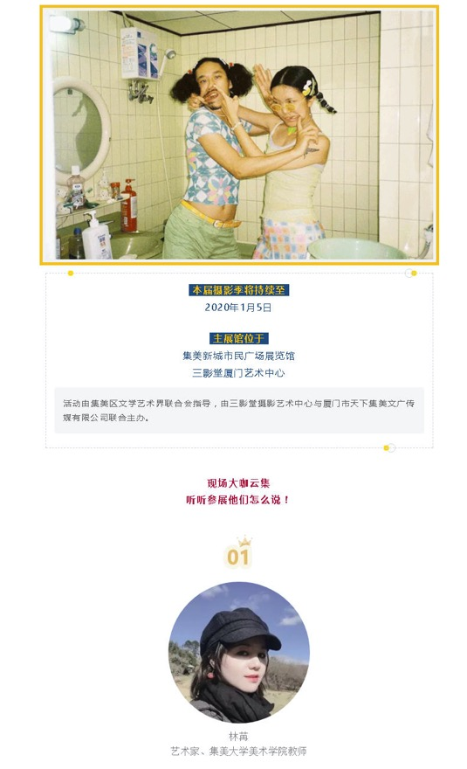
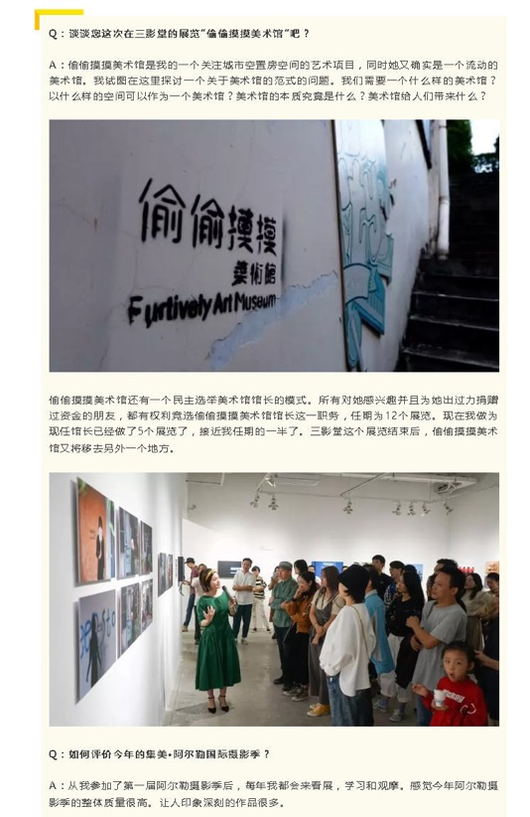
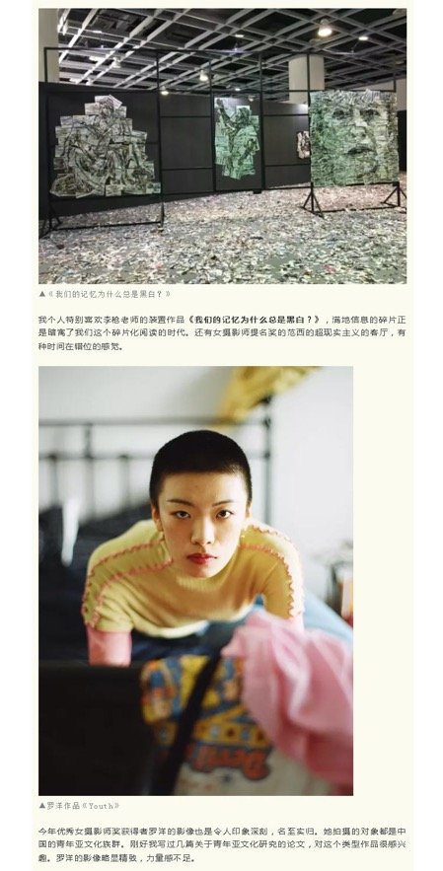
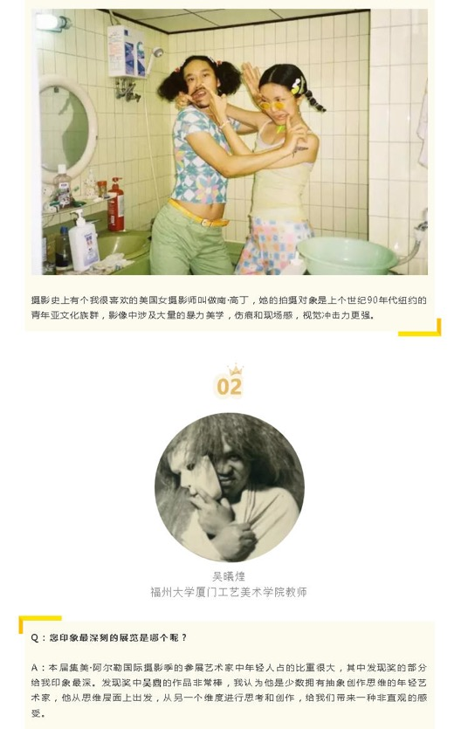
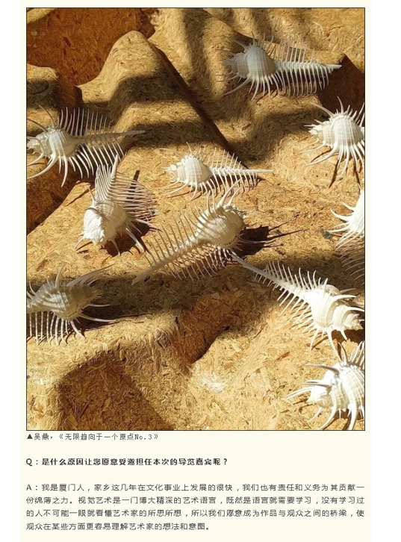
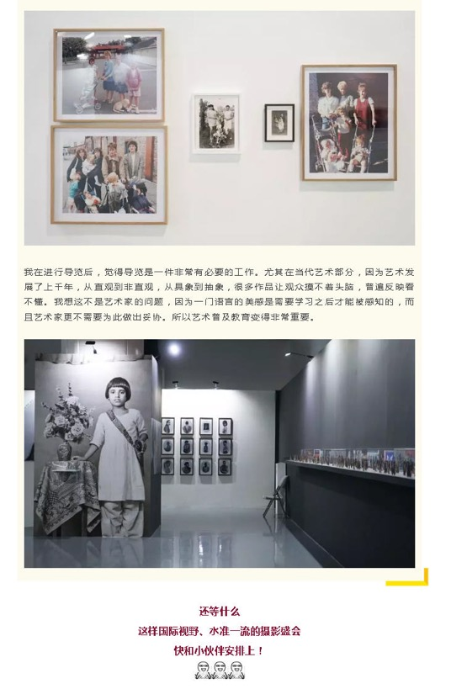

Publication : | WeChat/微信-集美旅游
Circulation : | 69
Date : | 2020-01-01
Page : | N/A
Headline : | Only 5 days to the end of 2019 Jimei x Arles International Photography Festival
 | 倒计时5天！梅婷、顾长卫倾情力荐の「阿尔勒摄影展」，错过再等一年！
Ad Value : | 159
PV : | 69
Summary : | The 2019 Jimei x Arles International Photography Festival kicked off on Nov 22 in Jimei district, Xiamen and will run until Jan 5, 2020. This year's event will feature eight exhibitions from the Les Rencontres d'Arles in France and 30 themed exhibitions by 55 artists from France, the UK, the US, Greece, Italy, India, and more. It is recommended by actress Mei Ting and director Gu Changwei.
Link : | https://mp.weixin.qq.com/s?__biz=MzA5NzA5NDEyMw==&mid=2653048577&idx=3&sn=b818bbf3fa8528504b47aeccf2658640&tt_from=sohunews

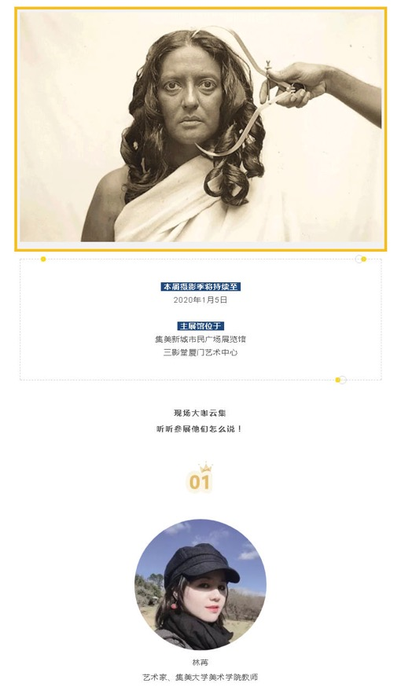
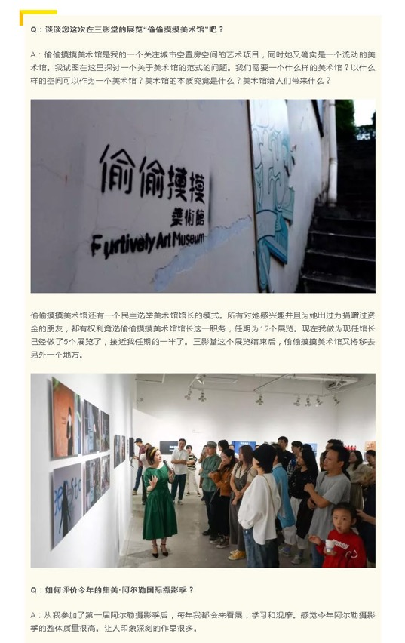
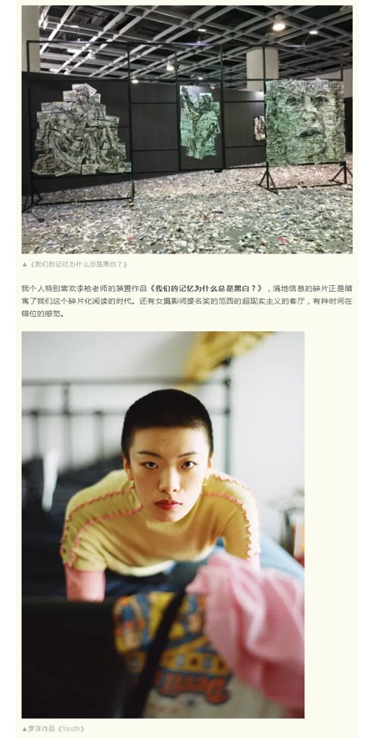
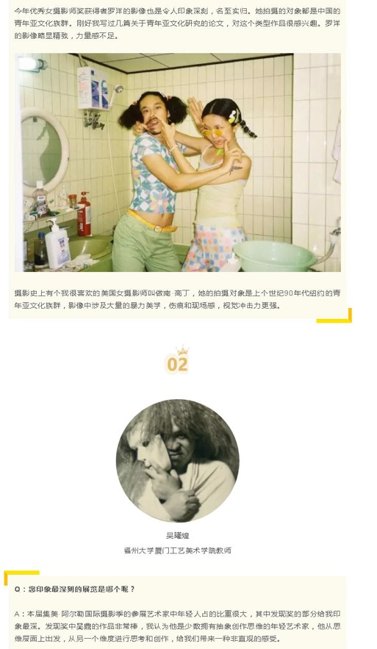
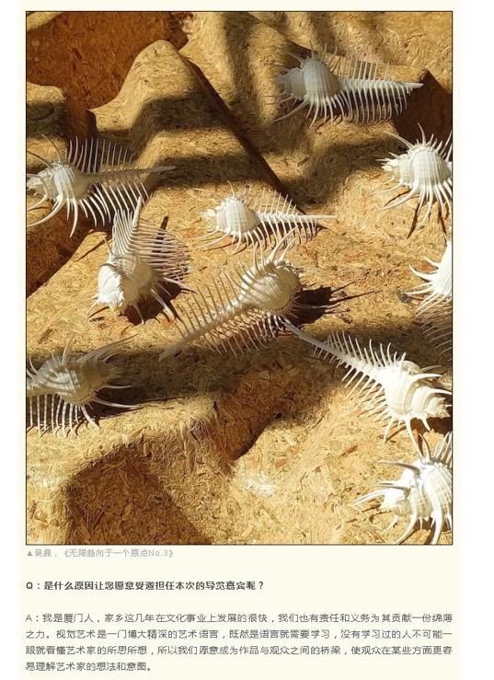
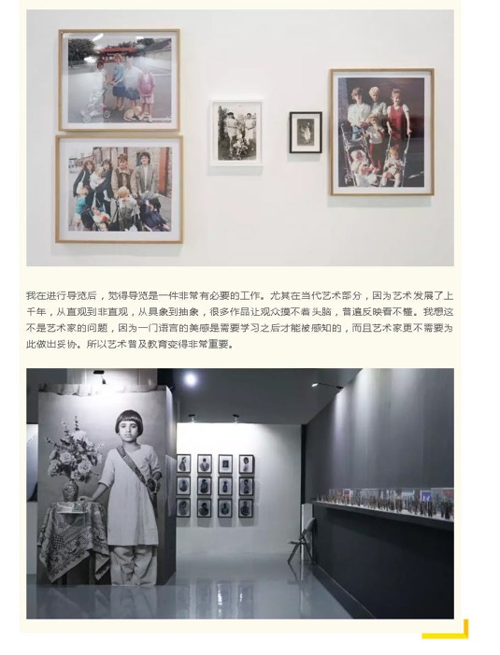
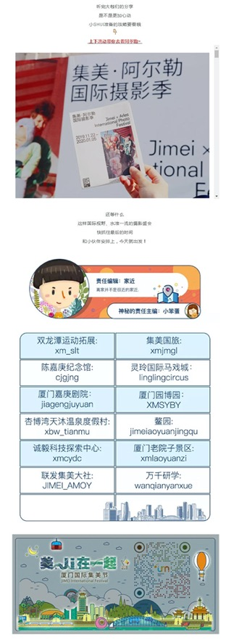

Publication : | WeChat/微信-天下集美
Circulation : | 814
Date : | 2020-01-01
Page : | N/A
Headline : | Night fields added to 2019 Jimei x Arles International Photography Festival
 | 倒计时4天！明星大咖疯狂打call！这个活动就藏在集美…
Ad Value : | 1,872
PV : | 814
Summary : | Night fields added in the last four days of 2019 Jimei x Arles International Photography Festival from January 1 to 5, extending the exhibition time to 20:30. Besides, artists guide and audio guide were also added, enhancing visitors' experience. There are also a variety of rich supporting activities, such as the 2019 Book Awards sharing, parent-kid reading.
Link : | https://mp.weixin.qq.com/s?__biz=MzUxNDYwMDA3Mw==&mid=2247521321&idx=2&sn=82a19f06dab9cfef446ba68120d07ff2&chksm=f941a9cfce3620d9

