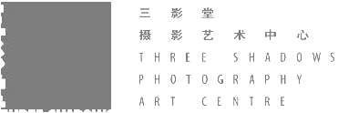 |  | Publication: | 蜂鸟网 | 
 |  | Date: | 2016年4月
 |  | Link: | http://image.fengniao.com/533/5334048.html
 |  | Title: | 林博彦和黄承聪获得第八届三影堂摄影奖
 |  | City: | Beijing 北京
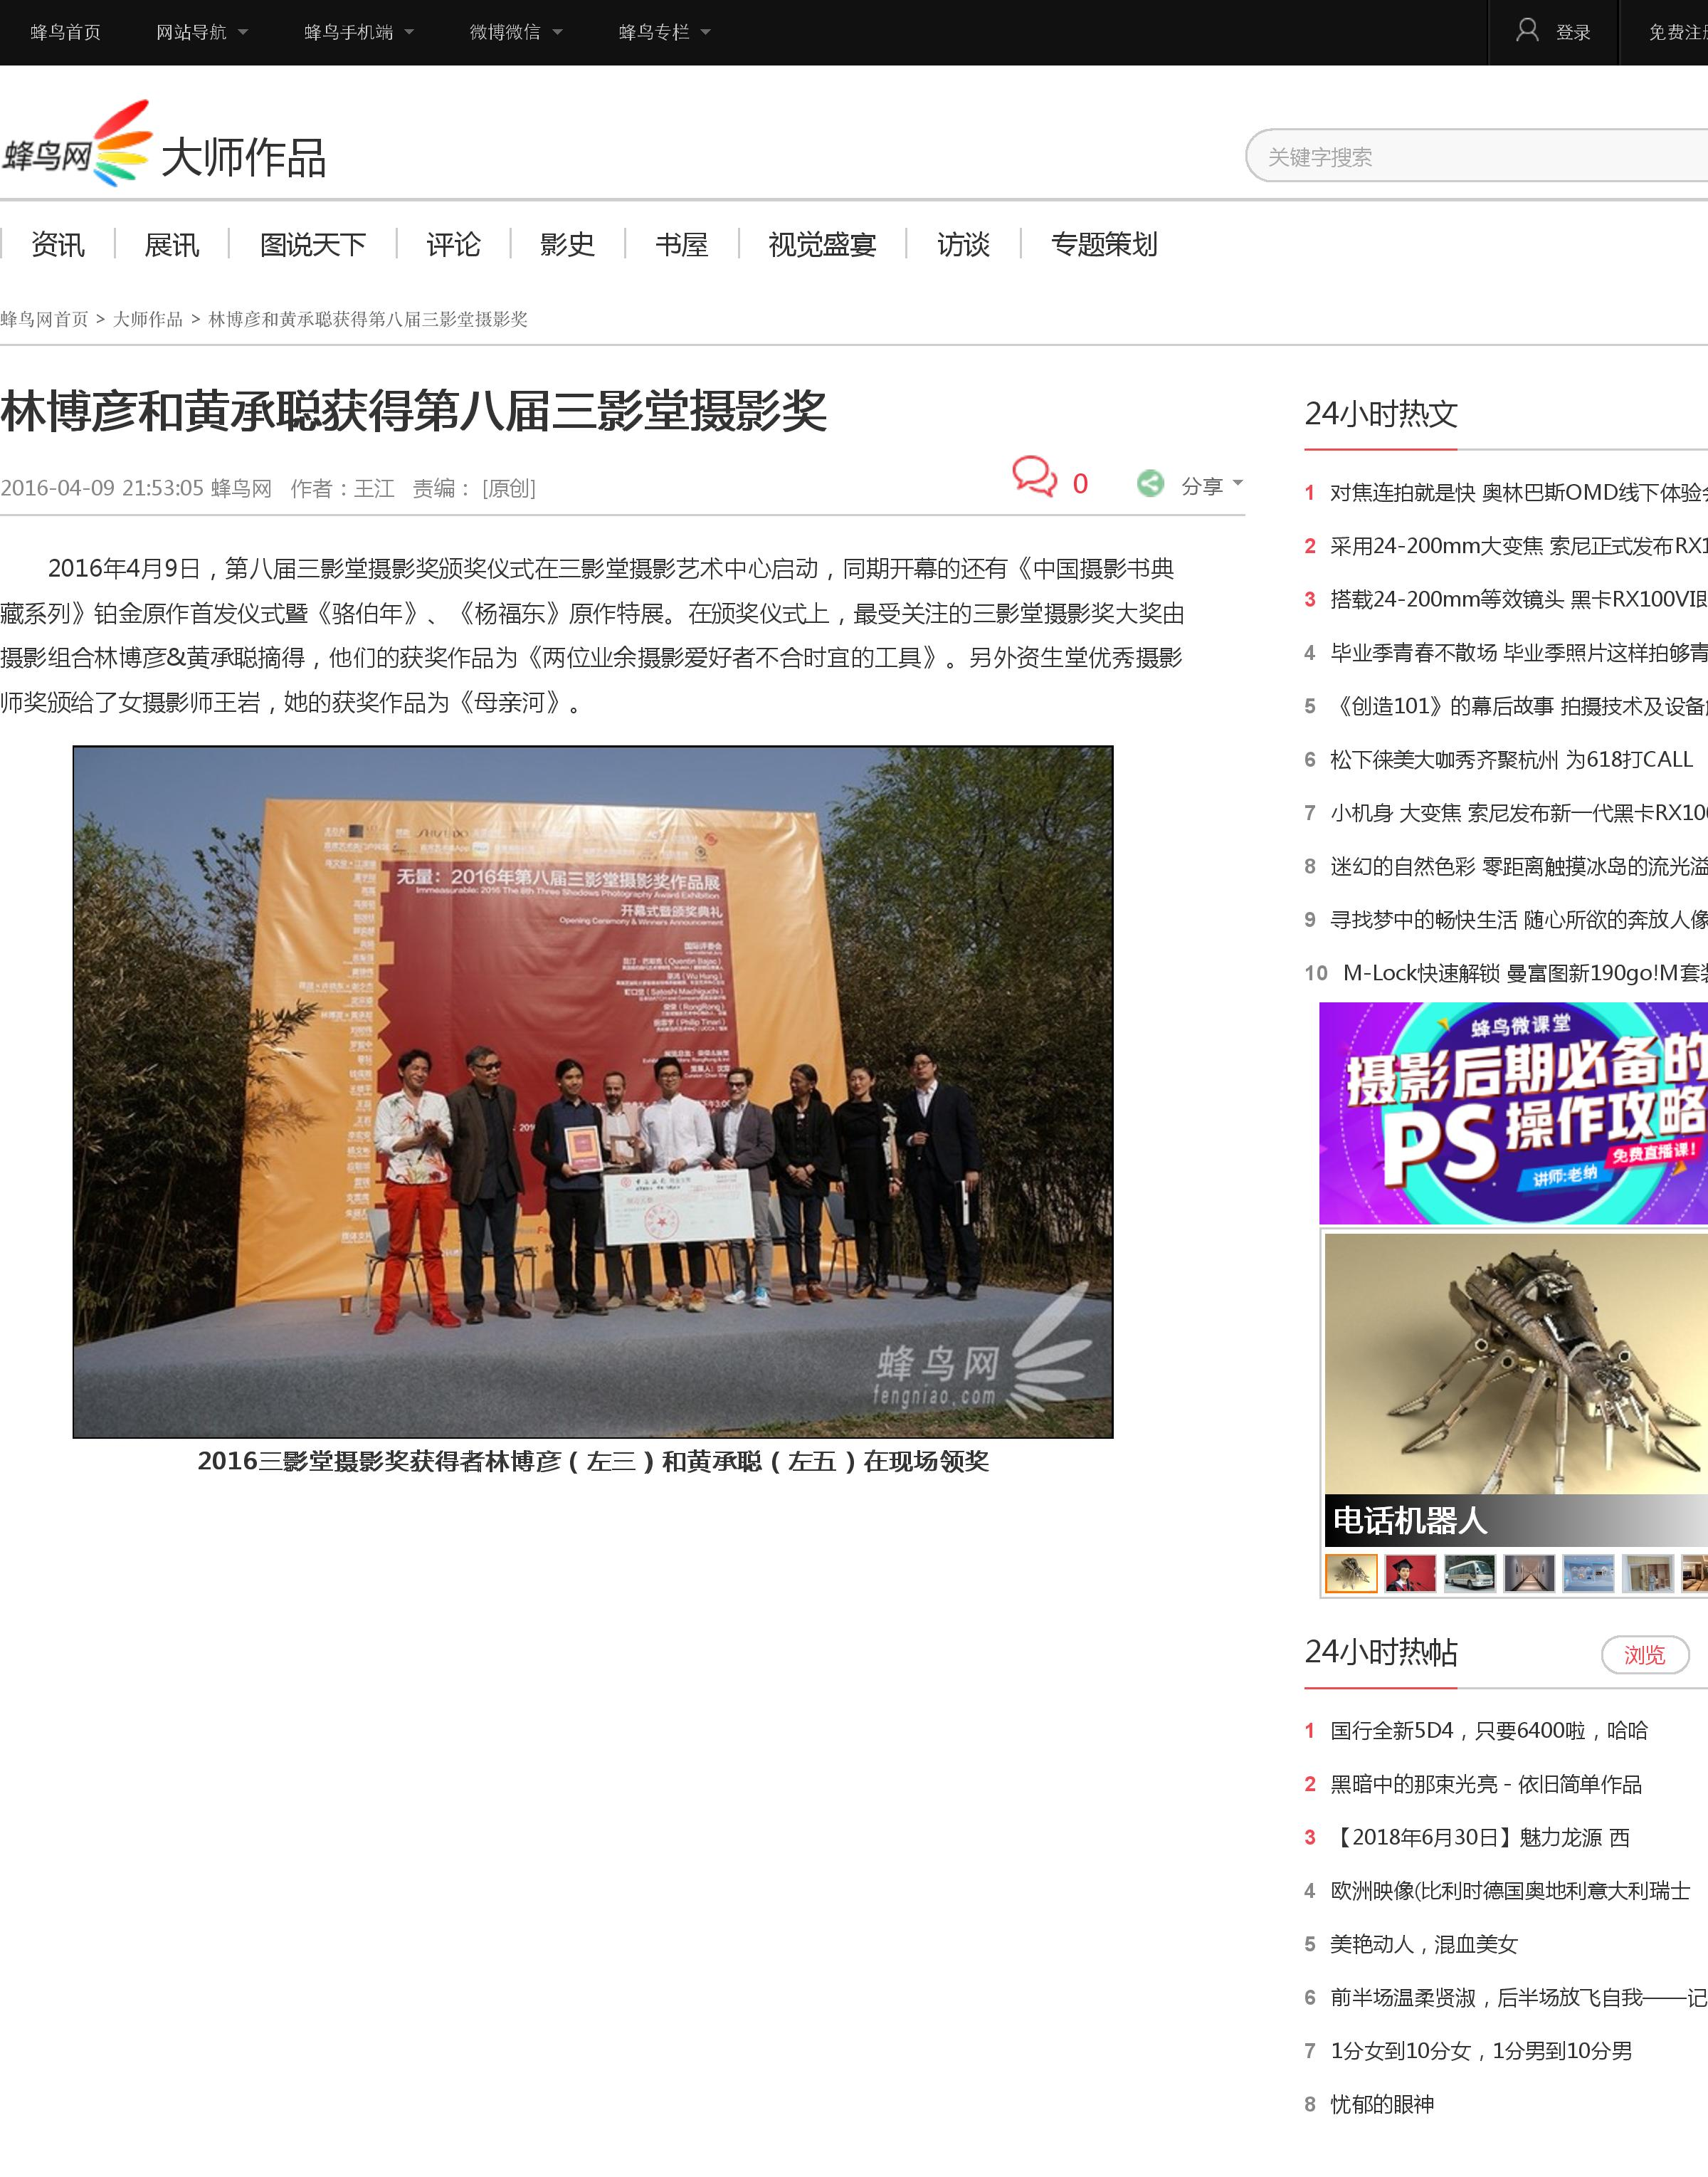
 |  | Publication: | 蜂鸟网
 |  | Date: | 2016年4月
 |  | Link: | http://image.fengniao.com/533/5334048.html
 |  | Title: | 林博彦和黄承聪获得第八届三影堂摄影奖
 |  | City: | Beijing 北京
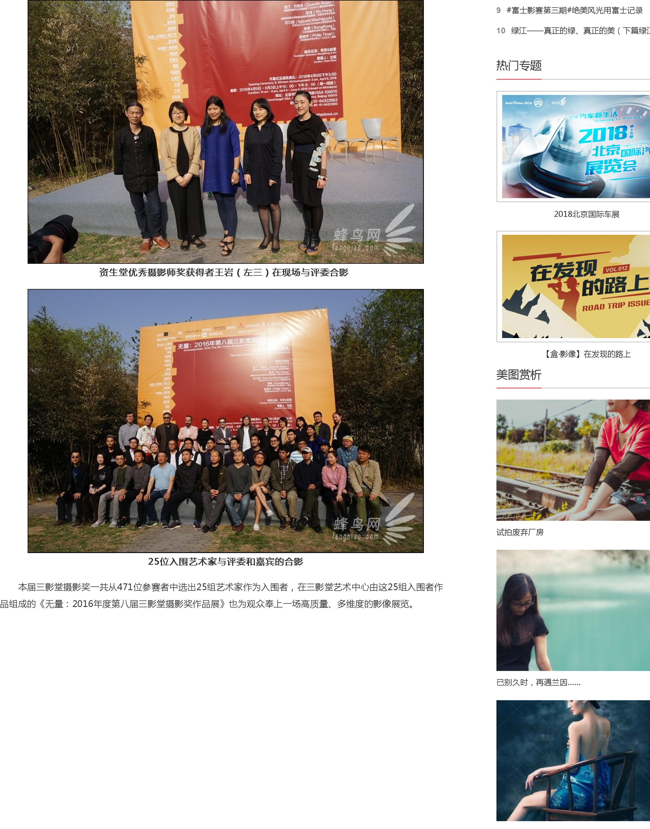
 |  | Publication: | 蜂鸟网
 |  | Date: | 2016年4月
 |  | Link: | http://image.fengniao.com/533/5334048.html
 |  | Title: | 林博彦和黄承聪获得第八届三影堂摄影奖
 |  | City: | Beijing 北京
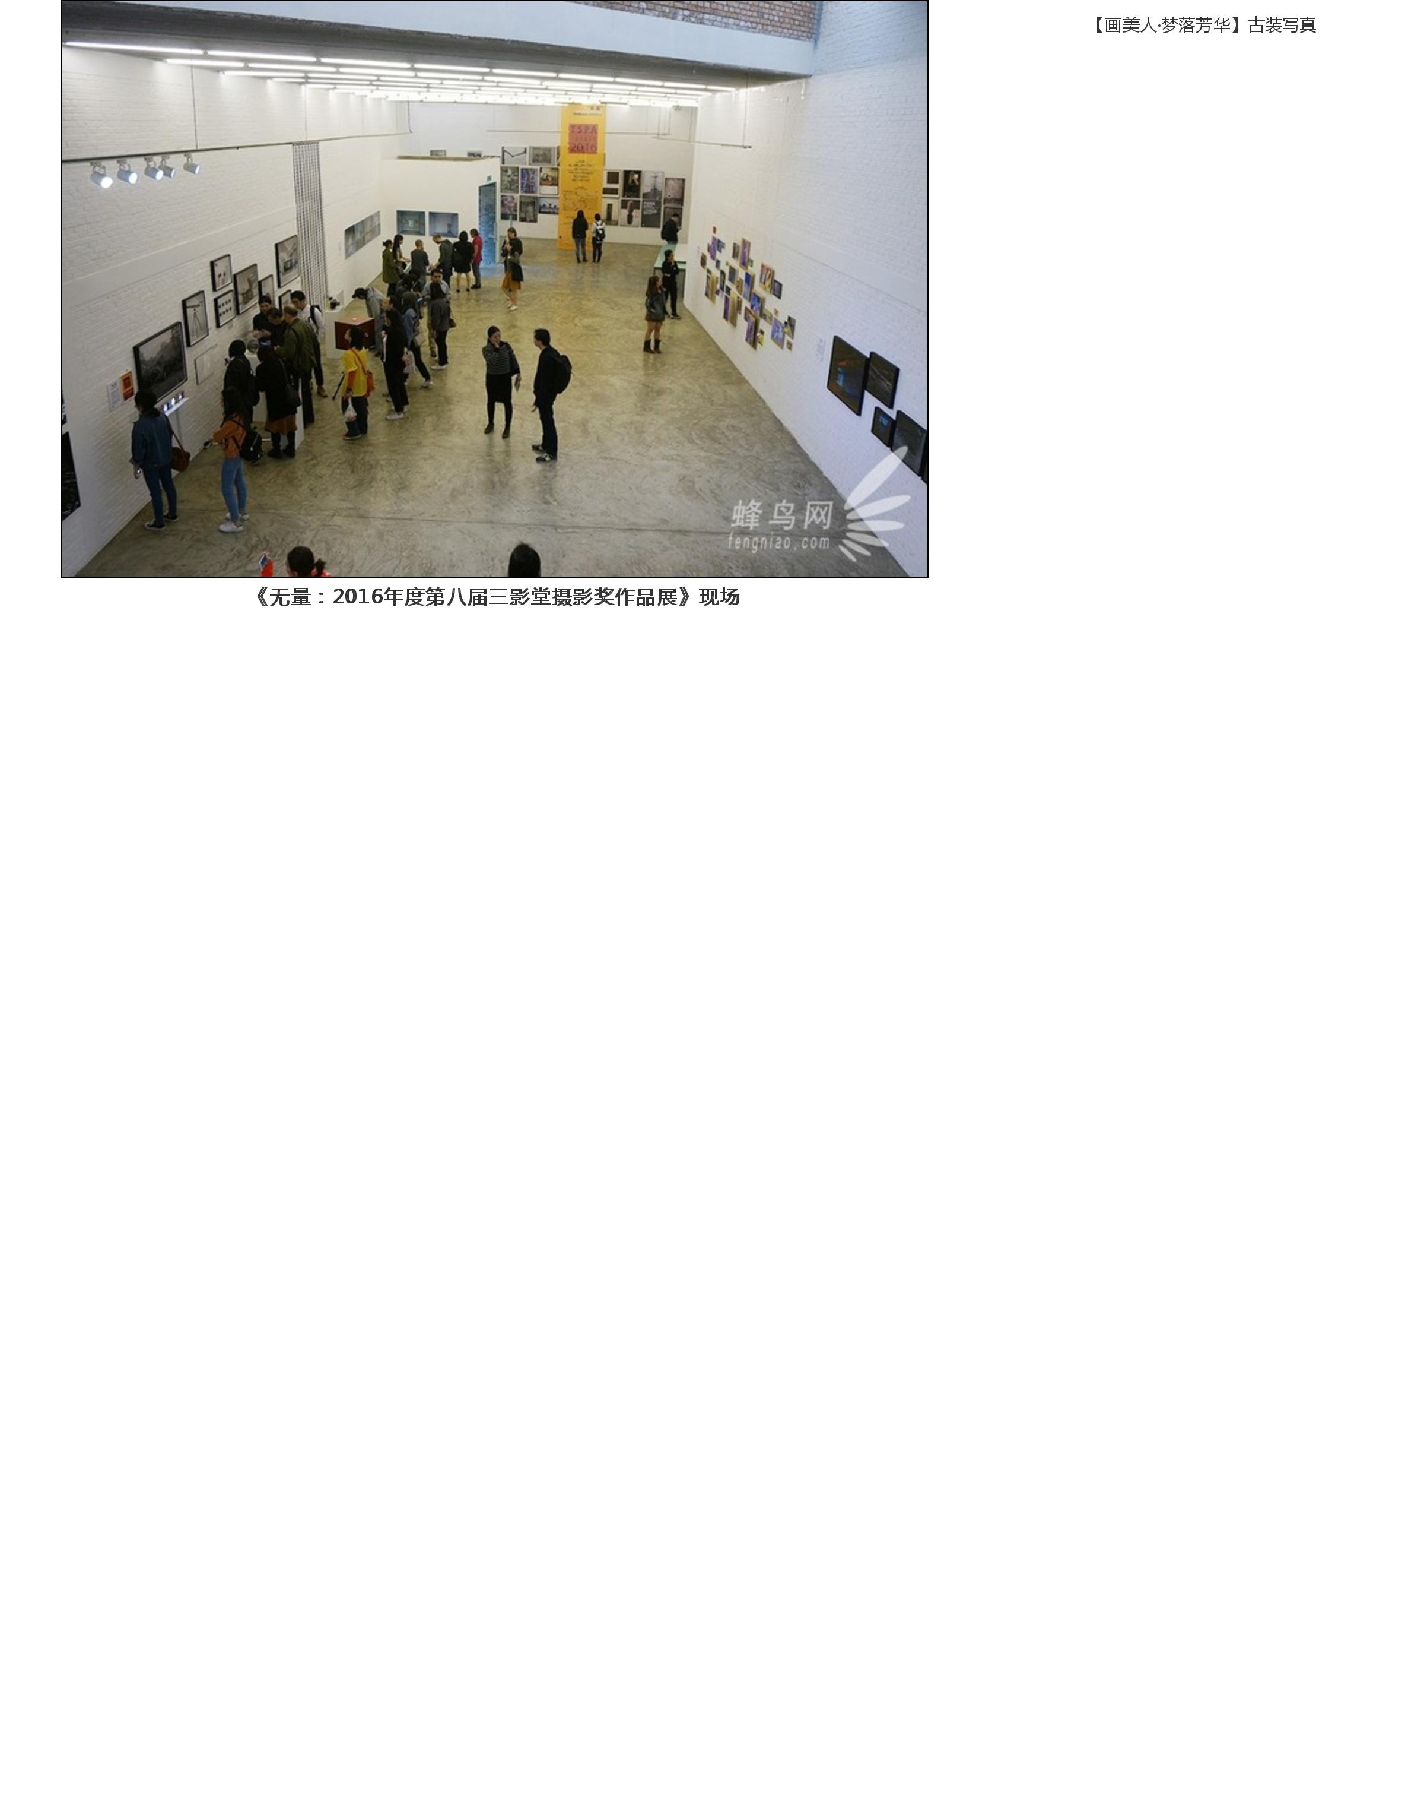

 |  | Publication: | 蜂鸟网
 |  | Date: | 2016年4月
 |  | Link: | http://image.fengniao.com/533/5334048.html
 |  | Title: | 林博彦和黄承聪获得第八届三影堂摄影奖
 |  | City: | Beijing 北京
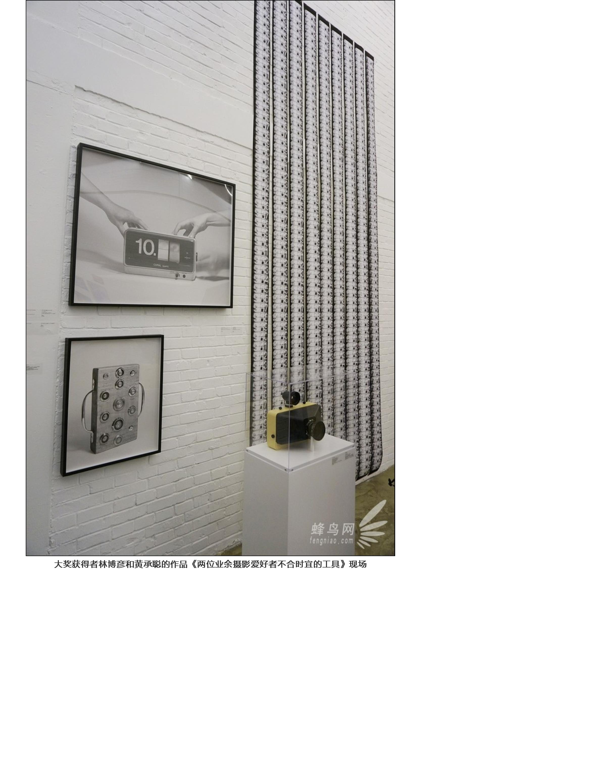

 |  | Publication: | 蜂鸟网
 |  | Date: | 2016年4月
 |  | Link: | http://image.fengniao.com/533/5334048.html
 |  | Title: | 林博彦和黄承聪获得第八届三影堂摄影奖
 |  | City: | Beijing 北京
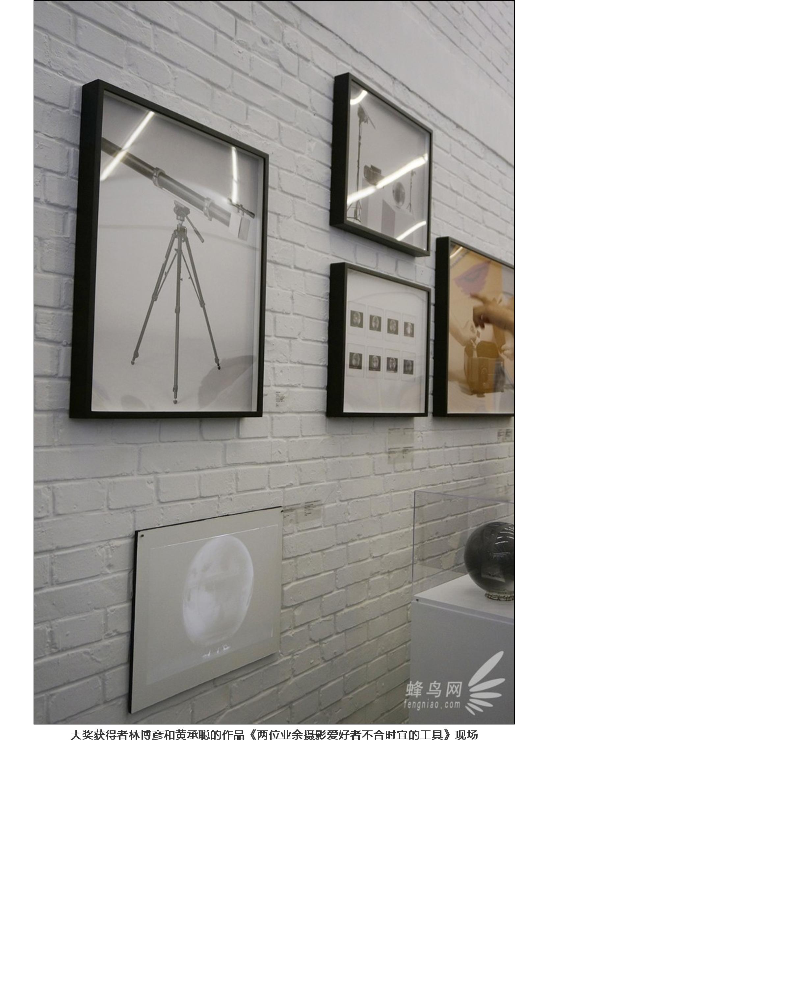

 |  | Publication: | 蜂鸟网
 |  | Date: | 2016年4月
 |  | Link: | http://image.fengniao.com/533/5334048.html
 |  | Title: | 林博彦和黄承聪获得第八届三影堂摄影奖
 |  | City: | Beijing 北京
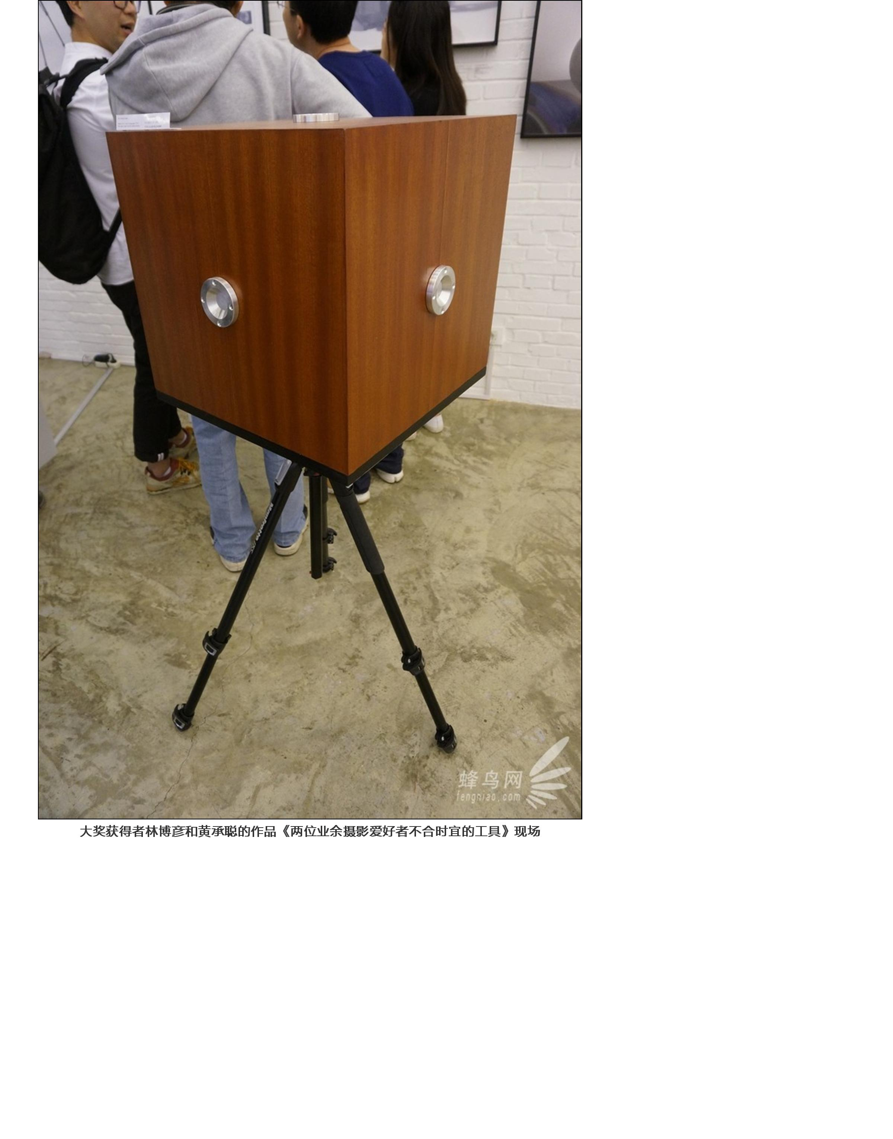
 |  | Publication: | 蜂鸟网
 |  | Date: | 2016年4月
 |  | Link: | http://image.fengniao.com/533/5334048.html
 |  | Title: | 林博彦和黄承聪获得第八届三影堂摄影奖
 |  | City: | Beijing 北京
