Three Shadows
Artist-in-Residence (AIR) Program
Application Form

Registering As | Individual / Group
First Name: |  | Last Name:
Primary Address:
Country: |  | City:
Passport Number:
Phone Number:
Email Address:
Recommended by
(Name of Institution):
Duration of Residence (DD/MM/YY): | to
Type of Living Quarters:

Types of living quarters | Availability | Description | Fee* (per day)
Beijing 50 m² loft | 1 | Loft, private bathroom, kitchen | RMB 800
Beijing 70 m² Studio | 1 | Large bedroom, private bathroom | RMB 800
Xiamen Studio | 1 | living room, private bathroom | RMB 250

· Fees include electricity, water, wireless Internet access, workspace and other support.

Please send a dossier including:
· CV
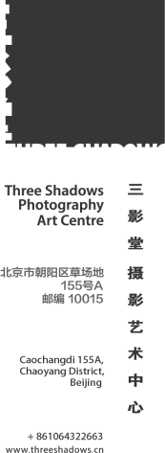
· Portfolio
· Plan of work for your stay
· Letter of recommendation
· Application form
· Any other relevant reference materials
Applications should be emailed to Ting Lin: linting@threeshadows.cn with subject line “Three Shadows_Artist in Residence”. Please submit applications at least three months before your anticipated arrival.

